DRAFT EAST AFRICAN STANDARD
Packaging -Ancillary materials — Specification -Part 2: Pressure sensitive adhesive tape

EAST AFRICAN COMMUNITY
Copyright notice
This EAC document is copyright-protected by EAC. While the reproduction of this document by participants in the EAC standards development process is permitted without prior permission from EAC, neither this document nor any extract from it may be reproduced, stored or transmitted in any form for any other purpose without prior written permission from EAC.
Requests for permission to reproduce this document for the purpose of selling it should be addressed as shown below or to EAC’s member body in the country of the requester:
© East African Community 2019 — All rights reserved
East African Community
P.O. Box 1096,
Arusha
Tanzania
Tel: + 255 27 2162100
Fax: + 255 27 2162190
E-mail: eac@eachq.org
Web: www.eac-quality.net
Reproduction for sales purposes may be subject to royalty payments or a licensing agreement. Violators may be prosecuted.
Foreword
Development of the East African Standards has been necessitated by the need for harmonizing requirements governing quality of products and services in the East African Community. It is envisaged that through harmonized standardization, trade barriers that are encountered when goods and services are exchanged within the Community will be removed.
The Community has established an East African Standards Committee (EASC) mandated to develop and issue East African Standards (EAS). The Committee is composed of representatives of the National Standards Bodies in Partner States, together with the representatives from the public and private sector organizations in the community.
East African Standards are developed through Technical Committees that are representative of key stakeholders including government, academia, consumer groups, private sector and other interested parties. Draft East African Standards are circulated to stakeholders through the National Standards Bodies in the Partner States. The comments received are discussed and incorporated before finalization of standards, in accordance with the Principles and procedures for development of East African Standards.
East African Standards are subject to review, to keep pace with technological advances. Users of the East African Standards are therefore expected to ensure that they always have the latest versions of the standards they are implementing.
The committee responsible for this document is Technical Committee EASC/TC 066, Packaging.
Attention is drawn to the possibility that some of the elements of this document may be subject of patent rights. EAC shall not be held responsible for identifying any or all such patent rights.
During the preparation of this Standard, reference was made to the following document:
IS 13262 Pressure sensitive adhesive tapes with plastic base — Specification.
Acknowledgment is hereby made for the assistance derived from this source.

Packaging -Ancillary materials — Specification -Part 2: Pressure sensitive adhesive tape

1 Scope
This Draft East African Standard specifies the requirements, methods of sampling and test for pressure sensitive adhesive cellulose, plasticized PVC, unplasticized PVC, polyester, polyethylene, polypropylene tapes for closing and sealing inner and outer containers normally used in packaging.

2 Normative references
The following documents are referred to in the text in such a way that some or all of their content constitutes requirements of this document. For dated references, only the edition cited applies. For undated references, the latest edition of the referenced document (including any amendments) applies.
ISO 291, Plastics — Standard atmospheres for conditioning and testing

3 Terms and definitions
For the purposes of this standard, the following term and definition apply
Packaging tape

3 Requirements

3.1 General requirements
3.1.1 Workmanship
3.1.1.1 The pressure sensitive adhesive tape shall consist of a base film, coated uniformly on one side with a suitable pressure sensitive adhesive composition, requiring no moisture, heat or other special preparation prior to application.
3.1.1.2 The packaging tape shall be free from defects that may affect its serviceability. The entire area of one side of the tape shall have a smooth, continuous and uniform coating of adhesive.
3.1.1.3 The gummed side of the tape shall face the core. The edges of the roll shall be neatly cut and free from fluff, and the adhesive tape for packaging on each roll shall be one continuous strip and shall be suitably joined at not more than two places.
3.1.1.3 Splices
A roll of tape shall not have more than one splice in 20m and not more than 3 in a roll. The splices shall be so made so as not to separate when unwound from the roll.
5
.

3.1.2 Base paper

The tape shall consist of polyolefin sheet. The paper shall resist excessive penetration of adhesive and shall be sufficiently flexible to ensure folding.
3.1.3 Adhesive

3.1.3.1 The adhesive used shall be homogeneous and free from solid particles so as to give a smooth finish on application to the base.

3.1.3.2 The adhesive shall emit no objectionable odour and shall not be toxic.

3.1.3.3 The adhesive shall also readily adhere to the base paper and the tape shall adhere immediately and firmly to clean, dry surfaces without wrinkling, curling, breaking or lifting.

3.1.3.4 The adhesive shall be such that on unwinding a roll of masking tape, adjacent layers shall show no sign of adhering to each other.

3.2 Specific requirements

3.2.1 Physical requirements
When tested in accordance with the methods specified in Table 1, the packaging tape shall meet the requirements specified therein.
Table 1 —Physical requirements for Pressure sensitive adhesive tape
S/N | Characteristic |  | Requirements | Test method
 | Breaking strength, N per 10mm,min | Typical Base material | 25 | Annex A
 | Breaking strength, N per 10mm,min | Cellulose | 25 | Annex A
 | Breaking strength, N per 10mm,min | Plasticized PVC | 13 | Annex A
 | Breaking strength, N per 10mm,min | Unplasticized PVC | 25 | Annex A
 | Breaking strength, N per 10mm,min | Polyester | 25 | Annex A
 | Breaking strength, N per 10mm,min | Polyethylene | 10 | Annex A
 | Breaking strength, N per 10mm,min | Polypropylene | 25 | Annex A
 | Breaking strength, N per 10mm,min | Heavy density polyethylene | 95 | Annex A
 | Elongation at break |  | Shall not be less than 7 % and not more than 20 %. | Annex A
 | Adhesive strength |  | Shall be not less than 1.6 N per 10 mm width. | Annex B
 | Width, mm, ± 0.1 |  | 2.5 | Annex C
 | Length, mm, min |  | 15,000 | Annex D

4 Packaging
Pressure sensitive adhesive tape shall be packed in suitable materials that prevents it from contamination and damage during normal handling, storage and transportation.

5 Labelling
5.1 Pressure sensitive adhesive tape shall be legibly and indelibly labelled marked with the following information:
- manufactures/suppliers name or trade mark or both;
- words, “Pressure sensitive adhesive tape”;
- month and year of manufacture;
- the grammage of the sheet of paper;
- length and width of the pressure sensitive adhesive tapes; and
- country of origin/manufacture.

Annex A
(normative)
Method for determination of breaking strength and elongation at break

A.1 Apparatus
Tensile testing machine, equipped with a continuous indicating device calibrated at intervals of 0.2 N or less and a rate of movement of the driven jaw of 300 ± 30 mm/minute.
A.2 Pre-conditioning
Immediately before pieces for testing are taken, condition each sample roll for at least 24 h at 23 ± 2 °C and 50 ± 5 % r.h. for at least 2 h immediately before testing. Remove and discard the three outer turns before cutting the test pieces from the conditioned roll.
A.3 Test pieces
Take three strips of tape, each of sufficient length to give an initial test length of 200 mm from the sample roll at intervals of not less than 300 mm.
A.4 Conditioning
Condition the test pieces by freely suspending them at 23 ± 2 °C and 50 ± 5 % r.h. for at least 2 h immediately before testing.
A.5 Procedure
Insert the test piece into the grips or jaws of the machine so that the load is applied evenly across the width and the initial test length is 200 mm. Elongate the test piece until it breaks and record the maximum force during the test and the increase in distance between the grips or jaws at the moment of break. Make three valid determinations, disregarding any test in which the break occurs within 5 mm of either grip or jaw. Ensure that during the test the tape does not slip in the grips or jaws of the testing machine.

A.6 Results

A.6.1 Breaking strength
From the central value of the three recorded maximum forces, calculate and report the breaking strength in newtons per 10 mm width.

A.6.2 Elongation at break
From the central value of the three recorded increases in distance between the grips or jaws at the moment of break, calculate and report the elongation at break as a percentage of the original distance between the grips or jaws.

Annex B
(normative)

Method for determination of adhesive strength to steel

B.1 Solvents
One of the following solvents is required:
- methanol;
- butanone (ethyl methyl ketone);
- acetone;
- Sulphur free toluene.

NOTE: All the above solvents shall be of general purpose chemical grade.

B.2 Apparatus

B.2.1 Five rectangular test plates of stainless steel, within the following compositional limits:
- carbon 0.16 %, max.;
- silicon 0.20 %, min.;
- manganese 2.00 %, max.;
- nickel 8 % to 14 %;
- chromium 11 % to 19 %.

A convenient size of plate is 200 mm x 50 mm; the thickness shall be not less than 2 mm. The plate is marked at equidistant intervals of 12.5 mm, along both of the longer edges, the first mark being made at 50 mm from end A (see Figure 1). The central 40 mm of the test plate width shall be free from marks.

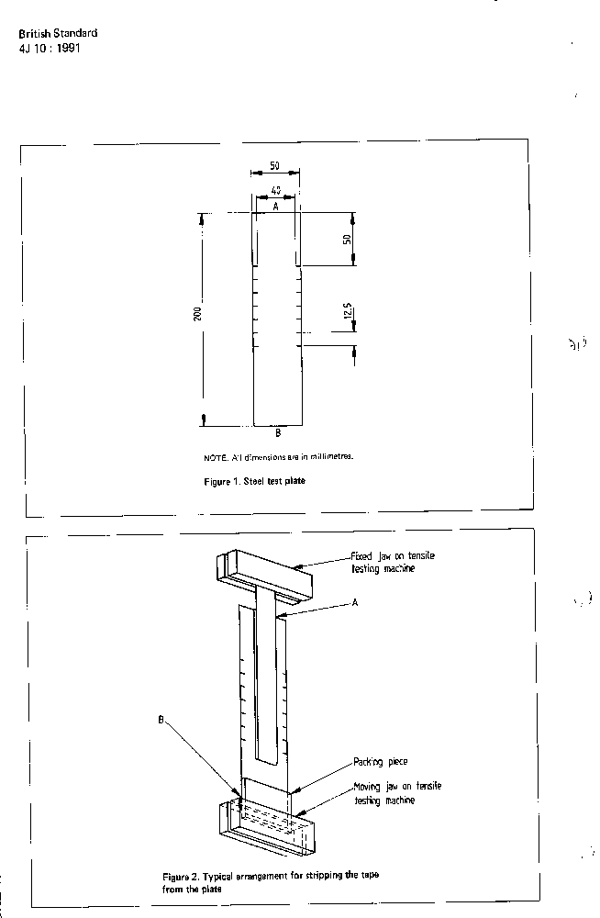
All dimensions in millimeters
Figure 1 — Steel test plate

The test surface of the plate shall be polished to give an abrasive satin finish (180 grit), the direction of gritting being parallel to the longer side of the plate. The surface roughness shall be determined from the mean line of the profile in accordance with BS 1134: Part 1¹⁾ and shall comply with the following:
0.05µm<R_{a}<0.40µm
R_{max}. < 3 µm

where,

R_{a} is the arithmetical mean deviation;
R _{max.} is the maximum height of irregularities.

B.2.2 Solid brass roller, 80 mm in diameter and 44 mm in width, covered with rubber approximately 6 mm thick having an IRHD (International Rubber Hardness Degree) of 60 ± 5; the mass of the roller shall be approximately 2 kg.

B.2.3 Power driven tensile testing machine, as described in A.1.1, but with the back stop or ratchet pawl removed in the case of a pendulum test machine.

B.2.4 Cleaning materials

B.2.4.1 4-hydroxy-4-methylpentan-2-one (diacetone alcohol).

B.2.4.2 Pharmaceutical quality, lint free cotton wool or paper tissue.

B.3 Preconditioning

Immediately before pieces for testing are taken, condition each sample roll for at least 24 h at 23 ± 2 °C and 50 ± 5 % r.h. for at least 2 h immediately before testing. Remove and discard the three outer turns before cutting the test pieces from the conditioned roll.

B.4 Test pieces

Take five strips of tape 450 mm long, unwound radially from the roll at intervals of 300 mm at a rate of approximately 300 mm/s. Avoid contamination of the adhesive surface and do not allow it to touch the fingers. If the tape is wider than 38 mm, cut a test piece 25 mm wide from it, using a sharp tool to produce clean cut edges. If the tape is 38 mm wide or less, use the tape in the width received.

B.5 Procedure

B.5.1 General

Test each strip on a separate plate as described in B.5.2, B.5.3 and B.5.4.

B.5.2 Cleaning of the plate

Wipe the test surface of the plate with a fresh piece of lint free cotton wool saturated with 4-hydroxy-4methylpentan-2-one (diacetone alcohol). Dry the plate with fresh cotton wool, then wipe the test surface with a fresh piece of cotton wool saturated with one of the solvents listed in B.1. Dry the plate with fresh cotton wool, then repeat for a total of three cleaning operations with this solvent. Maintain the plate at a temperature of 23 ± 2 °C for at least 5 min before proceeding with the adhesion test procedure.

NOTE 1: Paper tissue may be substituted for cotton wool.

NOTE 2: Cleaning shall be carried out in an area with good fume extraction.

B.5.3 Application of test piece
Apply the test piece as follows:

- place the plate, with the prepared surface upwards, at the edge of a bench with end 8 nearer the operator (see Figure 1);

- immediately after obtaining the test piece, apply it, adhesive surface downwards, to the plate with one pass of the roller, allowing approximately 250 mm to overhang end B. Ensure that the tape lies centrally on the plate and parallel to the longer sides and also that no air bubbles are trapped between the tape and the plate;

- place the roller centrally across the test piece on one end of the plate and, taking care not to apply any additional pressure with the hand, pass the roller at constant speed three more times over the test piece (making a total of twice in each direction) so that each traverse takes from 10 s to 12 s,ensuring that it travels in the exact line of the test piece;

cut off the excess tape overhanging end A.

B.5.4 Stripping of test piece

B.5.4.1 Allow the plate with the applied test piece to remain undisturbed for 5 min in the conditions given in B.5.3 and complete the test without removal from those conditions.

B.5.4.2 Double back the free end of the test piece and strip 25 mm to 50 mm from the plate at end B.

B.5.4.3 Attach end B of the plate to the moving jaw on the testing machine and grip the free end of the test piece in the fixed jaw, ensuring, by inserting packing in the moving jaw (see Figure 2), that the free tape is parallel in both planes to the applied tape.

D.5.4.4 Set the traversing jaw in motion and record the readings at five consecutive 12.5 mm interval marks.

B.6 Results

Record the five readings for each of the five tests. Arrange in ascending order the five readings for each test and take the central value of each group. Arrange the five central values so obtained in ascending order and take the central value and divide it by the width of the test sample measured in centimetres. This figure is the adhesion strength to steel measured in Newton’s per 10 mm width.

Figure 2 — Typical arrangement for stripping the tape from the plate

Annex C
(normative)
Measurement of width

A.1 Measure to the nearest 0.5 mm, the width, (parallel to the cross direction of the packaging tape) of each five test specimen taken across full width of five separate rolls and record the average of the results.
A.2 Measure to the nearest 1 mm, the diameter of each of the five rolls and record the results. Check for compliance with 4.4.

Annex D
(normative)
Measurement of length

A.1 Measure to the nearest 0.5 mm, the width, (parallel to the cross direction of the packaging tape) of each five test specimen taken across full width of five separate rolls and record the average of the results.
A.2 Measure to the nearest 1 mm, the diameter of each of the five rolls and record the results. Check for compliance with 4.4.

Bibliography
KS 2674, Paper and board food contact Packaging material — Specification

1) Assessment of surface texture Part 1. Methods and instrumentation.

