DRAFT EAST AFRICAN STANDARD
Hermetic Storage Bags —Specification

EAST AFRICAN COMMUNITY
Copyright notice
This EAC document is copyright-protected by EAC. While the reproduction of this document by participants in the EAC standards development process is permitted without prior permission from EAC, neither this document nor any extract from it may be reproduced, stored or transmitted in any form for any other purpose without prior written permission from EAC.
Requests for permission to reproduce this document for the purpose of selling it should be addressed as shown below or to EAC’s member body in the country of the requester:
© East African Community 2018 — All rights reserved
East African Community
P.O. Box 1096,
Arusha
Tanzania
Tel: + 255 27 2162100
Fax: + 255 27 2162190
E-mail: eac@eachq.org
Web: www.eac-quality.net
Reproduction for sales purposes may be subject to royalty payments or a licensing agreement. Violators may be prosecuted.
Foreword
Development of the East African Standards has been necessitated by the need for harmonizing requirements governing quality of products and services in the East African Community. It is envisaged that through harmonized standardization, trade barriers that are encountered when goods and services are exchanged within the Community will be removed.
The Community has established an East African Standards Committee (EASC) mandated to develop and issue East African Standards (EAS). The Committee is composed of representatives of the National Standards Bodies in Partner States, together with the representatives from the public and private sector organizations in the community.
East African Standards are developed through Technical Committees that are representative of key stakeholders including government, academia, consumer groups, private sector and other interested parties. Draft East African Standards are circulated to stakeholders through the National Standards Bodies in the Partner States. The comments received are discussed and incorporated before finalization of standards, in accordance with the Principles and procedures for development of East African Standards.
East African Standards are subject to review, to keep pace with technological advances. Users of the East African Standards are therefore expected to ensure that they always have the latest versions of the standards they are implementing.
The committee responsible for this document is the joint technical Committee of EASC/TC 066 Packaging, EASC/TC 014, Cereals, pulses and related products and EASC/TC/061 on textiles and textile products.
Attention is drawn to the possibility that some of the elements of this document may be subject of patent rights. EAC shall not be held responsible for identifying any or all such patent rights.
During the preparation of this Standard, reference was made to the following document:
KS 482, Specification for woven polyolefin sacks for seeds.

Acknowledgment is hereby made for the assistance derived from this source.

Hermetic Storage Bags —Specification

1 Scope
This Draft East African Standard specifies the requirements, methods of sampling and test for for hermetic bags for storage of dried food commodities, derived products and seeds.
2 Normative references
The following documents are referred to in the text in such a way that some or all of their content constitutes requirements of this document. For dated references, only the edition cited applies. For undated references, the latest edition of the referenced document (including any amendments) applies.
KS 1056-1 Specification for woven wrapping cloth - Part 1: Polypropylene cloth
KS 1037:1990 Methods of test for woven bags
KS 482, Specification for woven polyolefin sacks for seeds
ASTM D 398-13 Determination of water vapour transmission rate (WVTR) -- Gravimetric (dish) methodISO 4591 Plastics -- Film and sheeting -- Determination of average thickness of a sample, and average thickness and yield of a roll, by gravimetric techniques (gravimetric thickness)
ISO 2556 Plastics -- Determination of the gas transmission rate of films and thin sheets under atmospheric pressure -- Manometric method
ISO 7765 Plastic film and sheeting-Determination of Impact resistance by free falling dart method part 2: Instrumented punctured test
ISO 6383-2 Plastic film and sheeting-Determination of tear resistance part 2: Elmendorf-method
ISO 7965-2 Sack-drop test part 2: -Sacks made from thermoplastic flexible film
ISO 22198 Textile Fabrics-Determination of width and length
ISO 7211-5 Textile-woven Fabrics-Construction-methods of analysis-Part 5: Determination of linear density of yearn removed from fabrics.
ISO 3801 Textile-woven Fabrics-Determination of mass per unit length and mass per unit area
ISO 13934-1:2013 Textiles -- Tensile properties of fabrics -- Part 1: Determination of maximum force and
elongation at maximum force using the strip method
ISO 177 Plastics — Determination of migration of plasticizers
ASTM D-3985-95 Standard Test Method for Oxygen Gas Transmission Rate Through Plastic Film and Sheeting Using a Coulometric Sensor
ISO 2062:2009 Textiles -- Yarns from packages -- Determination of single-end breaking force and elongation at break using constant rate of extension (CRE) tester

ASTM F 1927 - 07 Standard Test Method for Determination of Oxygen Gas Transmission Rate, Permeability and Permeance at Controlled Relative Humidity Through Barrier Materials Using a Coulometric Detector
ASTM F1306 – 90 Standard Test Method for Slow Rate Penetration Resistance of Flexible Barrier Films and Laminates
ASTM D882-18 Standard Test Method for Tensile Properties of thin Plastic Sheeting
KS 2319:2011 Determination of overall migration of constituents of plastic materials and articles intended to come in contact with food stuffs – Methods of analysis

3 Terms and definition
3.1
grain
Small hard dry seed with or without an attached hull or fruit layer harvested for human or animal consumption

3.2

hermetic storage bag

A sealed storage system based on the generation of an oxygen and moisture depleted and carbon dioxide enriched inter granular atmosphere by respiration of the living organisms in the dried food commodities and derived products.

3.3
food grade material

packaging material, made of substances which are safe and suitable for the Intended use and which will not Impart any toxic substances or undesirable odour or flavor to the products.

3.4

Oxygen transmission rate (OTR)

Quantity of oxygen transmitted through unit area of a test specimen in unit time under specified conditions of temperature, humidity and thickness

3.5
Water vapour transmission rate (WVTR)

quantity of water vapour transmitted through unit area of a test specimen in unit time under specified conditions of temperature, humidity and thickness

3.6
dry food commodity
cereals and pulses whose moisture content is within acceptable limits as specified in the Standards

3.7
derived products

processed products from cereals and pulses

4 Requirements

4.1 General requirements for outer bag

4.1.1 The bag shall be made from woven polypropylene tapes of virgin resin
4.1.2 Stitching thread
a) The stitching thread shall be made from either polypropylene or polyester and unprocessed wood fibre.
4.1.3 Edge sealing
All raw edges of the bags shall be heat sealed or hemmed to prevent fraying
4.1.4 Base Closure
The closure shall be effected either by a turned-over and stitched seam or by bonding. Where the base closure is bonded, the seam shall be effected by applying capping tape over the ends of the sack and securing by means of an adhesive.
4.1.5 Longitudinal Seams
longitudinal seams shall not be used in the manufacture of hermetic storage bags

4.2. General requirements for hermetic liner

4.2.1 The liner shall be made from virgin polymer resins that are food grade material
4.2.2 The joints of the liners shall be heat sealed.
4.3. General requirements for closures of hermetic liners
The liner shall have a closing mechanism to secure and maintain the hermetic condition.
4.4. General requirements for closures of woven polypropylene bag
The bag shall have a closing mechanism to secure and maintain the contents without puncturing the liner.

5.3 Specific requirements
5.3.1 Specific requirements for woven polypropylene bags
Woven polypylene bags shall meet the physical requirements as specified in table 1.

Table 1 — Specific requirements for polypropylene bags
S/No. | Characteristic |  | Requirements | Test method
 | Degree of coverage,%, min. | Warp | 100 | Annex A
 | Degree of coverage,%, min. | weft | 100 | Annex A
 | Breaking Force of the Sacking,N,min | warp | 600 | ISO 13934-1
 | Breaking Force of the Sacking,N,min | weft | 600 | ISO 13934-1
 | Break strength of the tape  ( yarn),N,min |  | 20 | ISO 2062
 | Elongation at break of the tape,%, min |  | 20 | ISO 2062
 | Linear density,denier,min. |  | 700 | ISO 7211 Part 5
 | Mass per unit area of the sacking ,g/m²,min |  | 70 | ISO 3801
 | Stitch Density per 10 cm,min |  | 12 | Annex B
 | Seam Strength,N.min. |  | 480 | Annex C
 | Turned-over and stitched seam |  | The turn-over shall be 2 cm minimum and the stitch line shall be 1 ± 0.3 cm from the base so formed and shall pass through all the four thicknesses of the fabrics. | KS 482

5.3.2 Hermetic liner

When tested in accordance with the methods specified in Table 2, the hermetic liner shall comply with the requirements specified therein.

Table 2 — Specific requirements for hermetic liner
S/No. | Characteristic | Requirements | Test method
 | Thickness , µm ,min. | 65 µm | ISO 4591
 | OTR, (cc/m²/day),max | 250 | ISO 2556  ASTM D-3985-95  ASTMF-1927-98((23⁰C and 65% RH)
 | WVTR, (g/m²/day),max | 10 | ISO 2528
 | Impact resistance, g,min. | 350 | ISO 7765-2
 | Puncture resistance, N,min. | 50 | ISO 6383-2  ASTM F 1306-90

5.3.3 Specific requirements for fully assembled hermetic storage bag

5.3.3.1 Drop test

5.3.3.1.1 Butt dropping

When tested in accordance to ISO 7965-2 at a height of 1.20m on the bottom and the top of the bag, after each drop, there shall be no rupture or loss of contents.

5.3.3.1.2 -Flat dropping

When tested in accordance to ISO 7965-2 at a height of 1.60m twice on one flat face and twice on the opposite flat face., there shall be no rupture or loss of contents.

5.3.3.1.3 Dimension and capacity
When tested in accordance to ISO 22198 the nominal dimensions of the bags shall be as declared subject to a tolerance of ± 2 cm and capacity as stated.

5.3.4 Food grade requirements

5.3.4.1 When tested in accordance with ISO 177 the bag shall not transfer toxic substances injurious to human on the packed products.
6 Packaging and Labelling
6.1 Packaging
6.1.1 Hermetic bags shall be packed in suitable materials that prevents it from damage, contamination during normal handling, storage and transportation.
6.1.2 The bags shall be packaged in agreed quantities between the buyer and seller
6.2 Labelling
6.2.1 Woven polypropylene
The woven polypropylene bag shall be legibly and indelibly marked with the following information on the outer.
- Manufacturer’s name, address and /or registered trade mark.

- Description of goods, “Hermetic Storage bag”.

- Capacity of the hermetic bag in kg as dried maize equivalent, e.g. 25,50,90,100.

- Dimensions of the bag.

- Declaration of the number of liners in the bag

- Batch number or code

- Instruction for correct use

- Instruction for storage and disposal of used bag.
- The declaration, ‘country of manufacture and origin.

6.2.2 Liner
The liner shall be legibly and indelibly marked with the following information
- Manufacturer’s name, address and /or registered trade mark.

- Declaration, “Hermetic liner”.

- Indication of the type of polymer resin used.

- Capacity of the liner in kg as dried maize equivalent, e.g. 25,50,90,100.

- Dimensions of the liners.
- Batch number or code
- The declaration, ‘country of manufacture and origin

- Instruction for correct use, storage and disposal of the liner.

6.2.3 Bulk package
The bulk package shall be legibly and indelibly marked with the following information.
- Manufacturer’s name, address and /or registered trade mark.
- Description of goods, “Hermetic Storage bags”.
- Capacity of the hermetic bags in Kg as dried maize equivalent e.g. 25,50,90,100.
- The quantities of the bags
- Declaration of the number of liners in the bag
- Batch number or code
- Instruction for storage and disposal of bulk packaging material.
- The declaration, ‘country of manufacture and origin

Annex A
(normative)
Determination of degree of coverage for warp tapes and weft tapes

A1.1 Mark out separately five distinct spaces (areas), each measuring 20 cm x 20 cm, on each sample of wrapping cloth.

A1.2 Count the number of warp tapes within each space (area). Denote this by ‘N’.

A1.3 Count also the number of weft tapes within each space (area) and denote this by ‘n’.

A1.4 Remove ten (10) warp tapes form each sample and measure the width of each tape to the nearest 0.10 mm. Calculate the mean warp tape width and denote this by ‘a’.

A1.5 Remove also ten (10) weft tapes form each sample and measure the width for each tape to the nearest 0.10 mm. Calculate the mean weft tape width and denote the by ‘b’ mm.

A1.6 Determine the degree of warp coverage ‘Kp’ and weft covering Kf as follow:

A1.6.1 Kp = 1/5 (Kp₁ + Kp₂ + Kp₃ + Kp₄ + Kp₅)

where,

Kp = Degree of warp coverage for the sample and

Kp₁ Kp_{2 …}Kp₅ = Degree of warp coverage for each marked space (area).

Kpt = 0.5 Na

where,

t = 1, 2, 3, 4, 5

a = mean warp tape width in mm and

N = Number of warp tapes/20 cm.

A1.6.2 (Kf₁ = 1/5 (Kf₁ + Kf₂ + Kf₃ + Kf₄ + Kf₅)

where,

Kf = Degree of weft coverage for the sample and
Kf₁, Kf₂ …Kf₅ = Degree of weft coverage for each marked space (area).

Kft = 0.5nb

where,

t = 1, 2, 3, 4, 5,

n = number of weft tapes/20 cm, and

b = mean tape width in mm.

Annex B
(normative)
Stitch Density

B.1. Determination of Stitch Density — Count the number of stitches over a length of 10 cm on each side and
bottom seams (if any) of each bag. Space the measurements so that all the seams are adequately assessed
Calculate the mean reading and report the mean for each sack.

Annex C
(normative)
Determination of seam strength

C.1 Breaking strength of seam

C.1.1 Cut out two specimens from each bag in the form of a double “T” with 10 cm of seam and 5 cm of sacking as shown in Figure 1.

All dimensions in centimetres

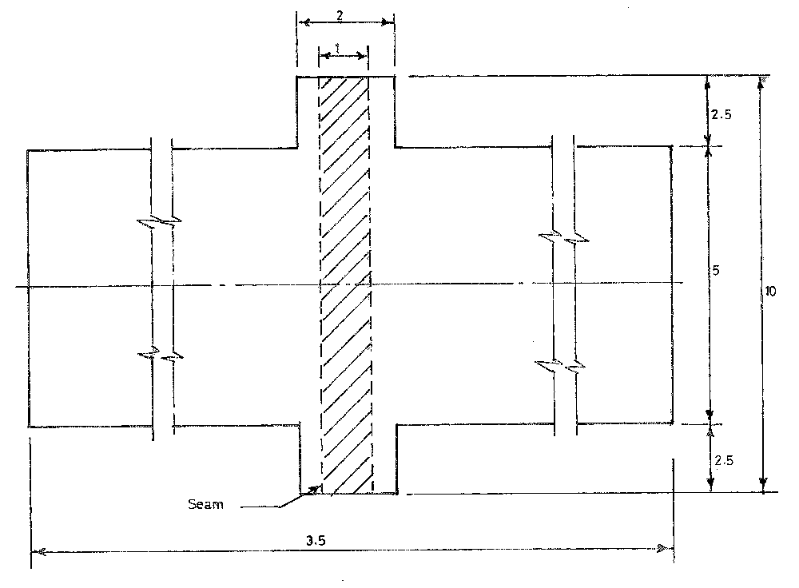

Fig. 1 — size and shape of test-specimen for seam strength

C.1.2 Determine the average breaking strength of the seam taking 20.0 cm as the nominal gauge length of the strength-tester, with the seam near about the center using a constant-rate-of-traverse of 20 cm per minute.

Bibliography
KS 2873, Hermetic Storage Bags —Specification

