DRAFT EAST AFRICAN STANDARD

Glass bottles for carbonated soft drinks—Specification

EAST AFRICAN COMMUNITY
Copyright notice
This EAC document is copyright-protected by EAC. While the reproduction of this document by participants in the EAC standards development process is permitted without prior permission from EAC, neither this document nor any extract from it may be reproduced, stored or transmitted in any form for any other purpose without prior written permission from EAC.
Requests for permission to reproduce this document for the purpose of selling it should be addressed as shown below or to EAC’s member body in the country of the requester:
© East African Community 2019 — All rights reserved
East African Community
P.O. Box 1096,
Arusha
Tanzania
Tel: + 255 27 2162100
Fax: + 255 27 2162190
E-mail: eac@eachq.org
Web: www.eac-quality.net
Reproduction for sales purposes may be subject to royalty payments or a licensing agreement. Violators may be prosecuted.
Foreword
Development of the East African Standards has been necessitated by the need for harmonizing requirements governing quality of products and services in the East African Community. It is envisaged that through harmonized standardization, trade barriers that are encountered when goods and services are exchanged within the Community will be removed.
The Community has established an East African Standards Committee (EASC) mandated to develop and issue East African Standards (EAS). The Committee is composed of representatives of the National Standards Bodies in Partner States, together with the representatives from the public and private sector organizations in the community.
East African Standards are developed through Technical Committees that are representative of key stakeholders including government, academia, consumer groups, private sector and other interested parties. Draft East African Standards are circulated to stakeholders through the National Standards Bodies in the Partner States. The comments received are discussed and incorporated before finalization of standards, in accordance with the Principles and procedures for development of East African Standards.
East African Standards are subject to review, to keep pace with technological advances. Users of the East African Standards are therefore expected to ensure that they always have the latest versions of the standards they are implementing.
The committee responsible for this document is technical Committee of EASC/TC 066 Packaging
Attention is drawn to the possibility that some of the elements of this document may be subject of patent rights. EAC shall not be held responsible for identifying any or all such patent rights.
During the preparation of this Standard, reference was made to the following document:
BS 6119-1 Glass bottles for carbonated soft drinks—Specification
Acknowledgment is hereby made for the assistance derived from this source.

Glass bottles for carbonated soft drinks—Specification

1 Scope
This Draft East African Standard specifies the requirements, methods of sampling and test for Glass bottles used for packaging of carbonated soft drinks.
2 Normative references
The following documents are referred to in the text in such a way that some or all of their content constitutes requirements of this document. For dated references, only the edition cited applies. For undated references, the latest edition of the referenced document (including any amendments) applies.

BS 6001, Sampling procedures and tables for inspection by attributes.

3 Terms and definition
For the purposes of this document, the following terms and definitions apply.

3.1
carbonation level

the number of volumes of carbon dioxide gas dissolved in one volume of liquid, measured at 20 ⁰C and1 bar pressure. Alternatively, it can be expressed in grams of carbon dioxide per litre

3.2
filling level

the distance from the top of the neck finish to the centre of the meniscus measured on the centre line of the bottle

3.3
filling level

the distance from the top of the neck finish to the centre of the meniscus measured on the centre line of the bottle

3.4
internal pressure resistance

the amount of internal pressure that the bottle can withstand for 60s without breaking

3.5
multi-trip

bottle a bottle having strength characteristics that enable it to perform a number of trip

3.6
vacuity

the free space left above the liquid in a sealed container. It is expressed as a percentage of the nominal volume of the liquid

4. Requirements

4.1 General requirements

4.1.1 Materials

The bottles shall be made from white-flint soda-lime glass.

4.2 Bottle design

A typical bottle designs shall be as shown in Figure 1 and Figure 2 and any other as specified. The glass distribution shall be as uniform as possible.

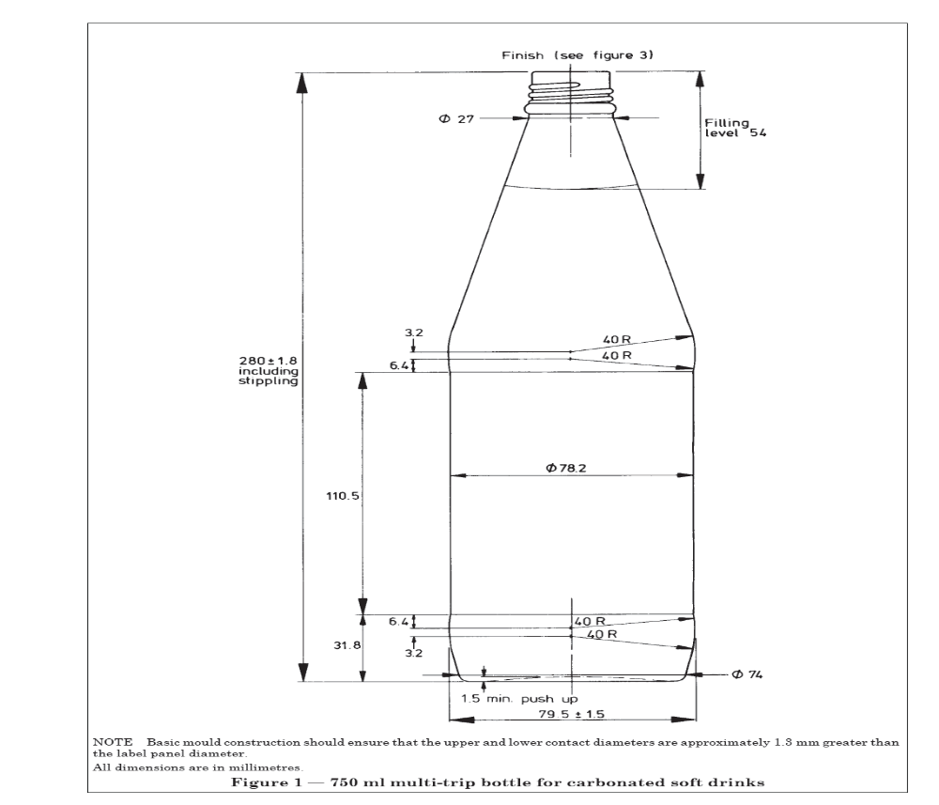

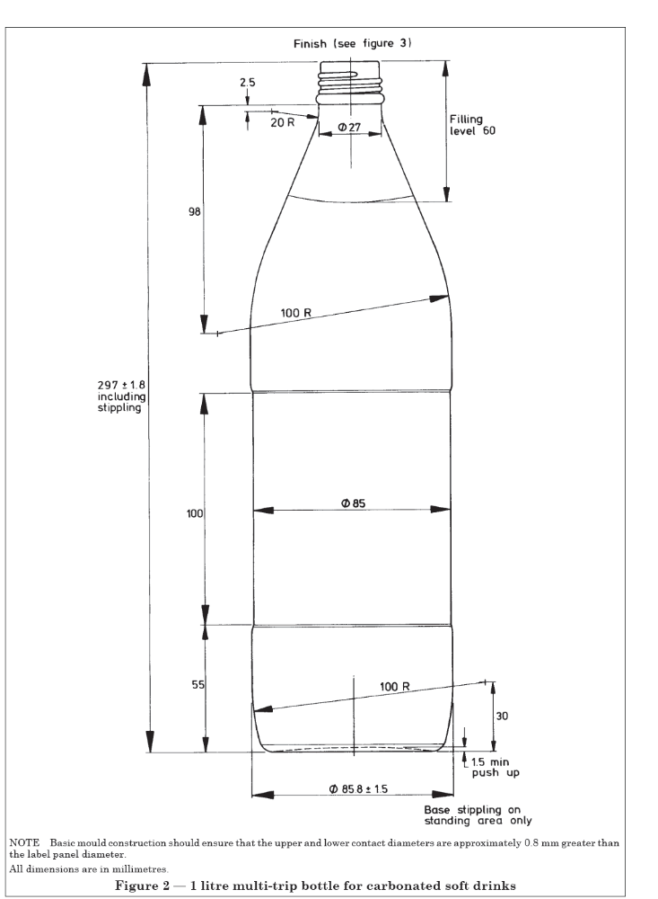

4.3 Dimensions

4.3.1 General.

The bottle dimensions shall be as shown in Figure 1 or Figure 2, as appropriate or any other as specified

4.4 Capacity

4.4.1 Capacity at filling level.

When tested in accordance with annex A the capacity at filling level shall be as specified in the marking clause.

4.4.1 The filling level shall be as shown in Figure 1 or Figure 2, as appropriate or specified.

4.4 Design vacuity.

The design vacuity shall be not more than 3.5%.

4.5 Neck finish

4.4.1 Design and dimensions.

The neck finish shall be of the continuous thread finish type. A typical design and dimensions of the neck finish shall be as shown in Figure 3.

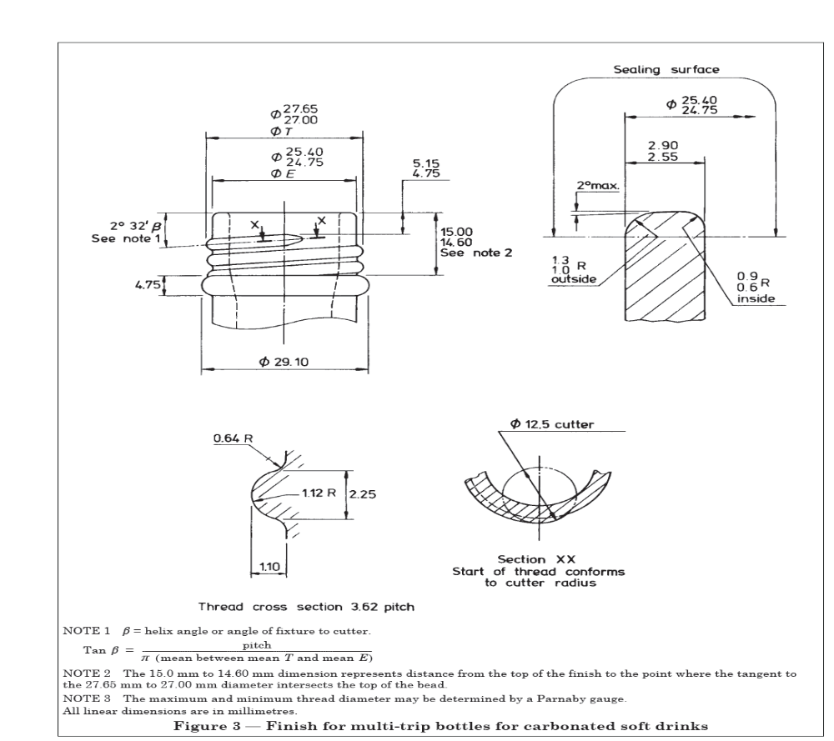

4.5. Bore dimensions

shall be measured using a gauge that enters the neck vertically.

4.6 Closure integrity.

All sealing surfaces shall be essentially smooth and free from features that prevent adequate sealing.

4.7 Internal pressure resistance

When tested in accordance to Annex B, the minimum resistance to internal pressure of the bottles, shall be16 bar sustained for 60s,

NOTE 1 bar = 105 Pa. ,1 bar = 0.98 kg/cm² ,1 bar = 14.5 lbf/in²

4.8 Thermal shock resistance

When tested in accordance with annex C the bottles shall resist, without breakage, the thermal shock imposed by a fall in temperature of 42 ⁰C.

7 Packaging and Labelling

7.1 Packaging

7.1.1 The bottles shall be suitably packed in a manner that prevents damage, contamination during normal handling, storage and transportation.

7.2 Labelling

All the bottles shall be embossed on the insweep with the following information.

- Manufacturer’s name and address /or registered trade mark.
- Nominal capacity in mL
- Filling level in millilitres
- Tare weight of the bottle in kg.
- Batch number or code
- Instruction for correct use,
- Instruction for storage and disposal
- The declaration, ‘Country of manufacture and origin.

8 Sampling
Sampling shall be done in accordance BS 6001,

Annex A
(normative)
Determination of Capacity using gravimetric method
A.1 The gravimetric test method for determining the capacity at filling level shall be as follows for either method.
A. Procedure
A.1. Weigh each bottle empty.
A.2 Fill each bottle to the filling level with water and weigh again.
A.3 Determine the mass of water by subtraction, and express the capacity in millilitres, corrected to 20C, using the temperature conversion given in Table 1 below.
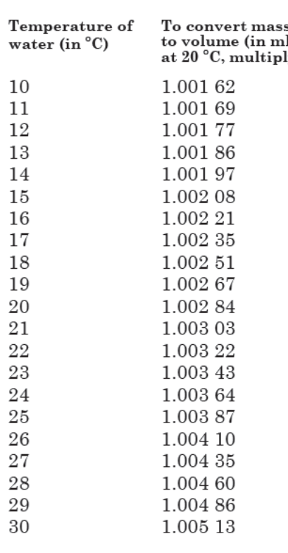
Annex B
(normative)
Internal pressure resistance test
B.1 Test Principle.
The internal pressure is measured by the application of internal hydraulic pressure to the bottle. Tap water is suitable for this purpose.
B.2 Apparatus.
Several different types of equipment are available to increase the pressure either in steps or continuously. In order to achieve comparability between different pieces of equipment, the measured result is corrected to give the result that would have been obtained if the pressure had been increased in steps at intervals of 60s as given in B.2.4.
B.2.3 Procedure.
Increase the pressure until the bottle breaks and measure the pressure. The rate of increase of pressure will be determined by the equipment used; if the pressure is being increased manually, increase the pressure in increments of 2 bar every 30s.
NOTE It is advisable to provide protection against flying glass which may be produced when the bottle breaks.
B.2.4 Correction of results. Most modern equipment will automatically correct to intervals of 60s. If this facility is not available correct the result as shown below:
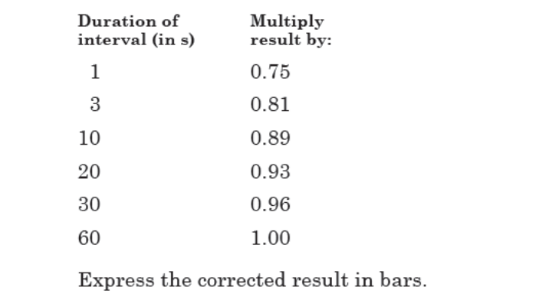
B. Report
Check for compliance with clause 4.7

Annex C
(normative)
Internal pressure resistance test
C.1 Apparatus
C.1.1 Two tanks filled with water.
C.1.2 Heating device
C.2 Procedure
C.2.2.1 Heat the water in the cold tank and maintained at a convenient temperature the range of 15 ⁰C to 25 ⁰C.
C.2.2.2 The water in the hot tank shall be maintained at a temperature 42 ⁰C above that of the water in the cold tank.
C.2.2.3 Fill the bottles under test with hot water by totally immersing the bottles, in an upright position, in the hot tank for not less than 5 min. Raise the filled bottles from the hot tank, hold for 15s to allow water to drain from their external surfaces, and then lower into the cold tank. Maintain the bottles in an upright position throughout the process of transfer.
C.3 Report
Record any breakages and check for compliance with clause 4.8.

Bibliography
BS 6119-1 2837, Glass bottles for carbonated soft drinks—Part 1: Specification for 750 ml and1litre multi-trip bottle

