Sylvain DUPERRIER 42 years old
Nairobi French citizen
Kenya Married, 2 children
cell : +254 793 299 151
Mail : sylvain.duperrier@rubiskenya.com – duperrier.sylvain@gmail.com
LPG⁽¹⁾ INDUSTRY EXPERT
OPERATIONS & SUPPLY CHAIN MANAGER

Academic degree
Graduated in 2003 by ENSI de Bourges (French Engineer School), Industrial Hazard Management Engineering

Employments
From May 2004 to October 2009 – HSE⁽²⁾ and technical Advisor
STOGAZ SAS, (TOTALGAZ subsidiary), LPG storage and filling (2 filling plants and 5 depots)
Relationship with local authorities (Labour department and Department of Environment)
HSE System Management:
Compliances Management
Quality and HSE audits (internally and other Group branches)

Main Achievements:
- Implementation of a new HSE management system ISSSRS⁽³⁾ certified
- Comprehensive review of all Hazardous Installations Risk Assessment
- Migration from a LPG sphere storage to a mounded storage
- Accommodation of an automatic filling line for a new model of cylinders
**

From November 2009 to May 2014 - Operations Manager
VITOGAZ Madagascar, (LPG Marketer, RUBIS subsidiary)
Management of 2 filling plants and 1 import terminal
Import and Supply Chain Management
Cylinders supply to Comoros Islands market
LPG Vessel discharge operations Shore Master
Stock control management
Procurement (industrial equipment’s, services, gas appliances, cylinders…)
Project Management of new customer facilities
Upgrade industrial facilities safety assets and management as per Group policies and objectives.
Implementation of a Computerized Maintenance Management System
Relationship with local authorities (Mines and Oil ministers)

Main Achievements:
- LPG Supply contract to AMBATOVY (Mining company) including storage and logistics.
- Revalidation and upgrades of all storages and pipe on industrial sites
- Upgrade of a CBM⁽⁴⁾
- Maintained continuity of supply despites of critical infrastructure challenges.
- Secured alternatives to critical service providers

**

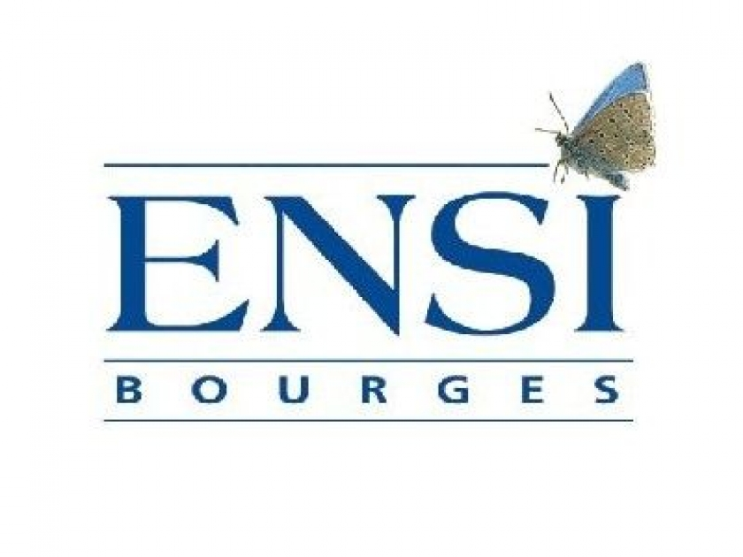

Post Graduation trainings
HSE and Quality Auditor
ATEX
Laws & regulations
Communication

Languages
French - Native
English Advanced
Spanish – Pre-Intermediate

IT
Office, ACCESS, AUTOCAD, Vba (advanced)

Risk assessment tools
HACCP, AMDEC, HAZOP, Critical tasks Analysis

Other skills
Budget Management,
Hazardous Goods Transport
Pressurized Equipment’s
Project Management
LPG Shore Master

Hobbies
Concerts, travels, hiking, cooking, family time

^{(1) Liquefied Petroleum Gas}
⁽²⁾ ^{Heath, Safety and Environment}
⁽³⁾ International Small Site Safety Rating System
^{(4) Conventional Buoy Mooring}

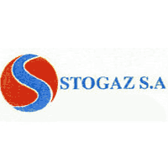

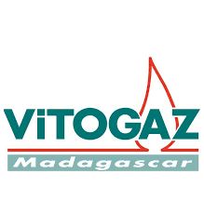

From June 2014 to October 2019– Operations Manager
EASIGAS (Pty)Ltd (LPG Marketer Southern Africa, RUBIS -Subsidiary),
Management of 11 filling plants, 1 import terminal and 1 strategic storage
Technical Assistance to filling plants operated by distributors (19)
Stock Management (Gas and cylinders)
Procurement: cylinders, vehicles, industrial services, labour broker…
Supply Management (5 refineries, 1 operated terminal and 2 third-party operated terminals)
Transport Management (40 road tankers, rail tankers and 35 packed trucks):
  - Scheduling,
  - Back office,
  - Contracts Management.
Technical Management
  - industrial and customer facilities,
  - new projects and maintenance,
  - Bulk network revalidations campaigns.
Identify, propose and lead strategic projects.
Relationship with local authorities (Labour department, Department of Energy, Department of Transport)
Represent the company at technical committees of Southern Africa LPG Safety Association and South African Bureau of Standards.
Lead HSEQ activities until 2018.

Main achievements:
- Successful Merger with local company
- Able to accommodate over 10% growth on packed market 4 years in row
- Upgrade of road tanker design (for safety and efficiency) with new transporter tender (-20% saving overall)
- Restructuration and upskilling of the technical department
- Upgrade industrial facilities safety assets and management as per Group policies and objectives.
(ongoing roadmap)
- Various production efficiency projects (Carrousel refurbishment, LPG cylinders maintenance workstations, …)
- Design, building and commissioning of 3 green field filling plants.
- Identified and developed skills of high potential employees.
- Maintained ISO 9001 certification

**

Since November 2019– Group LPG Technical Manager / Group QHSE Manager
RUBIS ENERGY Kenya
Management of 3 filling plants
LPG Technical Lead for Kenya and 3 affiliates (Rwanda, Uganda and Zambia)
Stock Management (Gas and cylinders)
Procurement: cylinders, vehicles, industrial services, labour broker…
Chairman of the LPG forum at the PIEA (Petroleum institute of East Africa)

Main achievements:
Project Management Design, construction and Commissioning of a new LPG plant.
Implementation of comprehensive digitalized QHSE Management System





