Chocolates ― Specification

© KEBS 2019 Third Edition 2019
TECHNICAL COMMITTEE REPRESENTATION

The following organizations were represented on the Technical Committee:

University of Nairobi — Department of Food Technology Ministry of Health — Public Health Department Nestle Foods (K) Ltd.
Consumer Information Network
Kenya Industrial Research and Development Institute (KIRDI) Cadbury (K) Ltd.
Mini Bakeries (Nairobi) Ltd.
Proctor and Allan
Jomo Kenyatta University of Agriculture and Technology Government Chemist’s Department Carlton Products (E.A.) Ltd.
Kenya Bureau of Standards — Secretariat

REVISION OF KENYA STANDARDS

In order to keep abreast of progress in industry, Kenya Standards shall be regularly reviewed. Suggestions for improvements to published standards, addressed to the Managing Director, Kenya Bureau of Standards, are welcome.

© Kenya Bureau of Standards, 2019

Copyright. Users are reminded that by virtue of Section 25 of the Copyright Act, Cap. 130 of 2001 of the Laws of Kenya, copyright subsists in all Kenya Standards and except as provided under Section 25 of this Act, no Kenya Standard produced by Kenya Bureau of Standards may be reproduced, stored in a retrieval system in any form or transmitted by any means without prior permission in writing from the Managing Director.

Chocolates ― Specification

KENYA BUREAU OF STANDARDS (KEBS)

Head Office: P.O. Box 54974, Nairobi-00200, Tel.: (+254 020) 605490, 602350, Fax: (+254 020) 604031
E-Mail: info@kebs.org, Web:http://www.kebs.org

Coast Region Lake Region Rift Valley Region
P.O. Box 99376, Mombasa-80100 P.O. Box 2949, Kisumu-40100 P.O. Box 2138, Nakuru-20120
Tel.: (+254 041) 229563, 230939/40 Tel.: (+254 057) 23549, 22396 Tel.: (+254 051) 210553, 210555
Fax: (+254 041) 229448 Fax: (+254 057) 21814

Foreword

This Kenya Standard was developed by the Technical Committee on Cocoa and Cocoa Products under the guidance of the Standards Projects Committee and it is in accordance with the procedures of the Kenya Bureau of Standards.

Chocolates are cocoa products obtained from the manufacture of one or more of the following: cocoa nib, cocoa mass, cocoa press cake, cocoa powder, with or without addition of cocoa butter or permitted ingredients and additives.

Various types of chocolates are available on the market depending on its use. Chocolate is used as a basic ingredient (raw material) or an additive for flavour in the food industry.

Many unknowing consumers have been made to believe that any confectionery containing some chocolate is “Chocolate” through misleading labels.

This standard clearly defines what should be labelled “Chocolate” and the minimum chocolate content it should contain.

This second edition has been made necessary because the corresponding Codex Standard was revised. The revision incorporates new Codex levels of various compositional requirements of various types of chocolates. It adds new requirements in labelling declarations of such additives as non nutritive sweeteners. New levels of various other ingredients and test method have been incorporated. A clause on disposal has been added. Aflatoxin levels have been reviewed.

This standard cancels and replaces KS 998:2008, Chocolates — Specification which has been technically revised.

In the preparation of this standard, reference was made to the following documents:

Codex Stan 87: 1981, 2016 Revision 1] Codex Standard for chocolate.

Codex Stan 142:1983, Codex Standard for composite and filled chocolate.

Acknowledgement is hereby made for the assistance derived from these sources

Chocolates ― Specification

1 Scope

This Draft Kenya Standard specifies the requirements and method of test for the various types and forms of chocolates processed for human consumption.

2 Normative references

The following documents are referred to in the text in such a way that some or all of their content constitutes requirements of this document. For dated references, only the edition cited applies. For undated references, the latest edition of the referenced document (including any amendments) applies.

KS 38, Plantation (mill) white sugar — Specification

KS 02-299, Specification for wrought aluminium and aluminium alloys, extruded bars, round tube and sections

KS 344, Honey — Specification

KS 345, Glucose syrup — Specification

KS 436-1, Cocoa powder — Specification Part 1: Unsweetened cocoa powder

KS 436-3, Cocoa powder — Test methods

KS 05-1051, Guide on maximum limits of pesticide residues in foods

KS 1701, Refined white sugar — Specification

KS 1702, Brown sugar — Specification

KS 1812-2, Cocoa and cocoa products — Test methods Part 2: Determination of moisture

KS 1812-3, Cocoa and cocoa products — Test methods Part 3: Determination of water-insoluble, water soluble and acid-insoluble ash

KS 1812-4, Cocoa and cocoa products — Test methods Part 4: Determination of pH.

KS 1812-7, Cocoa and cocoa products — Test methods Part 7: Determination of crude fibre soluble and acid-insoluble ash

KS CODEX STAN 54, Codex standard for powdered dextrose (icing dextrose)

Codex Stan 192, Codex general standard for food additives

KS EAS 39, Hygiene in the food and drink manufacturing industry — Code of practice

KS ISO 6579, Microbiology of food and animal feeding stuffs — Horizontal method for the detection of Salmonella spp.

KS ISO 16050, Foodstuffs — Determination of aflatoxin B₁, and the total content of aflatoxins B₁, B₂, G₁ and G₂ in cereals, nuts and derived products — High-performance liquid chromatographic method

KS EAS 38, Labelling of pre-packaged foods — Specification

CAC/GL 75, Guidelines on substances used as processing aids

3 Terms and definitions

For the purposes of this document, the following terms and definitions apply:

2.1

chocolate
a homogeneous product obtained by an adequate manufacturing process from one or more of the following cocoa materials; cocoa nib, cocoa mass, cocoa press cake, cocoa powder including fat reduced cocoa powder, with or without the addition of cocoa butter, with or without permitted optional ingredients, and/or flavouring agents. It is defined hereunder and complying with the compositional requirements of 3.1

2.1.1
chocolate
with the addition of sugars (3.1.1)

2.1.2
unsweetened chocolate
without the addition of sugars (3.1.2)

2.1.3
couverture chocolate
with the addition of sugar (3.1.3) and which is suitable for covering purposes

2.1.4
sweet (plain) chocolate
with the addition of sugars (3.1.4)

2.1.5
milk chocolate
a product made of addition of milk ingredients in their natural proportions, except that milk fat may be added, or removed with the addition of sugars and milk solids (3.1.5)

2.1.6
milk couverture chocolate
With the addition of sugars and milk solids (3.1.6) and which is suitable for covering purposes

2.1.7
Milk chocolate with high milk content
with the addition of sugars and milk solids (3.1.7)

2.1.8
skimmed milk chocolate
with the addition of sugars and skimmed milk solids (3.1.8)

2.1.9
skimmed milk couverture chocolate
with the addition of sugars and skimmed milk solids (3.1.9) and which is suitable for covering purposes

2.1.10
cream chocolate
with the addition of sugars and cream and milk solids (3.1.10)

2.1.11
chocolate vermicelli
cocoa products obtained by mixing, extrusion and hardening technique which gives unique, crisp textural properties to the product. With addition of sugars (3.1.11) and which is in the form of short, cylindrical grains

2.1.12
chocolate flakes
with the addition of sugars (3.1.12) and which is in the form of flakes

2.1.13
milk chocolate vermicelli
with the addition of sugars and milk solids (3.1.13) and which is in the form of grains

2.1.14
milk chocolate flakes
with the addition of sugars and milk solids (3.1.14) and which is in the form of flakes

2.1.15
family milk chocolate
with addition of sugars and milk solids. Contain not less than 20% cocoa solids,a minimum of 2.5% fat-free cocoa solids, not less than 20% milk solids and a minimum of 5% milk fat.

2.2
flavoured chocolate
is one of the chocolates defined in 2.1.1 through 2.1.10 to which flavouring agents, as permitted in 4.3, have been added in amounts such as to impart to the final product the organoleptic characteristics claimed in the name of the food

2.3

composite chocolate
is one of the chocolates defined in 2.1.1 to 2.1.10 and the corresponding flavoured chocolates as defined in 2.2 to which have been added edible substances, excluding flour, starch and fats, unless contained in a permitted ingredient

2.4

filled chocolate
is a product covered with one or more of the chocolates defined in 2.1, the centre of which is clearly distinct through its composition from the external coating. Filled chocolate does not include flour confectionery, pastry and biscuit products

2.5

sugars
For the purpose of this standard the following sugars shall be used: sucrose, lactose, fructose, dextrose, glucose and honey

3 Essential composition and quality factors

3.1 The various types of chocolates shall comply with the requirements in Table 1.

Table 1 — Composition (% calculated on the dry matter in the product)

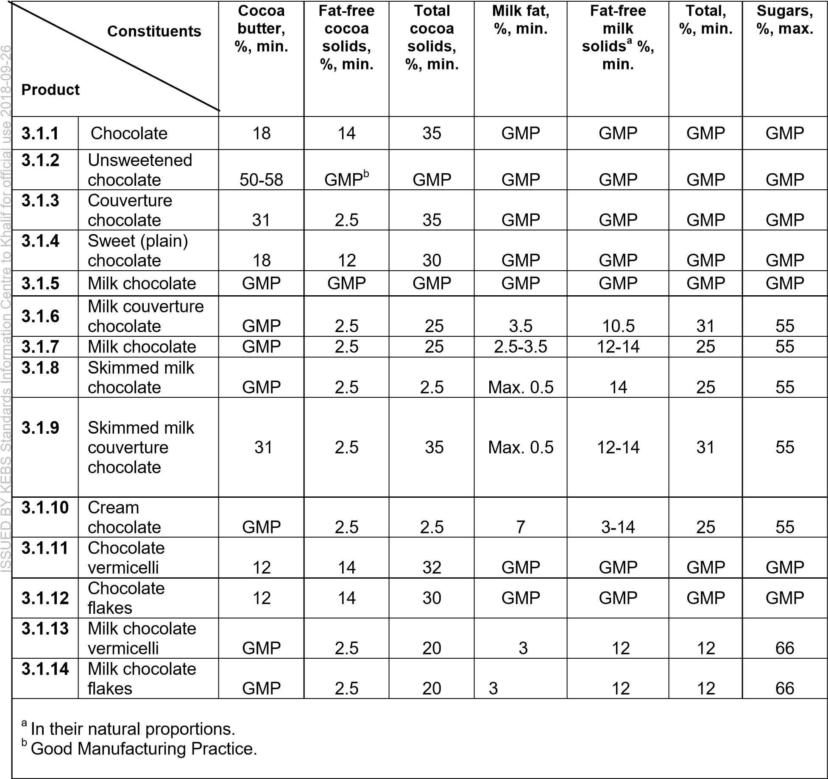

3.2 Flavoured chocolate

3.2.1 Coffee-chocolate

Not less than 1 % m/m roasted ground coffee or the corresponding amount of soluble coffee.

3.2.2 Other flavoured chocolate types

Sufficient amount of flavouring agents for imparting to the final product the organoleptic characteristics claimed in the name of the food.

3.3 Composite chocolate

3.3.1 Composite chocolate shall contain not less than 60 % m/m of chocolate as defined in 2.1.1 to 2.1.10 and 2.4.

3.3.2 Composite chocolate shall contain one or more edible substances excluding those which are prohibited in 2.3.

3.3.3 Added substances are subject to the following maximum limits:

3.3.3.1 Added in the form of visible and separate pieces: 40 % m/m.

3.3.3.2 Added in a form so as to be in practice indiscernible: 30 % m/m.

3.3.3.3 Added both in the form of visible and separate pieces and in a form so as to be in practice indiscernible: 40 % m/m.

The balance of the product in each case being chocolate as defined in 2.1.1 to 2.1.10.

3.4 Filled chocolate

3.4.1 Coating

3.4.1.1 The coating shall be made of chocolate that meets the requirements of one or more of the chocolate types listed in 2.1.1 to 2.1.10.

3.4.1.2 It may contain the ingredients stated under 3.2 and 3.3.2.

3.4.1.3 The amount of chocolate component of the coating shall be not less than 40 % of the total weight of the finished product.

3.4.2 Centre

The products and/or ingredients used to make up the centre shall comply with the requirements of the Kenya standards concerning them.

3.5 Optional ingredients

3.5.1 Spices

Maximum | Food
In small quantities to balance flavour | Products defined under 2.1 and 2.2

3.5.2 Salt (Sodium chloride)

3.5.3 Milk solids (one of the couverture compounds to be found unsweetened in dry whole milk (plain)

Maximum | Food
Not more than 5 % calculated on the dry matter | Chocolate and Chocolate, Chocolate, sweet
Not more than 5 % calculated on the dry matter | Chocolate vermicelli and  Chocolate flake

4 Food additives

Food additives usage shall be in compliance with CODEX STAN 192.

4.2 Emulsifiers

4.2.1 Mono- and di-glycerides of edible fatty acids
Maximum level | Food
GMP | Products defined under 2.1 and 2.2

4.2.2 Lecithin

Maximum level | Food
GMP | Products defined in 2.1.1 to 2.1.10
10 g/kg of the acetone | Products defined insoluble component of in 2.1.11 to 2.1.14

4.2.3 Ammonium salts of phosphatidic acids

Maximum level | Food
7 g/kg | Products defined in 2.1.1 to 2.1.10

4.2.4 Sorbitan monostearate 10 g/kg Products defined in 2.1.1 to 2.1.10

Maximum level | Food
10 g/kg | Products defined in 2.1.1 to 2.1.10

4.2.5 Sorbitan tristearate

4.2.6 Polyoxyethylene (20) sorbitan Monostearate

Maximum level | Food
10 g/kg | Products defined in 2.1.1 to 2.1.10

4.2.7 Total emulsifier

Maximum level | Food
GMP | Products defined in 2.1.1 to 2.1.10

4.3 Flavouring agents

4.3.1 Natural flavours and their synthetic equivalents, except those which would imitate natural chocolate or drink flavours.
Maximum level | Food
In small quantities to balance flavour | Products defined in 2.1 and 2.4.2

4.3.2 Vanillin

Maximum level | Food
1 g/kg | Products defined in 2.1 and 2.4

4.3.3 Ethyl vanillin

Maximum level | Food
In small quantities to balance flavour | Products defined in 2.1 and 2.4

4.4 Centre

As permitted in the standards concerning the products and/or the ingredients which constitute the centre.

4.5 Carry-over

Food additives carried over in proportion to those permitted in 4.1 to 4.4 and the permitted ingredients.

5 Contaminants

Contaminants in chocolate shall be as given in Table 2.

Table 2 — Tolerance for heavy metals for chocolate

S/N | Heavy metal | Maximum level | Food
 | Arsenic (As) | 0.5 mg/kg  1 mg/kg | Products defined in 2.1 and 2.2,  except unsweetened chocolate  Unsweetened chocolate, composite and filled chocolates
 | Copper (Cu) | 15 mg/kg  30 mg/kg | Products defined in 2.1 and 2.2,  except unsweetened chocolate  Unsweetened chocolates, composite and filled chocolates
 | Lead (Pb) | 1 mg/kg  3 mg/kg | Products defined in 2.1 and 2.4,  except unsweetened chocolate  Unsweetened chocolate

6 Pesticide residues

Pesticide residues in ginger, whole, in pieces and ground shall not exceed maximum residue limits as established by the Codex Online guideline for pesticide residue in food.

7 Hygiene

Chocolates shall be prepared and handled in a hygienic manner in accordance with EAS 39 and shall comply with the microbiological limits stipulated in Table 3 when tested in accordance with the methods specified therein.

Table 3 — Microbiological limits for chocolate

S/N | Micro-organism | Maximum limit | Test Method
 | Total plate count, per gram | 50 000 | ISO 7932
 | E. Coli, per gram | Absent | ISO 16654
 | Staphylococcus aureus, per gram | Absent | ISO 6888-1
 | Salmonella, per 25 gram | Absent | ISO 6579-1
 | Yeast and moulds, per gram | 10² | ISO 4833-1

9 Contaminants

Chocolate shall not contain heavy metal contaminants exceeding the limits stipulated in Table 4, when tested according to the Atomic Absorption Spectrophotometer (AAS) method.

Table 4 — Maximum limits for heavy metal contaminants for chocolate

S/N | Heavy metal | Maximum limit | Test method
 | Arsenic (As) | 0.5 mg/kg | ISO 21748.2
 | Lead (Pb) | 1 mg/kg | ISO 12193
 | Cadmium | 1 | AOAC 986-15

10 Mycotoxins

Chocolate shall comply with the mycotoxin limits established by the codex alimentarius as given on the Table 5.

Table 5 — Mycotoxin limits for chocolate

S/N | Type of mycotoxin | Maximum limit
 | Total aflatoxin B1+B2+G1+G2 | 10 ppb
 | Aflatoxin B1 | 5 ppb

11 Weights and measures

The weight and fill of chocolate shall comply with the weights and measures regulations.

12 Packaging

Chocolate shall be packaged in food grade containers that secure the integrity and safety of the product.

13 Labelling

In addition to the labelling requirements in KS EAS 38, the following specific declarations shall be legibly and indelibly marked on each label:

- the name of the product;

- net weight in g or kg;

- list of ingredients in descending order of proportion;

- expiry date;

- instructions for use;

- conditions of storage;

- country of origin;

- lot/batch number;

- Irradiation status where applicable; and

- status where applicable.

14 Sampling

Any container or package of cocoa-butter drawn from a lot or batch shall constitute a representative sample of that lot or batch in compliance with CODEX STAN 50.

