Ref.: KEBS/STA/16/11/1 Date: 20– 02 – 2019

Title: | DEAS 945:2018: Pickles— Specification  DEAS 946:2018: Dried Mango — Specification  DEAS 948:2018: Fruit Drinks— Specification  DEAS 947::2018 Jams, jellies and marmalades — Specification  DEAS 77-1: 2018 Fruit Juices and Nectars— Specification
Document Type: | PUBLIC REVIEW DRAFT
Dates: | CIRCULATION DATE | CLOSING DATE
Dates: | 20– 02– 2019 | 21 – 04 – 2019

PUBLIC REVIEW
DEAS 946:2018: Dried Mango — Specification
DEAS 948:2018: Fruit Drinks— Specification
DEAS 77-1: 2018 Fruit Juices and Nectars— Specification
DEAS 947::2018 Jams, jellies and marmalades — Specification
DEAS 945:2018: Pickles— Specification
This Draft East Africa Standards have been prepared by the EAS/TC 016/02 on PROCESSED FRUITS AND VEGETABLES Technical Committee in accordance with the procedures of the Bureau, and is now being circulated for public comments.

The Committee would appreciate any comments on this Draft Standard, which should be submitted before 21-04-2019 using the attached template. It will also be appreciated if those who have no specific comments to make but find the draft standard generally acceptable can notify us accordingly. Absence of any reply or comments shall be deemed to be an acceptance of the technical contents of the draft Kenya standard and shall constitute an approval vote.

Suggestions entailing amendments of the text should include wording preferred and the relevant clause number quoted against any comments made.

This draft standard is subject to change and should not be referred to or used as a Kenya Standard.

All correspondence pertaining to this draft standard should be addressed to the Managing Director, Kenya Bureau of Standards for the attention of NAOMI MARIACH

Yours faithfully,

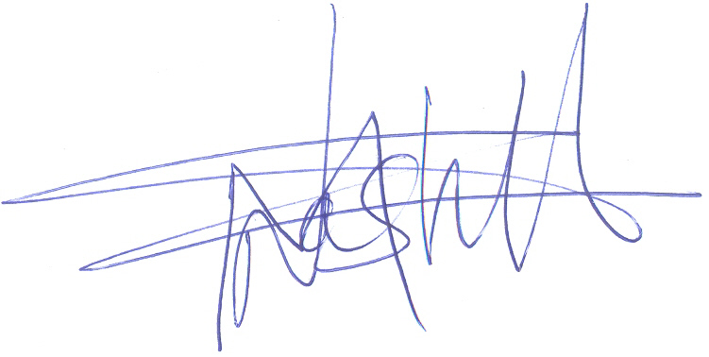

NAOMI MARIACH

For: DIRECTOR
STANDARDS DEVELOPMENT AND INTERNATIONAL TRADE
NCM/ Encl.

