Road vehicles — Fuel filters — Specification

©KEBS 2020 Third Edition 2020

TECHNICAL COMMITTEE REPRESENTATION

The following organizations were represented on the Technical Committee:

Toyota Kenya Ltd
D.T Dobie
Mitsumoto
Isuzu E.A
Kenya Association of Bus Manufacturers (KABM)
Kenya Motor Repairers Association (KEMRA)
Nissan
Numerical Machining Complex (NMC)
Gede Enterprises
Mobius Motors
KUMPIA
Kenya Industrial Research and development Institute (KIRDI)
Technical University of Kenya (TUK)
Motorwise Valuers
Kenya Auto Bazaar Association
Honda (Nairobi)
Egerton University
Olive Technical Services Ltd
Kenya Jua Kali Association
MCI Ltd
Kenya Bureau of Standards — Secretariat

REVISION OF KENYA STANDARDS

In order to keep abreast of progress in industry, Kenya Standards shall be regularly reviewed. Suggestions for improvements to published standards, addressed to the Managing Director, Kenya Bureau of Standards, are welcome.

© Kenya Bureau of Standards, 2020

Copyright. Users are reminded that by virtue of Section 25 of the Copyright Act, Cap. 12 of 2001 of the Laws of Kenya, copyright subsists in all Kenya Standards and except as provided under Section 26 of this Act, no Kenya Standard produced by Kenya Bureau of Standards may be reproduced, stored in a retrieval system in any form or transmitted by any means without prior permission in writing from the Managing Director.

Road vehicles — Fuel filters — Specification

KENYA BUREAU OF STANDARDS (KEBS)

Head Office: P.O. Box 54974, Nairobi-00200, Tel.: (+254 020) 605490, 602350, Fax: (+254 020) 604031
E-Mail: info@kebs.org, Web:http://www.kebs.org

Coast Region Lake Region Rift Valley Region
P.O. Box 99376, Mombasa-80100 P.O. Box 2949, Kisumu-40100 P.O. Box 2138, Nakuru-20100
Tel.: (+254 041) 229563, 230939/40 Tel.: (+254 057) 23549, 22396 Tel.: (+254 051) 210553, 210555
Fax: (+254 041) 229448 Fax: (+254 057) 21814

Foreword

This Kenya Standard was prepared by the Road Vehicles Technical Committee under the supervision of the Standards Projects Committee and is in accordance with the procedures of the Kenya Bureau of Standards.

This standard covers performance requirements for fuel filters.

Taking into consideration the views of consumers, it was felt necessary to revise this standard to improve the quality of fuel filters used in Kenya.

In the preparation of this standard, reference was made to the following document:

ISO 4020, Road vehicles — Fuel filters for diesel engines — Test methods.

Acknowledgement is hereby made for the assistance received from this source.

Road vehicles — Fuel filters — Specification

1 Scope

This Kenya Standard specifies materials, performance requirements, and methods of test for road vehicles fuel filters.

2 Normative references

The following referenced documents are indispensable for the application of this Kenya Standard. For dated references, only the edition cited applies. For undated references, the latest edition of the referenced document (including any amendments) applies.

KS ISO 4020, Road Vehicles — Fuel filters for diesel engines — Test methods

3 Materials

3.1 The filter shall be capable of withstanding normal mechanical stresses encountered in service. The use of dissimilar metals likely to cause corrosion shall be avoided.

3.2 The filtering media shall be impregnated fuel filter paper with a maximum pore size of 1.5 microns, wire gauze, felt material, reinforced impregnated paper (with wire gauze) or any other appropriate material that meets the performance requirements specified in this standard as per the particular type of application. The media shall not disintegrate in performance for the specified service period.

3.3 The filter casing may be made of plastic, but if made of sheet metal alloy, it shall be protected against corrosion.

3.4 The filter shall be free from any leaks.

3.5 All materials used for the construction of the filter shall be free from corrosion.

3.6 All seals shall be of rubber (e.g. nitril rubber) non-reactive with fuel and with a minimum Shore A hardness of 65 International Rubber Hardness degrees.

3.7 All gaskets required for mounting the filter element shall have a minimum Shore A hardness of 45 International Rubber Hardness degrees.

3.8 The threaded end plate may be made of galvanized steel sheet or any other non-corrosive material and shall be strong enough to hold engine pressures.

3.9 The compression spring shall be made of spring steel.

3.10 Any adhesive used to bond the filter parts shall be bonded epoxy-based adhesives or equivalent that shall be non-reactive to fuels and shall give a strong bond able to resist mechanical stress encountered in performance.

4 Tests

4.1 Pressure drop test

When tested as described in 6.3 of KS ISO 4020, the pressure drop across the filter shall not exceed the Original Equipment Manufacturer (OEM) specification.

4.2 Particle retention test

When tested as described in 6.4 of KS ISO 4020, the percentage particle retention shall be not less than 90 %.

4.3 Burst test for complete filter

When tested as described in 6.7 of KS ISO 4020, the burst pressure of the complete filter shall be not less than 1.45 Mpa.

4.4 Pulsating pressure fatigue test

When tested as described in 6.8 of KS ISO 4020, the filter shall withstand 50 000 cycles without failure.

4.5 Bubble test

When tested as described in Annex A of this standard, the volume of escaped air shall not exceed 200 cm³ per minute.

5 Marking

5.1 The filter and filter packaging shall be legibly and indelibly marked on the outer casing with the following:

a) Manufacturers’ name and/or registered trade mark;

b) Country of origin;

c) Manufacturers’ part number.

5.2 Additional markings indicated on the filter or package shall necessitate additional verifications that the filters comply with the claims indicated.

Annex A
(normative)

Bubble test

A.1 The test liquid shall be straight mineral oil at a temperature of 23 °C ± 5 °C and kinematic viscosity between 4 mm²/s and 6 mm²/s.

A.2 Other equipment shall be as in Figure A.1.

A.3 Procedure

Before mounting the filter element to be tested (9) (Figure A.1) on the rotating axle, immerse it in the test liquid sufficiently long to completely wet the filter medium, and drain off the surplus liquid.

A.3.1 Mount the filter element on the rotating axle (10) and immerse it in the tank (8).

A.3.2 Open the stopcock (3) and adjust the constant pressure device (5) to indicate a pressure of 1.3 kPa ± 0.1 kPa on the liquid manometer (6).

A.3.3 Turn the filter element at approximately 10 min⁻¹ on the rotating axle. The volume of air escaping in one minute shall be measured.

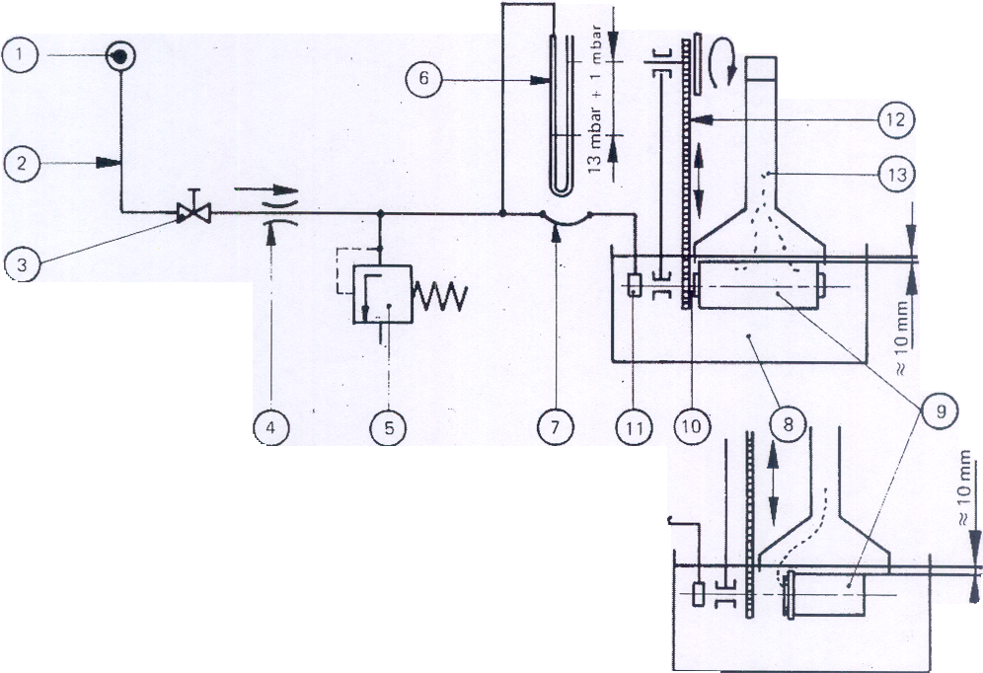

TEST COMPONENTS
① Connection to compressed air line; air must be dry
② Connection pipe, of metal, nominal internal diameter 4 mm to 6 mm
③ Stopcock
④ Needle valve (fixed throttle)
⑤ Constant-pressure device, adjustable
⑥ Manometer, adapted to the measuring range
⑦ Flexible hose, nominal diameter 4 mm to 6 mm
⑧ Tank, minimum capacity 20 L
⑨ Filter element to be tested 4 mm to 6 mm
⑩ Rotating axle
⑪ Rotary fitting
⑫ Device for rotation of filter element
⑬ Bubble trap, capacity approximately 1 L, with graduated scale, accuracy of reading 1 cm³

OTHER EQUIPMENT

Stop-watch

Figure A.1 — Bubble test

