KENYA STANDARD DKS 463:2020
ICS 43.040

Telescopic shock absorbers for automobile suspension damping — Specification

© KEBS 2020 Third Edition 2020

TECHNICAL COMMITTEE REPRESENTATION

The following organizations were represented on the Technical Committee:

Toyota Kenya Ltd
D.T Dobie
Mitsumoto
Isuzu E.A
Kenya Association of Bus Manufacturers (KABM)
Kenya Motor Repairers Association (KEMRA)
Nissan
Numerical Machining Complex (NMC)
Gede Enterprises
Mobius Motors
KUMPIA
Kenya Industrial Research and development Institute (KIRDI)
Technical University of Kenya (TUK)
Motorwise Valuers
Kenya Auto Bazaar Association
Honda (Nairobi)
Egerton University
Olive Technical Services Ltd
Kenya Jua Kali Association
MCI Ltd
Kenya Bureau of Standards — Secretariat

REVISION OF KENYA STANDARDS

In order to keep abreast of progress in industry, Kenya Standards shall be regularly reviewed. Suggestions for improvements to published standards, addressed to the Managing Director, Kenya Bureau of Standards, are welcome.

© Kenya Bureau of Standards, 2020

Copyright. Users are reminded that by virtue of Section 25 of the Copyright Act, Cap. 12 of 2001 of the Laws of Kenya, copyright subsists in all Kenya Standards and except as provided under Section 26 of this Act, no Kenya Standard produced by Kenya Bureau of Standards may be reproduced, stored in a retrieval system in any form or transmitted by any means without prior permission in writing from the Managing Director.

KENYA STANDARD DKS 463: 2020
ICS 43.040

Telescopic shock absorbers for automobile suspension damping — Specification

KENYA BUREAU OF STANDARDS (KEBS)

Head Office: P.O. Box 54974, Nairobi-00200, Tel.: (+254 020) 605490, 602350, Fax: (+254 020) 604031
E-Mail: info@kebs.org, Web:http://www.kebs.org

Coast Region Lake Region North Rift Region
P.O. Box 99376, Mombasa-80100 P.O. Box 2949, Kisumu-40100 P.O. Box 2138, Nakuru-20100
Tel.: (+254 041) 229563, 230939/40 Tel.: (+254 057) 23549, 22396 Tel.: (+254 051) 210553, 210555
Fax: (+254 041) 229448 Fax: (+254 057) 21814

Foreword

This Kenya Standard was prepared by the Road Vehicles Technical Committee under the supervision of the Transport, Packaging and Distribution Industry Standards Committee, and it is in accordance with the procedures of the Bureau.

It is intended to assist local manufacturers to meet the minimum performance requirements expected of shock absorbers, and also to ensure that customers get reasonable service for their investments in motor vehicle spare parts.

This Third Edition, which has been technically revised, cancels and replaces the First Edition, KS 463: 2005.

In developing this standard, the following documents were used:

JASO C 602-75: Telescopic shock absorbers.

IS 5423-1989: Requirements for telescopic type hydraulic shock absorbers for automotive suspension (Second Revision).

Acknowledgement is hereby made for the assistance derived from these sources.
KENYA STANDARD DKS 463: 2020

Telescopic shock absorbers for automobile suspension damping — Specification

1 Scope

This Kenya Standard specifies the general performance requirements for telescopic shock absorbers used in automobile suspension damping, not including struts and semi-struts.

2 Definitions

For the purposes of this standard, the following definitions shall apply:

sealed type shock absorbers
those which are not permitted to be overhauled, as the shock absorber has to be cut or machined to take out the internal parts

2.2
serviceable type shock absorbers
those which can be opened by removing the top threaded cap

2.3
double acting
shock absorbers which damp the oscillations of a vehicle suspension in both the directions, damping action being different or equal in either direction depending on the individual application requirements

2.4
single acting
shock absorbers which damp the oscillations of a vehicle suspension in one direction

2.5
compression stage
a stage in which the mountings of shock absorbers approach each other

2.6
extension stage
a stage in which the mountings of shock absorbers move away from each other

2.7
compressed length
the length between the mountings eyes (centre to centre distance) or centre of the plain portion of shank (in case of studs) or mounting eye and plain portion of shank (in case of eye and stud) of a shock absorber when it is compressed to the maximum (see Figure 1) (and shall be within a tolerance of 3 mm or subject to the original drawing of the vehicle manufacturer, whichever is less)

2.8
stroke
the difference between the extended length and the compressed length (effective maximum travel of the piston), see Figure 1

port
the inside diameter of the cylinder of the shock absorber

2.10
fitment dimensions
are required for mounting the shock absorber on the vehicle (according to the vehicle manufacturer's specification similar to A, B, C, D, in Figure 1)
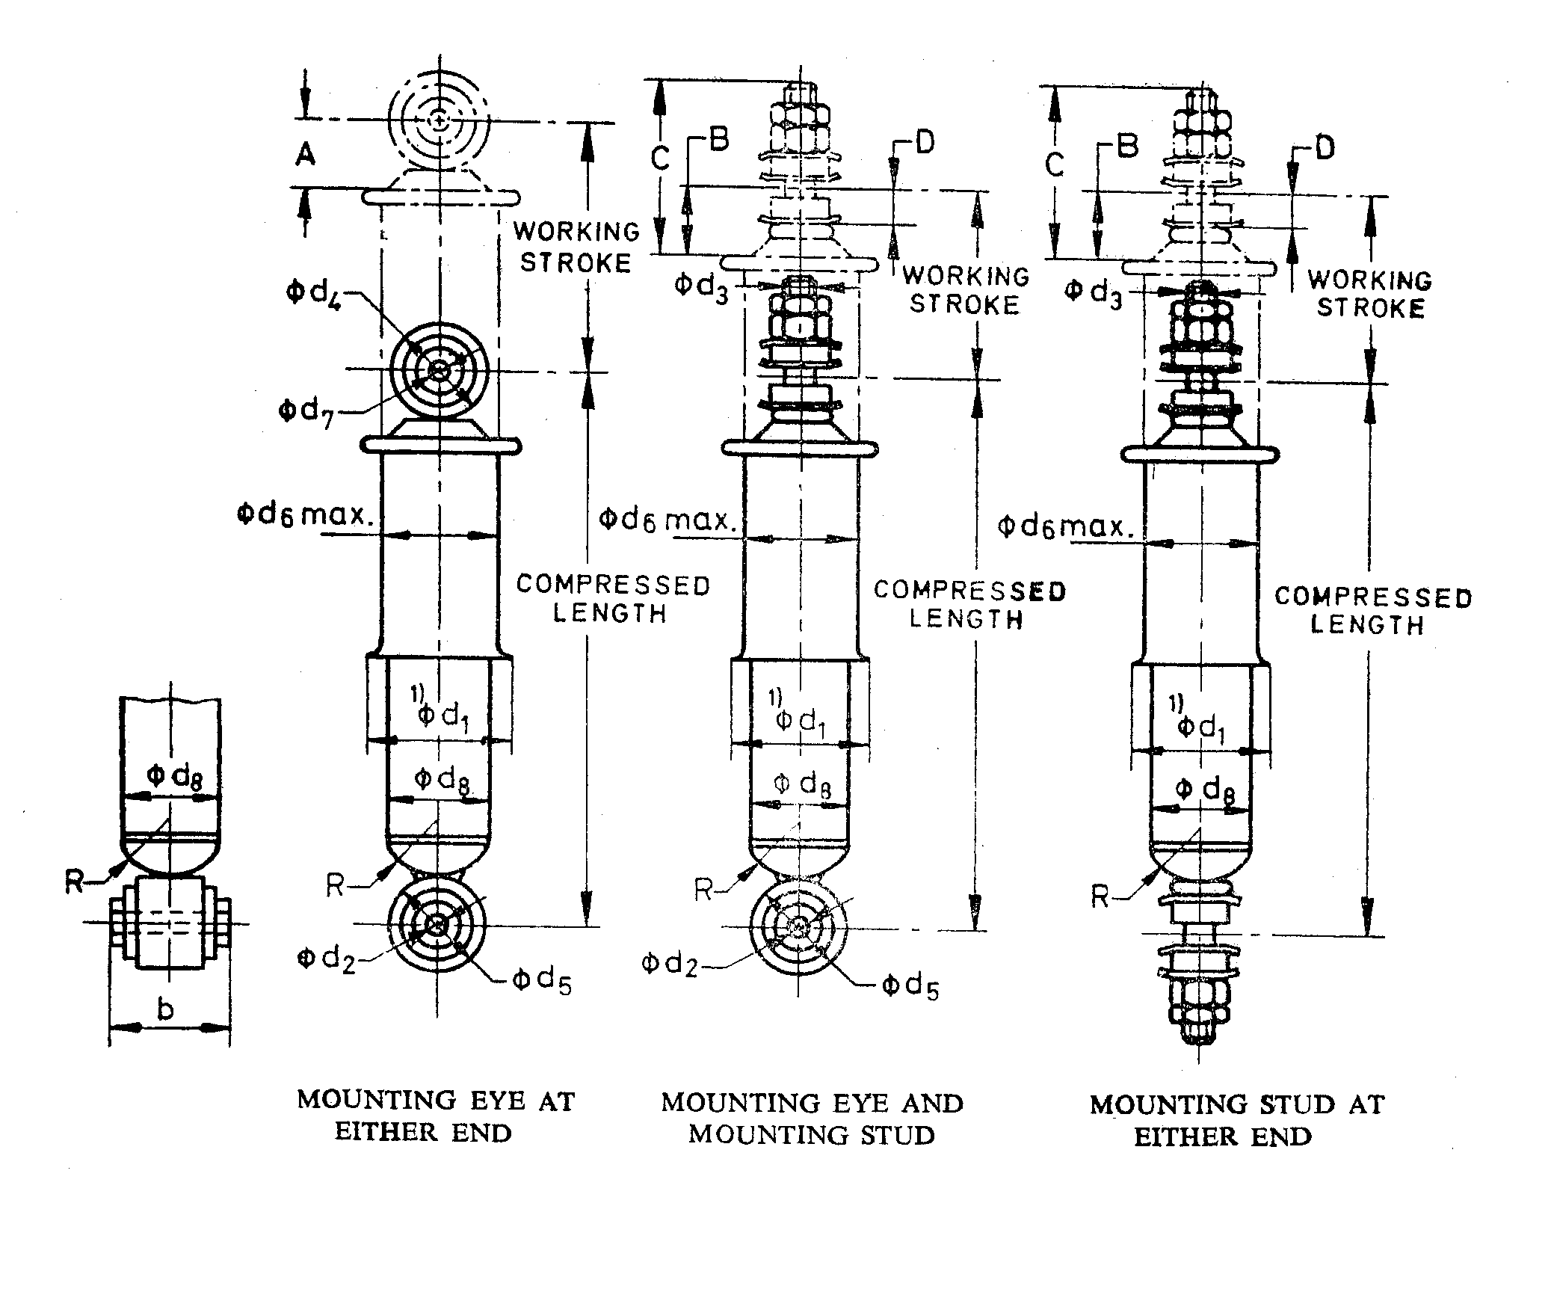

Figure 1 — Fitment dimensions.
2.11
damping characteristics
for any type of hydraulic shock, absorber, shall mean the damping forces at corresponding maximum piston velocity defined in 2.12

2.12
maximum piston velocity
subsequently referred to as “velocity”, shall be according to the vehicle manufacturer's specification or bear the relationship given by the expression:

V max. = π.n.s.

where,

V max. = maximum piston velocity, metres/sec;
n = machine revolution, Cps; and
s = stroke, metres.

NOTE n and s are derived from the endurance test of 4.2.

3 General requirements

3.1 Materials

Telescopic shock absorbers may be made from any suitable materials provided that the finished product shall pass the tests specified in Clause 4.

3.2 Finish

The piston shaft shall be uniformly hard chrome plated and be free from paint and other defects that may impair its assembly of performance. The exterior surface of the shock absorber shall be protected against corrosion.

3.3 Assembly

The shock absorbers shall be assembled in such a manner that the movement shall be smooth throughout the stroke. For this purpose, the shock absorbers shall be manually primed five times in a vertical position. This is only indicative of the uniformity of operation.

3.4 End mountings

Typical end mountings are shown in Figure 2.

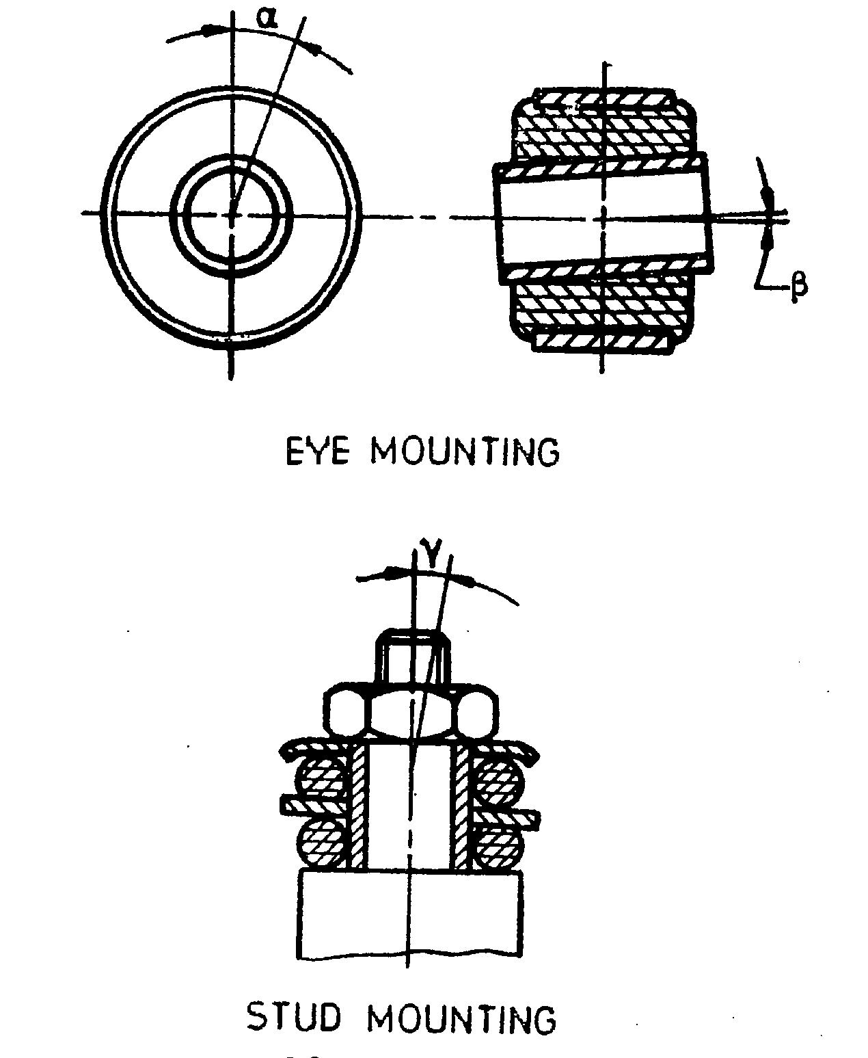

Figure 2 — Typical mountings.

3.4.1 When eye or stud mounting is used the maximum permissible deflection along the joint axis allowed during use shall be α = 5° maximum, or according to the manufacturer's specification.

3.4.2 For the garden angle which is perpendicular to the joint axis the deflection shall be β = 3° maximum, or according to the vehicle manufacturer's specification, whichever is the less.

3.5 Fitment

The fitment of the shock absorber shall be governed by the top and bottom mountings of the vehicle or bars.

3.6 Inclination

Telescopic shock absorbers shall not be mounted at an inclination angle of more than 45° to the vertical plane of the chassis, unless otherwise specified by the vehicle manufacturer.

3.7 Supplementary welding

All eyes shall be supplementary welded to the caps to a maximum length of 10 mm.

4 Tests

4.1 Damping force

4.1.1 Each shock absorber shall be tested along its own axis, that is, the damper axis parallel to the stroke of the torque tester.

4.1.2 Damping forces shall be recorded between the sixth and tenth stroke.

4.1.3 Test specification shall be only at one maximum piston velocity (or according to the vehicle manufacturer's specification).

4.1.4 Tolerances on test damping force shall be ± 10 %.

4.1.5 The arm of the application of damping force shall be selected at the discretion of the shock absorber manufacturer, provided that the specifications of the vehicle manufacturer shall be satisfied. In the case of preloaded shock absorbers, preloading shall be taken into account when performing this test.

4.1.6 The effect of temperature as given in Clause 5 shall be applicable wherever necessary.

4.2 Endurance test

4.2.1 The test shock absorber selected shall be mounted on the torque tester and the initial damping resistances in tension and compression shall be recorded.

4.2.2 Shock absorbers whose initial damping resistances have been measured shall be mounted on the endurance testing machine.

Testing speed shall be 104 ± 9 Cpm or according to the vehicle manufacturer's specification, whichever is the less.

4.2.3 During the test, temperature shall not exceed 85 °C, which shall be measured on the outer tube (reservoir) of shock absorbers. Where the temperature exceeds 85 °C, external cooling shall be applied to maintain the temperature at 80 ± 5 °C.

In the case of shock absorbers where temperature does not rise above 85 °C, the test shall be carried at the temperature attained.

    - The method of cooling during the endurance test is optional, but shall be such that any leakage of shock absorber fluid can be easily seen during the endurance test.

4.2.5 Shock absorbers shall be mounted on a torque tester with flexible end mountings, only in the vertical plane.

4.2.6 The test shall be conducted for one million cycles, but where vehicle manufacturer's specifications exist, they shall prevail. At the end of the test, no leakage or damage shall be noticeable; and the shock absorber when subjected to the damping force test as indicated in 4.1, variation in resistance shall not exceed the values indicated in Tables 1 and 2 (see also Figures 3 and 4) from the initial damping resistance recorded as in 4.2.1.

Table 1 — Decrease in damping resistance after one million-cycle endurance test

Damping resistance, newtons (N) |  | 500 | 600 | 700 | 800 | 900 | 1 000 | 1 100 | 1 200 | 1 300 | 1 400
Decrease in resistance | Tension | 75 | 80 | 85 | 90 | 100 | 105 | 110 | 120 | 130 | 140
Decrease in resistance | Compression | 100 | 110 | 120 | 130 | 145 | 165 | 185 | 190 | 195 | 210

NOTE For damping resistances 1 200 N and above a decrease of 10 % is allowable in tension and compression, respectively.

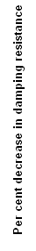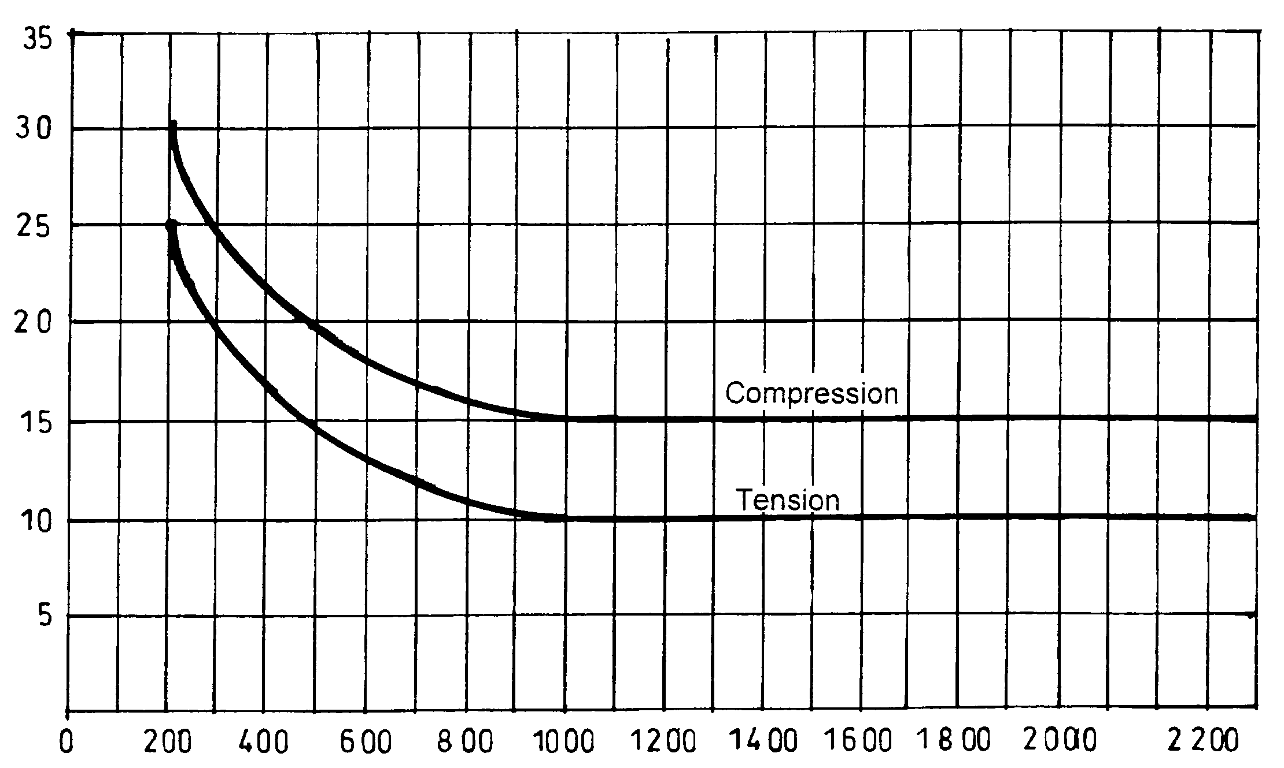

Initial damping resistance, newtons (N)

Figure 3 — Decrease in damping resistance after one million cycle endurance test.

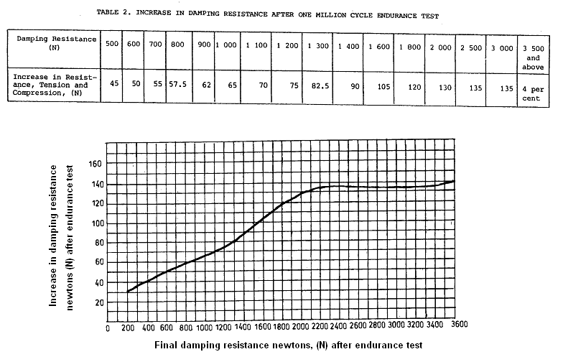
Figure 4 — Increase in damping resistance after one million cycle endurance test.

4.3 Weld pull test

Telescopic shock absorbers, when subjected to weld pull tests, shall withstand the following forces:

– small shock absorbers (up to 40 mm O.D.) 2.7 kN;

– medium-duty shock absorbers (over 40 mm up to 50 mm O.D.) 3.6 kN;

– heavy-duty shock absorbers (over 50 mm up to 65 mm O.D.) 4.5 kN;

– extra heavy-duty shock absorbers (over 65 mm O.D.) 5.4 kN;

5 Effect of temperature on damping characteristics

No temperature correction shall be applied if the test room temperature is within the range of 15 °C to 35 °C.

6 Marking

The shock absorbers shall be legibly and indelibly marked with the following:

i) manufacturer's name and/or trade mark;

ii) country of origin;

iii) month and year of manufacture;

iv) Part number (on body).

7 Packaging

Shock absorbers shall be packed in suitable cartons marked with the part number, or polythene packaging to allow the part number to be read on the product.

8 Additional information

The following information shall be supplied upon request:

8.1 Dimensions as indicated in Figure 1.

8.2 A graph showing the load characteristics, in newtons, for compression and extension at various piston velocities; or alternatively load values for compression and extension at specified maximum piston velocity.

8.3 Any other information relevant to the design of shock absorbers.

