Precast concrete waffle units

©KEBS 2020 First Edition 2020

TECHNICAL COMMITEE REPRESENTATION

The following organizations were represented on the Technical Committee:

- Atkins Consulting Engineers Limited.
- Bamburi Cement Lafargeholcims
- Bens Electronics Service Ltd
- East African Portland Cement Plc
- Handisi systems Ltd
- Institution of Engineers of Kenya
- Institution of Quantity Surveyors of Kenya
- Jomo Kenyatta University of Agriculture and Technology
- Kenya Builders & Concrete Company Ltd
- Kenya Electricity Transmission Company Ltd
- Malaba Keya and Partners Consultants
- Materials Testing and Research Division
- Ministry of Transport, Infrastructure, Housing, Urban Development & Public Works
- Ministry of water and sanitation
- Nairobi Western Bypass project
- National Housing Corporation
- Orkidstudio_ Design and Build
- QuestLinks Engineering Ltd
- Questworks Limited
- Stroutel Africa Limited
- Technical University of Kenya
- Surtech
- Kenya Bureau of Standards — Secretariat

REVISION OF KENYA STANDARDS

In order to keep abreast of progress in industry, Kenya Standards shall be regularly reviewed. Suggestions for improvements to published standards, addressed to the Managing Director, Kenya Bureau of Standards, are welcome.

© Kenya Bureau of Standards, 2020

Copyright. Users are reminded that by virtue of Section 25 of the Copyright Act, Cap. 12 of 2001 of the Laws of Kenya, copyright subsists in all Kenya Standards and except as provided under Section 26 of this Act, no Kenya Standard produced by Kenya Bureau of Standards may be reproduced, stored in a retrieval system in any form or transmitted by any means without prior permission in writing from the Managing Director.

Precast concrete waffle units

KENYA BUREAU OF STANDARDS (KEBS)

Head Office: P.O. Box 54974, Nairobi-00200, Tel.: (+254 020) 605490, 602350, Fax: (+254 020) 604031
E-Mail: info@kebs.org, Web:http://www.kebs.org

Coast Region Lake Region Rift Valley Region
P.O. Box 99376, Mombasa-80100 P.O. Box 2949, Kisumu-40100 P.O. Box 2138, Nakuru-20100
Tel.: (+254 041) 229563, 230939/40 Tel.: (+254 057) 23549, 22396 Tel.: (+254 051) 210553, 210555
Fax: (+254 041) 229448 Fax: (+254 057) 21814

Foreword

This Kenya Standard was developed by the Concrete Technical Committee, under the guidance of the standards Projects Committee, and it is in accordance with the procedures of the Kenya Bureau of Standards.
There is an increase of construction of floor slabs using precast waffles units in this country. Though waffle slabs are deeper than flat slabs, the reduction in concrete and steel quantities is considerable and where exposed, they are aesthetically appealing.

.

KENYA STANDARD KS 2932:2020

Precast concrete waffle units

- Scope

This Standard defines and specifies requirements and conformity for concrete waffle.

- Normative references

The following referenced documents are indispensable for the application of this document. For dated references, only the edition cited applies. For undated references, the latest edition of the referenced document (including any amendments) applies.

KS 95, Specification for natural aggregates for use in concrete.

KS EAS 18-1, Cement Part 1: Composition, specifications and conformity criteria for common cements

KS 2846, Mixing water for concrete — Specification for sampling, testing and assessing the suitability of water, including water recovered from processes in the concrete industry, as mixing water for concrete

KS 1780-1, Building lime - Part 1: Definitions, specifications and conformity

KS 2770-1, Admixtures for concrete, mortar and grout - Part 1: Common requirements.

KS 2770-2, Admixtures for concrete, mortar and grout - Requirements Part 2: Concrete admixtures

KS EN 1992-1-1, Eurocode 2: Design of concrete structures Part 1-1: General rules and rules for buildings

KS EN 1994-1-1, Eurocode 4: Design of composite steel and concrete structures Part -1-1: General rules and rules for buildings

KS EAS 412-1, Steel for the reinforcement of concrete - Part 1: Plain bars

KS EAS 412-2, Steel for the reinforcement of concrete - Part 2: Ribbed bars

KS EAS 412-3, Steel for the reinforcement of concrete - Part 3: Welded fabric

KS 22, Hot-rolled mild steel bars for reinforcement of concrete - Specification

KS 2168, General concrete works — Code of practice

- Terms and definitions

For the purposes of this Standard, the following terms and definitions shall apply

concrete waffle unit
precast concrete unit mainly of rectangular, square or triangular shape that is used in construction of floor slabs

- Requirements

  - General requirements

Precast Concrete waffle units shall meet the performance criteria stated in this standard.

  - Requirement for materials

    - Cement

The cement manufacturing the precast concrete waffle units shall comply to KS EAS 18.

    - Aggregate

The aggregate shall comply to KS 95.

    - Water

The mixing water shall comply to KS 2846.

    - Admixtures

The admixture used to manufacture the precast concrete waffle units shall comply to KS 2770.

    - Reinforcement

All the reinforcement steel shall comply to KS EAS 412.

    - Requirement for production

The production of the concrete and manufacturing of the precast concrete waffle units shall be in accordance with KS 2183

    - Design of concrete waffle unit

The design of the precast concrete waffle units shall be in accordance with KS EN 1992-1-1 and KS EN 1994-1-1

  - Dimensions and tolerances

    - Dimensions

Dimensions of preferred sizes of precast concrete waffles shall conform to Table 1 below.

Table 1. Sizes of precast concrete waffle unit

Waffle type | Nominal size  (mm) | Thickness  (mm) | Depth  (mm)
 | 1200 x 1200 | 25 | 300,450,600
 | 1040 × 1040 | 25 | 175,200,250,500
 | 900 × 900 | 25 | 150,200,300,450
 | 600 × 900 | 25 | 100,150,200,250,300
 | 600 × 600 | 25 | 100,150,200,250,300
 | 450 ×450 | 25 | 75,100,150,200,250
 | 450 × 900 | 25 | 75,100,150,200,250
 | - × 900 | 25 | 75,100,150,200,250

Other types of precast waffle units having shapes and sizes other than those given in Table 1, shall be such that they conform to the requirements of this standard.

    - Tolerances

The maximum dimensional tolerances for concrete waffle unit when measured in accordance with Annex A shall be as specified in Table 2.

Table 2. Dimensional tolerances

Dimension | Maximum dimensional deviation
Length  Width  Thickness | ± 2 mm  ± 2 mm  ± 3 mm
Squareness of plan (difference between diagonals) | 6mm
Flatness, straightness  Bowing and  Twisting | Measured over 550 mm to  850 mm ± 2 mm  Measured over  250 mm to 400 mm ± 1 mm

  - Flexural strength

When tested as described in Annex B, the mean flexural strength at 28 days shall be not less than 6 N/mm². No individual precast concrete waffle unit shall have a flexural strength of less than 5 N/mm².

  - Water absorption

When tested as described in Annex C, the water absorption shall not exceed 10 per cent by mass.

  - Visual Inspection

All precast concrete waffle units shall be sound and free of defects that shall interfere with the proper placing of the precast concrete waffle unit or impair the strength or permanence of the construction.

- Sampling

For the purpose of testing compliance with the requirements specified, samples for testing shall be selected at random at the site of manufacture, or from a delivered consignment.

- Marking and labelling

The name, trade mark or other means of identification of the manufacturing plant shall be marked on the precast concrete waffle unit. Other particulars relating to products made in accordance with this standard shall be clearly stated on the delivery note, invoice, manufacturer’s or suppliers certificate, or brochure relating to a consignment of products:

Annex A
Measurement of dimensions

A1. General

Note: It is recommended that all measurements be made using a suitable steel rule conforming to BS 4372 or BS 4484 or an equivalent Kenya Standard.

A1.1 Length

Measure the length of each product to the nearest 1 mm on the face, within 25 mm of the four extreme corners of the profile. Calculate the average length to the nearest 1 mm.

A1.2 Width and height

Measure the width and height of each product to the nearest 1 mm at both ends. Measure the width at the top and bottom of parallel faces and the overall height at the face and back of the product. Calculate the average height and width to the nearest 1 mm.

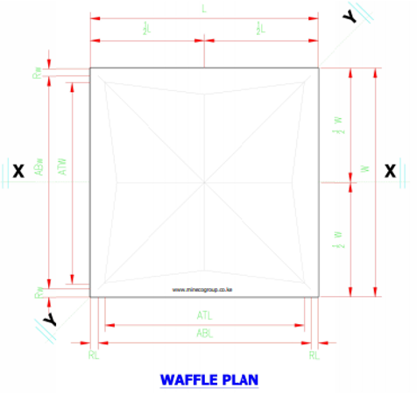
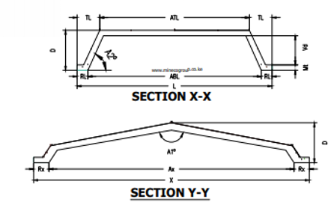

Figure 1- Waffle plan, section x-x and section y-y

A2. Determination of squareness

Place the stock of an engineer’s square in contact with the moulded faces of the product. Bring the blade into contact with the side of the product. Using a feeler gauge conforming to BS 957: Part 2, check that the clearance between the square and the side of the product at points not less than 30 mm from the top and the bottom does not exceed the appropriate tolerance.

Annex B

Determination of flexural strength

B1. Test specimens

Five precast concrete waffle units for each type and thickness shall be taken from each production batch after carrying out dimensional checks.

B2. Testing machine

The test shall be carried out using flexural strength testing machine of sufficient capacity capable of applying the loads continually and vertically. It shall be provided with two steel supporting rollers each 38 ± 3 mm in diameter or two steel bearers, each 6 mm minimum width on the supporting surface (see Figure 3). The spacing of the rollers or bearers shall be as given in Table 4.

Table 4. Spacing of rollers or bearers for flexural strength test

Waffle type | minimum spacing centre to centre of rollers or minimum clear distance between bearers in mm
1200 x 1200  1040 x 1040  900 x 900  600 x 900  600 x 600  450 x 900  300 x 900  450 x450 | 450 mm  375 mm

In either case, one support shall be horizontal and the other so mounted to enable loads to be applied without inducing any torsional restraint in the specimen, e.g. by pivoting about an axis parallel to the length of the specimen. The upper member of the loading frame shall be provided with a spherical seating to ensure that the load is applied axially without inducing any torsion in the specimen, and a steel platen at least 50 mm wide and of length not less than the width of the widest specimen to be tested.

B3. Procedure

Place the specimen symmetrically on the bearers of the testing machine and with its shorter sides parallel to the supporting rollers or bearers. Position a hardwood fillet 50 mm wide on the upper surface of the specimen at the midpoint of the span extending the whole width of the specimen parallel to the supporting rollers or bearer (see Figure 3). Apply the load without shock and increase it at a rate not exceeding 1 kN/min for each 100 mm of width as tested, until the specimen fails. Record individual failing loads.

B4. Calculation and expression of results

The flexural strength Fcf _{of} (in N/mm²) is given by the equation:

F _{cf} = 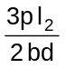

p = the individual failing load (in N);
I = the distance between the supporting rollers or bearers (in mm);
B = the average width of specimen at the point of fracture (in mm);
d = the average thickness of specimen at the point of fracture (in mm).

Express the flexural strength to the nearest 0.1 N/mm².

B5. Report

The following shall be reported:

(i) The individual flexural strength of each waffle unit to the nearest 0.1 N/mm ²; and

(ii) The average flexural strength of the five specimens to the nearest 0.1 N/mm².

All Dimensions in mm

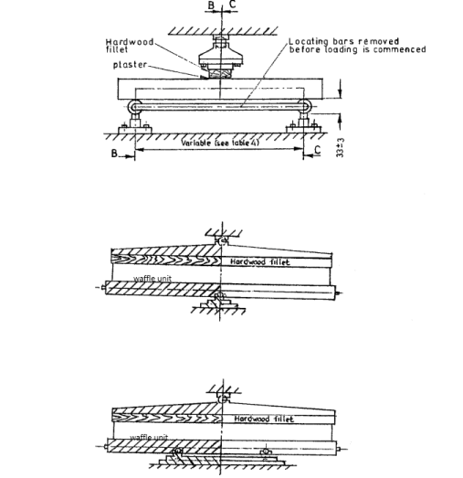
Side elevation
End elevation (BB)

End elevation (CC)

Figure 2 — Arrangement of loading for flexural strength test

Annex C
Determination of water absorption

C1. Test specimens

Three precast concrete waffle units for each type and thickness shall be taken from the sample after carrying out dimensional checks.

C2. Apparatus

C2.1 Balance — The balance used shall be accurate to within 0.5 per cent of the weight of the smallest specimen tested.

C2.2 Suitable concrete sawing machine

C2.3 Ventilated Oven — The temperature of which shall be maintained at 105 ± 5 ºC.

C2.4 Tank — Deep enough to immerse specimens, containing clean water maintained at a temperature of 20 ± 5 ºC.

C2.5 Dry airtight vessel, e.g. desiccator of sufficient size to contain the specimen to be tested.

C3. Preparation of specimens

Saw two square test pieces from diagonally opposite corners of each of the three concrete waffles, approximately 100 mm x 100 mm. Saw from the full thickness of the waffle unit such that each specimen has two sawn and two moulded edges (see Figure 4).

All dimensions are in mm

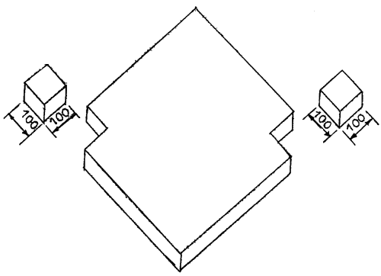

Figure 3 — preparation of specimens for water absorption test

C4. Procedure

C4.1 Place the six specimens in the ventilated drying oven so that each one is not less than 25 mm from any heating surface and from each other. Dry the six specimens in the oven for not less than 24 h and until two successive weighings at intervals of 2 h show an increment of loss not greater than 0.2 per cent of the last previously determined weight of the specimen.

C4.2 On removal from the oven, cool each specimen for 24 ± 0.5 h in the dry airtight vessel. Weigh each specimen and record the mass M₁. Immediately, completely immerse the specimen in water at
20 ± 5 º C with its longitudinal axis horizontal.

C4.3 Leave the specimen immersed in the water for 24 ± 0.5 h. Remove each specimen, shake it to remove the bulk of the water and dry it with a cloth as rapidly as possible until all free water is removed from the surface. Weigh each specimen and record the mass M₂.

C5. Calculation and expression of results

Water absorption of each specimen shall be calculated from the following expression:

Water absorption, per cent = 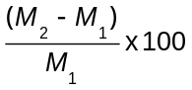

where,
M₁ = the mass of specimen oven dry (g); and
M₂ = the mass of specimen after 24 ± 0.5 h in water (g).

Express the results as the mean water absorption of the two specimens for each of the three precast concrete waffle units to the nearest 0.1 per cent.

C6. Report

Report the average value of the three means as the water absorption of the concrete waffles.

