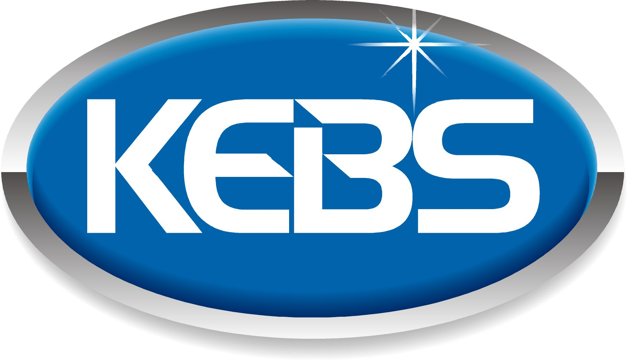 | Kenya Bureau of  Standards  standards for quality life

KEBS Head Office  P.O. Box 54974, Nairobi 00200  Tel: +254 (0) 20 605490,605506,  Mobile: 0722 202 137/8.  0734 600 471/1  Fax: +254 (0) 20 609 660  Direct Dial: +254 (0) 20 694 8000  E-mail: info@kebs.org  Web: http://www.kebs.org  KEBS Coast Region  P.O. Box 99376, Mombasa 80100  Tel: +254 (0) 41 229 563, 230 939/40  Fax: +254 (0) 41 229 448  E-mail: kebs-msa@kebs.org  KEBS Lake Region  P.O. Box 2949, Kisumu 40100  Tel: +254 (0) 57 202 8396, 202 9549  Fax: +254 (0) 57 202 7814  E-mail: kebs-kisumu@kebs.org  KEBS Rift Valley Region  P.O. Box 2138, Nakuru 20100  Tel: +254 (0) 51221 0553/5, 221 1208  Fax: +254 (0) 51221 0076  E-mail: kebs-nakuru@kebs.org  KEBS Mt. Kenya Region  P.O. Box 1790, Nyeri 10100  Tel: +254 (0) 61 203 1410/1  Fax: +254 (0) 61 203 2038  Email: kebs-nyeri@kebs.org  KEBS North Eastern Rgion  P.O. Box 978, Garissa 70100  Tel: +254 (0) 46 2519  Fax: +254 (0) 46 3455  E-mail: kebs-garissa@kebs.org |  | Our Ref. No: KEBS/STA/16/ Date: 9th July 2018  Dear Sir/Madam,  PUBLIC REVIEW DRAFT DKS 2832:2018 HAY AS ANIMAL FEED-SPECIFICATION PART 1: GRASS HAY  PART 2: LEGUMES HAY  These Draft Kenya Standards have been prepared by the Animal Feeds Technical Committee in accordance with the procedures of the Bureau, and is now being circulated for public comments.  The Committee would appreciate any comments on this Draft Standard, which should be submitted before 2018/09/10 using the attached template. It will also be appreciated if those who have no specific comments to make but find the draft standard generally acceptable can notify us accordingly.  Suggestions entailing amendments of the text should include wording preferred and the relevant clause number quoted against any comments made.  This draft standard is subject to change and should not be referred to or used as a Kenya Standard.  All correspondence pertaining to this draft standard should be addressed to the Managing Director, Kenya Bureau of Standards for the attention of Wangai Moses.  Yours faithfully,  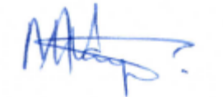  Wangai Moses  For: DIRECTOR  STANDARDS DEVELOPMENT AND INTERNATIONAL TRADE DIVISION

The Kenya Bureau of Standards (KEBS) is a member of the International Organization for Standardization (ISO), Codex Alimentarius Commission (CAC), The African Regional Organization for Standardization (ARSO), Associate Member of the International Electrotechnical Commission (IEC), Associate Member of Bureau International des Poids et Mesures (BIPM) and International Organization of Legal Metrology (OIML)

