KENYA STANDARD KS 2443-2:2018
ICS …..

Fireworks —Part 2: Roman candles — Specification and test methods

Up dated on 23rd February 2018

© KEBS 2018 1ST Edition 2018

TECHNICAL COMMITTEE REPRESENTATION

The following organizations were represented on the Technical Committee:

Ministry of Roads-Materials dept
Kenya Police
Tononoka Fireworks LTD.
Hindu Council of Kenya.
Ministry of Environment and Mineral –Mines Dept
UON- Geology Dept
Consumer Information Network
Government Chemist Dept
UON-Chemistry Dept
Kirdi
Kenya National Cleaner Production Centre
NEMA

REVISION OF KENYA STANDARDS

In order to keep abreast of progress in industry, Kenya Standards shall be regularly reviewed. Suggestions for improvements to published standards, addressed to the Managing Director, Kenya Bureau of Standards, are welcome.

©Kenya Bureau of Standards, 2018

Copyright. Users are reminded that by virtue of Section 25 of the Copyright Act, Cap. 12 of 2001 of the Laws of Kenya, copyright subsists in all Kenya Standards and except as provided under Section 26 of this Act, no Kenya Standard produced by Kenya Bureau of Standards may be reproduced, stored in a retrieval system in any form or transmitted by any means without prior permission in writing from the Managing Director.

KENYA BUREAU OF STANDARDS (KEBS)

Head Office: P.O. Box 54974, Nairobi-00200, Tel.: (+254 020) 605490, 602350, Fax: (+254 020) 604031
E-Mail: info@kebs.org, Web:http://www.kebs.org

Coast Region Lake Region Rift Valley Region
P.O. Box 99376, Mombasa-80100 P.O. Box 2949, Kisumu-40100 P.O. Box 2138, Nakuru-20100
Tel.: (+254 041) 229563, 230939/40 Tel.: (+254 057) 23549, 22396 Tel.: (+254 051) 210553, 210555
Fax: (+254 041) 229448 Fax: (+254 057) 21814

Foreword

This standard has been prepared by the Technical Committee on commercial explosives, Fireworks, Pyrotechnics and other Blasting materials under the guidance of the Standards Projects Committee, and it is in accordance with the procedures of the Kenya Bureau of Standards.

Roman candles are fireworks constructed with bentonite, lifting charge, pyrotechnic star, black powder, and delay charge. The device is ignited from the top, which should be pointed into the sky, away from people. The delay powder is packed tightly in the tube, so that the flame cannot reach around the sides of the plug of delay composition. It therefore burns slowly; as it is consumed, the flame moves down through the tube. When the flame reaches the topmost pyrotechnic star, the star is ignited. Because the star fits loosely in the tube, the fire spreads around it and ignites the lift charge. The lift charge burns quickly, propelling the star out of the tube. In doing so it also ignites the layer of delay powder beneath it, and the process repeats. Prior to the publication of CD/CHEM/99:2015, there had been no comprehensive document published in Kenya concerned with the quality of roman candles, although fireworks are subject to certain legislation, notably the Explosives Act Chapter 115 and the Firearms Act Chapter 114.

ocument:

BS EN 14035-28:2004 Fireworks —Part 28: Roman candles — Specification and test methods
The Explosives Act Chapter 115 Laws of Kenya.

Acknowledgement is hereby made for the assistance received from this source.

1 Scope
This Kenya Standard specifies requirements for the construction, performance, primary packaging and labelling of Roman candles and the corresponding test methods. It is applicable to fireworks, which are classified as Roman candles in categories 2 and 3 in KS 2443-1.

It is not applicable to Roman candles containing pyrotechnic composition, which includes any of the following substances:

— arsenic or arsenic compounds;
— mixtures containing a mass fraction of chlorates greater than 80 %;
— mixtures of chlorates with metals;
— mixtures of chlorates with red phosphorus;
— mixtures of chlorates with potassium hexacyanoferrate(II);
— mixtures of chlorates with sulfur;
— mixtures of chlorates with sulfides;
— lead or lead compounds;
— mercury compounds;
— white phosphorus;
— picrates or picric acid;
— potassium chlorate with a mass fraction of bromates greater than 0.15 %;
— sulfur with an acidity, expressed in mass fraction of sulphuric acid, greater than 0,002 %;
— zirconium with a particle size of less than 40 µm.

2 Normative references

The following referenced documents are indispensable for the application of this document. For dated references, only the edition cited applies. For undated references, the latest edition of the referenced document (including any amendments) applies.

KS 2443-1:2013, Fireworks —Part 1: Classification of fireworks
KS 2364 Glossary of terms used in commercial explosives, Fireworks, Pyrotechnics and other blasting materials
KS ISO 845, Cellular plastics and rubbers — Determination of apparent (bulk) density (ISO 845:1988).
KS ISO 868, Plastics and ebonite - Determination of indentation hardness by means of a durometer (Shore hardness) (ISO 868:2003).
KS ISO 2439, Flexible cellular polymeric materials - Determination of hardness (indentation technique)
Ks ISO 2859-1, Sampling procedures for inspection by attributes — Part 1: Sampling schemes indexed by acceptance quality limit (AQL) for lot-by-lot inspection.
3 Definitions
For the purposes of this document, the terms and definitions given in KS 2364 shall apply.

4 Construction

4.1 Means of ignition
A protruding fuse shall identify the means of ignition. Conformity to this requirement shall be verified by visual examination.
4.2 Attachment of initial fuse
The attachment of the protruding fuse to the Roman candle shall be secure when tested in accordance with Annex A.
4.3 Protection of initial fuse
4.3.1 General
The initial fuse shall be protected in one of the ways specified in 4.3.2, 4.3.3 or 4.3.4.
4.3.2 Initial fuse protected by fuse cover
An orange fuse cover shall be in place over the initial fuse. Conformity to this requirement shall be verified by visual examination.
4.3.3 Initial fuse protected by primary pack or selection pack
The Roman candle shall be contained in a primary pack or selection pack conforming to clause 6. Conformity to this requirement shall be verified by visual examination.
4.3.4 Protruding fuse designed to resist side ignition
When tested in accordance with Annex B, the protruding fuse shall not ignite.
4.4 Materials of firework case
The tube shall be made of paper, cardboard or plastics. The base and/or means of fixing shall be made of non-metallic material. Conformity to these requirements shall be verified by visual examination.
4.5 Integrity
There shall be no holes, splits, dents or bulges in the tube. There shall be no holes or splits in the end closure. If the end closures are separate components, they shall be securely in place. If the base is a separate component, it shall be securely in place.
Conformity to these requirements shall be verified by visual examination.
4.6 Net explosive content
4.6.1 When determined in accordance with Annex C, a category 2 Roman candle shall have a net explosive content of not more than 50,0 g. Each pyrotechnic unit shall have a net explosive content of not more than 10,0 g.
4.6.2 When determined in accordance with Annex C, a category 3 Roman candle shall have a net explosive content of not more than 300,0 g. Each pyrotechnic unit shall have a net explosive content of not more than 50,0 g.
4.7 Mass of report charge
4.7.1 When determined in accordance with annex C, a category 2 Roman candle shall not contain more than 5 pyrotechnic units containing report composition and each of these pyrotechnic units shall have a net explosive content of not more than 5.0 g of black powder or 4.0 g nitrate/metal-based report composition or 2.0 g perchlorate/metal-based report composition.
4.7.2 When determined in accordance with annex C, a category 3 Roman candle shall not contain more than 10 pyrotechnic units containing report composition and ˆeach of these pyrotechnic units shall have a net explosive content of not more than 10.0 g of black powder or 8.0 g of nitrate/metal-based report composition or 4.0 g of perchlorate/metal-based report composition.'
4.8 Vertical stability
For Roman candles designed to be placed on the ground, the Roman candle shall not fall over when tested in accordance with annex D.

5 Performance
5.1 Initial fuse

When tested in accordance with annex E, the initial fuse of a Roman candle shall ignite within 10 s and the ignition shall be visible. For category 2 Roman candles, the duration of the initial fuse burning shall be 3.0 s to 8.0 s, when tested in accordance with annex E.

For category 3 Roman candles, the duration of the initial fuse burning shall be 5.0 s to 13.0 s, when tested in accordance with annex E.

5.2 Invisible burning
When tested in accordance with annex E, any period of invisible burning occurring after the preliminary effect shall not exceed 5.0 s for a category 2 Roman candle or 10.0 s for a category 3 Roman candle.
5.3 Principal effects
When tested in accordance with annex E, the principal effects of the Roman candle shall be the ejection of pyrotechnic units in succession, producing a series of visual and/or aural effects, in the air.
5.4 Functioning
When tested in accordance with annex E all the pyrotechnic units of the Roman candle shall be ejected and function.
5.5 Sound pressure level
5.5.1 When tested in accordance with annex E, a category 2 Roman candle shall produce a maximum A-weighted impulse sound pressure level (L_{AImax}) of not higher than 120 dB(AI) at a horizontal distance of 8,0 m from the testing point and at a height of 1.0 m above the ground.

5.5.2 When tested in accordance with annex E, a category 3 Roman candle shall produce a maximum A-weighted impulse sound pressure level (L_{AImax}) of not higher than 120 dB(AI) at a horizontal distance of 15,0 m from the testing point and at a height of 1.0 m above the ground.
5.6 Height of explosions and bursting (if applicable)
5.6.1 When tested in accordance with annex E, the pyrotechnic units of a category 2 Roman candle shall not explode or burst below a height of 8 m.
5.6.2 When tested in accordance with annex E, the pyrotechnic units of a category 3 Roman candle shall not explode or burst below a height of 20 m.

5.7 Burning matter
5.7.1 When tested in accordance with annex E, no burning or incandescent matter from a category 2 Roman candle shall fall to the ground more than 6.0 m from the testing point.
5.7.2 When tested in accordance with annex E, no burning or incandescent matter from a category 3 Roman candle shall fall to the ground more than 15.0 m from the testing point.
5.7.2 When tested in accordance with annex E, any flames caused by the functioning of the Roman candle shall be extinguished within 60.0 s of the Roman candle ceasing to function.
5.8 Stability
When tested in accordance with annex E, the Roman candle shall remain upright whilst functioning.
5.9 Integrity of the firework case after functioning
When tested in accordance with annex E, there shall be no additional holes or splits in the firework case.
6 Primary pack or selection pack
6.1 If a primary pack or selection pack is required to protect the initial fuse(s) of the Roman candle(s), the pack shall completely enclose the Roman candle(s) and there shall be no holes or splits in the pack, except those which are intended to enable the packaging to be opened or otherwise technically necessary.
6.2 Conformity to these requirements shall be verified by visual examination.

7 Minimum labelling requirements

7.1 General

7.1.1 Roman candles and their primary packs, if any, shall be marked with the information specified in 7.2 to 7.5 and, if relevant, 7.7 and/or 7.8.

7.1.2 The specified information shall be given in the language(s) of the country in which the Roman candles or primary packs are offered for retail sale. For each language, it shall be presented as a whole and shall not be interrupted by other text. Additional text given in another language shall not conflict with the specified information.

7.1.1Conformity to the requirements specified in 7.1 to 7.5, 7.6.1, 7.7.2 and 7.8 shall be verified by visual examination.
7.2 Type name, category and number of shots

The type name and the number of shots shall be marked, in upper case, e.g. as '8 SHOT ROMAN CANDLE'. If a trade name is used in addition to the type name, it shall not conflict with the effect of a Roman candle or with the name of another type of firework.

The appropriate category shall be marked, in upper case, as 'CATEGORY 2' or 'CAT 2', for example.
7.3 Safety information

7.3.1 General

Safety information shall be emphasized by use of a heading, or bold type, or similar. If necessary, instructions in addition to those specified in 7.3.2 to 7.3.4 may be given.
7.3.2 Category 2 Roman candles
Labelling shall include at least the following safety information in the order as given:
— 'For outdoor use only’;
— 'Avoid overhead obstructions';
Specific placing instructions for different types of Roman candles, inserted as appropriate (see 7.3.4);
— 'Remove orange fuse cover'1);
— 'Standing sideways, light fuse at its outermost end and retire immediately at least 8 m'.
-Instruction for correct use, handling and storage and disposal
7.3.3 Category 3 Roman candles
Labelling shall include at least the following safety information in the order as given:
— 'For outdoor use only';
— 'Avoid overhead obstructions';
Specific placing instructions for different types of Roman candles, inserted as appropriate (see 7.3.4);
— 'Remove orange fuse cover'1);
— 'Standing sideways, light fuse at its outermost end and retire immediately';
— 'Spectators must be at least 25 m away';
— 'Operator must retire at least 15 m'.
- Instruction for correct use,handling and storage and disposal
7.3.4 Placing instructions:

For Roman candles to be placed on flat ground:

— 'Place Roman candle upright on flat ground'. For Roman candles to be buried into soft ground:
— 'Bury two-thirds of Roman candle upright in ground'. For Roman candles to be inserted in soft ground:
— 'Insert Roman candle upright in soft ground or other non-flammable material, e.g. sand';
— 'Ensure Roman candle will not fall over' For Roman candles to be fixed to a post:
— 'Fix Roman candle firmly and upright to a solid post';
— 'Ensure top of Roman candle clears post'.
For Roman candles supplied with a special holding device, or for which particular instructions are necessary, the manufacturer shall provide appropriate instructions.

7.4 Name, address and telephone number of manufacturer or distributor or importer
Labelling shall include:
— the name or trade mark, the address and the telephone number of the manufacturer; or
— an abbreviation or a code allowing the identification of the manufacturer, and the name or trade mark, the address and the telephone number
— of his authorized distributor; or The address shall comprise at least the town and the country. On the Roman candle at least the abbreviations allowing the identification of
— the manufacturer; or
— the distributor or importer, with an additional code or abbreviation for the manufacturer shall be marked.

7.6 Printing

7.6.1 Labelling

Labelling shall be clearly visible, easily legible, indelible and on a single-colour background.

7.6.2 Type size

When measured in accordance with annex F, the type sizes shall be such that the height of the character 'X' (in upper cases) is at least 2.8 mm for the information specified in 7.2, 7.3 and 7.8 and at least 2.1 mm for the other information.

7.7 Marking of very small Roman candles
7.7.1 Reduced size
If the Roman candle does not provide enough space for the specified information using the types sizes specified in 7.6.2, for the information specified in 7.2 and 7.3 the type size shall be reduced to 2.1 mm.
7.7.2 Reduced information
If the Roman candle does not provide enough space to carry all the specified information even in reduced type size, at least the information specified in 7.4 shall be given on the Roman candle, if at all possible.

7.8 Additional information on the primary pack (if applicable)

If the Roman candle is not labelled completely with the information specified in 7.2 to 7.5, or if the primary pack acts as protection of the initial fuses according to 4.3.3, the Roman candle shall be sold only in a primary pack. The primary pack shall be marked with the statement

'Must be sold as packaged'.

This statement shall appear adjacent to the type name or category. For the printing 7.6 applies.

Annex A
(normative)

Attachment of protruding fuse (type test and batch test)

A.1 Apparatus

8.1.1 Means of clamping the Roman candle.

8.1.2 Weight, of mass 100 g.

8.1.3 Timing device, capable of being read to the nearest 0, 1 s.

8.1.2 Procedure

Clamp the Roman candle by means of the clamping device (A.1.1) in a position such that the protruding fuse is pointing vertically downwards. Securely attach the 100 g weight (8.1.1.2) to the protruding fuse.

Using the timing device (A.1.3), determine and record whether the protruding fuse will support the weight for at least 10 s without becoming detached. If the protruding fuse becomes detached, do not proceed with further testing of that Roman candle.

Annex B
(normative)
Side ignition of initial fuse (type test)

B.1 Material

Cigarette, untipped, of length (70 ± 4) mm, diameter (8,0 ± 0,5) mm and mass (1,0 ± 0,1) g, and having a smouldering rate of (9,5 ± 3,0) min over a 40 mm distance when determined in accordance with annex J.

B.2 Test area

The test area shall be a flat, horizontal, non-flammable surface inside a fume cupboard, or similar enclosed space, which is capable of preventing movement of air. A means of extracting fumes shall be provided but this shall be switched off during the test.

B.3 Apparatus

Three wire supports, (2,0 ± 0,1) mm diameter, approximately 50 mm long.

B.4 Test specimen

Use the initial fuse obtained by dismantling the Roman candle for the determination of net explosive content

B.5 Procedure

Ignite the cigarette and rest it horizontally on three wire supports, above the non-flammable surface in the test area . Place the test specimen crosswise over the cigarette, 15 mm from the end which has been ignited, as shown in Figure 3. Allow the cigarette to burn 10 mm beyond the point where the initial fuse crosses it. Record whether the initial fuse ignites.

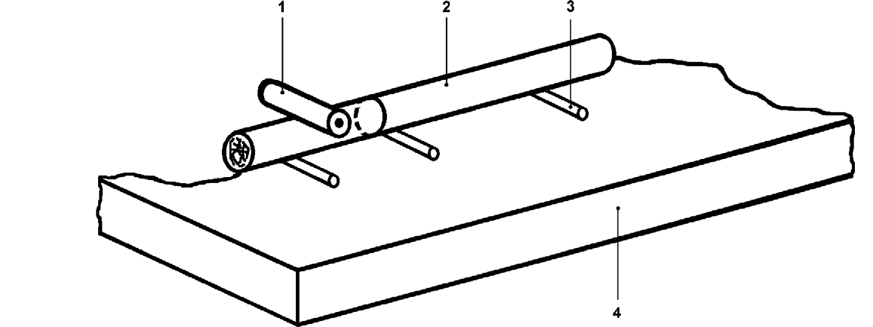
Key

1 Test specimen
2 Cigarette
3 Wire support
4 Non-flammable surface

Fig 3 (a)

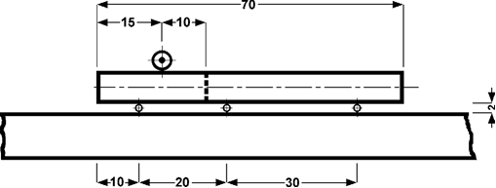

Fig 3 (b) –Side ignition test

Annex C
(normative)
Determination of net explosive content (type test)

C.1 Apparatus
Laboratory balance, capable of weighing to the nearest 0.1 g.
C.2 Procedure
C.1 Carefully dismantle a Roman candle. Separate the protruding fuse and retain this for the side ignition test Separate any pyrotechnic unit containing report composition, if any, and count them. Record the number of pyrotechnic units containing report composition.
C.2 Weigh the pyrotechnic composition not contained in pyrotechnic units, to the nearest 0.1 g, using the balance Record the mass.
C.3 If applicable, remove the pyrotechnic composition from each pyrotechnic unit not containing any report charge and weigh each portion, to the nearest 0.1 g, using the balance . Record the masses.
C.3 If applicable, remove the report composition from each pyrotechnic unit with report charge and weigh each portion, to the nearest 0.1 g, using the balance . Record the masses.
C.4 Determine the net explosive content of the Roman candle by adding the weighed masses of all pyrotechnic compositions. Record the net explosive content.

Annex D
(normative)
Vertical stability test (type test)
D.1 Apparatus

D.1.1 Wooden block, rectangular, with an upper surface inclined at 10° to the horizontal.

D.1.2 Timing device, capable of being read to the nearest 0,1 s.

D.2 Procedure

D.2.1 Place the base of the Roman candle on the inclined surface of the wooden block.For polygonal (triangular, etc.) bases, align one edge of the base with the top edge of the wooden block.

D.2.2 Using the timing device, observe and record whether the Roman candle falls over within 5 s. If it falls over discontinue the test.

D.2.3 Rotate the Roman candle clockwise through 90° and repeat the observation described in D.2.2.

D.2.4 Repeat the operations described in D.2.3 twice more (unless the Roman candle falls over).

Annex E
(normative)
Performance (type test and batch test)

E.1 Test environment

E.1.1 Test area for category 2 Roman candles.

E.1.1.1 The test area shall be an outdoor site, on level ground, with a radius of at least 9 m and a smooth, hard, horizontal, sound-reflecting, non-flammable surface (for example, concrete). If applicable, provision shall be made at the centre of the test area for partially burying the Roman candle to be tested. A circle, radius 6.0 m, shall be marked around the centre of the test area.

E.1.1.2 One position for monitoring the height of explosion or bursting of the pyrotechnic units shall be provided, at a measured distance of at least 8 m from the testing point (in the centre of the test area).
E.1.2 Test area for category 3 Roman candles.

E.1.2.1 The test area shall be an outdoor site, on level ground, with a radius of at least 16 m and a smooth, hard, horizontal, sound-reflecting, non-flammable surface (for example, concrete). If applicable, provision shall be made at the centre of the test area for partially burying the Roman candle to be tested. A circle, radius 15.0 m, shall be marked around the centre of the test area.

E.1.2.2 One position for monitoring the height of explosion or bursting of the pyrotechnic units shall be provided, at a measured distance of at least 15 m from the testing point (in the centre of the test area).

E1.3 Wind speed. A means of measuring the wind speed at a height of 1.5 m above the ground shall be provided. No performance testing shall be carried out if the wind speed exceeds 5.0 m/s.

E.2 Apparatus

E.2.1 Timing device, suitable of displaying at least one intermediate time, capable of being read to the nearest 0.1s.

E2.2 Ignition source, capable of producing a small flame or of smouldering.

E.2.3 Sound level meter (for type testing only) with a free-field microphone.

E.2.4 Means of monitoring the height of explosion and bursting of pyrotechnic units, capable of indicating vertical heights of 8 m above the ground for category 2 Roman candles and 20 m above the ground for category 3 Roman candles.

Note: 1 A suitable viewing screen is shown in Figure 1 and the principle of its use is shown in

Note: 2 A vertical height of 8 m can be indicated by 8 m poles around the perimeter of the test area.

Distance X is given, in millimetres, by the equation:

$$X=600-(\frac{19.4x600}{y})$$

Where y is the distance, in m, from the viewing point to the testing point (see Figure 2).

The observer is positioned so that the bottom edge of the triangle on the front screen coincides with the lower edge of the Roman candle and the bottom edge of the back screen coincides with the bottom edge of the horizontal tape on the front screen.

Dimension in milimetere
.
Key
1 Acrylic glass Fig 1:-Viewing screen

2 Black tape, 10 mm to 20 mm wide

3 Solid base

4 Stand

Key Figure 2 – Use of a viewing screen to monitor a height of 20 m

1 Upper end of tube

2 Sighting device

3 Position of observer

E 2.5 Measuring device, capable of measuring a height of 1,0 m to the nearest 10 mm.

E.3 Procedure

E.3.1 Measure and record the wind speed.

E.3.2 If carrying out a type test of Roman candles, set up the microphone of the sound level meter in the test area, at a height of 1.0 m above the ground, determined by the measuring device , and at a horizontal distance from the testing point of 8.0 m for category 2 Roman candles or 15.0 m for category 3 Roman candles. Direct the microphone horizontally towards the testing point and, if necessary, connect it to the sound level meter.

E.3.3 Position the Roman candle, in accordance with the instructions on the label, in the centre of the test area. Remove the orange fuse cover, if any, and straighten the initial fuse, if necessary. Apply the ignition source and at the same instant, start the timing device. Stop the intermediate time at the moment the protruding fuse ignites. If the initial fuse fails to ignite within 10 s, record the fact and do not proceed with further testing of that Roman candle.

Otherwise, stop the timing device when the Roman candle starts to produce its first effect. Record whether the initial fuse ignited within 10 s and whether the ignition of the initial fuse was visible.

E.3.4 Record the duration of the initial fuse burning. Observe and record whether any period of invisible burning exceeds 5.0 s for a category 2 Roman candle or 10.0 s for a category 3 Roman candle. Observe and record the principal effects and the number of shots produced by the Roman candle. After the Roman candle has ceased to function, start the timing device immediately and record whether any flames caused by the functioning of the Roman candle are extinguished within 60,0 s after the Roman candle has ceased to function.

If testing a Roman candle with pyrotechnic units, using the monitoring apparatus, observe and record whether the pyrotechnic units of the roman candle explode or burst at a height of less than 8 m above the ground for category 2 Roman candles or less than 20 m for category 3 Roman candles.

Observe and record whether any burning or incandescent matter falls to the ground at a distance of more than
6.0 m, for a category 2 Roman candle, or 15.0 m, for a category 3 Roman candle, from the testing point. Observe and record whether the Roman candle remains upright whilst functioning.
E.3.5 Record the maximum A-weighted impulse sound pressure level, as measured by the sound level meter.

E.3.6 After the Roman candle has ceased to function, examine the firework case and record, whether it has any additional holes or splits.

E.3.7 After functioning, examine the Roman candle visually and record whether all the pyrotechnic units of the Roman candle have been ejected and functioned.

Annex F
(normative)
Labelling (type test and batch test)

Check conformity to 7.6.2 and 7.7.1, for example by comparing the type sizes on the actual label with a transparent copy made from Figure 4 (for the empty frame, use the inside). Record whether the type sizes were correct.

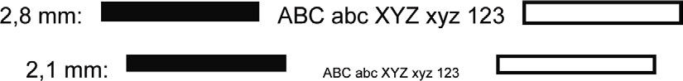

Figure 4 – Type sizes of print

Annex G
(normative)
Type testing
G.1 General

For the purposes of type testing each of the Roman candles tested, except those used for the determination of net explosive content, shall meet one of the following sets of requirements.

a) If the Roman candle has an initial fuse which is not designed to resist side ignition, it shall conform to 4.1,4.2, 4.3.2 or 4.3.3, 4.4, 4.5, 4.8 (if applicable) 5 and 7.

b) If the Roman candle has an initial fuse designed to resist side ignition, it shall conform to 4.1, 4.2, 4.3.4, 4.4,4.5, 4.8 (if applicable) 5 and 7.
The Roman candles used for the determination of net explosive content shall each conform to 4.6 and 4.7 and, if the initial fuse is designed to resist side ignition, it shall conform to 4.3.4.

The Roman candles subjected to mechanical conditioning in accordance with G.5 shall, additionally, conform to G.3.

For Roman candles which are supplied in primary packs in order to protect the initial fuses of the Roman candles (see 4.3.3), each of the packs examined shall conform to 6 and 7.

G.2 Number of Roman candles to be tested

A total of 33 Roman candles shall be tested, in accordance with Table G.1. If the Roman candles are supplied in primary packs they shall be selected at random from at least 5 packs.

Table G.1 – Number of Roman candles to be tested
Number of  Roman  candles to be tested | Condition | Tests
10 | 'As received' | - Visual examination  - 8.1  - 8.2, if applicable  - 8.3  - 8.6
10 | After thermal conditioning in accordance with G.4 | - Visual examination  - 8.1  - 8.3
10 | After mechanical conditioning in accordance  with G.5 | - Visual examination  - 8.1  - 8.3
3 | 'As received' | - 8.4  - 8.5, if applicable

G.3 Loose pyrotechnic composition
The mass of any loose pyrotechnic composition collected after mechanical conditioning in accordance with G.5 shall not exceed 100 mg.
G.4 Thermal conditioning

Store the Roman candles for four weeks at a temperature of (50.0 ± 2.5) °C and then for at least two days at room temperature before testing. For Roman candles, which are supplied in primary packs, condition the Roman candles by storing the appropriate number of complete, unopened packs.
G.5 Mechanical conditioning

G.5.1 Apparatus
G.5.1.1 Mechanical shock apparatus, as illustrated in Figures G.1 to G.3, comprising the following components:

a) flat horizontal platform made of steel, 800 mm × 600 mm, 2 mm to 3 mm thick, with a 3 mm thick rim having a height of 15 mm; the platform is reinforced with eight steel ribs, 5 mm thick with a height of 30 mm, which are welded to the underside and run from the centre to each of the four corners and to the middle of each edge;
b) 20 mm thick plate of fibreboard, firmly attached to the platform by screws;
c) cylindrical steel boss, diameter 125 mm and height 35 mm, located under the centre of the platform;
d) 284 mm long shaft, with diameter of 20 mm, fixed to the centre of the boss;
e) restraining peg, to prevent the platform from rotating; the mass of the platform assembly (items a) to e))
shall be (23 ± 1) kg;
f) annular, elastomeric pressure spring, with a Shore A hardness, when determined in accordance with EN ISO 868, of 68, outside diameter 125 mm, inside diameter 27 mm and height 32 mm, on which the cylindrical boss will rest;
g) shallow steel cylinder, inside diameter 126 mm, wall thickness 5 mm, outside height 30 mm, with a base 8 mm thick which has a 25 mm diameter hole drilled through the centre, to contain the elastomeric spring;
h) supporting steel cylinder, outside diameter 80 mm, inside diameter 60,1 mm and height 92,4 mm, to which the shallow cylinder is screwed;
i) PVC liner, outside diameter 60 mm, inside diameter 20,2 mm and height 92,4 mm, located inside the supporting cylinder and attached by a screw;
j) steel mounting plate, thickness 12 mm, with a 25 mm hole drilled through the centre, to which the supporting steel cylinder is screwed;
k) steel base plate, thickness 12 mm;
l) four supporting pillars, height 260 mm and diameter 32 mm, screwed to the mounting plate and to the base plate;
m) framework to support the base plate so that the complete assembly is at a convenient working height;

n) attachment to the shaft, allowing adjustment to the overall length, fitted with a cam wheel, outside diameter
30,0 mm, with a contact surface 8,0 mm wide;
o) cylindrical cam, outside diameter 120 mm, inside diameter 100 mm, wall thickness 10 mm, with a 'vertical drop' of 50,0 mm between the high point and the low point;
p) collar, outside diameter 50 mm, height 4,0 mm;
q) electric motor and suitable gearing, to rotate the cam at a rotational frequency of 1 Hz.

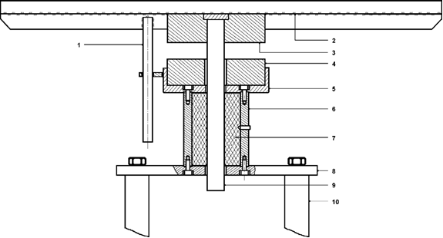

Key

1 Restraining peg

2 Platform

3 Boss

4 Pressure spring

5 Cup

6 Supporting cylinder

7 PVC liner

8 Mounting plate

9 Shaft

10 Supporting pillar

Figure G.1 — Detail of top section of mechanical shock apparatus

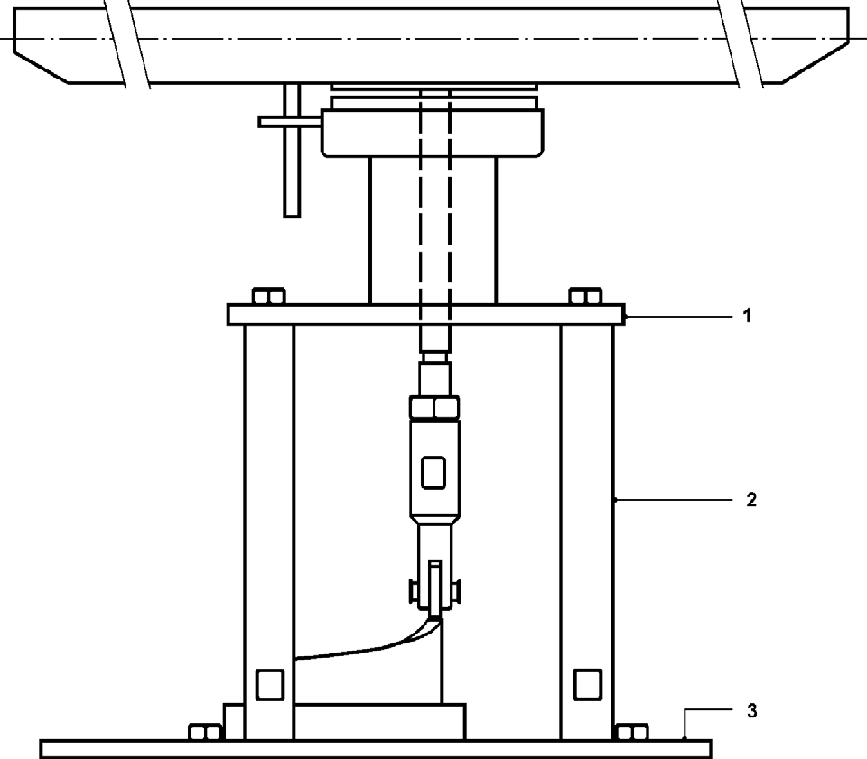

Key

1 Mounting plate

2 Supporting pillar

3 Base plate

Figure G.2 — General assembly of mechanical shock apparatus

G.5.1.2 Cellular rubber sheet, 100 mm thick. The material used shall have an apparent density, when determined in accordance with KS ISO 845, of 35 kg/m3 and an indentation hardness check, when determined in accordance with KS ISO 2439, of 215 N.

G.5.1.3 Laboratory balance, capable of weighing to the nearest 1 mg.

G.5.2 Procedure

G.5.2.1 Conditioning. Place a sheet of paper on the platform of the mechanical shock apparatus (A.5.1.1) and place the Roman candles on top of the sheet of paper. Cover the Roman candles with the cellular rubber sheet (A.5.1.2) and secure it to the platform around its edges. Start the machine so that the platform is raised and dropped onto the elastomeric spring, having adjusted the drop height (to about 25 mm) so that the maximum deceleration of each shock is 490 m/s2 and the duration of each shock impulse is about 60 ms.
Continue running the machine for 2 h.

G.5.2.2 Collection of loose pyrotechnic composition. At the end of the 2 h period stop the machine and remove the Roman candles. Separate any pyrotechnic composition from the other loose material and weigh this pyrotechnic composition to the nearest 1 mg using the balance (A.5.1.3). Record whether the mass of the pyrotechnic composition exceeds 100 mg.

G.6 Number of primary packs to be examined

For Roman candles which are supplied in primary packs in order to protect the initial fuses of the Roman candles, examine at least five packs to assess conformity to 6 and 7. The packs to be examined shall include all those whose contents are used for the tests described in 8.

G.7 Test report

The test report shall include at least the following information, with items m) to u) and w) to hh) being given for each Roman candle tested:

a) | * | reference to this standard
b) | * | complete identification of the sample under test;
c) | * | date of completion of the testing;
d) | * | whether the means of ignition is identified by a protruding fuse;
e) | * | means by which the initial fuse is protected;
f) |  | if the initial fuse is a protruding fuse designed to resist side ignition, whether the  protruding fuse ignited for each of the items tested for that purpose;
g) | * | if applicable, for each primary pack or selection pack examined, whether the pack  completely enclosed the Roman candle(s) and whether there were any holes or splits in the pack except those intended to enable the packaging to be opened and those which are otherwise technically necessary;

h) |  | net explosive contents of the Roman candle for that purpose, in grams,  and  whether the net explosive content of each Roman candle tested for that purpose exceeds 50,0 g for a category 2 Roman candle, or exceeds 300,0 g for a category 3  Roman candle and,  whether the net explosive content of each pyrotechnic unit exceeds 10,0 g for a category 2 Roman candle, or exceeds 50,0 g for a category 3 Roman candle,  and  if applicable, whether the Roman candle contains more than 5 report units for a category 2 Roman candle or 10 report units for a category 3 Roman candle and,  whether the mass of the report charge, of each report unit, if any exceeds  for a category 2 Roman candle 5,0 g of black powder or 4,0 g of nitrate/metal-based composition or 2,0 g of perchlorate/metal-based composition, or for a category 3  Roman candle 10,0 g of black powder or 8,0 g of nitrate/metal-based composition or  4,0 g of perchlorate/metal-based composition;
i) | * | if applicable, for each primary pack examined, whether the type name, category,  safety information, name and address and telephone number of the manufacturer2) or distributor2) or importer2) and the reference to this standard were correctly stated on the pack;
j) | * | if applicable, for each primary pack examined, whether the statement ‘Must be sold as  packaged’ was correctly stated on the pack;
k) | * | if applicable, for each primary pack examined, whether the specified information on the pack was clearly visible, easily legible, indelible, on a single-colour background  and whether the type sizes were correct;
l) |  | whether the mass of any loose pyrotechnic composition collected after mechanical  conditioning exceeded 100 mg;
m) | * | materials of the firework case and of the base and/or the means of fixing and  whether the materials of the body of the firework case are paper, cardboard, or plastics and whether the materials of the base and/or the means of fixing are of non- metallic material;
n) | * | if applicable, whether the orange fuse cover was in place over the initial fuse;
o) | * | whether there were any holes, splits, dents or bulges in the body of the firework case;
p) | * | if applicable, whether the base was securely in place;

q) | * | if applicable, whether there were any holes or splits in the end closures and whether  the end closures were loose or missing;
r) | * | if applicable, whether the type name, category, safety information, name and address and telephone number of manufacturer2) or distributor2) or importer2) and the reference to this standard were correctly stated on the Roman candle;
s) | * | If applicable, whether the specified information on the Roman candle was clearly  visible, easily legible, indelible, on a single-colour background and whether the type sizes were correct;
t) | * | whether the protruding fuse was securely attached to the Roman candle;
u) |  | if applicable, whether the Roman candle over fell when tested for vertical stability;
v) |  | wind speed at the time of performance testing, in metres per second;
w) | * | whether the initial fuse ignited within 10 s;
x) | * | whether the ignition of the initial fuse was visible;
y) | * | duration of the initial fuse burning, in seconds and whether the duration of the initial  fuse burning was not less than 3,0 s or more than 8,0 s for a category 2 Roman candle or not less than 5,0 s or more than 13,0 s for a category 3 Roman candle;
z) | * | whether the Roman candle produced its principal effects;
aa) | * | If applicable, whether the pyrotechnic units explode or burst below a height of 8 m for  category 2 Roman candles or 20 m for category 3 roman candles above the ground;
bb) | * | whether all the pyrotechnic units of the Roman candle have been ejected and  functioned;
cc) | * | whether any period of invisible burning occurring after the preliminary effect shall not  exceed 5,0 s for a category 2 Roman candle or 10,0 s for a category 3 Roman candle;
dd) |  | maximum A-weighted impulse sound pressure level, in decibels (AI) and whether the maximum A-weighted impulse sound pressure level exceeded 120 dB(AI);
ee) | * | whether any burning or incandescent matter fell to the ground a distance of more than  6,0 m, for category 2 Roman candles, or 15,0 m, for category 3 Roman candles, from the testing point;
ff) | * | whether any flames caused by the functioning of the Roman candle were extinguished  within 60,0 s of the Roman candle ceasing to function;
gg) | * | whether the Roman candle remained upright whilst functioning;
hh) | * | whether there were any additional holes or splits in the firework case.

Annex H
(normative)
Batch testing

H.1 General
For the purposes of batch testing, acceptance sampling in accordance with B.2 to B.6 shall be applied.
H.2 Sampling plans
Sampling shall be in accordance with ISO 2859-1 using double sampling plans and applying the switching procedures for normal, tightened and reduced inspection. Inspection level S-4 shall apply.
H.3 Unit of product
For Roman candles which are not supplied in primary packs, the unit of product on which the sample size is based shall be the individual Roman candle.
For Roman candles which are supplied in primary packs, the unit of product for the purpose of sampling to assess compliance with the requirements for the Roman candles shall be an individual Roman candle and the sample shall comprise the contents of the appropriate number of primary packs. The primary pack shall be the unit of product for the purpose of sampling to assess compliance with the requirements for the primary packs themselves and the appropriate number of primary packs shall be sampled separately and examined for faults.
H.4 Nonconformities

Nonconformities shall be classed in accordance with Table B.1.
Table H.1 – Summary of requirements and types of nonconformity for batch testing
Ref. | Property | Requirement | Test  method | Type of  noncon- formitya
4.1 | Identification of means of ignition | See 4.1 | Visual | Major
4.2 | Attachment of protruding fuse | Shall be secure | 8.1 | Major
4.3.2 | Orange fuse cover over initial fuse b | Shall be in place | Visual | Major
4.4 | Materials of firework case | See 4.4 | Visual | Critical
4.5 | Integrity of firework case | See 4.5 | Visual | Major
5.1 | Ignition of initial fuse | See 5.1  Shall be visible | 8.3  8.3 | Major  Major
5.1 | Duration of initial fuse burning:  Category 2 Roman candles  Category 3 Roman candles | (3,0 s to 8,0 s)  Extent of nonconformity:  < 2,0 s or > 10,0 s  ≥ 2,0 s and < 3,0 s  > 8,0 s and ≤ 10,0 s  (5,0 s to 13,0 s)  Extent of nonconformity:  < 3,0 s or > 15,0 s  ≥ 3,0 s and < 5,0 s  > 13,0 s and ≤ 15,0 s | 8.3 | Critical  Major  Major  Critical  Major  Major
5.2 | Invisible burning:  Category 2 Roman candles  Category 3 Roman candles | ≤ 5,0 s for any period  ≤ 10,0 s for any period | 8.3 | Major  Major
5.3 | Principal effects | See 5.3 | 8.3 | Minor
5.4 | Functioning | All pyrotechnic units of the  Roman candle shall be ejected and function | 8.3 | Major
5.6 | Height of explosion or bursting of pyrotechnic units b  Category 2 Roman candles  Category 3 Roman candles | ≥ 8 m  ≥ 20 m | 8.3 | Major  Major
5.7 | Burning or incandescent matter | See 5.7 | 8.3 | Major
Ref. | Property | Requirement | Test  method | Type of  noncon- formitya
 | falling to the ground
5.7 | Extinguishing of any flames | ≤ 60,0 s after the Roman candle has ceased to function | 8.3 | Minor
5.8 | Stability | Shall remain upright whilst  functioning | 8.3 | Critical
5.9 | Integrity of the firework case  after functioning | Shall have no additional  holes or splits | 8.3 | Minor
6 | Integrity of primary pack or  selection pack c | Pack shall completely  enclose the Roman candle and shall have no holes or splits, except if they are intended to open the packaging or otherwise technically necessary | Visual | Major
7 | Labelling of Roman candle b | Shall be correctly stated and  legible and on a single- colour background | Visual | Minor
7 | Labelling of primary pack d | Shall be correctly stated and  legible and on a single- colour background | Visual | Minor
7 | Type sizes | See 7.6.2, 7.7.1 and 7.8, as  appropriate | 8.6 | Minor

H.5 Test report

The test report shall include at least the items marked with an asterisk in A.7 (with items m) to t), w) to bb) and dd) to hh) being given for each Roman candle tested);

H.6 Acceptance or rejection of a batch

H.6.1 Nonconforming units

Acceptance or rejection of the batch shall be determined by the number of nonconforming units of each type, in accordance with H.6.2 to B.6.5.

Note: Acceptance or rejection of the batch is determined by the number of nonconforming units of each type and not necessarily by the number of nonconformities found.

H.6.2 Critical nonconforming units

For critical nonconforming units an Acceptance Quality Limit (AQL) of 0,65 % shall apply. If the batch fails to meet this criterion, it shall be rejected. Any critical nonconforming units shall not also be counted as major nonconforming units or minor nonconforming units.

H.6.3 Major nonconforming units

For major nonconforming units an AQL of 2,5 % shall apply. If the batch fails to meet this criterion, it shall be rejected. Any major nonconforming units shall not also be counted as minor nonconforming units.

H.6.4 Minor nonconforming units

For minor nonconforming units an AQL of 10 % shall apply. If the batch fails to meet this criterion, it shall be rejected.

BH.6.5 Roman candles supplied in primary packs or selection packs3)

For Roman candles which are supplied in primary packs or selection packs3), the acceptance criteria in H.6.2, BH.6.3 and H.6.4 shall be applied separately to the actual Roman candles and to the primary packs or selection packs3) (see H.3).

Annex J
(normative)
Method for determination of smouldering rate of cigarette

J.1 Condition the cigarette for at least 16 h, immediately before the test, at a temperature of (23 ± 2) °C and a relative humidity of (50 ± 5) %.
J.2 Mark the cigarette at 10 mm and 50 mm from the end to be lit. Ignite the cigarette and draw air through it until the tip glows brightly. Not less than 5 mm and not more than 8 mm of the cigarette shall be consumed in this operation. In draught-free air, impale the cigarette horizontally on a horizontal spike inserted not more than 13 mm from the unlit end. Record the time taken for the cigarette to smoulder from the 10 mm mark to the 50 mm mark.

