 | Kenya Bureau of  Standards  A world of quality products

KEBS Head Office  P.O. Box 54974, Nairobi 00200  Tel: +254 (0) 20 6005490,6005506,  Mobile: 0722 202 137/8.  0734 600 471/1  Fax: +254 (0) 20 609 660  Direct Dial: +254 (0) 20 694 8000  E-mail: infor@kebs.org  Web: http://www.kebs.org  KEBS Coast Region  P.O. Box 99376, Mombasa 80100  Tel: +254 (0) 41 229 563, 230 939/40  Fax: +254 (0) 41 229 448  E-mail: kebs-msa@kebs.org  KEBS Lake Region  P.O. Box 2949, Kisumu 40100  Tel: +254 (0) 57 202 8396, 202 9549  Fax: +254 (0) 57 202 7814  E-mail: kebs-kisumu@kebs.org  KEBS Rift Valley Region  P.O. Box 2138, Nakuru 20100  Tel: +254 (0) 51221 0553/5, 221 1208  Fax: +254 (0) 51221 0076  E-mail: kebs-nakuru@kebs.org  KEBS Mt. Kenya Region  P.O. Box 1790, Nyeri 10100  Tel: +254 (0) 61 203 1410/1  Fax: +254 (0) 61 203 2038  Email: kebs-nyeri@kebs.org  KEBS North Eastern Rgion  P.O. Box 978, Garissa 70100  Tel: +254 (0) 46 2519  Fax: +254 (0) 46 3455  E-mail: kebs-garissa@kebs.org |  | OUR REF: KEBS/STA/ 16/5/4/  DATE: 2018-4-5  TO: ALL INTERESTED STAKEHOLDERS  Dear Sir/Madam,  PUBLIC REVIEW DRAFT FOR DKS 662-1:2018 REQUIREMENTS FOR ELECTRICAL INSTALLATIONS PART 1. SCOPE, OBJECT AND FUNDAMENTAL  PRINCIPLES  This draft Kenya Standards has been prepared by the Electrical Installations and Distribution Systems Technical Committee in accordance with the procedures of the Bureau, and is now being circulated for public comments.  The Committee would appreciate any comments on this draft Kenya Standards, which should be submitted before 5th June 2018 using the attached template. It will also be appreciated if those who have no specific comments to make but find that this draft Kenya Standards is generally acceptable can notify us accordingly.  Suggestions entailing amendments of the text should include wording preferred and the relevant clause number quoted against any comments made.  This draft standard is subject to change and should not be referred to or be used as a Kenya Standard.  All correspondence pertaining to this draft Kenya standard slips should be addressed to the Managing Director, Kenya Bureau of Standards for the attention of Robert Njoroge (njoroger@kebs.org)  Yours faithfully,  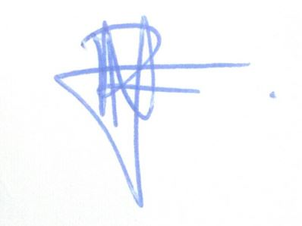  For: DIRECTOR  STANDARDS DEVELOPMENT AND INTERNATIONAL TRADE  Rnn
  Title: | DKS 662-1:2018 Requirements for Electrical Installations  Part 1. Scope, object and fundamental  Principles
  Document Type: | PUBLIC REVIEW DRAFT
  Dates: | Circulation date | Closing date
  Dates: | 5th April 2018 | 5th June 2018

The Kenya Bureau of Standards (KEBS) is a member of the International Organization for Standardization (ISO), Codex Alimentarius Commission (CAC), The African Regional Organization for Standardization (ARSO), Associate Member of the International Electrotechnical Commission (IEC), Associate Member of Bureau International des Poids et Mesures (BIPM) and International Organization of Legal Metrology (OIML)

