KENYA STANDARD KS 830:2019

Specification for precast concrete paving slabs

TECHNICAL COMMITTEE REPRESENTATION

The following organizations were represented on the Technical Committee:

- Architectural Association of Kenya
- Bamburi Cement
- CHRYSO Eastern Africa Limited
- Concrete Products (K)Ltd
- Consumer Information Network
- Howards Humpreys East Africa LTD
- Institute of quantity surveyors of Kenya
- Kenya Industrial Research and Development Institute (KIRDI
- Kenya Institute of Highways and Building Technology (KIHBT)
- Ministry of Transport, Infrastructure, Housing and Urban Development.
- National Environment Management Authority
- National Housing Corporation
- Technical University of Kenya
- University of Nairobi
- Kenya Bureau of Standards — Secretariat

REVISION OF KENYA STANDARDS

In order to keep abreast of progress in industry, Kenya Standards shall be regularly reviewed. Suggestions for improvements to published standards, addressed to the Managing Director, Kenya Bureau of Standards, are welcome.

© Kenya Bureau of Standards, 1994

Copyright. Users are reminded that by virtue of section 6 of the Copyright Act, Cap. 130 of the Laws of Kenya, copyright subsists in all Kenya Standards and except as provided under section 7 of this Act, no Kenya Standard produced by Kenya Bureau of Standards may be reproduced, stored in a retrieval system in any form or transmitted by any means without prior permission in writing from the Managing Director.

Permission may be conditional on an appropriate royalty payment.

Care should be taken to ensure that material used is from the current edition of the standard and that it is updated whenever the standard is amended or revised. The number and date of the standard should therefore be clearly identified.

The use of material in print or in electronic form to be used commercially with or without payment or in commercial contracts
is subject to payment of a royalty.

KENYA STANDARD KS 830: 2019

Specification for precast concrete paving slabs

KENYA BUREAU OF STANDARDS (KEBS)

Head Office: P.O. Box 54974, Nairobi-00200, Tel.: (+254 020) 605490, 602350, Fax: (+254 020) 604031
E-Mail: info@kebs.org, Web:http://www.kebs.org

Coast Region Lake Region North Rift Region
P.O. Box 99376, Mombasa-80100 P.O. Box 2949, Kisumu-40100 P.O. Box 2138, Nakuru-20100
Tel.: (+254 041) 229563, 230939/40 Tel.: (+254 057) 23549, 22396 Tel.: (+254 051) 210553, 210555
Fax: (+254 041) 229448 Fax: (+254 057) 21814

Foreword

This Kenya Standard was revised by the Concrete Technical Committee, under the guidance of the standards Projects Committee, and it is in accordance with the procedures of the Kenya Bureau of Standards.

Precast concrete paving slabs are popular materials for the construction of pedestrian and light-trafficked areas due to their ease of manufacture, attractive appearance, and relative ease of reinstatement. In this standard it is assumed that the design of the concrete mix for the manufacture of the slabs will be in accordance with approved practices in the construction industry, and that for the slabs to comply with the provisions of this standard, the slabs shall have been manufactured of cement, aggregates and water of the quality specified. A guideline is given in Annex E for use of particular type and thickness of precast concrete paving slabs in various locations. It is to be noted that concrete paving slabs are mainly impaired by differential settlement, and thus for satisfactory performance, the foundation and bedding conditions must be adequate.

During the preparation of this standard, reference was made to the following documents:

BS 7263: Part 1: 1990 Specification for precast concrete flags, kerbs, channels, edgings and
quadrants.

DIN 485: 1987 Precast concrete paving flags.

SABS 541: 1971 Specification for precast concrete paving slabs.

Acknowledgement is hereby made for the assistance derived from these sources.

KENYA STANDARD

Specification for precast concrete paving slabs

- Scope

This Kenya Standard specifies the requirements for precast concrete paving slabs manufactured for the construction of pedestrian and light-trafficked areas.

- Definitions

For the purposes of this standard, the following definitions shall apply:

  - nominal size — The size of a paving slab unit used for the purpose of general identification.

  - work size — The size of a paving slab specified for its manufacture, to which its actual size shall conform within specified tolerances.

  - facing concrete — Layer of fine grained concrete which forms the wearing face of the slab to give a fine smooth surface finish.

- Materials

  - Cement — The cement used for the manufacture of precast concrete paving slabs shall be ordinary portland cement or portland pozzolana conforming to KS EAS 18* .

  - Aggregates — The aggregates used for the manufacture of precast concrete paving slabs shall be natural aggregates conforming to KS 02-95‡.

  - Water — Water used for the manufacture of precast concrete paving slabs shall be clean and free from substances that are deleterious to concrete.

- Dimensions and tolerances

  - Dimensions

    - Preferred Sizes — Dimensions of preferred sizes of precast concrete paving slabs shall conform to Table 1 below.
Table 1. Sizes of paving slabs

Paving slab type | Nominal size  (mm) | Work size  (mm) | Thickness  (mm)
A  B  C  D | 600 x 450  600 x 600  600 x 750  600 x 900 | 595 x 445  595 x 595  595 x 745  595 x 895 | 50 and 63  50 and 63  50 and 63  50 and 63
E | 450 x 450 | 445x 445 | 50 and 70
F | 400 x 400 | 395 x 395 | 50 and 65
G  H | 300 x 300  300 x 600 | 295 x 295  295 x 595 | 50 and 60  50 and 63

    - Other shapes and sizes — Other types of paving slabs, having shapes and sizes other than those given in Table 1, shall be such that they conform to the requirements of this standard.

    - Tolerances — The maximum dimensional tolerances for paving slab measured in accordance with Annex A shall be as specified in Table 2.

Table 2. Dimensional tolerances

Dimension | Maximum dimensional deviation
Length  Width  Thickness | ± 2 mm  ± 2 mm  ± 3 mm
Squareness of plan (difference between diagonals) | Paving slabs  Type A,B,C,D, and H 6 mm  Paving slabs  type E,F and G 3 mm
Flatness, straightness  Bowing and  Twisting | Measured over 550 mm to  850 mm ± 2 mm  Measured over  250 mm to 400 mm ± 1 mm

Note: Where specified, a wearing surface edge chamfer with dimensions 5 ± 1 mm vertically and horizontally 5 ± 1 mm measured at right angles, shall be provided (see Figure 1).

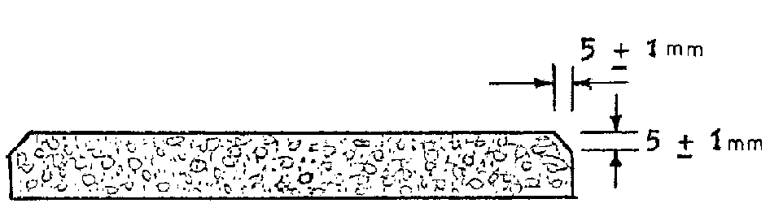
Cross-section

Figure 1 — wearing surface edge chamfer

- Requirements

  - General — Precast concrete paving slabs shall comply with requirements specified in 5.2 to 5.6 at the time of delivery, and at the latest, at an age of 28 days.

  - Finish — where paving slabs are finished with facing concrete, the later shall be not less than 12 mm thick and shall form an integral part of the slab and be monolithic. Fine-grained concrete, which is used only to seal pores, shall not be deemed as facing concrete within the meaning of this standard. The thickness of facing concrete shall be measured as described in Annex A.

  - Flexural strength — When tested as described in Annex B, the mean flexural strength at 28 days shall be not less than 6 N/mm². No individual slab has a flexural strength of less than 5 N/mm².

  - Water Absorption — When tested as described in Annex C, the water absorption shall not exceed 6.5 per cent by mass.

  - Abrasion Resistance — When tested as described in Annex D, the abrasion resistance of paving slabs, or of pieces cut from them, shall not be such as to result in a total loss of mass of more than 900 g in the case of large specimen and 450 g in the case of small specimen. The wear shall be uniform in character, the whole wearing surface at the end of the test being free from any excrescences and depressions.

  - Visual Inspection — All paving slabs shall be sound and free of defects that shall interfere with the proper placing of the slab or impair the strength or permanence of the construction.

- Sampling

For the purpose of testing compliance with the requirements specified, samples for testing shall be selected at random at the site of manufacture, or from a delivered consignment.

- Suitability of paving slabs

The suitability of paving slabs of particular type and thickness for use in various locations, shall be as given in the guideline in Annex E.

- Marking

Concrete paving slabs shall be legibly and indelibly marked with the following information:

- Manufacturer’s name or trade mark;

- The type and thickness, in millimeters of paving slab; and

- The date of manufacture.

Annex A

Measurement of dimensions

A1. Test specimens

12 samples for each type and thickness of concrete paving slabs shall be selected in the manner described in Clause 6 for dimensional checks and other tests.

A2. Apparatus

A2.1 Vernier Caliper

A2.2 Notched straightedge and gauge block

A3. Procedure

A3.1 General — Remove any fins or protrusions on the slab.

A3.2 Thickness

A3.2.1 The thickness shall be measured, 30 mm from the edge of the slab at a distance not more than 100 mm from each corner, and at the centre of the side faces (see Figure 2 (a)).

A3.2.2 From the measurements obtained, the following shall be stated to the nearest 1 mm:

(i) The greatest difference between the measured values of each slab; and

- The average thickness of each slab.

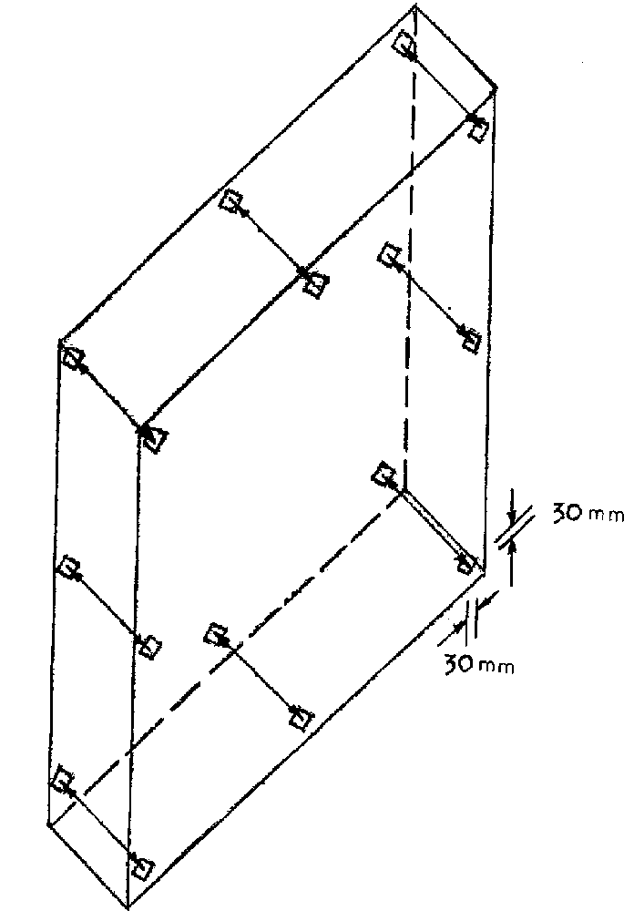

Figure 2(a) — eight positions for checking thickness of a whole slab

A3.3 Length and Width

A3.3.1 The length and width shall be measured with the jaws at right angles to the wearing face, at the slab edges and at the centre (see Figure 2(b)).

A3.3.2 For all dimensions obtained, the following shall be stated to the nearest 1 mm.

- The maximum deviation from the work size; and

- The average length and width of each slab.

Note: In the case of square slabs, this shall be done separately for each direction.

A3.4 Thickness of Facing Concrete — The thickness of the facing concrete layer shall be measured at the fractured section after the flexural strength test. The thickness of the facing concrete measured at the thinnest point shall be stated to the nearest 1 mm (see Figure 2 (c)).

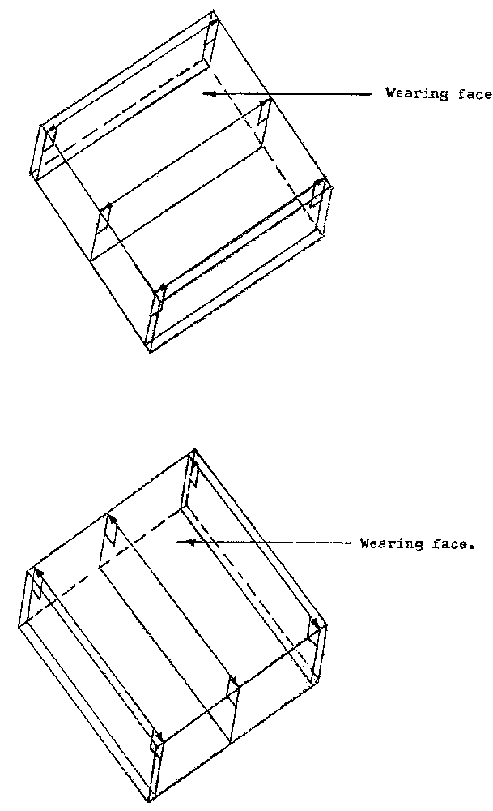
(ii) Three positions for checking width of a whole slab.
(i) Three positions for checking length of a whole slab.

Figure 2(b) — length and width measurements of slab

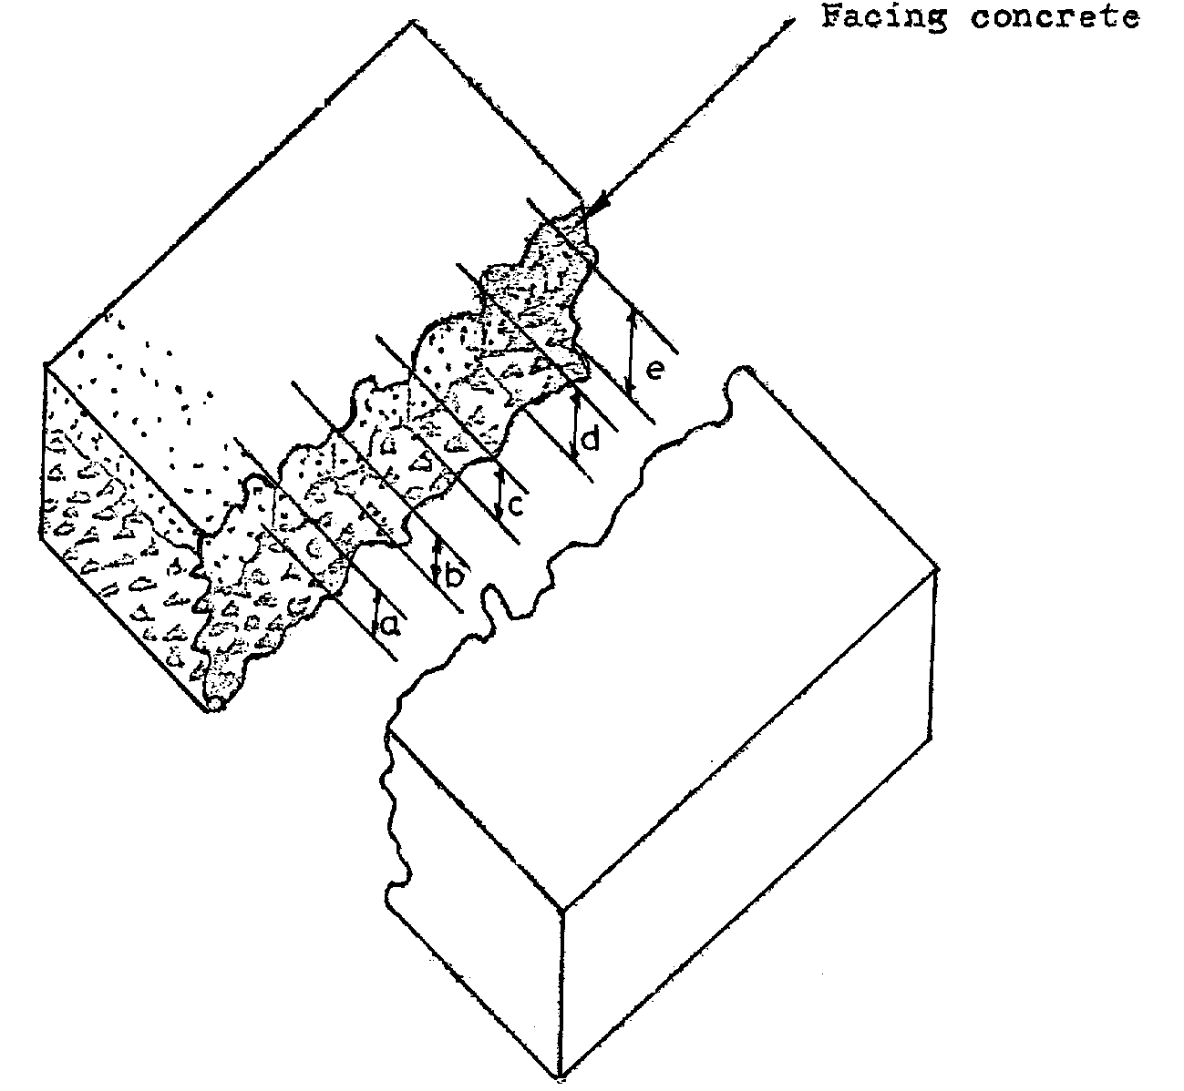
A3.5 Squareness on plan — Measure the two diagonal of each paving slab to the nearest 1 mm (see Figure 2 (d). The difference between the measured individual values of each slab shall be stated as the out of squareness.

Figure 2(c) — Measuring thickness of facing concrete after the slab has undergone flexure test

A3.6 Flatness, straightness, bowing and twisting

A3.6.1 Use the appropriate notched straightedge and gauge block made of steel as shown in Figure 2 (e).

A3.6.2 With the slab placed on a flat surface, place the notched straightedge in any position on the wearing face of each slab.

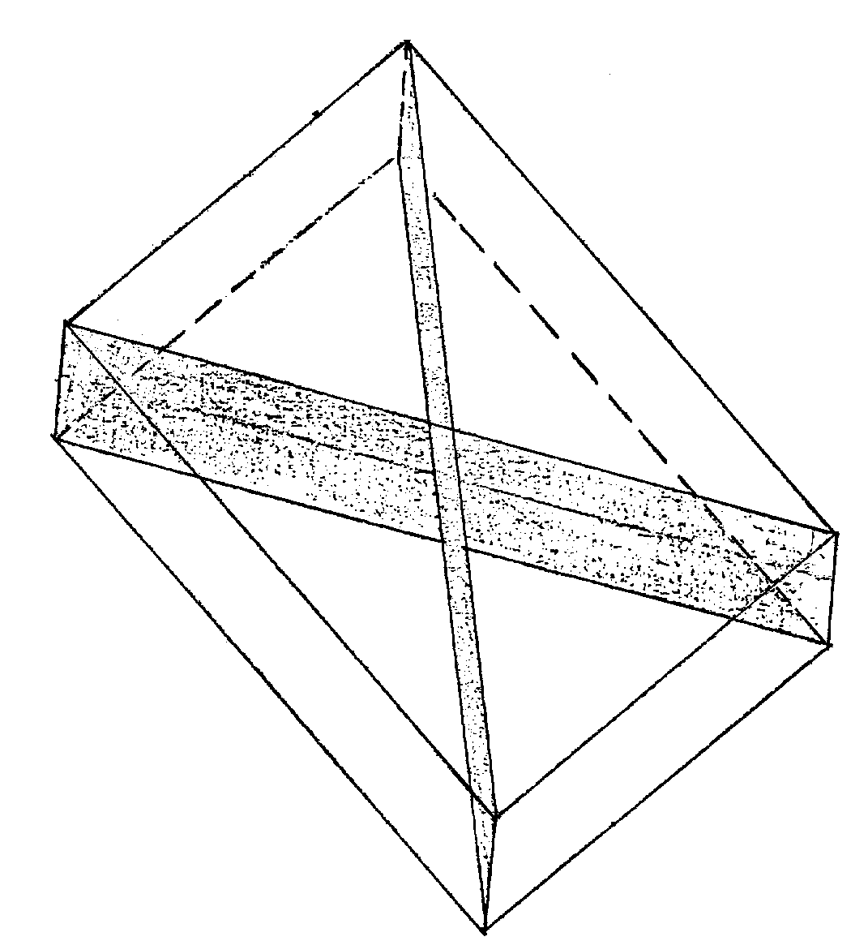

Figure 2(d) — Measuring the outer squareness of a whole slab

A3.6.3 Check that the surface of the slab does not touch the notched section of the straightedge when both the support ends of the notched straightedge are in contact with the slab.

A3.6.4 Using the gauge block, check that the gauge black does not pass between the notched straightedge and the surface of the slab when placed in any position on the wearing face of each sample slab.

A3.6.5 Report whether the sample passed or failed the test, any failure shall include the reason or classification as failure.

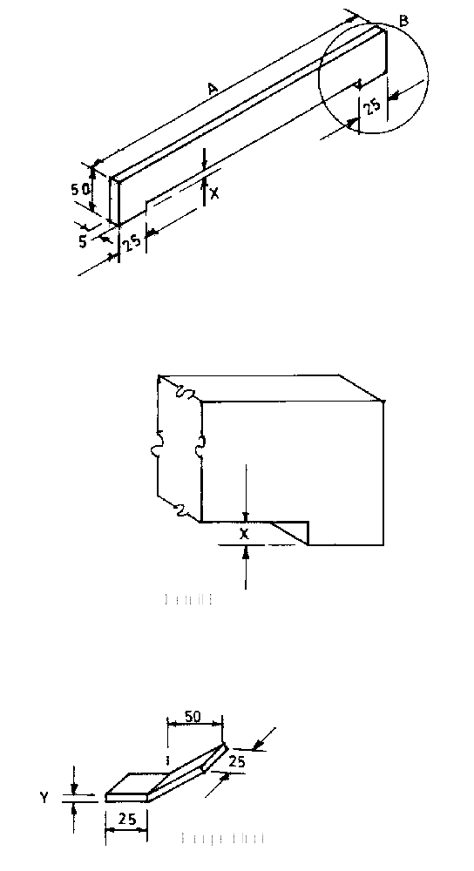

Dimension A | Dimension X | Dimension Y
550 to 850  250 to 400 | 2  1 | 4  2

Figure 2(e) — notched straight edge and gauge block

Annex B

Determination of flexural strength

B1. Test specimens

Five concrete paving slabs for each type and thickness shall be taken from sample after carrying out dimensional checks.

B2. Testing machine

The test shall be carried out using flexural strength testing machine of sufficient capacity capable of applying the loads continually and vertically. It shall be provided with two steel supporting rollers each 38 ± 3 mm in diameter or two steel bearers, each 6 mm minimum width on the supporting surface (see Figure 3). The spacing of the rollers or bearers shall be as given in Table 4.

Table 4. Spacing of rollers or bearers for flexural strength test

slab type | minimum spacing centre to centre of rollers or minimum clear distance between bearers in mm
A, B, C, D and H  E  F  G | 450 mm  375 mm  350 mm  250 mm

In either case, one support shall be horizontal and the other so mounted to enable loads to be applied without inducing any torsional restraint in the specimen, e.g. by pivoting about an axis parallel to the length of the specimen. The upper member of the loading frame shall be provided with a spherical seating to ensure that the load is applied axially without inducing any torsion in the specimen, and a steel platen at least 50 mm wide and of length not less than the width of the widest specimen to be tested.

B3. Procedure

Place the specimen symmetrically on the bearers of the testing machine and with its shorter sides parallel to the supporting rollers or bearers. Position a hardwood fillet 50 mm wide on the upper surface of the specimen at the midpoint of the span extending the whole width of the specimen parallel to the supporting rollers or bearer (see Figure 3). Apply the load without shock and increase it at a rate not exceeding 1 kN/min for each 100 mm of width as tested, until the specimen fails. Record individual failing loads.

B4. Calculation and expression of results

The flexural strength F_{cf} of (in N/mm²) is given by the equation:

F _{cf} = 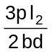

p = the individual failing load (in N);
I = the distance between the supporting rollers or bearers (in mm);
B = the average width of specimen at the point of fracture (in mm);
d = the average thickness of specimen at the point of fracture (in mm).

Express the flexural strength to the nearest 0.1 N/mm².

B5. Report

The following shall be reported:

(i) The individual flexural strength of each slab to the nearest 0.1 N/mm ²; and

(ii) The average flexural strength of the five specimens to the nearest 0.1 N/mm².

All Dimensions in mm

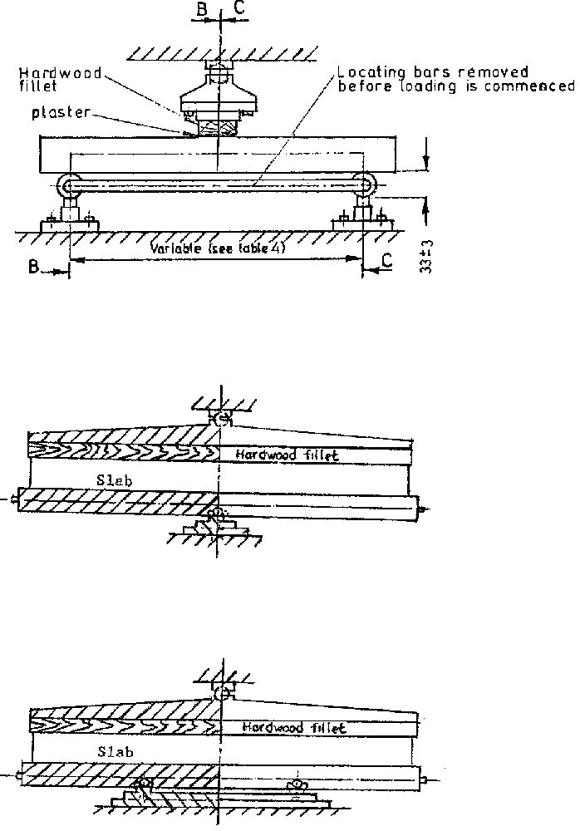
Side elevation
End elevation (BB)
End elevation (CC)

Figure 3 — Arrangement of loading for flexural strength test

Annex C

Determination of water absorption

C1. Test specimens

Three concrete paving slabs for each type and thickness shall be taken from the sample after carrying out dimensional checks.

C2. Apparatus

C2.1 Balance — The balance used shall be accurate to within 0.5 per cent of the weight of the smallest specimen tested.

C2.2 Suitable Concrete Sawing Machine

C2.3 Ventilated Oven — The temperature of which can be maintained at 105 ± 5 ºC.

C2.4 Tank — Deep enough to immerse specimens, containing clean water maintained at a temperature of 20 ± 5 ºC.

C2.5 Dry airtight vessel, e.g. desiccator of sufficient size to contain the specimen to be tested.

C3. Preparation of specimens

Saw two square test pieces from diagonally opposite corners of each of the three concrete paving slabs, approximately 100 mm x 100 mm. Saw from the full thickness of the slab such that each specimen has two sawn and two moulded edges (see Figure 4).

C4. Procedure

C4.1 Place the six specimens in the ventilated drying oven so that each one is not less than 25 mm from any heating surface and from each other. Dry the six specimens in the oven for not less than 24 h and until two successive weighings at intervals of 2 h show an increment of loss not greater than 0.2 per cent of the last previously determined weight of the specimen.

C4.2 On removal from the oven, cool each specimen for 24 ± 0.5 h in the dry airtight vessel. Weigh each specimen and record the mass M₁. Immediately, completely immerse the specimen in water at
20 ± 5 ºC with its longitudinal axis horizontal.

C4.3 Leave the specimen immersed in the water for 24 ± 0.5 h. Remove each specimen, shake it to remove the bulk of the water and dry it with a cloth as rapidly as possible until all free water is removed from the surface. Weigh each specimen and record the mass M₂.

C5. Calculation and expression of results

Water absorption of each specimen shall be calculated from the following expression:

Water absorption, per cent = 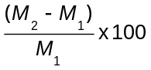

where,
M₁ = the mass of specimen oven dry (g); and
M₂ = the mass of specimen after 24 ± 0.5 h in water (g).

Express the results as the mean water absorption of the two specimens for each of the three slabs to the nearest 0.1 per cent.

C6. Report

Report the average value of the three means as the water absorption of the concrete paving slabs.

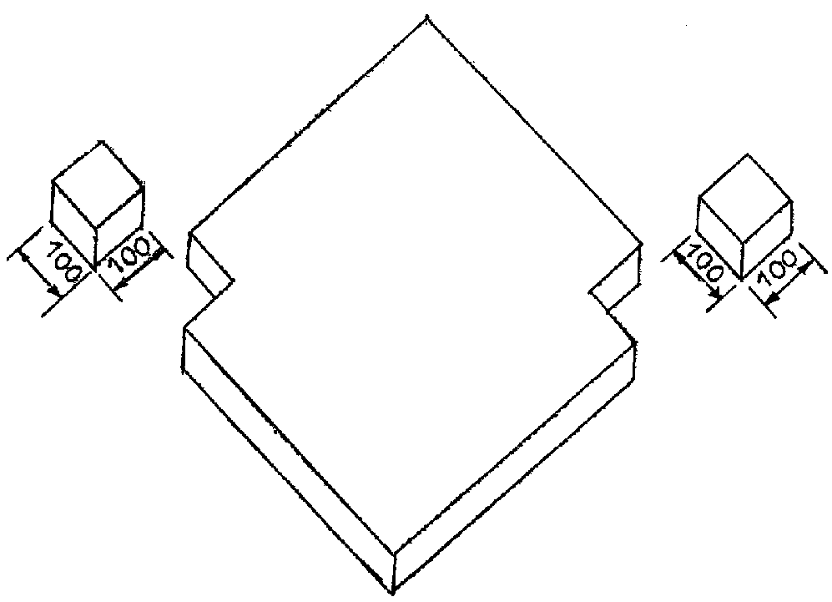
All dimensions are in mm

Figure 4 — preparation of specimens for water absorption test

Annex D

Determination of abrasion resistance

D1. Test specimens

Four concrete paving slabs for each type and thickness shall be taken from the sample after carrying out dimensional checks.

D2. Apparatus

D2.1 Balance — The balance used shall be accurate within 0.5 per cent of the weight of the smallest specimen tested.

D2.2 Suitable concrete sawing machine

D2.3 An apparatus that comprises a rectangular container having solid ends that are secured centrally to a steel shaft of nominal diameter 38 mm (see Figure 5). For large specimens the ends shall be 560 mm apart and each of the four sides shall have an opening of size 560 mm x 255 mm. For small specimens the ends shall be 255 mm apart and the size of the openings shall be 255 mm x 255 mm. The shaft projects from the ends of the container, is supported on bearings so arranged as to maintain the shaft horizontal and allow it to revolve freely, and is driven at a speed of 1 revolution per second by an electric motor. The container is equipped with means for securing a test specimen against the outer surface of each opening in a side, and the surface of each slab is subjected to wear by steel balls inside the container. The balls used shall be made of hard steel and shall have a diameter not

greater than 12.5 mm or less than 11.0 mm. In the case of large specimens, 1 000 balls shall be used, and in the case of small specimens, 500 balls. A suitable counter shall be fitted to the apparatus for accurately recording number of revolutions of the containers.
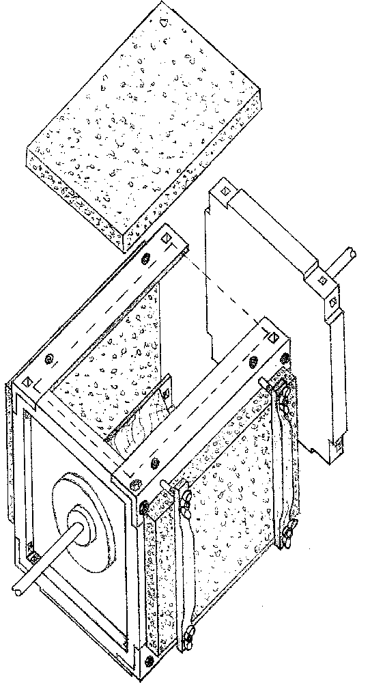
Figure 5 — Abrasion resistance testing apparatus
(a) Cross-section
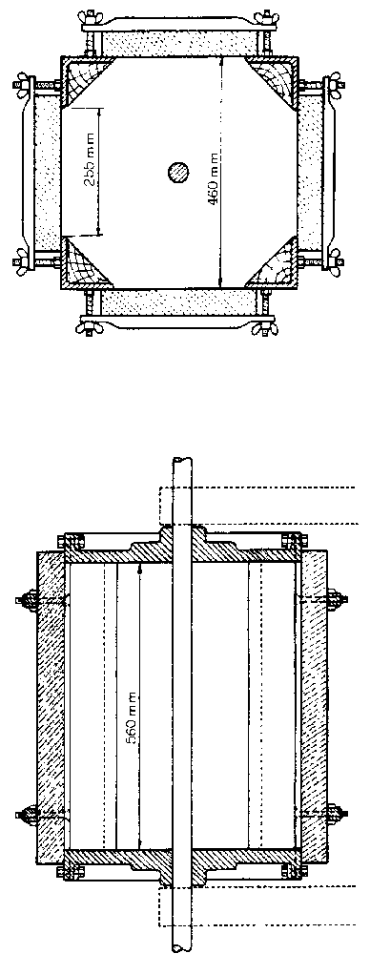
(b) Longitudinal section
(a) Cross-Section

D3. Preparation of specimens

The following approximate sizes of test specimens shall be out if necessary from the slabs in the test sample, saw from the full thickness of the slab.

- Large specimens of size approximately 600 mm x 300 mm; or

- Small specimens of size approximately 300 mm x 300 mm.

D4. Conditioning of test specimens

The test specimens shall be conditioned by being dried at a temperature not higher than 40 ºC until the difference between any successive weighings does not exceed 0.1 per cent.

D5. Procedure

D5.1 After conditioning, weigh each specimen and record the mass M_{1.}

D5.2 Secure the specimens in the apparatus so that they cover the openings in the sides of the container, with the wearing surfaces facing inwards. Before securing the fourth specimen, place the balls in the containers.

D5.3 Revolve the container for 24 h at a uniform speed of 1 revolution per second in one direction. At the end of this period, remove all dust from the machine, then run for a further 24 h at the same speed in the reverse direction.

D5.4 Remove all dust from each specimen and weigh, record the mass M₂.

D6. Calculation and expression of results

Abrasion resistance of each specimen shall be calculated from the following expression:

Abrasion resistance = M₁ – M₂

where,
M₁ = the mass of specimen before undergoing abrasion resistance test (g) and;

M₂ = the mass of specimen after undergoing abrasion resistance test (g).

Express the results of abrasion resistance in grams to nearest 1 g.

D7. Report

Report the individual loss of mass of each specimen as the abrasion resistance, and examine the wearing surface for compliance with the other requirements of 5.6.

Annex E

Suitability of precast concrete paving slabs for various locations

Precast concrete paving slabs of particular types and thickness shall be used in various locations as given in Table 5.

Table 5. Suitability of paving slabs

Location and use | Paving slabs type and thickness
Location and use | A 50  B 50  C 50  C 63  D 50  D 63  E 50  F 50  G 50  H 50 | A 63  B 63  H 63 | E 70  F 65  G 60
No vehicle use of any kind, e.g. pedestrian precincts and footways protected by street furniture | * | * | *
Very occasional use by cars and light mechanical sweepers e.g. unprotected footways in parking areas or other foot ways where over-run is not a problem | * | * | *
Vehicle crossing of footways to house driveways |  | * | *
Footways subject to frequent car and occasional commercial vehicle over-run; unprotected pedestrian precincts with about 25 commercial vehicles/day each way, giving service access, or for fire access |  |  | *

* Indicates that this paving slab type and thickness is suitable for the location.

Note: Paving slabs will only perform satisfactorily if the foundation and bedding conditions are adequate.

* Cement — Part 1: Composition, specification and conformity criteria for common cements
‡ Specification for natural aggregates for concrete.

