DRAFT EAST AFRICAN STANDARD

Silk (sheen) emulsion paint for interior use — Specification
EAST AFRICAN COMMUNITY
Copyright notice
This EAC document is copyright-protected by EAC. While the reproduction of this document by participants in the EAC standards development process is permitted without prior permission from EAC, neither this document nor any extract from it may be reproduced, stored or transmitted in any form for any other purpose without prior written permission from EAC.
Requests for permission to reproduce this document for the purpose of selling it should be addressed as shown below or to EAC’s member body in the country of the requester:
© East African Community 2019 — All rights reserved
East African Community
P.O.Box 1096
Arusha
Tanzania
Tel: 255 27 2504253/8
Fax: 255 27 2504481/2504255
E-mail: eac@eachq.org
Web: www.eac-quality.net
Reproduction for sales purposes may be subject to royalty payments or a licensing agreement. Violators may be persecuted
Contents Page
Foreword v
1 Scope 1
2 Normative references 1
3 Terms and definitions 1
4 Requirements 1
4.1 General requirements 1
4.1.1 Composition 1
4.1.2 Condition in the container 2
4.1.2 Application properties 2
4.2 Specific requirements 2
4.2.1 Thinning 2
4.2.3 Resistance to accelerated weathering 2
4.2.4 Fungal resistance 2
4.2.5 Gloss 2
4.2.6 Colour 2
4.2.7 Temperature stability at 20 °C 2
5 Weights and measures 3
6 Packaging, labelling and marking 3
6.1 Packaging 3
6.2 Labelling and marking 3
7 Sampling 4
8 Quality of reagents 4
Annex A (normative) Determination of recoating properties 5
A.1 Apparatus 5
A.2 Procedure 5
Annex B (normative) Determination of fungal resistance 6
B.1 Principle 6
B.2 Apparatus 6
B.3 Procedure 6
Annex C (normative) Determination of colour 8
C.1 Principle 8
C.2 Procedure 8
Annex D (normative) Determination of temperature stability 9
D.1 Principle 9
D.2 Procedure 9
Annex E (normative) Determination of the quantity of material 10
E.1 Apparatus 10
E.2 Procedure 10
E.3 Calculation 10
Annex F (normative) Determination of pH 11
F.1 Apparatus and materials 11
F.2 Principle 11
F.3 Procedure 11
Annex G (normative) Determination of resistance to wet abrasion 12
G.1 Principle 12
G.2 Apparatus 12
G.3 Reagents 12
G.4 Procedure 12
Bibliography 14

Foreword
Development of the East African Standards has been necessitated by the need for harmonizing requirements governing quality of products and services in the East African Community. It is envisaged that through harmonized standardization, trade barriers that are encountered when goods and services are exchanged within the Community will be removed.
In order to achieve this objective, the Community established an East African Standards Committee mandated to develop and issue East African Standards.
The Committee is composed of representatives of the National Standards Bodies in Partner States, together with the representatives from the private sectors and consumer organizations. Draft East African Standards are circulated to stakeholders through the National Standards Bodies in the Partner States. The comments received are discussed and incorporated before finalization of standards, in accordance with the procedures of the Community.
East African Standards are subject to review, to keep pace with technological advances. Users of the East African Standards are therefore expected to ensure that they always have the latest versions of the standards they are implementing.
EAS 849 was prepared by Technical Committee EASC/TC 070, Paints, varnishes and related products.
This second edition cancels and replaces the first edition (EAS 849:2016) and amendment 1:2019, which has been technically revised on the requirement of titanium dioxide content if used as a single opacifier.

Silk (sheen) emulsion paint for interior use — Specification

1 Scope
This Draft East African Standard specifies requirements, sampling and test methods for silk (sheen) emulsion paint for interior use.

2 Normative references
The following referenced documents are indispensable for the application of this document. For dated references, only the edition cited applies. For undated references, the latest edition of the referenced document (including any amendments) applies.
EAS 31, Laundry soaps — Specification
ISO 591-1, Titanium dioxide pigments for paints — Part 1: Specifications and methods of test
ISO 2811, (all parts), Paints and varnishes — Determination of density
ISO 2813, Paints and varnishes — Determination of gloss value at 20 degrees, 60 degrees and 85 degrees
ISO 3251, Paints varnishes and plastics — Determination of non-volatile content
ISO 6503, Paints and varnishes — Determination of total lead — Flame atomic absorption spectrometric method”.ISO 4618, Paints and varnishes — Terms and definitions
ISO 6504-3, Paints and varnishes — Determination of hiding power — Part 3: Determination of contrast ratio of light coloured paints at a fixed spreading rate
ISO 9117-3, Paints and varnishes — Drying test — Part 3: Surface drying test using Ballotini
ISO 15528, Paints, varnishes and raw materials for paints and varnishes — Sampling

3 Terms and definitions
For the purposes of this document, the terms and definitions given in ISO 4618 apply.

4 Requirements

4.1 General requirements

4.1.1 Composition
4.1.1.1 The paint shall be a medium consisting of any stable synthetic polymer emulsion in water containing pigments and suitable ingredients as may be necessary to produce a paint so as to satisfy the requirements of this standard.
4.1.1.2 It shall contain a suitable level of an effective non-mercurial or non-phenolic fungicide approved by an authorised organisation of the country. The level used should not render the finish or its film hazardous to health.

4.1.2 Condition in the container
4.1.2.1 The paint shall:
- have no irritating or offensive odour;
- be free from lumps, skins; and
- be free from corrosion, mould and petrification.
4.1.2.2 The condition of the paint shall be such that settling, if any, shall be easily incorporated by stirring.

4.1.2 Application properties

The paint shall be suitable for application by brush, spray, roller or a suitable applicator. The resulting film shall not show pigment flocculation, coarseness or other undesirable characteristics.

4.2 Specific requirements

4.2.1 Thinning
Paints ready for use, if thinned, not more than 15 % (v/v) of water shall be used. The paint shall mix readily with a minimum amount of foaming to a smooth homogeneous state. The foaming, if any, shall dissipate rapidly.

4.2.2 Recoating properties
When tested in accordance with Annex A, all grades of the paint shall not show any lifting or softening of the underlying coat. It shall not exhibit colour separation, sagging, pitting, flaking or cracking.

4.2.3 Resistance to accelerated weathering
When tested in accordance with ISO 21207, the paint film shall not exhibit any flaking, cracking, chalking or colour fading.

4.2.4 Fungal resistance
When tested in accordance with Annex B, paint panels shall be free from surface fungal growth.

4.2.5 Gloss
When tested in accordance with ISO 2813, the gloss level shall not be more than 45 % when dried for 2 h and not less than 20 % after further drying for 16 h at 60º gloss meter angle.

4.2.6 Colour
When tested in accordance with Annex C, the colour of the paint shall be as agreed between the purchaser and the supplier

4.2.7 Temperature stability at 20 °C
When tested in accordance with Annex D, the paint shall be free from lumps, skins and settling.

4.2.8 Additional specific requirements
The paint shall comply with the quality requirements specified in Table 1 when tested in accordance with the methods therein.
Table 1 — Specific requirements for silk (sheen) emulsion paint”.
S/ No. | Characteristic | Requirement | Test method
 | Quantity of paint, % of declared volume at 25 ºC ± 2 ºC, min. | ± 2 | Annex E
 | Specific gravity at 25 ºC ± 2 ºC | 1.2 – 1.3 | ISO 2811
 | Opacity, % , min | 90 | ISO 6504-3
 | Fineness of grind, µm, max. | 20 | ISO 1524
 | Solids content, % (m/m), min. | 50 | ISO 11890-1
 | Drying time:  - Surface drying time, at 25 ºC ± 2 ºC, hours, max.  - Hard drying time, at 25 ºC ± 2 ºC, hours, max. | 2  4 | ISO 9117-3
 | pH | 8 – 9 | Annex F
 | Resistance to wet abrasion, cycles, min. | 5 000 | Annex G
 | Titanium dioxide content, % (m/m) (if used for white pigments),used as single opacifier, min. | 15 | ISO 591-1
 | Lead content, ppm, max. | 90 | ISO 6503

5 Weights and measures
The fill and volume of the paint, shall comply with Weights and Measures regulations of the respective Partner States.

6 Packaging, labelling and marking

6.1 Packaging
The paint shall be packaged in a suitable container that prevents it from deterioration during storage, transportation and normal handling.

6.2 Labelling and marking
6.2.1 The labelling shall be either in English, Kiswahili or French or in combination as agreed between the manufacturer and the supplier. Any other language shall be optional.
6.2.2 The paints shall be packaged in containers that are legibly and indelibly marked with the following information:
- the name of the product shall appear as ”Silk emulsion paint”;
- manufacturer’s name and/or registered trade mark;
- indication of colour/colour code;
- date of manufacture;
- net content;
- batch/code number;
- country of origin;
- expiry date or best before date; and
- instructions for use and safety.

7 Sampling
Sampling shall be done in accordance with ISO 15528.

8 Quality of reagents
Analytical grade reagents and distilled water or deionized water shall be used for the appropriate tests.

Annex A
(normative)
Determination of recoating properties
A.1 Apparatus
A.1.1 Aluminium metal, flat sheets of size 300 mm x 100 mm x 4 mm
A.1.2 Soft hair brush, a clean soft hair brush with a width of about 1 cm and a hair length of about 2 cm
A.1.3 Glass stirrer long enough to stir the paint without dipping the hands into the paint
A.2 Procedure
Suitably thin the paint where necessary and apply one coat of the paint onto a dry panel and leave to dry for 2 h at ambient temperature. By a step-coating method, apply a second coat and examine for recoating properties after drying for 30 min. Figure A.1 shows how step coating is applied.

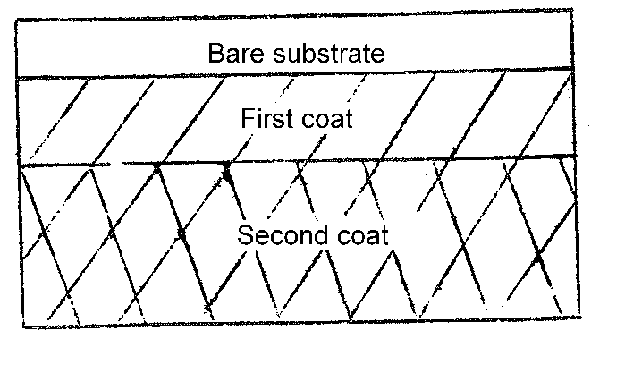
Figure A.1 — Suitable method of step coating
Annex B
(normative)
Determination of fungal resistance
B.1 Principle
Aluminium metal panel is evenly coated with two coats of the paint by brushing and then air-dried for a specified period. The panel is exposed on an exposure rack for a specified period and the intensity of fungal growth is observed.
B.2 Apparatus
B.2.1 Exposure rack shall usually support the panels at an angle of 45º to the horizontal.
B.2.2 The rack shall be so situated that the specimens are not protected or overshadowed by neighbouring objects.
B.2.3 The construction of the racks shall be such that the backs of the specimens are freely exposed to the atmosphere and such that water drainage does not occur from one panel to the other.
B.2.4 Specimens shall not be in electrical contact with metals, nor as far as possible in direct contact with wood or other porous material. A suitable method of mounting panels is shown in Figure B.1. If panels are supported in grooves, the suitable drainage holes shall be provided to prevent accumulation of water.

B.3 Procedure
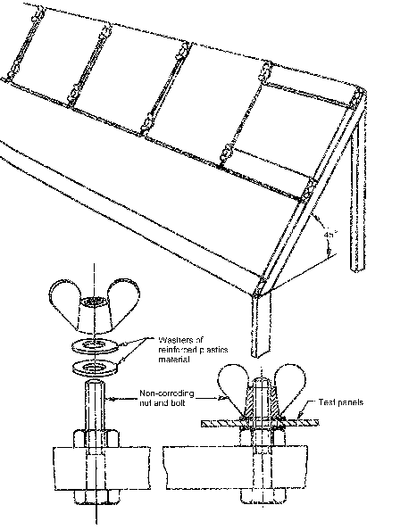
Apply two coats of the paint by brushing on a 300-mm x 150-mm x 4-mm clean, dry, aluminium panel with ½ h drying between coats. The edges and back of the panels shall be coated with protective paint. Expose the panels on the exposure rack and examine the fungal growth on the panels monthly, for six months.
Figure B.1 — Suitable method of mounting panels
Annex C
(normative)
Determination of colour
C.1 Principle
The colour of the paint applied on a white unglazed art paper is compared visually in diffused daylight with that of the standard.
C.2 Procedure
C.2.1 Apply the paint using a film applicator to give a wet film thickness of 50 μm on a 150-mm x 150-mm white unglazed art paper. Air-dry the film for 4 h in a well ventilated room in a horizontal position. When the film is dry, apply a second coat of the paint to give again a combined wet film thickness of 50 mm and air dry. After 16 h, compare the colour of the film with that of the standard colour visually in diffused daylight.
C.2.2 The paint shall be deemed to have passed the test if the colour of the paint matches with the standard colour.
Annex D
(normative)
Determination of temperature stability
D.1 Principle
The paint is subjected to extremes of temperature and then tested for thinning and application properties.
D.2 Procedure
D.2.1 Fill two clean 500-mL metal containers with paint leaving the usual ullage and seal tightly. Keep one of the containers at 20 ºC ± 1 ºC and the other at 60 ºC ± 2 ºC for 48 h. Keep these two containers at room temperature for 24 h thereafter. Subsequently, examine the paint in the two containers.
D.2.2 The paint shall be deemed to have passed this test if it is free from lumps, skins and settling.
Annex E
(normative)
Determination of the quantity of material
E.1 Apparatus
E.1.1 Graduated measuring cylinder
E.1.2 Empty container
E.2 Procedure
Measure out the volume of the paint by pouring it into the measuring cylinder and emptying the paint into an empty container. Measure out until all the paint is finished and record the total volume of the paint by adding up the volume.
E.3 Calculation
The measured volume shall be expressed as follows:
% of volume measured is 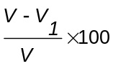
Where,
V₁ is the total measured volume; and
V is the declared volume.

Annex F
(normative)
Determination of pH

F.1 Apparatus and materials
F.1.1 Beaker, 150-ml
F.1.2 pH meter with glass calomel electrodes
F.1.3 Analytical balance
F.1.4 Glass rod
F.1.5 Distilled water
F.2 Principle
The paint is mixed with freshly boiled water to remove the carbon dioxide and the hydrogen ion concentration is measured using a pH meter.
F.3 Procedure
Weigh 5.00 g ± 0.01 g of the paint. Place it in a 150-mL beaker and add 50 g, freshly boiled, distilled water. Mix well by means of a glass rod and cool to 23 ºC ± 2 ºC. Measure the pH with a pH meter using glass calomel electrode by carefully following the instructions of the meter.

Annex G
(normative)
Determination of resistance to wet abrasion
G.1 Principle
The painted panels are subjected to wet rubbing in the abrasion test apparatus at a specified speed and load of the brush. The panels are examined at the end of the stipulated oscillations for film defects.
G.2 Apparatus
Wet abrasion tester, as shown in Figure G.1 and having the following accessories:
- Washing unit, of such a construction as to hold the brush in a box or holder, which moves backwards and forwards in a straight line across the test panels at the rate of 38 ± 2 strokes per minute. The trays shall be watertight to hold the panels;
- Brush a pad made out of polyurethane foam of density 25 kg/m³ and of size 85 mm x 36 mm x 12 mm. The total mass of the brush and the holder shall be 500 g; and
- Fractional horse power motor, of suitable speed to regulate the oscillations of the brush.
G.3 Reagents
Soap solution, dissolve 0.5 g of laundry soap complying with EAS 31 weighed to the nearest 0.001 g (previously dried at 105 ºC ± 2 ºC for 30 min) in distilled water to give 0.5 % (m/v) solution.
G.4 Procedure
G.4.1 To prepare the panel, clean a glass panel, 415 mm x 120 mm. Apply a coat of the undercoating enamel to give a wet film thickness of 35 µm - 38 µm and store at 120 ºC for 30 min. Rub down with an emery paper and wipe until the gloss is removed completely.
Apply a coat of the paint by use of a brush or film applicator to give a wet film thickness of 150 µm. Allow this to air dry for 16 h.
G.4.2 Dip the brush in distilled water at 25 ºC for 30 min. to a depth of 12 mm. Shake off excess water and soak in the soap solution for 5 min. Fix the painted test panel in the tray in position with painted surface upwards. Mix the brush in its holder, having a total load of 0.5 kg and adjust the stroke in such a way that not less than 10 mm of the film is left free on both ends. Start the oscillations of the brush.
Keep the panel wet by adding soap solution at the rate of 10 to 12 drops per minute in the path of the brush. Wash with water, allow to dry, and examine the film for any defects and note the number of oscillations when these defects start showing.
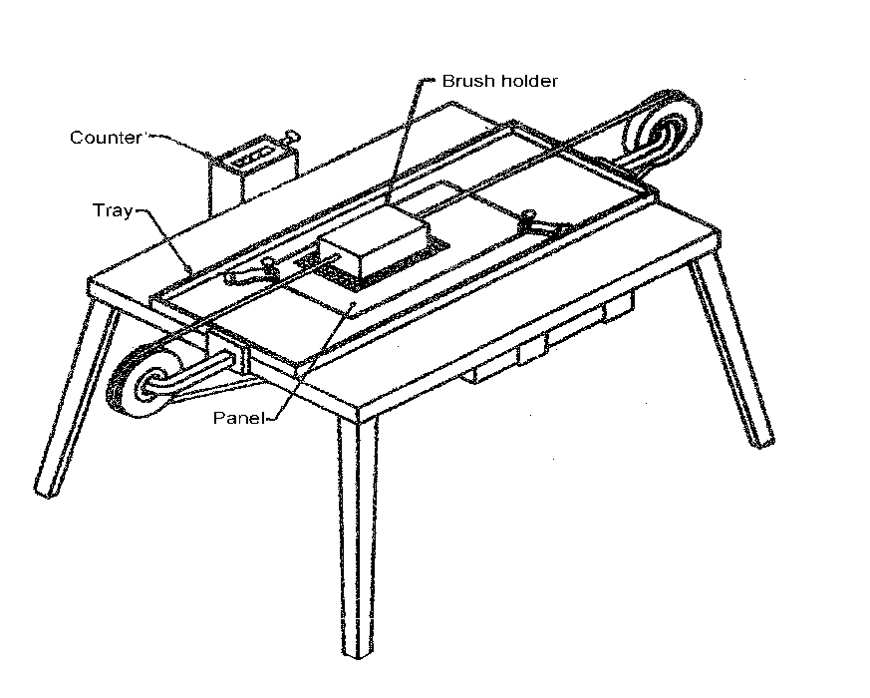
Figure G.1 — Wet abrasion tester
Bibliography
KS 811:2013, Silk (sheen) emulsion paints for interior and exterior use — Specification
€

