DRAFT EAST AFRICAN STANDARD
Drop on materials for road marking paints -— Specification

EAST AFRICAN COMMUNITY
Copyright notice
This EAC document is copyright-protected by EAC. While the reproduction of this document by participants in the EAC standards development process is permitted without prior permission from EAC, neither this document nor any extract from it may be reproduced, stored or transmitted in any form for any other purpose without prior written permission from EAC.
Requests for permission to reproduce this document for the purpose of selling it should be addressed as shown below or to EAC’s member body in the country of the requester:
© East African Community 2019 — All rights reserved
East African Community
P.O. Box 1096,
Arusha
Tanzania
Tel: + 255 27 2162100
Fax: + 255 27 2162190
E-mail: eac@eachq.org
Web: www.eac-quality.net
Reproduction for sales purposes may be subject to royalty payments or a licensing agreement. Violators may be prosecuted.
Contents Page
Foreword v
1 Scope 1
2 Normative references 1
4 Requirements 2
4.1 Glass beads 2
4.1.1. General requirements 2
4.1.1.1 Surface treatments of glass beads 2
4.1.3 Specific requirements 2
4.1.5 Durability aspects - Resistance to chemicals: water, hydrochloric acid, calcium chloride andsodium sulphide 4
4.2 Transparent antiskid aggregates 5
4.2.1 Specific requirements 5
4.2.2 Granulometry 5
4..2.3 Dangerous substances 6
4.2.4 Durability aspects — Resistance to fragmentation (friability) 6
4.3 Non transparent antiskid aggregate 7
4.3.1 pH value 7
4.3.2 Visibility characteristics 7
4.3.3 Granulometry 7
4.4 Mixtures of glass beads and antiskid aggregates 9
4.4.1 General 9
5 Packaging 9
6 Labelling 9
8 Sampling 9
Annex A (normative) Test method to determine the presence of the moisture proof coating 11
A.1 Procedure A 11
A.1.1 General 11
A.1.2 Results 12
Annex B (normative) Test method to determine the presence of floatation coating 13
B.1 General 13
B.2 Principle 13
B.3 Apparatus and reagents 13
B.4 Procedure 13
B.5 Results 13
Annex C (normative) Test method to determine the refractive index of the glass beads 15
C.1 General 15
C.2 Principle 15
C.3 Apparatus 16
C.4 Test conditions 16
C.5 Procedure 16
Annex D (normative) Test method to determine maximum weighted percentage of defective glass beads 17
D.1 General 17
D.2 Results of counting 18
Annex E (normative) Glass beads defects 19
E.1 Oval glass beads (see Figure E.1) 19
E.2 Satellites (see Figure E.2) 19
E.3 Tear shaped glass beads (see Figure E.3) 19
E.4 Glass beads fused together (see Figure E.4) 20
E.5 Roundish glass beads (see Figure C.5) 20
E.6 Opaque glass beads (see Figure E.6) 20
E.7 Milky glass beads (see Figure E.7) 21
E.8 Gas inclusions (see Figure E 8) 21
E.9 Grains (see Figure E.9) 21
E.10 Foreign particles 22
Annex F (normative) Test method to determine the friability index of the antiskid aggregates 23
F.1 General 23
F.1.1 Principle 23
F.1.2 Friability Index 23
F.2 Apparatus 23
F.2.1 Standard apparatus 23
F.2.2 Special apparatus 23
F.3 Material to be tested 24
F.3.1 Obtaining the sample 24
F.3.2 Preparing the sample 24
F.4 Procedure 24
F.5 Expression of results 24
Annex G (normative) Test method to determine the presence of dangerous substances 25
G.1 Reference method 25
Annex H (normative) Test methods to determine the resistance of the glass beads to the effects of water, hydrochloric acid, calcium chloride and sodium sulphide 27
H.1 Resistance to the effects of water 27
H.2 Resistance to the effects of hydrochloric acid 27
H.3 Resistance to the effects of calcium chloride 27
H.4 Resistance to the effects of sodium sulphide 27
H.4.1 Apparatus and reagents 27
H.4.2 Procedure 28
H.4.3 Results 28
Bibliography 29

Foreword
Development of the East African Standards has been necessitated by the need for harmonizing requirements governing quality of products and services in the East African Community. It is envisaged that through harmonized standardization, trade barriers that are encountered when goods and services are exchanged within the Community will be removed.
The Community has established an East African Standards Committee (EASC) mandated to develop and issue East African Standards (EAS). The Committee is composed of representatives of the National Standards Bodies in Partner States, together with the representatives from the public and private sector organizations in the community.
East African Standards are developed through Technical Committees that are representative of key stakeholders including government, academia, consumer groups, private sector and other interested parties. Draft East African Standards are circulated to stakeholders through the National Standards Bodies in the Partner States. The comments received are discussed and incorporated before finalization of standards, in accordance with the Principles and procedures for development of East African Standards.
East African Standards are subject to review, to keep pace with technological advances. Users of the East African Standards are therefore expected to ensure that they always have the latest versions of the standards they are implementing.
The committee responsible for this document is Technical Committee EASC/TC 070, Paints, varnishes and related products.
Attention is drawn to the possibility that some of the elements of this document may be subject of patent rights. EAC shall not be held responsible for identifying any or all such patent rights.

Drop on materials for road marking paints — Specification

1 Scope
This Draft East African Standard specifies requirements, methods of sampling and test for glass beads, anti-skid aggregates, and the mixture of the two, which are applied as drop-on materials on road marking paints
This Standard is not applicable to glass beads and/or anti-skid aggregates, or their mixture, applied during the process of manufacturing road marking paints.

2 Normative references
The following documents are referred to in the text in such a way that some or all of their content constitutes requirements of this document. For dated references, only the edition cited applies. For undated references, the latest edition of the referenced document (including any amendments) applies.
ISO 4618, Paints and varnishes — Terms and definitions
ISO 787-9, General methods of test for pigments and extenders — Part 9: Determination of pH value of aqueous suspension
ISO 565, Test sieves — Metal wire cloth, perforated metal plate and electroformed sheet — Nominal sizes of openings
lSO 2591-1, Test sieving — Part 1: Methods using test sieves of woven wire cloth and perforated metal plate
ISO 7724-2, Paints and varnishes — Calorimetry — Part 2: Colour measurement
ASTM D1155, Standard test method for roundness of glass spheres

3 Terms and definitions
For the purposes of this document, the definitions given in ISO 4618 and the following apply:
3.1
glass bead
transparent spherical glass particle, used to provide night visibility for the road markings by retro-reflecting the incident headlight beams of a vehicle towards the driver
NOTE This product is defined by five characteristics: refractive index, maximum weighted percentage of defective -glass beads, granulometry, content of dangerous substances and resistance to chemicals. In addition, surface treatment with its intended use need to be declared by manufacturer (if any).
3.1.2
antiskid aggregate
hard grain of natural or artificial origin, used to provide antiskid qualities for the road markings
NOTE This product is defined by the following characteristics:
- transparent antiskid aggregates: granulometry, resistance to fragmentation (friability); in addition, for transparent antiskid aggregates in glass, content of dangerous substances;
- non-transparent antiskid aggregate granulometry, resistance to fragmentation (friability) chromaticity co-ordinates and luminance factor
3.1.3
mixture of glass beads and antiskid aggregates
product which is a combination of here above product criteria and their relative ratio
3.2
intermediate bulk container IBC
container with a capacity of up to 1 300 kg, used as an intermediate solution in between bags and tins (25 kg to 50 kg) and bulk transport

4 Requirements

4.1 Glass beads

4.1.1. General requirements

4.1.1.1 Surface treatments of glass beads
Glass beads special coatings may be applied to the surface of the glass beads to enhance their properties.The glass beads shall be clean, smooth, spherical, dry and free from lumps and clusters.

4.1.3 Specific requirements
4.1.3.1 The glass beads shall meet the specific requirements specified in Table 1 when tested in accordance with the test methods specified therein.
Table 1 — Specific requirements for glass beads
S/N | Characteristic |  | Requirement | Test method
 | Moisture proof coating, %, min.  When declared by the manufacturers |  | 80 | Annex A
 | Floatation coating, when declared, %,min. | Xylene | 90 | Annex B
 | Floatation coating, when declared, %,min. | n-heptane | 75 | Annex B
 | Refractive Index | Class A | ≥1.5 | Annex C
 | Refractive Index | Class B | ≥1.7 | Annex C
 | Refractive Index | Class C | ≥1.9 | Annex C
 | Total lead content, ppm, max. |  | 90 | ISO 6503
 | Roundness,%, min. (true spheres) |  | 70 | ASTM D1155

4.1.3.2 Maximum weighted percentage of defective glass beads
4.1.3.2.1 In a collection of glass beads, maximum weighted percentage of defective glass beads is used to identify the percentage of glass beads that are not perfectly spherical.
When tested in accordance with Annex D Glass beads defects are listed in Annex E the maximum weighted percentage of defective beads shall be 20 % including a maximum of 3 % of grains and foreign particle (see Table 2). lf a granulometry includes beads with diameters lower than 1 mm and diameters equal to or greater than 1 mm they shall be separated by means of a sieve with nominal sizes of openings of 1 mm and checked separately.
Table 2 — Maximum weighted percentage of defective glass beads
Diameter of glass beads, mm | Maximum weighted,  % of defective glass beads | Maximum weighted,  % of grains and foreign particles
≥1 | 20 | 3
≤1 | 20 | 3

During the separate checking of the glass beads with diameters lower than 1 mm and diameters equal to or greater than 1 mm, the maximum weighted percentage of defective glass beads of each fraction shall be recorded separately in the results of counting.

4.1.3.3 Granulometry
Granulometry is the measure of the size gradation of a collection of grains.
The granulometry of the transparent antiskid aggregates shall be described giving the minimum and the maximum percentages, by mass, of the cumulative retained particles on metal wire cloth test sieves ISO 565: - sizes R 40/3 - using the test sieving procedure defined in ISO 2591-1.
Granulometry of transparent antiskid aggregates shall be described by selecting sieves in accordance with the following rules (see also Table 3):
- The upper safety sieve shall retain 0 % to 2 % of the total mass of the antiskid aggregates.
- The upper nominal sieve shall retain 0 % to 10 % of the antiskid aggregates.
- If necessary, intermediate sieves shall be added to limit the ratio between the nominal sizes of openings of two successive sieves to a maximum of 1.7: 1.
- For each of the intermediate sieves, the range by mass between the minimum N₁ % and the maximum N₂ % of the cumulative retained percentages shall be not more than 40 % (N₂ - N₁ ≤ 40).
- The lower nominal sieve shall retain 95 % to 100 % of the beads.
Table 3 — Selecting sieves for aggregates
Sieves ISO 565  R 40/3 | Cumulative retained mass,  %
Upper safety | 0 to 2
Upper nominal | 0 to 10
Intermediate | N₁ to N₂
Lower nominal | 95 to 100

The range of possible granulometries is defined in this clause and by Table 3 above'
Many granulometries are acceptable dependent on customer requirements and manufacturer specifications. The examples showed in Table 4 and table 5 are given to demonstrate proper interpretation of the standard' Granulometries are not only restricted to the two examples of Table 6 and Table 7.
Table 4 — Example 1:425-90 microns
Sieves ISO 565 R 40/3,  µm | Cumulative retained mass,  %
500 | 0 to 2
425 | 0 to 10
250 | 20 to 60
150 | 60 to 95
90 | 95 to 100

Table 5— Example 2:600-125 microns
Sieves ISO 565 R 40/3,  µm | Cumulative retained mass  %
710 | 0 to 2
600 | 0 to 10
355 | 30 to 70
212 | 70 to 100
125 | 95 to 100

4.1.3.3.6 The granulometry of the antiskid aggregates shall be determined in accordance with ISO 2591-1
4.1.3.4 Dangerous substances
When tested in accordance to Annex G each element (As, Pb, sb) shall be separately classified into one of the following two classes:
Class 0: no value requested.
Class 1: < 200 ppm (mg/kg).

4.1.5 Durability aspects - Resistance to chemicals: water, hydrochloric acid, calcium chloride andsodium sulphide
When tested in accordance to Annex H, the glass beads shall not develop any surface haze or dulling when in contact with water or any of the following chemicals: hydrochloric acid, calcium chloride and sodium sulphide.

4.1.3.4 Durability aspects — Resistance to fragmentation (friability)
Resistance to fragmentation is indicated by the friability index.
The friability index of non-transparent antiskid aggregates shall be determined in accordance with Annex F and the maximum value of the friability index shall be declared.
The compliance with the durability test is presumed to retain the performances stated for the requirements.

4.2 Transparent antiskid aggregates

4.2.1 Specific requirements

4.2.2.2 pH value
When tested in accordance to ISO 787-9 the pH value shall be not less than 5 and not greater than 11.

4.2.2 Granulometry
Granulometry is the measure of the size gradation of a collection of grains.
The granulometry of the transparent antiskid aggregates shall be described giving the minimum and the maximum percentages, by mass, of the cumulative retained particles on metal wire cloth test sieves ISO 565:1990 - sizes R 40/3 - using the test sieving procedure defined in ISO 2591-1.
Granulometry of transparent antiskid aggregates shall be described by selecting sieves in accordance with the following rules (see also Table 6):
- the upper safety sieve shall retain 0 % to 2 % of the total mass of the antiskid aggregates.
- the upper nominal sieve shall retain 0 %o lo 10 o/o of the antiskid aggregates.
- if necessary, intermediate sieves shall be added to limit the ratio between the nominal sizes of openings of two successive sieves to a maximum of 1.7: 1.
- for each of the intermediate sieves, the range by mass between the minimum N₁ % and the maximum N₂ % of the cumulative retained percentages shall be not more than 40 % (N₂ - N₁ < 40).
- the lower nominal sieve shall retain 95 % to 100 % of the @ antiskid aggregates.
Table 6 — Example 1:600-125 microns
Sieves ISO 656 R 40/3 | Cumulative retained mass,  %
Upper safety | 0 to 2
Upper nominal | 0 to 10
Intermediate | N₁ to N₂
Lower nominal | 95 to 100
Lower safety | 99 to 100

The range of possible granulometries is defined in this clause and by Table 6 above.
Many granulometries are acceptable dependent on customer requirements and manufacturer specifications. The examples showed in Table 7 and Table 8 are given to demonstrate proper interpretation.
Table 7 — Example 3:710-150 microns
Sieves ISO 656 R 40/3 | Cumulative retained mass,  %
1 mm | 0 to 2
710 µm | 0 to 10
425 µm | 5 to 25
250 µm | 40 to 80
150 µm | 95 to 100
90 µm | 99 to 100

Table 8 — Example 4:1000-150 microns
Sieves ISO 656 R 40/3 | Cumulative retained mass,  %
1.18 mm | 0 to 2
1 mm | 0 to 10
600 µm | 10 to 50
355 µm | 50 to 80
212 µm | 85 to 100
150 µm | 95 to 100
90 µm | 99 to 100

The granulometry of the antiskid aggregates shall be determined in accordance with ISO 2591-1

4..2.3 Dangerous substances
When tested in accordance to Annex G each element (As, Pb, sb) shall be separately classified into one of the following two classes:
Class 0: no value requested;
Class 1: < 200 ppm (mg/kg)

4.2.4 Durability aspects — Resistance to fragmentation (friability)
Resistance to fragmentation is indicated by the friability index.
The friability index of non-transparent antiskid aggregates shall be determined in accordance with annex F and the maximum value of the friability index shall be declared.
The compliance with the durability test is presumed to retain the performances stated for the requirements.

4.3 Non transparent antiskid aggregate

4.3.1 pH value
When tested in accordance to ISO 787-9 the pH value shall be not less than 5 and not greater than 11.

4.3.2 Visibility characteristics

4.3.2.1 Chromaticity co-ordinates
The colour of non transparent antiskid aggregate shall be defined by chromaticity co-ordinates (X,Y).
When tested in accordance to ISO 7724-2, the chromaticity co-ordinates shall shall lie inside the region defined by the corner points given in Table 9.
Table 9 — Corner points of the chromaticity regions for non transparent antiskid aggregates
Corner point No | 1 | 2 | 3 | 4
X | 0.355 | 0.305 | 0.285 | 0.335
Y | 0.355 | 0.305 | 0.285 | 0.335

4.3.2.2 Luminance factor
When tested in accordance to ISO 7724-2 non transparent antiskid aggregate shall luminance factor β greater than 0.70.

4.3.3 Granulometry
Granulometry is the measure of the size gradation of a collection of grains.
The granulometry of non transparent antiskid aggregates shall be described giving the minimum and the maximum percentages, by mass, of the cumulative retained particles on metal wire cloth test sieves ISO 565:1990 - sizes R 40/3 - using the test sieving procedure defined in ISO 2591-1.
Granulometry of non transparent antiskid aggregates shall be described by selecting sieves in accordance with the following rules (see also Table 9):
- the upper safety sieve shall retain 0 o/o to 2 % of the total mass of the antiskid aggregates.
- the upper nominal sieve shall retain 0 o/o to 10 % of the antiskid aggregates.
- if necessary, intermediate sieves shall be added to limit the ratio between the nominal sizes of openings of two successive sieves to a maximum of 1.7: 1.
- for each of the intermediate sieves, the range by mass between the minimum N₁ % and the maximum N₂% of the cumulative retained percentages shall be not more than 40 % (N₂ - N¹ < 40).
- the lower nominal sieve shall retain 95 o/o lo 100 % of the beads.
- the lower safety sieve shall retain 99 % to 100 % of the aggregates; this sieve shall not be lower than 90 u.

Table 10 — Selecting sieves for aggregates
Sieves ISO 656 R 40/3 | Cumulative retained mass,  %
Upper safety | 0 to 2
Upper nominal | 0 to 10
Intermediate | N₁ to N₂
Lower nominal | 95 to 100
Lower safety | 99 to 100

The range of possible granulometries is defined in this clause and by Table 10.
Many granulometries are acceptable dependent on customer requirements and manufacturer specifications.
The examples showed in Table 11 and Table 12 are given to demonstrate proper interpretation of the standard. Granulometries are not only restricted to the two examples of Table 11 and Table 1 2.
Table 11 — Example 5:710-150 microns
Sieves ISO 656 R 40/3 | Cumulative retained mass,  %
1 mm | 0 to 2
710 µm | 0 to 10
425 µm | 5 to 25
250 µm | 40 to 80
150 µm | 95 to 100
90 µm | 99 to 100

Table 12 — Example 6:1000-150 microns
Sieves ISO 656 R 40/3 | Cumulative retained mass,  %
1.18 mm | 0 to 2
1 mm | 0 to 10
600 µm | 10 to 50
355 µm | 50 to 80
212 µm | 85 to 100
150 µm | 95 to 100
90 µm | 99 to 100

The granulometry of non transparent antiskid aggregates shall be determined in accordance with ISO 2591-1.

4.4 Mixtures of glass beads and antiskid aggregates

4.4.1 General
The characteristics of a mixture of glass beads and anti-skid aggregates and their requirements, together with their test methods and the way of expression their results, shall be determined separately for glass beads and antiskid aggregated in the following way:
- for glass beads: according to entire 4.1,
- for transparent antiskid aggregates: according to entire 4.2, or
- non transparent antiskid aggregates according to entire 4.3.

5 Packaging
The glass beads, anti-skid aggregates, and the mixture of the two shall be packaged in a suitable container that prevents it from deterioration during storage, transportation and normal handling.

6 Labelling
6.1 The labelling shall be either in English, Kiswahili or French or in combination as agreed between the manufacturer and / or the supplier. Any other language is optional.
6.2 Each container shall be legibly and indelibly marked with the following information.
- the words “glass beads, anti-skid aggregates, and the mixture of the two”;
- name and address of the manufacturer;
- product identification:(commercial name or identification of granulometry);
- Colour and/or colour;
- date of manufacture;
- presence of surface treatment;
- best before date;
- content of packaging;
- instructions for use,storagedisposal and safety requirements; and
- batch number.

8 Sampling
In order to test glass beads, antiskid aggregates and mixtures of them a representative sample of the material to be tested shall be taken as follows.
The drop on material sample shall be taken from at least three bags or one Intermediate Bulk Container (lBC).

When M, in kilograms, is the mass of the drop on material to be tested, at least 1.5 kg of the material shall be taken by inserting an appropriate probe in the full height of the certain number 'S' of bags, or inserting the probe “S” in the whole height of an IBC. The probe shall be driven to the bottom of the bag, in an upright position, or into the IBC containing the material to be tested' Another possibility to take a representative sample from the S bags is to use a 1/1 splitter'
Another possibility to take a representative sample from the S bags is to use a 1/1 splitter'
S is calculated by the formula: S =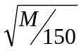 ; and it shall be rounded up to the next higher unit'
A representative sample shall be obtained by mixing the material taken with the S insertions of the probe in the bags. The representative samples shall 'be split by means of a 1/1 splitter in the number of samples necessary for the tests.
NOTE A test probe can be constructed from a tube of 28 mm and 34 mm diameter and 1000mm to 1200 mm length. The end of which reaches the bottom of the bag or the IBC should be fitted with a plugging system. After the penetration of the probe to the full depth of the bag or IBC, the plug is inserted and the probe removed. The contents of the probe represent a simple of the material to be tested.
When sampling into the IBC, if the test probe cannot go to the full depth of the container, the following alternative method shall be used:
- a quantity of 20 kg ±1 kg shall be removed from the IBC in a bucket; and
- the content to the bucket shall be split by means of a l/1 splitter the number of samples necessary for the tests.
Annex A
(normative)
Test method to determine the presence of the moisture proof coating

A.1 Procedure A

A.1.1 General
Procedure A shall be used when a quick indication is required
The percentage of moisture proofed glass beads shall be checked in accordance with the following test method.
For this test, 1 ml of glass beads is required, measured using a tube with an inside diameter ranging from 2 mm to 5 mm and which is graduated in 1/20 ml.

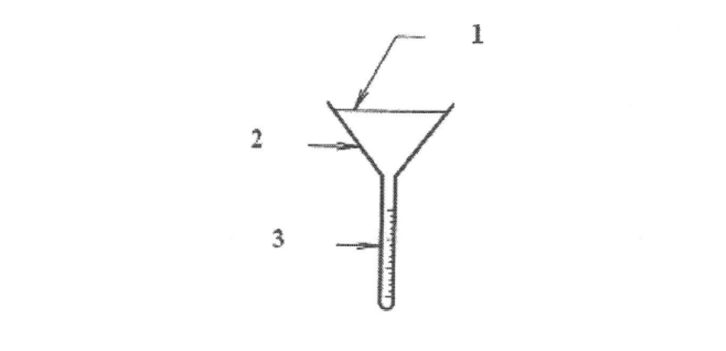

Key
1 about 1dm² surface
2 water
3 graduated tube
Figure A.1 — Funnel
The glass beads shall be sprinkled from a height of 5 mm onto a roughly dm² (± 5%) still water surface lying in a funnel equipped with a graduated tube whose inside diameter ranges from 2 mm to 5 mm and which is graduated in 1120 ml from its sealed base as showed in Figure A.1.

Ensure that:
- the inner wall of the container above the water is dry;
- the surface of the water is still; and
- the glass beads do not fall on top of one another.

A.1.2 Results
With V being the volume in milliliters of glass beads collected in the tube 5 min after sprinkling, the percentage of moisture proofed glass beads is equal to:
(1-V) x 100

Annex B
(normative)
Test method to determine the presence of floatation coating

B.1 General
This test method is only valid if the granulometry of the glass beads is between 300 um and 180 um.

B.2 Principle
To determine the presence of floatation coating by estimating the percentage of glass beads floating on the surface of xylene or n-heptane.

B.3 Apparatus and reagents
The apparatus necessary to execute the test is described in the following list:
B.3.1 A watch glass or petri dish, 50 mm to 75 mm in diameter
B.3.2 A syringe, pipette or eye dropper of 5 ml to 20 ml capacity
B-3.3 Test sieves, conforming with the requirements of ISO 565
B.3.4 Xylene, of reagent grade
B.3.5 n-heptane, of reagent grade

B.4 Procedure
- Sieve out from a representative sample the fraction passing a 300 pm sieve but retained on a 180 pm sieve.
- Spread a monolayer of glass beads on to the clean watch glass and, using the syringe; slowly introduce the xylene at the edge of the watch glass until the liquid is deep enough to allow the beads to float.
- Care should be taken to avoid agitation of the glass beads whilst the xylene is being added.
- Visually estimate the percentage of glass beads floating on the surface of the xylene.
- Repeat a) and b) using a new sample of glass beads and using n-heptane in place of xylene.

B.5 Results
In order to pass the test, the minimum percentage of glass beads floating shall be as in Table B.1.

Table B.1 — Percentages of floating glass beads
S/N | Liquid | Min, % floating
 | Xylene | 90
 | n-heptane | 75
Annex C
(normative)
Test method to determine the refractive index of the glass beads

C.1 General
The method used to determine the refractive index of glass beads is immersion with oblique illumination.
This technique, known as the Shrober van der Kolk method, only applies to isotropic or to mono refracting bodies, as is the case where glass beads are concerned.

C.2 Principle
Viewed under the microscope, transparent solids which are immersed in a liquid give an image bounded by dark or luminous bands. The appearance will vary, depending upon the difference between the refractive indices of the two bodies, according to their dispersing capacity and illumination.
Under axial lighting conditions index differences are perceptible; but they become considerably more pronounced under oblique lighting, due to the fact that under such conditions the bands become sharper on one side than on the other. Their position .is determined by the direction of the incident beam and by the difference between the index of the solid under examination and that of the liquid in which it is immersed.
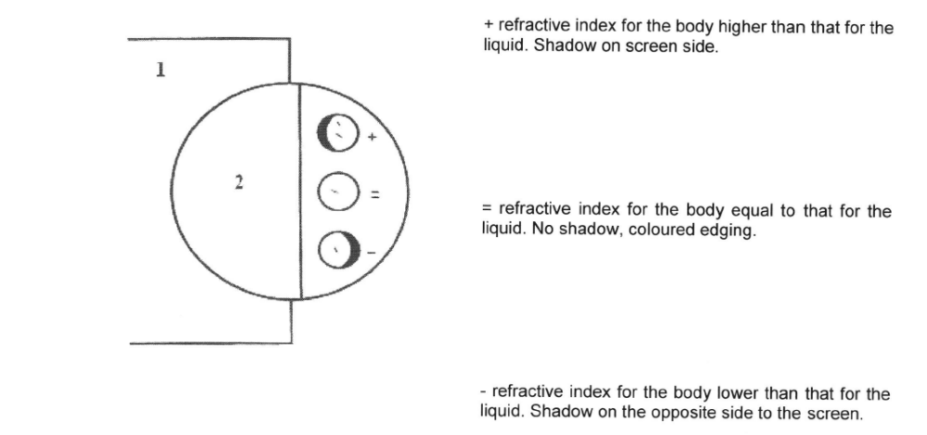

Key
cardboard or screen
dark part of the field
Figure C.1 — Shematic diagram showing the technique for determining the refractive index

NOTE The position of the shaded part of the field may be reversed, depending upon the microscope setting. Only the position of the screen should therefore be taken into account

Where devices are fitted with an image rectifier (magnifiers and certain microscopes), the phenomenon is reversed. lf there is any doubt as to the properties of the device which is being used, a test should be carried out with water, since glass beads always have a higher refractive index. This will reveal how the phenomenon appears.
When preparing in advance a series of liquids with known indices and immersing the test objects in them one after the other, it shall be determined either that there is a liquid with the same index or that the index for the test object falls between the indices for two liquids, one higher and one lower.

C.3 Apparatus
The following apparatus are required:
C.3.1 Roller coater — Of size 10 cm to 15 cm
C.3.2 Commercial roller tray
C.3.3 Test panel — Burnished mild steel or tinplate panels complying with ISO 1514, placed vertically or nearly vertically and rigidly held to prevent movement during the test.

C.4 Test conditions

The test shall be carried out at a temperature of 23 ± 2 0C and a relative humidity of 65 ± 2 per cent.

C.5 Procedure
The procedure shall be as follows:
- Saturate the roller with paint using the roller tray.
- Remove the excess paint by rolling on the subsidiary panel.
- Apply paint to
- Continue steps a) to c) until three quarters of the panel is covered evenly. Noting the ease or difficulty of lapping until the whole panel is coated. During application, note such properties as rolling, flowing, spreading, leveling, bubbling, dripping, logging and fly-off.
- Allow the film to dry for 24 h and examine the area of lapping and that adjacent for difference in gloss and/or other defects.

Annex D
(normative)
Test method to determine maximum weighted percentage of defective glass beads

D.1 General
ln a representative sample, the determination of the percentage of the defective of the glass beads shall be made using the fraction quantities retained on each sieve after the granulometric analysis carried out in conformity with ISO 565 and ISO 2591-1; the residue of the last sieving shall not be deemed to constitute a fraction. The study of the defects of the glass beads shall be made using an optical device with a magnification which results in the glass beads having an apparent diameter of 4 mm to 5 mm in its visual field.
The glass beads collected from a sieve (e.g. 300 pm) shall be homogenized by passing them at least five times through a small divider, after which a small sample shall be prepared (approximately 0,5 g), by repeated division.
This sample then passed in its entirety through a sieve with a mesh size very slightly larger than that of the sieve from which the refuse material was collected (e.g. a 500 pm mesh where the refuse material was left by a sieve with a 300 pm mesh) on to a transparent adhesive strip with a width of 20 mm or less and with a length equal to the diameter of the sieve. Any glass beads which are not held on the strip shall be gathered and- repositioned until all have been affixed to the adhesive strip. Where there is an excess, a fresh sample shall be prepared and a fresh adhesive strip shall be made up. lt is recommended that the glass beads be laid without rolling them, thus avoiding separation of the spherical glass beads from the remainder.
The specimen thus prepared shall be examined in the following manner under the optical device. In order to make the examination easier, the adhesive strip holding the glass beads may be cut into pieces, all of which shall be treated under exactly the same conditions: a) the minimum requirement for assessment of the number of defectives glass beads shall be the observation of 600 glass beads per sieve, obtained from at least six different areas spread evenly over the whole surface of the adhesive strip (or the whole collection of pieces) on which the glass beads have been placed: in the case of the sieve associated with the highest amount of retained material, the following two additional conditions shall also be fulfilled:
- each area shall contain not less than 100 glass beads; where this is not the case, a number of adjoining areas shall be assembled in order to satisfy the criterion; and
- the difference between the highest and the lowest number of defectives glass beads for lhe various areas containing no less than 100 glass beads.
- A single area or adjoining areas which have been assembled) shall not exceed 20 in absolute terms; if this criterion cannot be satisfied, another adhesive strip shall be prepared.
Example
- Area 1: 17 defective glass beads in 108 glass beads;
- Area 2: 21 defective glass beads in 119 glass beads;
- Area 3: 18 defective glass beads in 103 glass beads;
- Area 4: 23 defective glass beads in 141 glass beads;
- Area 5: '16 defective glass beads in 123 glass beads; and
- Area 6: 27 defective glass beads in 106 glass beads
The range between the extreme number of defective of glass beads is: 27 - 16 = 11
- only those glass beads which are entirely located in the visual field are examined;
- first of all, count all the glass beads present in the visual field, and then all the glass beads which feature at least one of the defects referred to in defined in Annex E.
Where examination is made by screen projection, the glass beads shall be immersed totally in a liquid with a refractive index close to that of glass in order to highlight any gas inclusions, amongst other defects.
NOTE Where direct examination is made using stereoscopic microscopy, it may assist if an eye piece with a grid is used and if the areas studied are restricted to about 20 glass beads at a time.

D.2 Results of counting
Sieving a representative sample of a glass bead granulometry through its n specific sieves, the total weighted percentage of the defective glass beads shall be calculated using the following equation:
W=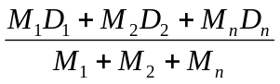

where
W is the total weighted percentage of defective glass beads;
M_{i} is the percentage by mass of the glass beads retained on each of the n sieves; and
D_{i} is the arithmetic mean of the percentage by number of the defective glass beads counted on five or more samples properly taken from the glass beads retained on each of the n sieves.
The total weighted percentage of grains and foreign particles shall be calculated in the same manner.
Results of counting shall be presented in accordance with format of Table D.1.
Annex E
(normative)
Glass beads defects

E.1 Oval glass beads (see Figure E.1)
When the ratio of the major diameter D to the minor diameter d is greater than 1.3 (D/d >1.3), the oval glass bead shall be considered defective.
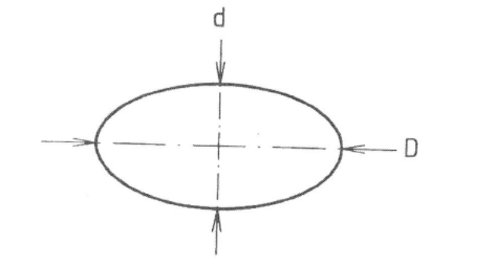
Figure E.1 — Oval glass beads

E.2 Satellites (see Figure E.2)
When a glass bead supports more than two smaller glass beads, called satellites, or when, in the case of two satellites, the ratio of the diameter d of the major of them to the diameter D of the supporting glass bead is greater than 0.25 (dl D > 0.25), the glass bead shall be considered defective.

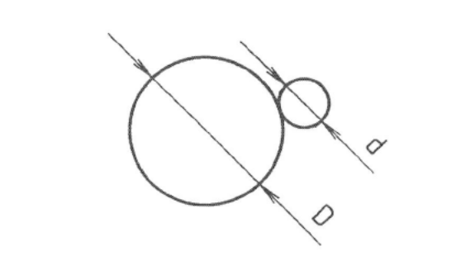
Figure E.2 — Satellites

E.3 Tear shaped glass beads (see Figure E.3)
When the ratio of the major dimension L to the minor dimension / is greater than 1.3 (LIl>1.3), the glass bead shall be considered defective.
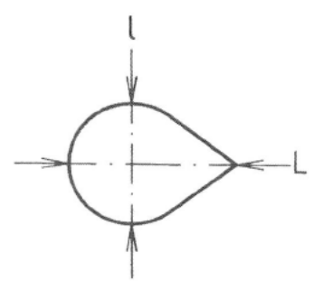
Figure E.3 — Tear shaped glass beads

E.4 Glass beads fused together (see Figure E.4)

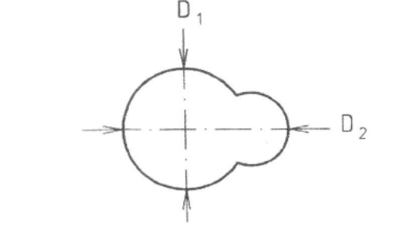
Figure E.4 — Glass beads fused together

E.5 Roundish glass beads (see Figure C.5)
When the ratio of their major dimension L to the minor dimension / is greater than bead shall be considered defective 1.3 (L l l >1.3), the glass bead shall be considered defective

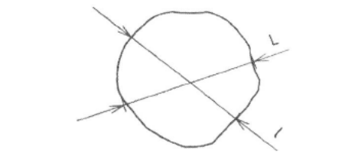
Figure E.5 — Roundish glass beads

E.6 Opaque glass beads (see Figure E.6)
Opaque glass beads shall always be considered defective.
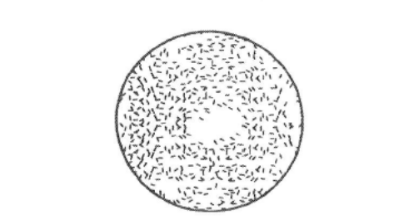
Figure E.6 — Opaque glass beads

E.7 Milky glass beads (see Figure E.7)
The milky appearance is due to gaseous inclusions in part or in the whole volume of the bead. Milky glass beads shall always be considered defective
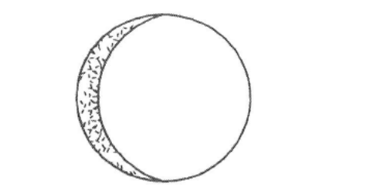
Figure E.7 — Milky glass beads

E.8 Gas inclusions (see Figure E 8)
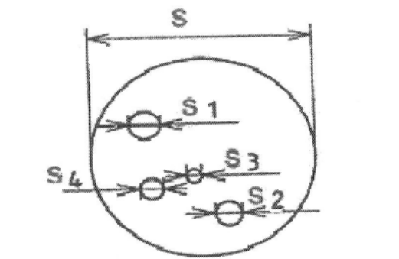
Figure E.8 — Gas inclusions

E.9 Grains (see Figure E.9)
Glass particles which present one or more sharp angles shall be considered defective glass beads

Figure E.9 — Grain

E.10 Foreign particles
Particles which are not composed of glass, shall be considered defective glass beads
Annex F
(normative)
Test method to determine the friability index of the antiskid aggregates

F.1 General

F.1.1 Principle
The friability index expresses the resistance to fragmentation.
The test consists of measuring the granulometric variation of aggregates produced in a rotating cylinder under strictly defined conditions by a process of fragmentation using a load in the presence of water.
The representative sample granulometry of the aggregates shall be: 0.2 mm to 2 mm or 0.2 mm to 4 mm.
Aggregates finer than 0.2 mm shall not be taken into consideration.

F.1.2 Friability Index
The friability index shall be defined by the quantity of material of less than 0.1 mm produced during the test.
lf M is the mass of the material subjected to testing and m is the mass of the material of less than 0.1 mm produced during the test, the friability index will be, by definition:
F=100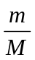

F.2 Apparatus

F.2.1 Standard apparatus
The equipment necessary for sampling the material and carrying out the granulometric analysis by sieving shall be used, together with a set of sieves at least 200 mm in diameter with opening sizes of 0,1,0,2,12,4 and 8.

F.2.2 Special apparatus
The following special apparatus shall be used to execute the test:
F.2.2.1 Rotating cylinder (micro-Deval apparatus)
F.2.2.2 An abrasive load consisting of balls of X30 Cr13 stainless steel with diameters
(30 +0.1) mm, and (10± 0.5) mm
-0.5

F.3 Material to be tested

F.3.1 Obtaining the sample
The mass of the material to be tested shall be at least 2 000 g

F.3.2 Preparing the sample
Prepare the sample for testing as follows:
- wet sieving of 2 000 g of material; using the sieves 0.2 mm and 2 mm or 0.2 mm and 4 mm to obtain the representative fraction (see F.1.1);
- dry the material in an oven at 105 ºC until its mass is constant, that is until successive weighing of the sample separated by t h do not differ more than 0.1 %;
- homogenise and weigh a (500 ± 2) g test sample.
Prepare the steel balls used for the load as follows:
- take nine balls 30 mm diameter the total mass being ( 975₋ ₅₀⁺⁰¹⁰)
- add 21 balls 18 mm diameter the mass being (490 ⁺¹⁰ ₋₅₀) g,
- complete the load, using balls of 10 mm diameter so that the total mass of the load is (2 500 ± 4) g. The load wear shall be checked periodically. The 18 mm and 30 mm balls shall be checked by weighing as a whole and replacing those which are most worn, by separate weighing until the load is again within the tolerances. The 10 mm balls shall be controlled per lot of 10; below a 34 g lot they shall be replaced by conforming balls.

F.4 Procedure
To carry out the test the following 8 points shall be executed: Introduce the load into the test cylinder arranged with its opening upward; then insert 500 g of the material prepared in accordance with the requirements of G.3.1 and G.3.2. Add 2.5 I of water and replace the cover. Rotate the cylinder at a speed of (100 j 5; min-1 for 1 500 rotations or 15 min. Slowly pour all the contents of the tray over two superimposed sieves of 8 mm (to collect the abrasive load) and of 0.1 mm respectively.
- wash the whole, using a jet of water, until the water runs clear then remove the g mm sieve. Dry the 0.1 mm sieve in an oven at 105 ºC until the mass is constant. Dry sieve the oversize material using the 0.1 mm sieve. Weigh all the oversize material on the 0.1 mm sieve. Let this mass be m.

F.5 Expression of results
The mass m of the material less than 0.1 mm produced during the test, from the initial 500 g is equal
500- m' (m=500-m').
Therefore the friability index shall be: F_{s} =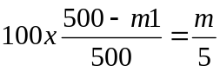
Annex G
(normative)
Test method to determine the presence of dangerous substances

G.1 Reference method
The reference method to determine the content of chemical substances in glass beads and in anti-skid aggregates shall be inductively coupled plasma, atomic emission spectrometry (ICP-AES) capable of measuring parts per million levels of requested elements.
A representative sample of glass beads or glass aggregates shall be milled to a fine particle size (< 80 p) which helps facilitate complete dissolution using a hydrofluoric acid solution. Once the glass is completely dissolved and in solution, analysis of the requested chemical elements shall be conducted by lCP.
The appropriate dilution shall be chosen to give results within the range of the standards and optimum operation range of the instrument. Where necessary the relevant instrument manuals shall be referred for details about each instrument.
The mass of sample used in the digestion and the dilution factors shall be taken into consideration when the final results are calculated.
WARNING:
- This is an analytical test procedure and shall be conducted following recognised analytical principles.
- Dangerous chemical agents shall be used in this process and shall be handled and used following the required laboratory standards.
- The ICP analysis shall be carried using recognised reference materials traceable to international standards. Repeatability shall be demonstrated as part of the analysis process.
The test report shall include the following information:
- Clear identification of the sample in term of origin and type, and also consignment or shipping details and date of receipt of consignment, as appropriate.
- The content of any of the following chemical substances, as the elemental form:
- Arsenic;
- Lead;
- Antimony;
The classification of each element into one of the following two classes:
- Class 0: no value requested;
- Class 'l: < 200 ppm (mg/kg);
Name, address of testing laboratory,
The date on which testing was conducted,
Reference of this method,
Details of any deviation from this test method.
Annex H
(normative)
Test methods to determine the resistance of the glass beads to the effects of water, hydrochloric acid, calcium chloride and sodium sulphide

H.1 Resistance to the effects of water
ln a distillation flask fitted with a glass tube at the top, this tube to serve as a reflux condenser' boil 10 g ± 0.1 g glass beads for 60 min ±10 s of CO₂ free water. After the test objects have been boiled for the required period, filter the glass beads, cool the liquid to room temperature and then add two drops of phenolphthalein solution as an indicator.
Using a solution of hydrochloric acid, titrate the liquid until the phenolphthalein changes colour' A blank test shall be carried out in parallel.
Note any changes which appear in the Surface using microscope enlargement of between 20X and 50X: Note also the quantity of HCL used.

H.2 Resistance to the effects of hydrochloric acid
Immerse 10 g ± 0.1 g of glass beads in 100 ml ± r 0.1 ml of dilute hydrochloric acid solution, buffered to give a pH of 5.0 to 5.3, for 90 h at a temperature of 20 ºC ± 3 ºC.
With the help of a microscope with 20x to 50x magnification, note any changes which may have appeared on the surface after the glass beads have been rinsed in distilled water and dried.

H.3 Resistance to the effects of calcium chloride
Immerse 10 g ± 0.1 g of glass beads in 100 ml r 0.1 ml of a normal solution of calcium chloride for 3 h at a temperature of 20 ºC ± 3 ºC.
With the help of a microscope with 20x to 50x magnification note any changes which may have appeared on the surface after the glass beads have been rinsed in distilled water and dried.

H.4 Resistance to the effects of sodium sulphide

H.4.1 Apparatus and reagents
H.4.1.1 Microscope, with minimum magnification of 10.8.4.1-2
H.4.1.2 50 ml bottle, with a glass stopper
H.4.1.3 Distilled water
H.4.1.4 A saturated solution of sodium sulphide in distilled water at 20 ºC with the addition of 2.0 % anionic wetting agent.

H.4.2 Procedure
Take 10 g ± 0.1 g of glass beads from a representative sample.
Place the glass beads in a stoppered bottle and cover with the solution containing the sodium sulphide and allow to stand for1 h.
Pour off the solution containing the sodium sulphide and rinse three times with distilled water.
Dry the glass beads in an oven at 100 ºC ± 5 ºC and, using the microscope, compare these with an untreated sample.

H.4.3 Results
When compared with an untreated sample the glass beads shall not be darker.
Bibliography

EN 1423, Road marking materials — Drop on materials — Glass beads, antiskid aggregates and mixtures of the two

