KENYA STANDARD KS 640-1: 2017 ICS 61.020

Specification for pyjamas

Part 1. Making up requirements

TECHNICAL COMMITTEE REPRESENTATION

The following organizations were represented on the Technical Committee

Moi University, Eldoret- Department of Textile Industrial & Manufacturing Engineering
Kenya Industrial Research and Development Institute (KIRDI)
Ken Knits Ltd, Eldoret
RIVATEX E.A LTD,Eldoret
SAMREF Textile Weavers LTd,Nakuru
Min of industry, Trade & cooperatives
Kenya Bureau of Standards — Secretariat

REVISION OF KENYA STANDARDS

In order to keep abreast of progress in industry, Kenya Standards shall be regularly reviewed. Suggestions for improvements to published standards, addressed to the Managing Director, Kenya Bureau of Standards, are welcome.

© Kenya Bureau of Standards, 2017

Copyright. Users are reminded that by virtue of section 6 of the Copyright Act, Cap. 130 of the Laws of Kenya, copyright subsists in all Kenya Standards and except as provided under section 7 of this Act, no Kenya standard produced by Kenya Bureau of Standards may be reproduced, stored in a retrieval system in any form or transmitted by any means without prior permission in writing from the Managing Director.

Permission may be conditional on an appropriate royalty payment.

Care should be taken to ensure that material used is from the current edition of the standard and that it is updated whenever the standard is amended or revised. The number and date of the standard should therefore be clearly identified.

The use of material in print or in electronic form to be used commercially with or without payment or in commercial contracts is subject to payment of a royalty.

KENYA STANDARD KS 08-640-1 2017 ICS 61.020

Specification for pyjamas

Part 1. Making up requirements

KENYA BUREAU OF STANDARDS (KEBS)

Head Office: P.O. Box 54974, Nairobi-00200, Tel.: (+254 020) 605490, 602350, Fax: (+254 020) 604031
E-Mail: info@kebs.org, Web:http://www.kebs.org

Coast Region Lake Region North Rift Region
P.O. Box 99376, Mombasa-80100 P.O. Box 2949, Kisumu-40100 P.O. Box 2138, Nakuru-20100
Tel.: (+254 041) 229563, 230939/40 Tel.: (+254 057) 23549, 22396 Tel.: (+254 051) 210553, 210555
Fax: (+254 041) 229448 Fax: (+254 057) 21814

FOREWARD

This Kenya Standard was prepared by the working group on Ready-made Garments under the direction of the Textile Industry Standards Committee and the National Standards Council.

This standard was formulated with a view to help manufacturers in producing goods of satisfactory quality. Manufacturers and others concerned are urged to label their pyjamas in accordance with KS ISO 3758, Care labelling code using symbols and KS 08-640, Specification for pyjamas — Part 2, Measurements for pyjamas.

In the preparation of this standard, reference was made to Canadian Standard 38-GP-20 Pyjamas, polyester/cotton men’s hospital.

Acknowledgement is hereby made for the assistance received from this source.

SPECIFICATION FOR PYJAMAS -PART 1 MAKING UP REQUIREMENTS

1. SCOPE

This Kenya Standard specifies the fabrics, ancillaries and making up requirements for pyjama suit (coat and trouser) and pajama dress.

2. APPLICATION

This standard applies to pyjamas made from woven or knitted fabrics.

3. SIZE DESIGNATION

3.1 The sizes of pyjamas suit (coat and trouser) shall be designated by chest measurements as follows:

82 cm – 86 cm, 90 cm – 94 cm, 98 cm – 102 cm, 106 cm – 110 cm, 114 cm – 118 cm.

3.2 The sizes of pyjamas suit age (2-16) shall be designated by age and chest measurements as follows:

Age | 2 | 4 | 6 | 8 | 10 | 12 | 14 | 16
Chest (cm) | 54 | 58 | 62 | 66 | 70 | 74 | 78 | 82

3.3 The pyjama dresses shall be designated by numbers as follows: 8, 10, 12, 14, 18, 28

The sizes of pyjamas dress age (6-16) shall be designated by age and burst measurements as follows:

Age | 6 | 7 | 8 | 9 | 10 | 11 | 12 | 13 | 14 | 15 | 16
Chest (cm) | 58 | 61 | 64 | 67 | 70 | 73 | 76 | 79 | 82 | 85 | 88

4. FABRICS

4.1 The fabrics for the manufacture of pyjamas shall comply with KS 08-539, Specification for men’s and boys’ woven pyjama fabrics, and any other relevant Kenya Standard for pyjama fabrics.

5. WORKMANSHIP

5.1 Assembly

5.1.1 Major components of the pyjamas shall be assembled so that on the finished garment the warp shall run in the same direction (up and down the garment).

5.2 Seams and Stitching

5.2.1 Stitch Finishing and Quality — The ends of all seams and stitches and all breaks in the threads shall be securely backstitched.

Stitches shall present a regular appearance without fabric pucker and shall be free from skips.

5.2.2 All seams shall be finished by the most suitable method.

5.2.3 Number of Stitches — For plain sewing, the number of stitches shall be not less than 4 stitches per centimetre.

5.3 Coat

5.3.1 Pocket (if any) — A pocket shall be attached to the left front breast shell material (see Figure 1). The sides and bottom edges shall be turned and stitched to the forepart. The top corners of the pocket shall be sewn with a triangular stitch pattern or backstitched. Pockets shall be straight and parallel to the centre front.

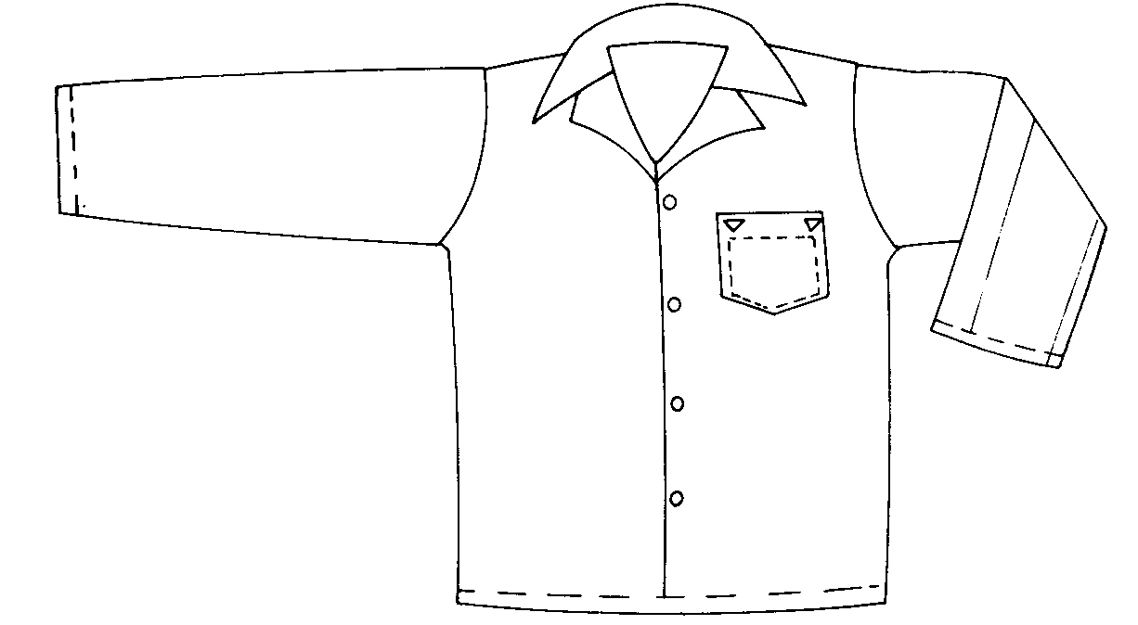

FIG. 1 — Pyjama coat

5.3.2 Front Facings in front fly — The front edges of the left and right foreparts shall be folded under to form a minimum 60-mm hem. The raw edges of the foreparts may be selvedges or shall be finished by the most suitable method.

5.3.3 Buttons and Buttonholes

5.3.3.1 Button sewing — Buttons shall be sewn with not less than 12 stitches per button including tying stitches correctly locked.

5.3.3.2 Buttonholes — Not less than 14 stitches per centimetre shall be used. The stitches shall be measured on one side of the buttonhole and shall not include the bar-tacks.

5.3.3.3 Buttonhole placement — Buttonholes shall not be placed closer than 1.6 cm from a closing edge.

5.3.3.4 Buttonholes shall be bar-tacked with not less than 5 stitches or fishtailed and cleanly cut.

5.3.3.5 Buttonhole appearance — Buttonholes shall be of neat appearance with even, continuous, secure and compactly placed stitches.

5.3.3.6 ‘Cut after’ buttonholes shall have a clean cut made close to the stitches.

5.3.4 Hems — The bottom edge of both sleeves and the coat shall be finished with a hem of not less than 12 mm. The hems shall be neatly finished by the most suitable method.

5.4 Trousers (pants)

5.4.1 The Crotch — The crotch seam (inseam to bottom of fly assembly) shall be joined with double-

lapped seam lock-stitches or lock chain stitch with two rows of stitching placed 4.5 mm apart.

5.4.2 Waistband — The raw edges of the waistband shall be neatly finished by the most suitable method.

5.4.3 Hems — The legs shall be finished with not less than 15 mm hem. The raw edge shall be neatly finished by the most suitable method.

5.4.4 The fly — When wearing, the right side of the fly opening shall be cut with a self facing. The edge shall be folded back not less than 50 mm and the raw edge folded under and stitched.

Not less than 40 mm curtain facing of shell material shall be seamed to the left forepart, folded back and with the raw edge folded under and stitched to the forepart. (Selvedge need not be turned under.) The left edge of the fly opening shall be folded to overlap the right edge to form not less than 47 mm curtain.

The overlapped curtain shall be stitched through all plies as shown in Figure 2. The bottom of the fly opening shall be reinforced with a double row of triangular stitching.

This 5.4.4 is applicable to men’s and boys’ (aged 14 years to 16 years) pyjamas.

5.4.5 Front Closure — Two buttons and buttonholes shall be uniformly placed and stitched in the fly in addition to those provided on the waistband for men’s and boy’s (aged 14 years to 16 years) pants.

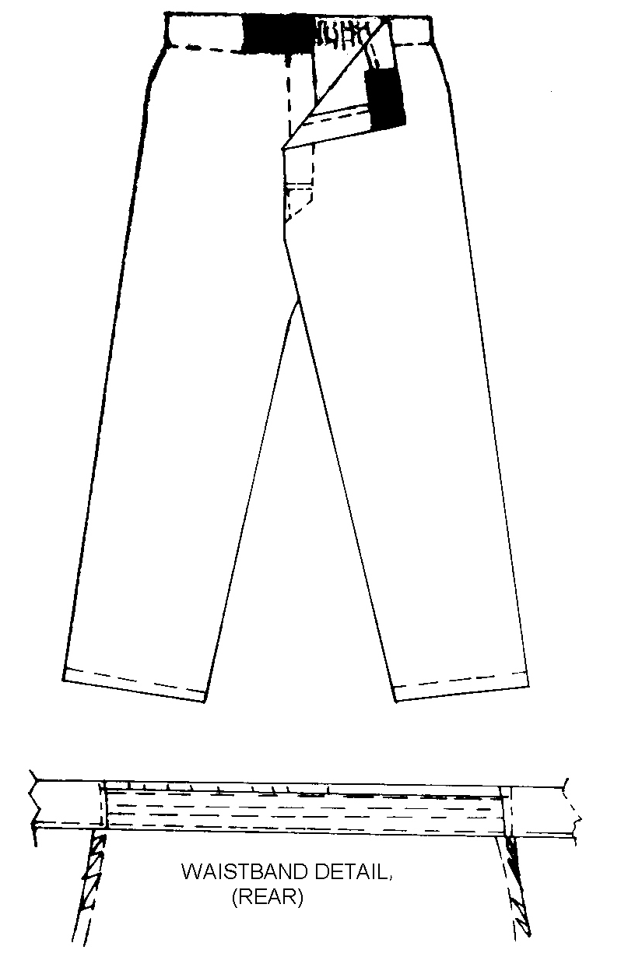

FIG 2 — Pyjama pants

Dress

5.4.6. Seams — All seams shall be sewn without puckering, stretching and wobbling and finished without a
tangle or ravellings, or crooked edges. The seam allowance shall not be less than 15 mm.

Reinforcing — Seams with corners shall have reinforcement stitches to strengthen it at the point.

5.4.7 Tailoring Defects — The pyjamas shall be free from the following defects:

(a) Stains.

(b) Defective stitching

(c) Loose ends of sewing thread getting easily frayed.

(d) Holes, cuts or tears.

(e) Non-alignment of pocket, buttons and buttonholes.

(f) Narrow seams.

6. ANCILLARIES

6.1 Buttons — Plastic buttons shall be of good quality and comply with KS 03-398, Specification for thermosetting plastic buttons.

6.2 Elastic Flat Braid — The elastic flat braid shall be as durable as the pyjama fabric and shall comply with the requirements of KS 08-529, Specification for elastic flat braid.

7. MARKING AND LABELLING

7.1 Each pair of pyjamas shall bear a permanent label including:

- The manufacturer’s name or trade mark.

- Care instruction in accordance with KS ISO 3758,

- The size designation.

- Fibre composition of the fabric.

8. PACKING

Each pair of pyjamas shall be packed in suitable material ensuring protection from stains and dust.

