KENYA STANDARD KS 640-2: 2017

Specification for pyjamas

Part 2. Measurements for pyjamas

TECHNICAL COMMITTEE REPRESENTATION

The following organizations were represented on the Technical Committee

Moi University, Eldoret- Department of Textile Industrial & Manufacturing Engineering
Kenya Industrial Research and Development Institute (KIRDI)
Ken Knits Ltd, Eldoret
RIVATEX E.A LTD,Eldoret
SAMREF Textile Weavers LTd,Nakuru
Min of industry, Trade & cooperatives
Kenya Bureau of Standards — Secretariat

REVISION OF KENYA STANDARDS

In order to keep abreast of progress in industry, Kenya Standards shall be regularly reviewed. Suggestions for improvement to published standards, addressed to the Managing Director, Kenya Bureau of Standards, are welcome.

© Kenya Bureau of Standards, 2017
Copyright. Users are reminded that by virtue of section 6 of the Copyright Act, Cap. 130 of the Laws of Kenya, copyright subsists in all Kenya Standards and except as provided under section 7 of this act, no Kenya Standard produced by Kenya Bureau of Standards may be reproduced, stored in a retrieval system in any form or transmitted by any means without prior permission in writing from the Managing Director.

Specification for pyjamas

Part 2. Measurements for pyjamas

KENYA BUREAU OF STANDARDS (KEBS)

Head Office: P.O. Box 54974, Nairobi-00200, Tel.: (+254 020) 605490, 602350, Fax: (+254 020) 604031
E-Mail: info@kebs.org, Web:http://www.kebs.org

Coast Region Lake Region Rift Valley Region
P.O. Box 99376, Mombasa-80100 P.O. Box 2949, Kisumu-40100 P.O. Box 2138, Nakuru-20100
Tel.: (+254 041) 229563, 230939/40 Tel.: (+254 057) 23549, 22396 Tel.: (+254 051) 210553, 210555
Fax: (+254 041) 229448 Fax: (+254 057) 21814

FOREWARD

This Kenya Standard was prepared by the working group on Ready-made Garments under the direction of the Textile Industry Standards Committee and the National Standards Council.

This standard was formulated with a view to help manufacturers in producing goods of satisfactory quality. Manufacturers and others concerned are urged to label their pyjamas in accordance with KS ISO 3758, Care labelling code using symbols and KS 08-640, Specification for pyjamas — Part 2, Measurements for pyjamas.

In the preparation of this standard, reference was made to Canadian Standard 38-GP-20 Pyjamas, polyester/cotton men’s hospital.

Acknowledgement is hereby made for the assistance received from this source.

pyjamas Specification -Part 2. Measurements for pyjamas

1. SCOPE

This Kenya Standard specifies the dimensions considered essential to provide fit for woven and knitted pyjamas for men and boys.

2. REQUIREMENTS

When placed without tension, buttoned or with openings closed, on a flat surface so that they are free from wrinkles and creases and measured at the points indicated in Figures 1, 2 and 3, the garments shall conform to the measurements shown in Tables 1, 2, 3 and 4.

3. DEFINITIONS

3.1 There are two separate groups of measurement provided which are defined as follows:

3.1.1 size indicator body measurements — Body measurements taken over skin or lightweight underwear that relate directly to each individual garment size. These measurements when applied on a garment label, are used to determine the correct garment size.

3.1 2 garment measurements (Tables 1, 2, 3 and 4) — Consists of two or more of the following types which are defined as follows:

3.1.2.1 critical measurements — Those garment measurements that are essential to a good fit. These measurements must be within the tolerances specified in Tables 1 to 4.

3.1.2.2 minimum measurements — Those garment measurements that must not be less than the figures shown in Tables 1 to 4. Measurements may exceed the minimum specified and still comply with the requirements of this dimensional standard.

3.1.2.3 recommended measurements — Those garment measurements that are not critical for fit. Deviations in either direction from the figures in Tables 1 and 3 are permissible and may even be desirable to allow for variations in styling.

4. MEASUREMENT DEFINITIONS APPLICABLE TO TABLES 1 TO 4

4.1 Definitions of Pyjama Coats (Table 1 and 2)

4.1.1 back width (critical) — The distance across the back of the garment between the seams of the armhole measured at the narrowest point (G, to H, Figure 2).

4.1.2 armhole circumference (minimum) — The distance around the armhole measured along the curvature of the seam (curvature of the outer edge of the armhole for sleeveless).

4.1.3 long sleeve length (minimum) — The distance from the center back of the neck over the shoulder to the outer end of the sleeve following the contour of the garment (J to R, Figure 1).

4.1.4 chest circumference (minimum) — Twice the distance across the closed jacket measured 2 cm below the lowest point of the armhole seam (2 cm below lowest point of armhole for sleeveless) (twice A to B, Figure 1).

4.1.5 short sleeve length (recommended) — The distance from the center back of the neck over the shoulder to the outer end of the sleeve following the contour of the garment (J to M, Figure 1).

4.1.6 sleeve aperture at bottom (long sleeve, recommended) —Twice the distance across the bottom of the sleeve (twice R to S, Figure 1).

4.1.7 length (minimum) — The distance from the neck seam at the center back of the neck to the bottom of garment (L, Figure 2).

4.1.8 bottom of coat (minimum) — Twice the distance across the bottom of the coat when the garment is buttoned (twice T, Figure 1).

Pyjama trousers (Tables 2 and 4)

4.1.9 waist all elastic, and elastic back or inserts relaxed (critical) — Twice the distance between the outer edges or the waist with the elastic relaxed (twice A to B, Figure 3).

4.1.10 front rise (minimum) — The distance from the highest point of the inseam at the crotch to the top edge of the waist at the centre back (E to G1, Figure 3).

4.1.11 back rise (minimum) —the distance from the highest point of the inseam at the crotch to the top edge of the waist at the center front (E to G2, Figure 3).

4.1.12 long leg, total side length (minimum) — the distance from the top of the waist to the bottom of the leg (or ribbed cuff if fitted) measured at the side of the garment following the contour of the fabric (A to H, Figure 3).

4.1.13 waist circumference stretched (minimum) — Twice the distance between the outer edges of the waist with the elastic stretched fully (twice A to B, Figure 3).

4.1.14 seat width (minimum) — The distance across the garment measured at the distance above the crotch seam (highest point of the inseam at the crotch) as indicated below (C to D, Figure 3).

Ages | 2 to 5 | 6 to 12 | 14 to 16 | 18 to 20 | Adults
Distance (cm) | 5 | 6.5 | 8 | 9 | 9.5

4.1.15 thigh width (minimum) —the distance across the leg of the garment at the highest point of the leg at the crotch level (P to L, Figure 3).

4.1.16 leg aperture (minimum) — Twice the distance across the bottom of the leg, or if a rib cuff is fitted, where the leg is joined to rib cuff with the cuff stretched to permit a full measurement of the leg aperture (twice N to M, Figure 3).

4.1.17 Chest girth
The maximum horizontal girth measured during normal breathing with the subject standing erect and the tape measure placed horizontally around the chest at the level of the nipples.

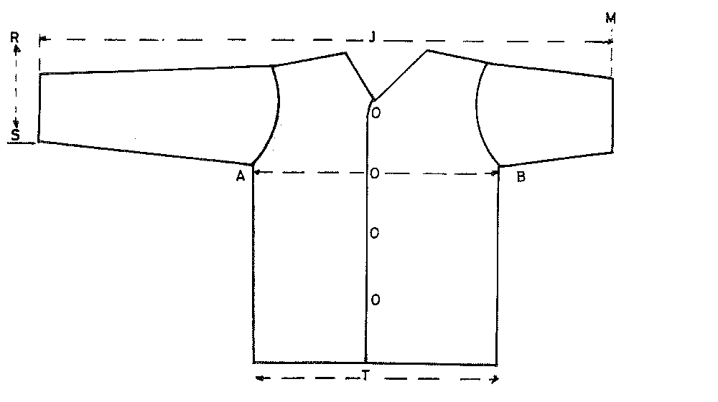

FIG. 1

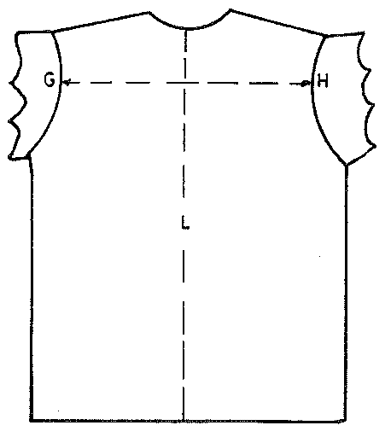

FIG. 2

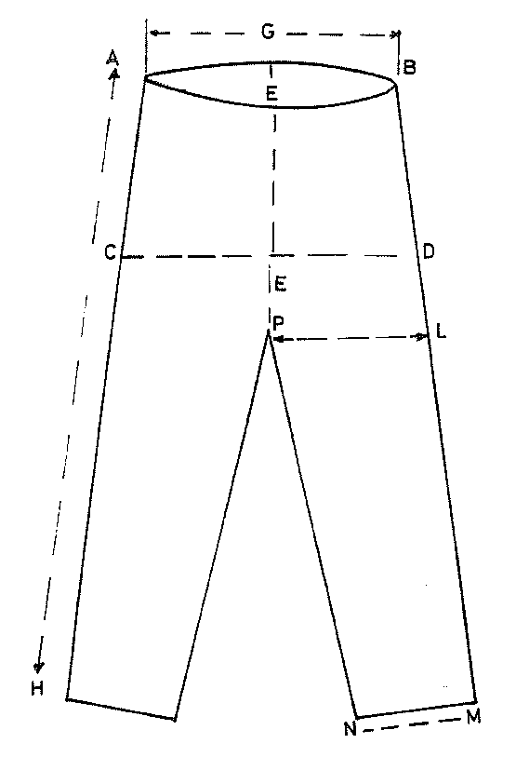
FIG. 3

TABLE 1. MEASUREMENTS FOR PYJAMAS COATS — BOYS AGED 2 – 16 YEARS

ALL MEASUREMENTS IN CENTIMETRES

AGE | SIZE INDICATOR BODY MEASUREMENTS |  | GARMENT MEASUREMENTS
AGE |  |  | CRITICAL | MINIMUM |  |  |  |  | RECOMMENDED
AGE | Chest girth ± 2.5 | Hip girth ± 2.5 | *Back width ± 1.5 | Chest circumference | *Armhole circumference | Long sleeve length | Coat length | Bottom of coat | Sleeve aperture at bottom | Short sleeve length
2 | 54 | 58 | 28.5 | 68 | 30 | 42 | 42 | 68 | 22 | 22.5
4 | 58 | 62 | 29.5 | 72 | 32 | 48 | 46 | 72 | 23 | 25.5
6 | 62 | 66 | 31 | 76 | 34 | 54 | 50 | 76 | 24 | 28.5
8 | 66 | 70 | 33 | 81 | 36 | 60 | 54 | 81 | 25 | 31.5
10 | 70 | 74 | 35 | 85 | 38 | 64 | 58 | 85 | 26 | 34.5
12 | 74 | 78 | 37 | 89 | 40 | 68 | 62 | 89 | 27 | 37.5
14 | 78 | 84 | 39 | 93 | 42 | 72 | 66 | 93 | 28 | 40.5
16 | 82 | 90 | 41 | 97 | 44 | 76 | 70 | 97 | 29 | 43.5

* NOTE: Not applicable to pyjama coat with raglan sleeves.
TABLE 2. MEASUREMENT FOR PYJAMA TROUSERS — BOYS AGED 2 – 16 YEARS

ALL MEASUREMENTS IN CENTIMETRES

SIZES | CRITICAL |  | MINIMUM
SIZES | Waist circumference (relaxed) |  | Front rise | Back rise | Seat width | Waist circumference — Long leg |  |  |  | Thigh width
SIZES | All Elastic ± 2 | Elastic insert ± 2 | Front rise | Back rise | Seat width | Elastic (stretched) | Drawstring style | Total side length |  | Thigh width
2 | 41 | 44 | 21 | 25 | 36 | 64 | 64 | 60 |  | 18
4 | 44 | 47 | 23 | 27 | 38 | 67 | 67 | 66 |  | 20
6 | 47 | 50 | 25 | 29 | 40 | 70 | 70 | 72 |  | 22
8 | 50 | 53 | 27 | 32 | 43 | 74 | 74 | 78 |  | 24
10 | 53 | 56 | 29 | 34 | 46 | 78 | 78 | 84 |  | 26
12 | 56 | 59 | 31 | 36 | 49 | 84 | 84 | 90 |  | 28
14 | 59 | 62 | 33 | 38 | 52 | 90 | 90 | 96 |  | 30
16 | 62 | 65 | 35 | 40 | 55 | 96 | 96 |  | 102 | 32

TABLE 3. MEASUREMENTS FOR MEN’S PYJAMA COATS

ALL MEASUREMENTS IN CENTIMETRES

SIZE INDICATOR BODY MEASUREMENTS | GARMENT MEASUREMENTS
SIZE INDICATOR BODY MEASUREMENTS | CRITICAL | MINIMUM |  |  |  |  | RECOMMENDED
Chest girth | Back width ± 1.5 | Chest circumference | Armhole circumference | Long sleeve length | Coat length | Bottom of coat | Long sleeve aperture at bottom | Short sleeve length
82 – 86 | 44 | 104 | 52 | 81 | 72 | 104 | 29 | 49
90 – 94 | 46 | 112 | 54 | 84 | 74 | 112 | 30 | 50
98 – 102 | 48 | 120 | 56 | 86 | 76 | 120 | 31 | 51
106 – 110 | 50 | 128 | 58 | 89 | 78 | 128 | 32 | 52
114 - 118 | 52 | 136 | 60 | 89 | 80 | 136 | 33 | 53

TABLE 4. MEASUREMENTS FOR MEN’S PYJAMA TROUSERS

ALL MEASUREMENTS IN CENTIMETRES

SIZE INDICATOR BODY MEASUREMENTS |  | GARMENT MEASUREMENTS
 |  | MINIMUM
Chest girth | Waist girth |  | Waist circumference (relaxed) |  | Front rise | Back rise | Seat width | Waist circumference (stretched) |  |  | Thigh width
Chest girth |  |  | All elastic ± 2 | Elastic back ± 2 | Front rise | Back rise | Seat width | All elastic | Elastic back or inserts | Drawstring | Thigh width
82 – 86 | 70 –74 |  | 66 | 68 | 35 | 42 | 54 | 91 | 91 | 91 | 32
90 – 94 | 78 –82 |  | 74 | 76 | 36 | 43 | 58 | 99 | 99 | 99 | 34
98 – 120 | 86 –90 |  | 82 | 84 | 37 | 44 | 62 | 107 | 107 | 107 | 36
106-110 | 94 – 98 |  | 90 | 92 | 38 | 45 | 66 | 115 | 115 | 115 | 38
114-118 | 102 -106 |  | 98 | 100 | 39 | 46 | 70 | 123 | 123 | 123 | 40

NOTE: Total side length shall be one of the following 96, 100,104, 107, 112 ± 2

