
CD/ 196: 2014

ICS 77.140

EAST AFRICAN STANDARD

High-strength low-alloy Carbon Steel for hot rolled sheet and cold rolled sheet — Specification

EAST AFRICAN COMMUNITY

© EAC 2019 Third Edition 2019

CD/ 196: 2014

Copyright notice

This EAC document is copyright-protected by EAC. While the reproduction of this document by participants in the EAC standards development process is permitted without prior permission from EAC, neither this document nor any extract from it may be reproduced, stored or transmitted in any form for any other purpose without prior written permission from EAC.

Requests for permission to reproduce this document for the purpose of selling it should be addressed as shown below or to EAC’s member body in the country of the requester:

© East African Community 2013 — All rights reserved
East African Community

P.O.Box 1096

Arusha
Tanzania
Tel: 255 27 2504253/8
Fax: 255 27 2504481/2504255
E-mail: eac@eachq.org

Web: www.eac-quality.net

Reproduction for sales purposes may be subject to royalty payments or a licensing agreement. Violators may be persecuted

ii © EAC 2019 – All rights reserved

Contents
CD/ 196: 2014

Page

Foreword iv

1 Scope 1

2 Description 1
2.1 Steel types 1
2.2 Product types 1

3 Normative references 2

4 General requirements for delivery 3

5 Manufacture 3

6 Chemical composition 4
6.1 Limits 4
6.2 Cast or heat (formerly ladle) analysis 4
6.3 Product analysis 4
6.4 Sampling for product analysis 5

6.5 Specimen preparation 5
6.6 Test methods 5

7 Mechanical requirements 5

8 Dimensions, tolerances, and allowances 5

9 Finishes and condition 12
9.6 Oiling 13

10 Workmanship and surface conditions 13
10.1 Workmanship 13
10.2 Surface conditions 13

11 Retests 14

12 Inspection 14

13 Rejection and rehearing 14

Annex A (normative) Standard chemical ranges and limits 15

Annex B (informative) Effect of aging of cold-rolled carbon steel sheet on drawing and forming 17

B.1 Commercial quality and drawing quality 17
B.2 Special killed, drawing quality 17

Annex C (informative) Procedure for determining breakage allowance levels (applicable to
carbon steel sheet only) 18

Annex D (informative) Procedures for determining the extent of plastic deformation encountered
in forming or drawing 19
D.1 Introduction 19
D.2 Circle grid method 19
D.3 Procedure 20
D.4 Measurement of strain after forming 21

D.5 Evaluation of strain measurements 22
D.6 Example of major and minor strain distribution 23
D.7 Example for reducing splitting tendency 23

D.8 Scribed square method 24
D.9 Thickness method 24

Bibliography 25

© EAC 2019 – All rights reserved iii

CD/ 196: 2014

Foreword

Development of the East African Standards has been necessitated by the need for harmonizing requirements governing quality of products and services in the East African Community. It is envisaged that through harmonized standardization, trade barriers that are encountered when goods and services are exchanged within the Community will be removed.

In order to achieve this objective, the Community established an East African Standards Committee mandated to develop and issue East African Standards.

The Committee is composed of representatives of the National Standards Bodies in Partner States, together with the representatives from the private sectors and consumer organizations. Draft East African Standards are circulated to stakeholders through the National Standards Bodies in the Partner States. The comments received are discussed and incorporated before finalization of standards, in accordance with the procedures of the Community.

East African Standards are subject to review, to keep pace with technological advances. Users of the East African Standards are therefore expected to ensure that they always have the latest versions of the standards they are implementing.

CD/ 196 was prepared by Technical Committee EASC/TC 035, TC Steel and Steel Products.

iv © EAC 2019 – All rights reserved
EAST AFRICAN STANDARD CD/ 196:2014

High-strength low-alloy Carbon Steel for hot rolled sheet and cold rolled sheet — Specification

1 Scope

1.1 This Draft East African Standard specifies the requirements for steel sheet in coils and cut lengths. It applies to the carbon steel and high-strength, low-alloy steel (HSLA) supplied as hot-rolled sheet and cold-rolled sheet.

1.2 This East African Standard is not applicable to hot-rolled, heavy-thickness carbon sheet coils.

1.3 In case of any conflict in requirements, the requirements of the individual material specification shall prevail over those of the general specification.

1.4 For the purposes of determining conformance with this specification and the various material specifications, values shall be rounded to the nearest unit in the right-hand place of figures used in expressing the limiting values.

2 Description

2.1 Steel types

2.1.1 Carbon steel is the designation for steel where no minimum content is specified or required for aluminium, chromium, cobalt, columbium, molybdenum, nickel, titanium, tungsten, vanadium, zirconium, or any element added to obtain a desired alloying effect, where the specified minimum for copper does not exceed 0.40 %, or where the maximum content specified for any of the following elements does not exceed manganese 1.65 %, silicon 0.60 %, or copper 0.60 %.

2.1.2 In all carbon steels, small quantities of certain residual elements unavoidably retained from raw materials are sometimes found which are not specified or required, such as copper, nickel, molybdenum, chromium, etc. These elements are considered as incidental and are not normally determined or reported.

2.1.3 High-strength low-alloy steel is a specific group of steels in which higher strength, and in some cases additional resistance to atmospheric corrosion or improved formability, are obtained by moderate amounts of one or more alloying elements.

2.2 Product types

2.2.1 Hot-rolled sheet is manufactured by hot rolling slabs in a continuous mill to the required thickness and shall be supplied in coils or cut lengths as given in Table 1.

© EAC 2019 – All rights reserved | 1

CD/ 196: 2014

Table 1 — Hot-rolled coils and cut lengths

Dimensions in millimetres

Width, w | Thickness, x
 | Carbon steel | HSLA
300 < w ≤ 1200 | 1.2 ≤ x < 6.0. | 1.8 ≤ x < 6.0
w > 1200 | 1.2 ≤ x < 4.5 | 1.8 ≤ x < 4.5

2.2.2 Cold-rolled sheet is manufactured from hot-rolled descaled coils by cold reducing to the desired thickness, generally followed by annealing to recrystallize the grain structure. If the sheet is not annealed after cold reduction it is known as full hard with a hardness of 84 HRB minimum and shall be used for certain applications where ductility and flatness are not required.

2.2.3 Cold-rolled carbon sheet is commonly classified by size as given in Table 2.

Table 2 — Cold-rolled carbon sheet

Dimensions in millimetres

Width, w | Thickness, x
50 ≤ w-≤ 300 ^{a)} | 0.35 ≤x-≤ 2.0
w > 300 ^{b)} | x ≥ 0.35

- Cold-rolled sheet coils and cut lengths, slit from wider coils with cut edge (only) and in thicknesses 0.35 mm to 2.0 mm, incl. carbon 0.25 % max. by heat analysis.

- When no special edge or finish (other than matte, commercial bright, or luster finish) or single strand rolling of width, or both, up to and including 600 mm not specified or required.

2.2.4 Cold-rolled high-strength, low-alloy sheet is commonly classified by size as given in Table 3.

Table 3 — Cold-rolled high strength, low-alloy carbon sheet

Dimensions in millimetres

 | Width, w | Thickness, x
 | 50 ≤ w-≤ 300 ^{a)} | 0.5 ≤ x-≤ 2.0
 | w > 300 ^{b)} | x ≥ 0.5

- Cold-rolled sheet coils and cut lengths, slit from wider coils with cut edge (only) and in thicknesses 0.35 mm to 2.0 mm, incl. Carbon 0.25 % maximum by heat analysis.

- When no special edge or finish (other than matte, commercial bright, or luster finish) or single strand rolling of width, or both, up to and including 600 mm not specified or required.

3 Normative references

The following referenced documents are indispensable for the application of this document. For dated references, only the edition cited applies. For undated references, the latest edition of the referenced document (including any amendments) applies.

2 © EAC 2019 – All rights reserved
CD/ 196: 2014

EAS194-1, Steel and steel products — Part 1: Location and preparation of sample and test pieces for mechanical testing

EAS 199, Steel and cast iron — Determination of sulphur content — Combustion titrimetric method

EAS 200, Steel and cast iron — Determination of phosphorus content —Phosphovanadomolybdate spectrophotometric method

ISO 437, Steel and cast iron — Determination of total carbon content — Combustion gravimetric method

ISO 439, Steel and iron — Determination of total silicon content — Gravimetric method

ISO 629, Steel and cast iron — Determination of manganese content — Spectrophotometric method

ISO 671, Steel and cast iron — Determination of sulphur content — Combustion titrimetric method ISO 4829-1 Steel and cast iron — Determination of total silicon content — Reduced molybdosilicate spectrophotometric method — Part 1: Silicon contents between 0.05 and 1.0 %

ISO 4829-1, Steel and cast iron — Determination of total silicon content — Reduced molybdosilicate spectrophotometric method — Part 1: Silicon contents between 0.05 and 1.0 %

ISO 4829-2, Steel and iron — Determination of total silicon content — Reduced molybdosilicate spectrophotometric method — Part 2: Silicon contents between 0.01 and 0.05 %

ISO 4943, Steel and cast iron — Determination of copper content — Flame atomic absorption spectrometric method

ISO 10714, Steel and iron — Determination of phosphorus content — Phosphovanadomolybdate spectrophotometric method

ISO 14284; Steel and iron — sampling and preparation of samples for the determination of chemical composition

4 General requirements for delivery

4.1 Products covered by this standard are produced to metric decimal thicknesses only and metric thickness tolerances shall apply.

4.2 Steel may be produced as ingot-cast or strand-case. When different grades of strand-cast steel are sequentially cast, identification and separation of the transition material shall be required.

5 Manufacture

5.1 Hot-rolled material supplied shall not be annealed or pickled.

5.2 Coil breaks, stretcher strains, and fluting can occur during the user's processing of hot-rolled or hot-rolled pickled sheet. When any of these features are detrimental to the application, the manufacturer shall be notified at the time of ordering in order to properly process the sheet.

5.3 Cold-rolled carbon steel sheet may be available as discussed in 9.2 and 9.3. .

5.4 Cold-rolled sheet for exposed applications shall be temper rolled and is usually specified and furnished in the strain free condition as shipped (see Annex B).

Cold-rolled sheet for unexposed applications may be specified and supplied as "annealed last" or "temper rolled”. ”Annealed last" shall be produced without temper rolling, but may be lightly temper rolled during oiling

© EAC 2019 – All rights reserved | 3

CD/ 196: 2014

or rewinding. Unexposed temper-rolled material may be specified strain-free or non-fluting. Where specific hardness range or limit, or a specified surface texture is required, the application shall be considered as exposed.

NOTE Skin-passed sheet is subject to an aging phenomenon (see Annex B). Unless special killed (non-aging) steel is specified, it is to the user’s interest to fabricate the sheet as soon as possible, for optimum performance.

6 Chemical composition

6.1 Limits

6.1.1 The chemical composition shall be in accordance with the applicable product specification. However, if other compositions are required for carbon steel, they shall be prepared in accordance with Annex A.

6.1.2 Where the material is used for fabrication by welding, care shall be exercised in selection of chemical composition or mechanical properties to assure compatibility with the welding process and its effect on altering the properties.

6.2 Cast or heat (formerly ladle) analysis

6.2.1 An analysis of each cast or heat of steel shall be made by the manufacturer to determine the percentage of elements specified or restricted by the applicable standard.

6.2.2 When requested, cast or heat analysis for elements listed or required shall be reported to the purchaser or to his representative.

6.3 Product analysis

6.3.1 Non-killed steels such as capped or rimmed steels are not technologically suited to product analysis due to the non-uniform character of their chemical composition and therefore, the tolerances in Table 4 shall not apply. Product analysis is appropriate on these types of steel only when misapplication is apparent or for copper when copper steel is specified.

Table 4 — Tolerances for product analysis

 |  |  |  |  |  | Dimensions in millimetres
 | Element | Limits of specified | Tolerance |  |  | Test method
 |  | element,
 |  | element, | Under |  | Over
 |  | % | minimum. | maximum.
 |  |  | limit, |  | limit,
 |  |  | mm |  | mm
 | Carbon | ≤ 0.15 | 0.02 |  | 0.03 | ISO 437
 |  | 0.15 < x ≤ 0.40 | 0.03 |  | 0.04
 |  | 0.40 < x ≤ 0.80 | 0.03 |  | 0.05
 |  | > 0.80 | 0.03 |  | 0.06
 | Manganese | ≤ 0.60 | 0.03 |  | 0.03 | ISO 629
 |  | 0.60 < x ≤ 1.15 | 0.04 |  | 0.04
 |  | 1.5 < x ≤ 1.65 | 0.05 |  | 0.05
 | Phosphorus | - | - |  | 0.01 | ISO 10714
 |  |  |  |  |  | EAS 200
4 |  |  |  |  | © EAC 2019 – All rights reserved

 |  |  |  | CD/ 196: 2014
Sulfur | - | - | 0.01 | ISO 671
 |  |  |  | EAS 199
Silicon | ≤ 0.30 | 0.02 | 0.03 | ISO 439
 |  |  |  | ISO 4829-1
 | 0.30 < x ≤ 0.60 | 0.05 | 0.05 | ISO 4829-1
 |  |  |  | ISO 4829-2
Copper |  | 0.02 |  | ISO 4943

6.3.2 For steels other than non-killed (capped or rimmed), product analysis may be made by the purchaser. The chemical analysis shall not vary from the limits specified by more than the amounts in Table 4. The several determinations of any element in a cast shall not vary both above and below the specified range.

6.4 Sampling for product analysis

6.4.1 Sampling of the products shall be in accordance to ISO 14284

6.4.2 When the steel is subject to tension test requirements, samples for product analysis may be taken either by drilling entirely through the used tension test specimens themselves, or as covered in 6.4.3.

6.4.3 When the steel is not subject to tension test requirements, the samples for the analysis shall be taken by milling or drilling entirely through the sheet in a sufficient number of places so that the samples are representative of the entire sheet or strip. The sampling may be facilitated by folding the sheet both ways, so that several samples shall be taken at one drilling. Steel subjected to certain heating operations by the purchaser may not give chemical analysis results that properly represent its original composition. Therefore users shall analyze chips taken from the steel in the condition in which it is received from the steel manufacturer.

6.5 Specimen preparation

Drillings or chips shall be taken without the application of water, oil, or other lubricant, and shall be free of scale, grease, dirt, or other foreign substances. They shall not be overheated during cutting to the extent of causing decarburization. Chips shall be well mixed and those too coarse to pass a 2.0-mm sieve size or too fine to remain on a 600 µm sieve size are not suitable for proper analysis.

6.6 Test methods

Chemical analysis shall be done in accordance with the test methods given in Table 4.

7 Mechanical requirements

7.1 The mechanical property requirements, number of specimens and test locations and specimen orientation shall be in accordance with the applicable product standard.

7.2 Unless otherwise specified in the applicable standard, test specimens shall be prepared in accordance with EAS 194-1.

7.3 Mechanical tests shall be conducted in accordance with appropriate methods of test.

8 Dimensions, tolerances, and allowances

8.1 Dimensions, tolerances, and allowances applicable to products covered by this standard are contained in this clause.

© EAC 2019 – All rights reserved | 5

CD/ 196: 2014

8.2 Flatness tolerances are not applicable to "annealed last" cold-rolled sheet, but that product will normally be within two times standard flatness when shipped in cut lengths and after removal of coil set when shipped in coils.

Table 5 — Thickness tolerances of hot-rolled sheet (carbon steel)

 |  |  | Dimensions in millimetres
Thickness tolerance (x, ±) for specified width and nominal thickness
Specified thickness | x ≤ 2.0 | 2.0 < x ≤ 2.5 | 2.5 < x ≤ 4 | 4 < x ≤ 5
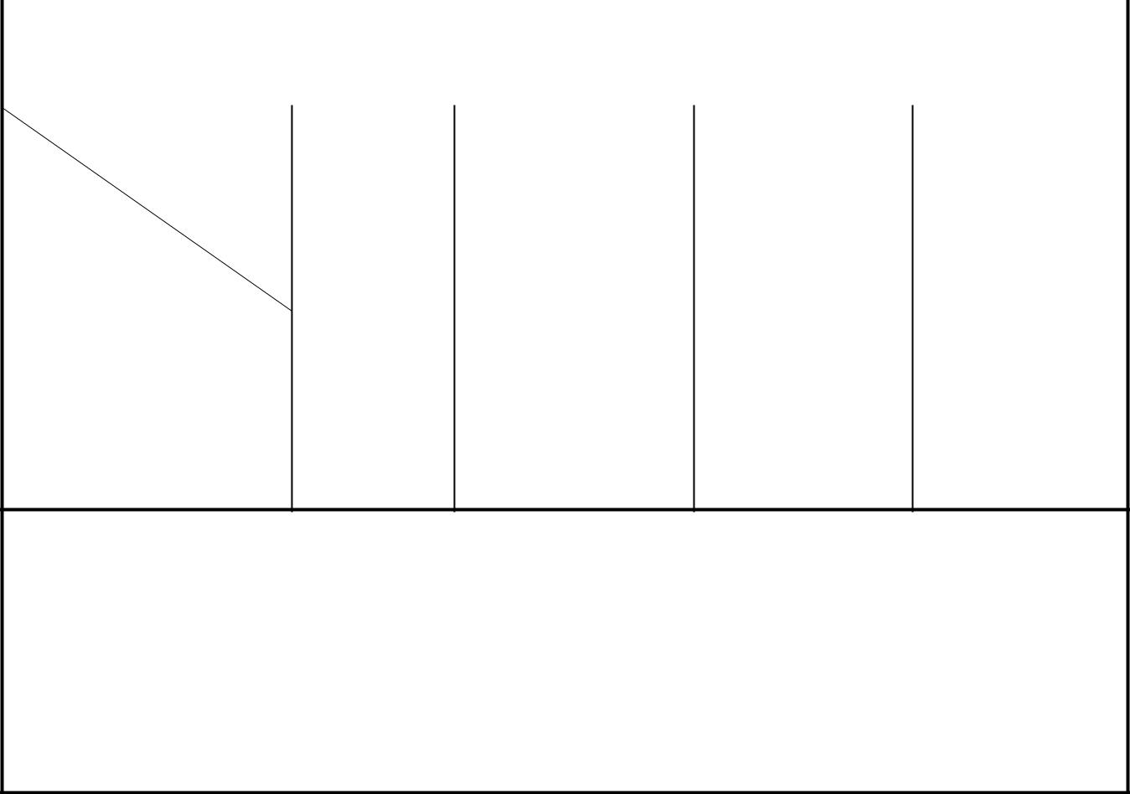

Specified width (w)
300 ≤ w < 600 | 0.30 | 0.30 | 0.35 | 0.407
600 < w ≤ 1200 | 0.30 | 025 | 0.40 | 0.45
1200 < w ≤ 1500 | 0.35 | 0.35 | 0.40 | -
1500 < w ≤ 1800 | 0.35 | 0.40 | 0.40 | -
w > 1800 | 0.35 | 0.40 | 0.40 | -

NOTE 1 Thickness is measured at any point across the width not less than 10 mm from a cut edge and not less than 20 mm from a mill edge. This table does not apply to the uncropped ends of mill edge coils.

NOTE 2 The specified thickness range captions also apply when sheets specified to a nominal thickness and the tolerances are divided equally over and under.

NOTE 3 Where minimum thickness is specified only positive tolerance is accepted.

NOTE 4 Where nominal thickness is specified, positive and negative tolerances apply.

Table 6 — Thickness tolerances of hot-rolled sheet (High strength low-alloy steel) (coils and cut lengths, including pickled)

 |  |  |  |  | Dimensions in millimetres
Specified width (w) |  | Thickness tolerance, over only, for specified minimum thickness
 |  | X ≤ 2.0 | 2.0 < x ≤ 2.5 | 2.5 < x ≤ 4 | 4 < x ≤ 5
300 ≤ w< 600 |  | 0.30 | 0.35 | 0.40 | 0.40
600 < w ≤ 1 200 |  | 0.35 | 0.40 | 0.45 | 0.50
1 200 < w ≤ 1 500 |  | 0.35 | 0.40 | 0.50 | -
1 500 < w ≤ 1 800 |  | 0.40 | 0.45 | 0.55 | -
1 800 < w ≤ 2 000 |  | 0.40 | 0.45 | 0.60 | -
w > 2 000 |  | - | 0.50 | 0.60 | -
NOTE 1 | Thickness is measured at any point across the width not less than 10 mm from a cut edge and
not less than 20 mm from a mill edge. This table does not apply to the uncropped ends of mill edge coils.
NOTE 2 | The specified thickness range captions also apply when sheet F specified to a nominal
thickness, and the tolerances are divided equally, over and under.

6 © EAC 2019 – All rights reserved
CD/ 196: 2014

Table 7 — Width tolerancesa) of hot-rolled mill edge sheet (carbon and high-strength low alloy steel, (coils and cut lengths, including pickled)

Dimensions in millimetres

 | Specified width (w) |  |  | Width tolerance, over only
 |  |  |  | Carbon | HSLA
 | 300 | ≤ w < | 600 | 16 | 16
 | 600 < w ≤ 1200 |  |  | 26 | 28
 | 1200 | < w ≤ | 1500 | 32 | 38
 | 1500 | < w ≤ | 1800 | 35 | 45
 | w ˃ 1800 |  |  | 48 | 50
NOTE | The above tolerances do not apply to the uncropped ends of mill
edge coils.

Table 8 — Width tolerances of hot-rolled cut edge sheet and cold-rolled sheet (carbon and high-strength low-alloy steel, (not re-squared coils and cut lengths, including pickled)

Dimensions in millimetres

Specified width, w | Width tolerance, over only
300 ≤ w < 600 | 3
600 < w ≤ 1200 | 5
1200 < w ≤ 1500 | 6
1500 < w ≤ 1800 | 8
w > 1800 | 10

Table 9 — Length tolerances of hot-rolled sheet (carbon and high-strength low-alloy steel, (Cut lengths not resquared, including pickled)

Dimensions in millimetres

Specified width (w) |  |  | Width tolerance, over only
 | mm
300 ≤ w< 600 |  |  | 6
600 | < w ≤ | 900 | 8
900< w ≤ |  | 1500 | 12
1500 | < w ≤ | 3000 | 20
3000 | < w ≤ | 4000 | 25
4000< w ≤ |  | 5000 | 35
5000< w ≤ 6000 |  |  | 40
W > 6000 |  |  | 45

© EAC 2019 – All rights reserved | 7

CD/ 196: 2014

Table 10 — Diameter tolerances of circles from hot-rolled sheet (including pickled) and cold rolled sheet (over 300 mm width)

 |  |  |  | Dimensions in millimetres
Specified thickness, x | Tolerances over specified diameter (no tolerances under)
 |  |  | Diameter, D
 | D ≤ 600 |  | 600 ≤ D ≤ 1200 | D > 1200
x ≤ 1.5 | 1.5 |  | 3.0 | 5.0
1.5 < x ≤ 2.5* | 2.5 |  | 4.0 | 5.5
x > 2.5 | 3.0 |  | 5.0 | 6.5
.* For hot-rolled high-strength low-alloy steel sheet |  | the minimum thickness .shall be 1.8 mm min

Table 11 — Camber tolerances for hot-rolled (including pickled) and cold-rolled sheet (over 300 mm width, carbon and high-strength low-alloy steel, cut lengths, not resquared)

 |  |  |  |  | Dimensions in millimetres
 | Cut length, L |  |  |  | Camber tolerance,*
 | L ≤ 1 200 |  |  |  | 4
 | 1 200 | < L ≤ 1 800 |  |  | 5
 | 1 800 | < L≤ | 2 400 |  | 6
 | 2 400 | < L ≤ 3 000 |  |  | 8
 | 3 000 < L ≤ |  | 2 700 |  | 10
 | 3 700 < L ≤ |  | 4 300 |  | 13
 | 4 300 | < L ≤ 4 900 |  |  | 16
 | 4 900 | < L ≤ 5 500 |  |  | 19
 | 5 500< L ≤ 6 000 |  |  |  | 22
 | 6 000< L ≤ 9 000 |  |  |  | 32
 | 9 000< L ≤ 1 2200 |  |  |  | 38
 | NOTE Camber is the | greatest deviation of a side edge |  |  | from a straight line, the
 | measurement being taken on the concave side with a straightedge.
* | The camber tolerance for coils is 25.0 mm in any 6 000 mm.

8.3 Out-of-square tolerances of hot-rolled cut-edge (including pickled) and cold-rolled sheet square is the greatest deviation of an end edge from a straight line at right angle to a side and touching one comer. It is also obtained by measuring the difference between the diagonals of the cut length. The out-of-square deviation is one half of that difference. The tolerance for all thicknesses and all sizes is 1.0 mm/100 mm of width or fraction thereof.

8.4 When cut lengths are specified resquared, the width and the length are not less than the dimensions specified. The individual tolerance for over-width, over-length. camber, or out of-square should not exceed 1.6 mm up to and inducting 7, 200 mm in width and up to and inducting 3, 000 mm in length. For cut lengths wider or longer, the applicable tolerance is 3.2 mm.

8 © EAC 2019 – All rights reserved
CD/ 196: 2014

Table 12 — Flatness tolerances of hot-rolled sheet including pickled cut lengths not specified to stretcher-leveled standard of flatness (Carbon and high strength low-alloy steel)

Specified |  | Specified width | Flatness tolerance ^{a), b)}, specified yield point,
thickness, |  | mm |  | minimum,
mm |  |  |  | _{MPa}c)' d)
 |  |  | < 310 | 310 - 345 Yield point
1.2 < x ≤ | 1.5 | x ≤ 900 | 15 | -
 |  | 900 < x ≤ 1 500, | 20 | -
 |  | x ˃ 1 500 | 25
1.5 < x ≤ | 4.5 | x ≤ 1 500 l | 15 | 20
 |  | 1 500 < x ≤ 1 800 | 20 | 30
 |  | x ˃ 1 800 | 25 | 40
44.5 < x ≤ 6.0 |  | x ≤ 1 200 | 15 | 20

a) | The above tolerances also apply to cut lengths from coils by the consumer when adequate flattening
operations are performed.
b) | Maximum deviation from a horizontal flat surface.
c) | Tolerances for high-strength, low-alloy steels with specified minimum yield point in excess of 345 Mpa are
subject to negotiation.
d) | 1.8 minimum thickness

Table 13 — Flatness tolerances of Hot-rolled sheet including pickled cut lengths specified to stretcher-leveled standard of flatness (carbon and high-strength low-alloy steel)

Specified thickness, | Specified width, | Specified | Flatness tolerance^{a)}
mm | mm | length, | specified yield point,
mm | mm |  |  | min.
 |  | mm
 |  |  |  | MPa^{b)}
 |  |  | ˂ 310 |  | 310 -
 |  |  |  |  | 345^{c)}
1.2 ˂ x ≤ 4.5 | ≤ 1 200 | ≤ 2 400 | 3 |  | N/A-
 | ˃ 1 200 | ˃ 2 400 | 6
 | ˃ 1 200 | ˃ 2 400 | 6 |  |  | - | N/A
4.5 ˂ x ≤ 6.0 | ≤ 1 200 | ≤ 2 400 | 3 |  | N/A-
 | ˃ 1 200 | ˃ 2 400 | 6
 | ˃ 1 200 | ˃ 2 400 | 6 |  |  | - | N/A

^{a)} Maximum deviation from a horizontal flat surface.
b) | 1.8 mm minimum thickness for HSLA.
c) | .For the specified yield point between 310-345 the values of the flatness tolerance do not apply.

© EAC 2019 – All rights reserved | 9

CD/ 196: 2014

Table 14 — Allowances in width and length of hot-rolled sheet (carbon-steel) and cold-rolled sheet (carbon and high-strength low-alloy steel, cut length sheets specified to stretcher-leveled standard of flatness, not resquared, including pickled)

 |  |  |  | Dimensions in millimetres
Specified length (L) |  | Allowance over specified dimensions*
 | Width |  | Length
 | Width | Specified "grip or entry |  | Specified "grip or entry
 |  | marks outside specified |  | marks inside specified
 |  | length" |  | length"
L ≤ 3 000 | 20 | 100 |  | 75
3 000 < L ≤ 4 000 | 25 | 100 |  | 75
L > 4 000 | 30 | 125 |  | 100
* Allowances given when cut lengths are specified to stretcher-leveled standard of flatness and not
resquared, shall apply. These allowances are added by the manufacturer to the specified width and length
and the tolerances given in Tables 5, 6, 7, 14, 15, and 16 apply to the new size established. The camber
tolerances in Table 11 do not apply.
NOTE When cut lengths are not to have grip or entry marks within the specified length, the purchaser
should specify "gap entry marks outside specified length" When cut lengths may have grip or entry
marks within the specified length the purchaser should specify "grip or entry marks inside specified
length".

Table 15 — Thickness tolerances of cold-rolled sheet (carbon and high-strength low-alloy steel) ^{a)}

Dimensions in millimetres
 | Specified width | Thickness tolerances, over only, for specified minimum thickness
 |  | ≤ 0.4 |  | 0.4 ˂ x ≤ 1.0 | 1.0 ˂ x ≤ 1.2 | 1.2 ˂ x ≤ 2.5 | 2.5 ˂ x ≤ 4.0
 | 50 ˂ x ≤ 1 800 | 0.10 |  | 0.15 | 0.20 | 0.25 | 0.30^{b)}
1 800 ˂ x ≤ 2 000 |  |  |  | 0.15 | 0.20 | 0.30 | 0.35
 | ˃ 2 000 |  |  | 0.30 | 0.30 | 0.35 | 0.40
a) | 0.50 mm minimum thickness for high-strength low-alloy.
b) | Not applicable to width under 300 mm.

Table 16 — Length tolerances of cold-rolled sheet (carbon and high-strength low-alloy steel, cut lengths over 300 mm in width, not resquared)

 | Dimensions in millimetres
Specified length | Tolerance over specified length (no tolerance under)
3001 ˂ x ≤ 500 | 6
1 500 ˂ x ≤ 3 000 | 20
3 000 ˂ x ≤ 6 000 | 35
˃ 6 000 | 45

10 © EAC 2019 – All rights reserved
CD/ 196: 2014

Table 17 — Length tolerances of cold-rolled sheet (carbon and high-strength low-alloy steel, cut length sheets, 50 mm to 300 mm in width and 0.35 mm to 2.0 mm in thickness, not resquared)

 | Dimensions in millimetres
Specified length | Tolerance over specified length (no
 | tolerance under)
600 ˂ x ≤ 1 500 | 15
1 500 ˂ x ≤ 3 000 | 20
3 000 ˂ x ≤ 6 000 | 25

NOTE This table applies to width produced by slitting from wider sheets.

Table 18 — Width tolerances for cold-rolled sheet (carbon and high-strength low-alloy steel, coils and cut lengths 50 to 300 mm in width, not resquared, and 0.35 mm to 2.0 mm in thickness)

 |  | Dimensions in millimetres
Specified width |  | Width tolerance, (over and under) *
50 ˂ x ≤ 100 |  | 0.3
100 ˂ x ≤ 200 |  | 0.4
200 ˂ x ≤ 300 |  | 0.8
* 0.50 mm thickness for high-strength low-alloy.
NOTEThis table applies to width produced by slitting from wider sheet.

Table 19 — Camber tolerances of cold-rolled sheet in coils (carbon and high-strength low-alloy steel 0.35 to 2.0 mm in thickness)

 | Dimensions in millimetres
Width | Camber tolerances
50 - 300 | 5.0 in any 2 000

NOTE 1 Camber is the greatest deviation of a side edge from a straight line the measurements being taken on the concave side with a straightedge.

NOTE 2 This table applies to width produced by slitting from wider sheet.

Table 20 — Flatness tolerances of cold-rolled sheet (carbon and high-strength low-alloy steel ^{a)} ,cut lengths over 300 mm in width, not specified to stretcher levelled standard or flatness)

Specified | Specified width, | Flatness tolerance, specified yield point,
thickness, | mm |  | min,
mm | mm
mm |  |  | MPa
 |  | ˂ 310 |  | 310 - 345
 | ≤ 900 | 10 |  | 20
≤ 1.0
≤ 1.0 | 900 ˂ x ≤ 1 500 | 15 |  | 30
 | ˃ 1 500 | 20 |  | 40
˃ 1.0 | ≤ 900 | 8 |  | 20

© EAC 2019 – All rights reserved | 11

CD/ 196: 2014

 | 900 ˂ x ≤ 1 500 | 10 | 20
 | 1 500 ˂ x ≤ 1 800 | 15 | 30
 | ˃1 800 | 20 | 40

NOTE 1 This table does not apply when product is ordered full hard, to a hardness range or “annealed last” (dead soft).

NOTE 2 This table also applies to lengths cut from coils by the consumer when adequate flattening measures are performed.

- Maximum deviation from a horizontal flat surface.

9 Finishes and condition

9.1 Hot-rolled sheet has a surface with an oxide or scale resulting from the hot-rolling operation. The oxide or scale can be removed by pickling or blast cleaning when required for presswork operations or welding. Hot-rolled and hot-rolled descaled sheet is not generally used for exposed parts where surface is of prime importance.

Hot-rolled sheet can be supplied with mill edges or cut edges as specified mill edges are the natural edges resulting from the hot-rolling operation. They do not conform to any particular contour. They may also contain some edge imperfections, the more common types of which are cracked edges, thin edges (feather), and damaged edges due to handling or processing and which should not extend in beyond the ordered width. These edge conditions are detrimental where joining of the mill edges by welding is practiced. When the purchaser intends to shear or to blank a sufficient width allowance should be made when purchasing to assure obtaining the desired contour and size of the pattern sheet. The manufacturer may be consulted for guidance. Cut edges are the normal edges, which result from the shearing, slitting, or trimming of mill-edge sheet.

The ends of plain hat-rolled mill-edge coils are irregular in shape and are referred to as uncropped ends. Where such ends are not acceptable, the purchaser's order should so specify. Processed coils such as pickled or blast cleaned are supplied with square-cut ends.

9.2 Cold-rolled carbon sheet (exposed) is intended for those applications where surface appearance is of primary importance. This class will meet requirements for controlled surface texture, surface quality, and flatness. It is normally processed by the manufacturer to be free of stretcher strain and fluting. Subsequent user roller levelling immediately before fabrication will minimize strain resulting from aging.

Cold rolled carbon sheet, when ordered for exposed applications, can be supplied in the following finishes:

- Matte finish is a dull finish, without luster, produced by rolling on rolls that have been roughened by mechanical or chemical means to various degrees of surface texture depending upon application. With some surface preparation matte finish is suitable for decorative painting. It is not generally recommended for bright plating.

- Commercial bright finish is a relatively bright finish having a surface texture intermediate between that of matte and luster finish. With some surface preparation commercial bright finish is suitable for decorative painting of certain plating applications. If sheet is deformed in fabrication the surface may roughen to some degree and areas so affected will require surface preparation to restore surface texture to that of the undeformed areas.

- Luster finish is a smooth bright finish produced by rolling on ground rolls and is suitable for decorative painting or plating with additional special surface preparation by the user. The luster may not be retained after fabrication; therefore, the formed parts will require surface preparation to make them suitable for bright plating.

9.3 Cold-rolled carbon sheet, when intended for unexposed applications, is not subject to limitations on degree and frequency of surface imperfections, and restrictions on texture and mechanical properties are not

12 © EAC 2019 – All rights reserved
CD/ 196: 2014

applicable. When ordered as "annealed last," the product will have coil breaks: and a tendency toward fluting and stretcher straining. Unexposed cold-rolled sheet may contain more surface imperfections than exposed cold-rolled sheet because steel applications, processing procedures, and inspection standards are less stringent.

9.4 Cold-rolled high-strength low-alloy sheet is supplied with a matte finish, unless otherwise specified.

9.5 The cold-rolled products covered by this specification are furnished with cut edges and square cut ends, unless otherwise specified.

9.6 Oiling

9.6.1 Plain hot-rolled sheet is customarily furnished not oiled. Oiling shall be specified, when required.

9.6.2 Hot-rolled pickled or descaled sheet is customarily furnished oiled. If the product is not to be cited it shall be so specified since tile-cleaned surface is prone to rusting.

9.6.3 Cold-rolled products covered by this standard can lie furnished oiled or not oiled as specified.

9.7 Sheet steel in coils or cut lengths may contain surface imperfections that can be removed with a reasonable amount of metal finishing by the purchaser.

10 Workmanship and surface conditions

10.1 Workmanship

10.1.1 Cut lengths shall have a workmanlike appearance and shall not have imperfections of a nature of degree for the product, the grade, class, and the quality ordered that will be detrimental to the fabrication of the finished part.

10.1.2 Coils may contain some abnormal imperfections that render a portion of the coil unusable since the inspection of coils does not afford the producer the same opportunity to remove portions containing imperfections as in the case with cut lengths.

10.2 Surface conditions

10.2.1 Exposed cold-rolled sheet is intended for application where surface appearance is of primary importance, that is, exposed applications. Unexposed or annealed cold rolled sheet is intended for applications where surface appearance is not of primary importance, that is, unexposed applications.

10.2.2 Cut lengths for exposed applications shall not include individual sheets having major surface imperfections (holes, loose slivers, and pipe) and repetitive minor surface imperfections. Cut lengths may contain random minor surface imperfections that can be removed with a reasonable amount of metal finishing by the purchaser. These imperfections shall be acceptable to the purchaser within the manufacturer’s published standards.

10.2.3 For coils for exposed applications, it is not possible to remove the surface imperfections listed in

10.2.2. Coils will contain such imperfections, which shall be acceptable to the purchaser within the manufacturer's published standards. Coils contain more surface imperfections than cut lengths because the producer does not have the same opportunity to sort portions containing such imperfections as is possible with cut lengths.

10.2.4 Cut lengths for unexposed applications shall not include individual sheets having major surface imperfections such as holes, loose slivers, and pipe. In addition, unexposed cut lengths can be expected to contain more minor imperfections such as pits, scratches, sticker breaks, edge breaks, pinchers, cross breaks, roll marks, and other surface imperfections than exposed. These imperfections shall be acceptable to the purchaser without limitation.

© EAC 2019 – All rights reserved | 13

CD/ 196: 2014

10.2.5 For coils for unexposed applications, it is not possible to remove the surface imperfections listed in

10.2.4. Coils will contain surface imperfections that are normally not repairable. Minor imperfections shall be acceptable to the purchaser within the manufacturer's published standards. Unexposed coils contain more surface imperfections than exposed coils.

11 Retests

11.1 If any test specimen shows defective machining or develops flaws, it shall be discarded and another specimen substituted.

11.2 If the percent elongation of any test specimen is less than that specified and any part of the fracture is more than 20 mm from the centre of the gauge length of a 50-mm specimen or is outside the middle half of the gauge length of a 200-mm specimen, as indicated by scribe scratches marked on the specimen before testing, a retest is allowed.

11.3 If a bend specimen fails, due to conditions of bending more severe than required by the specification, a retest is permitted either on a duplicate specimen or on a remaining portion of the failed specimen.

12 Inspection

When purchaser's order stipulates that inspection and tests (except product analyses) for acceptance on the steel be made prior to shipment from the mill, the manufacturer shall afford the purchaser's inspector all reasonable facilities to satisfy him that the steel is being produced and furnished in accordance with the specification. Mill inspection by the purchaser shall not interfere unnecessarily with the manufacturer's operation.

13 Rejection and rehearing

13.1 Unless otherwise specified, any rejection shall be reported to the manufacturer within a reasonable time after receipt of material by the purchaser.

13.2 In addition to 13.1, when specified in the contract or order, and for direct procurement or direct shipment, preservation, packaging, and packing shall be as agreed upon between the manufacturer and the purchaser.

14 © EAC 2019 – All rights reserved
CD/ 196: 2014

Annex A
(normative)

Standard chemical ranges and limits

A.1 Standard chemical ranges and limits are prescribed for carbon steels in Tables A.1 and A.2.

Table A.1 — Standard steel – carbon sheet steel compositions

Steel designation SAE or |  | Chemical composition limits, %
AISI No. | C |  | Mn |  | P max. | S max.
1002 | 0.02 - 0.04 |  | 0.35 max. |  | 0.030 | 0.035
1003 | 0.02 - 0.06 |  | 0.35 max. |  | 0.030 | 0.035
1004 | 0.02/ 0.08 |  | 0.35 max. |  | 0.030 | 0.035
1005 | 0.06 max |  | 0.35 max. |  | 0.030 | 0.035
1006 | 0.08 max. |  | 0.45 max. |  | 0.030 | 0.035
1007 | 0.02/0.08 |  | 0.50 max. |  | 0.030 | 0.035
1008 | 0.10 max. |  | 0.50 max. |  | 0.030 | 0.035
1009 | 0.15 max. |  | 0.60 max. |  | 0.030 | 0.035
1010 | 0.08 - 0.13 |  | 0.30 - 0.60 |  | 0.030 | 0.035
1012 | 0.10 - 0.15 |  | 0.30 - 0.60 |  | 0.030 | 0.035
1015 | 0.13 - 0.18 |  | 0.30 - 0.60 |  | 0.030 | 0.035
1016 | 0.13 - 0.18 |  | 0.60 - 0.90 |  | 0.030 | 0.035
1017 | 0.15 - 0.20 |  | 0.30 - 0.60 |  | 0.030 | 0.035
1018 | 0.15 - 0.20 |  | 0.60 - 0.90 |  | 0.030 | 0.035
1019 | 0.15 - 0.20 |  | 0.70 - 1.00 |  | 0.030 | 0.035
1020 | 0.18 - 0.23 |  | 0.30 - 0.60 |  | 0.030 | 0.035
1021 | 0.18 -0.23 |  | 0.60 - 0.90 |  | 0.030 | 0.035
1022 | 0.18 - 0.23 |  | 0.70 - 1.00 |  | 0.030 | 0.035
1023 | 0.20 - 0.25 |  | 0.30 - 0.60 |  | 0.030 | 0.035
1025 | 0.22 - 0.28 |  | 0.30 - 0.60 |  | 0.030 | 0.035
1026 | 0.22 - 0.28 |  | 0.60 - 0.90 |  | 0.030 | 0.035
1029 | 0.25 -0.31 |  | 0.60 -0.90 |  | 0.030 | 0.035
1030 | 0.28 - 0.34 |  | 0.60 - 0.90 |  | 0.030 | 0.035
1033 | 0.30 - 0.36 |  | 0.70 - 1.00 |  | 0.030 | 0.035
1035 | 0.32 - 0.38 |  | 0.60 - 0.90 |  | 0.030 | 0.035
1037 | 0.32 - 0.38 |  | 0.70 - 1.00 |  | 0.030 | 0.035
1038 | 0.35 - 0.42 |  | 0.60 - 0.90 |  | 0.030 | 0.035
1039 | 0.37 - 0.44 |  | 0.70 - 1.00 |  | 0.030 | 0.035
1040 | 0.37 - 0.44 |  | 0.60 - 0.90 |  | 0.030 | 0.035
1042 | 0.40 - 0.47 |  | 0.60 - 0.90 |  | 0.030 | 0.035
1043 | 0.40 - 0.47 |  | 0.70 - 1.00 |  | 0.030 | 0.035
1045 | 0.43 - 0.50 |  | 0.60 - 0.90 |  | 0.030 | 0.035
1046 | 0.43 - 0.50 |  | 0.70 - 1.00 |  | 0.030 | 0.035
1049 | 0.46 - 0.53 |  | 0.60 - 0.90 |  | 0.030 | 0.035
1050 | 0.48 - 0.55 |  | 0.60 - 0.90 |  | 0.030 | 0.035
1055 | 0.50 - 0.60 |  | 0.60 - 0.90 |  | 0.030 | 0.035
1060 | 0.55-0.65 |  | 0.60 - 0.90 |  | 0.030 | 0.035
1064ª | 0.59 - 0.70 |  | 0.50 - 0.80 |  | 0.030 | 0.035
1065 | 0.60 - 0.70 |  | 0.60 - 0.90 |  | 0.030 | 0.035
1070 | 0.65 - 0.75 |  | 0.60 - 0.90 |  | 0.030 | 0.035
1074 | 0.70 - 0.80 |  | 0.50 - 0.80 |  | 0.030 | 0.035
1075 | 0.70 - 0.80 |  | 0.40 - 0.70 |  | 0.030 | 0.035
1078 | 0.72 - 0.85 |  | 0.30 - 0.60 |  | 0.030 | 0.035
1080 | 0.75 - 0.88 |  | 0.60 - 0.90 |  | 0.030 | 0.035
1084 | 0.80 - 0.93 |  | 0.60 - 0.90 |  | 0.030 | 0.035
1085 | 0.80 - 0.93 |  | 0.70 - 1.00 |  | 0.030 | 0.035
1086 | 0.80 - 0.93 |  | 0.30 - 0.50 |  | 0.030 | 0.035
1090 | 0.85 - 0.98 |  | 0.69 - 0.90 |  | 0.030 | 0.035
1095 | 0.90 - 1.03 |  | 0.30 - 0.50 |  | 0.030 | 0.035
1515 | 0.13 - 0.18 |  | 1.10 - 1.40 |  | 0.030 | 0.035
1521 | 0.18 -0.23 |  | 1.10 - 1.40 |  | 0.030 | 0.035

© EAC 2019 – All rights reserved | 15

CD/ 196: 2014

 |  | 1522 | 0.18 - 0.24 | 1.10 - 1.40 | 0.030 | 0.035
 |  | 1524 | 0.19 - 0.25 | 1.30 - 1.65 | 0.030 | 0.035
 |  | 1526 | 0.22 - 0.29 | 1.10 - 1.40 | 0.030 | 0.035
 |  | 1527 | 0.22 - 0.29 | 1.20 - 1.50 | 0.030 | 0.035
 |  | 1536 | 0.30 - 0.37 | 1.20 - 1.50 | 0.030 | 0.035
 |  | 1541 | 0.36 - 0.44 | 1.35 - 1.65 | 0.030 | 0.035
 |  | 1547 | 0.43 - 0.51 | 1.35 - 1.65 | 0.030 | 0.035
 |  | 1548 | 0.44 - 0.52 | 1.10 - 1.40 | 0.030 | 0.035
 |  | 1552 | 0.47 - 0.55 | 1.20 - 1.50 | 0.030 | 0.035
 |  | 1566 | 0.60 - 0.71 | 0.85 - 1.15 | 0.030 | 0.035
a | Steel designation No. 1064 is not an SAE Standard chemistry.
NOTE |  | When silicon is required, the following steel designation ranges and limits are commonly used:
 | • | < 1 015: | 0.10 max.
 | • | 1 015 - 1 025: | 0.10 - 0.25
 | • | >1 025: | 0.10 - 0.30

Table A.2 — Standard chemical ranges and limits

Element | Carbon steels only, cast or heat analysis
 | Minimum of specified element, | Range |  | Lowest max.
 | %
Carbon (see Note) | ≤ 0.15 | 0.05 |  | 0.08
 | 0.15 ˂ x ≤ 0.30 | 0.06
 | 0.30 ˂ x ≤ 0.40 | 0.07
 | 0.40 ˂ x ≤ 0.60 | 0.08
 | 0.6 ˂ x ≤ 0.80 | 0.11
 | 0.80 ˂ x ≤ 1.35 | 0.14
Manganese | ≤ 0.50 | 0.20 |  | 0.40
 | 0.50 ˂ x ≤ 1.15 | 0.30
 | 1.15 ˂ x ≤ 1.65 | 0.35
Phosphorus | ≤ 0.08 | 0.03 |  | 0.030^{a)}
 | 0.08 ˂ x ≤ 0.15 | 0.05
Sulfur | ≤ 0.08 | 0.03 |  | 0.035^{a)}
 | 0.08 ˂ x ≤ 0.15 | 0.05
 | 0.15 ˂ x ≤ 0.23 | 0.07
 | 0.23 ˂ x ≤ 0.33 | 0.10
Silicon | ≤ 0.15 | 0.08 |  | 0.10
 | 0.15 ˂ x ≤ 0.30 | 0.15
 | 0.30 ˂ x ≤ 0.60 | 0.30
Copper | When copper is required 0.20 mm is
 | commonly specified

NOTE The carbon ranges shown in the column headed "Range" apply when the specified maximum limit for manganese does not exceed 1.00 %. When the maximum manganese limit exceeds 1.00 %, add 0.01 to the carbon ranges shown in the table.

a | Certain individual specifications provide for lower standard limits for phosphorus and sulfur

16 © EAC 2019 – All rights reserved
CD/ 196: 2014

Annex B
(informative)

Effect of aging of cold-rolled carbon steel sheet on drawing and forming

B.1 Commercial quality and drawing quality

B.1.1 Cold-rolled sheet is usually temper rolled after annealing. Maximum ductility and minimum hardness exist in cold-rolled sheet in the annealed or dead soft conditions (not temper rolled); however, such sheet is not suitable for most formations due to the fact that it will flute or stretcher strain. A certain amount of cold work (temper rolling) will prevent these conditions from occurring, but the effect of temper rolling, is only temporary due to the phenomenon commonly known as aging.

B.1.2 Effective roller levelling of temper-passed steel immediately prior to fabrication will minimize the tendency of the sheet to stretcher strain and to flute, but such levelling will not restore softness and ductility. In fact, roller levelling further work hardens the sheet and hence further reduces ductility. Rotation of stock by fabricating the oldest material first is important. Stocking material for extended periods of time should be avoided.

B.2 Special killed, drawing quality

B.2.1 Special killed steel is essentially non-aging. It will not stretcher strain or flute or suffer loss of ductility with elapsed time when suitably temper rolled after annealing. This quality should be ordered when stretcher strains or fluting during fabrication are objectionable and the user does not have roller levelling equipment. This quality also should be ordered when the user plans to store sheet over an extended period of time without experiencing adverse changes due to aging.

B.2.2 Drawing quality, special killed steel has its maximum ductility in the annealed or dead-soft conditions, but in this state it is subject to stretcher straining or fluting during fabrication.

B.2.3 The superiority of special killed steel is not limited to the fact that it is essentially non-aging. It also has the exceptional ductility required for draws that cannot be made of drawing quality.

© EAC 2019 – All rights reserved | 17

CD/ 196: 2014

Annex C
(informative)

Procedure for determining breakage allowance levels (applicable to carbon steel sheet only)

C.1 In spite of the many extra precautions exercised in making sheet for drawing purposes, certain manufacturing variables may be encountered, all beyond the manufacturer’s reasonable control, which may contribute to breakage in fabrication and shall be considered as part of the normal hazard of the purchaser’s use. The manufacturer will undertake to establish with the purchaser’s concurrence a breakage allowance level.

C.2 Breakage, for the purpose of this proposal, is defined as un-repairable parts broken during drawing and classed as scrap. Parts showing laminations, resulting from pipe, may be excluded provided they are separately identified. Broken parts that can be salvaged are not covered in this procedure.

C.3 This procedure is intended to establish a breakage allowance without the need for re-inspection of each broken stamping. It will apply to overall breakage on a given part (as calculated by the method outlined below) in excess of 1 % up to and including 8 %. Inherent variations in steel sheet and normal variables in the stamping operation preclude 100 % satisfactory performance. Therefore, it is accepted that practical perfection is attained when 99 % of the stampings are produced without breakage. When the overall breakage is in excess of 8 %, it is considered to be the result of abnormal stamping conditions, and this method does not apply.

C.4 When there are two or more suppliers, the recommended procedure for determining a breakage allowance for an identified part is based on the average percentage of breakage of at least 75 % minimum is to be included in the calculation starting with the best performance. The average breakage thus determined shall be considered the allowance for the part. For example,

Vendor | Parts produced | Parts scrap | % scrap
A | 32 466 | 630 | 1.94
B | 27 856 | 579 | 2.08
C | 67 120 | 1 477 | 2.20
D | 56 200 | 1 349 | 2.40
E | 40 900 | 1 125 | 2.75
F | 850 | 60 | 7.05
All | 225 392 total | 5 220 total | 2.32 avg.

Seventy-five percent of 225 392 equals to 169 044; there, it is necessary to include the total production of vendors A, B, C and D (A + B + C + D = total production of 183 642 parts) since the total of A, D, and C is only 127 442; which is less than 75 % of the total. Total production of 183 642 parts (A + B + C + d) with 4035 parts being rejected, results in a percentage allowance of 2.20 %. On this basis, vendors D, E and F exceed the allowance.

18 © EAC 2019 – All rights reserved
CD/ 196: 2014

Annex D
(informative)

Procedures for determining the extent of plastic deformation encountered in forming or drawing

D.1 Introduction

There preferred method for determining plastic grain is the circle grid and forming limit curve. The scribed square and change in thickness methods may also be used to evaluate deformation during the forming of a flat sheet into the desired shape.

D.2 Circle grid method

D.2.1 The test system employs photographic or electrochemically etched circle patterns on the surface of a sheet metal blank of known "quality" and a forming limit curve for the evaluation of strains developed by forming in press operations. It is useful in the laboratory and in the pressroom. Selection from the various steels that are commercially available can be done effectively by employing this technique. In addition, corrective action in die or part design to improve performance is indicated.

D.2.2 The forming limit curve in Figure D.1 has been developed from actual measurements of the major (e1) and associated minor (e2) strains found in critical areas of production type stampings. Strain combinations that locate below this curve are safe, while those that fail above the curve are critical. For analysis of metal strain on production stampings, one shall recognize that day-to-day variations of material, lubrication and die settings will affect the strain level. To ensure trouble-free press performance a zone below the forming limit curve bounded by the dashed and solid lines is designated as the “safety band”. Therefore, strain combinations falling below the dashed lines should not exceed the forming limit curve in normal production operations. The left of zero portion of the curve defines the limiting biaxial tension-compression strain combination while the right side defines the forming limit curve. Because the production stampings used to develop for forming limit curve represented all qualities of low-carbon light-gage sheet steel, this single forming limit curve can be used successfully for these products.

D.2.3 The circle grid method can also be used for other low-carbon sheet categories if the following adjustments to the forming limit curve are made:

D.2.3.1 Material thickness

As the metal thickness increases the forming limit curve shifts upwards in a parallel manner, 0.2 % (e1) strain for each 0.025 mm increase in metal thickness above 0.75 mm.

D.2.3.2 Material properties

When material properties are considerably different from that of conventional low-carbon sheet steel (for example, higher strength-low ductility), the forming limit curve is lower. The magnitude of the downgrade displacement is specific to each material; therefore, current material information should be consulted to determine placement of the forming limit curve

© EAC 2019 – All rights reserved | 19

CD/ 196: 2014

D.3 Procedure

D.3.1 Obtain a sheet sample of "known quality", the sheet quality being established by either supplier designation, consumer purchase order, or most preferred tensile data obtained from a companion sheet sample.

D.3.2 Obtain or prepare a negative on stencil with selected circles in a uniform pattern. The circles may be 2.5 mm to 25.0 mm in diameter; the most convenient diameter is 5.0 mm because it is easy to read and the gage spacing is short enough to show the maximum strain in a specific location on the part.

D.3.3 The sheet metal blanks should be cleaned to remove excess oil and dirt; however, some precoated sheets can be etched without removing the coating. The areas to be etched should be determined from observation of panels previously formed; generally, the area that has a split problem is selected for etching. Normally, the convex side of the radius is gridded. If sufficient time is available, the entire blank may be etched, since valuable information can be obtained about the movement of metal in stamping a part when strains can be evaluated in what may appear to be non-critical areas. Additionally, for complex shapes it may be desirable to etch both surfaces of blanks so that the strains that occur in reverse draws can be determined.
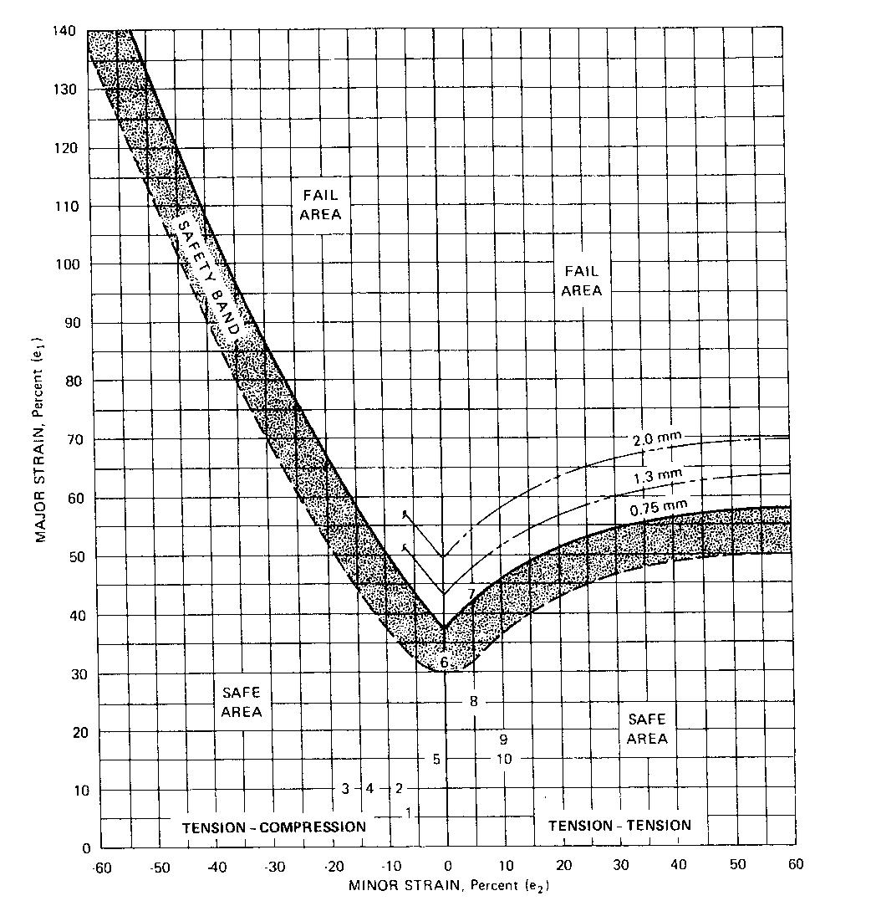

Figure D.1 — Forming limit curve

D.3.4 The sheet metal blanks may be etched by a photographic or electrochemical method. In the former method a photosensitive solution, for example, 50 % Kodak Photo Resist (KPR) emulsion and 50 % Q KPR-thinner, is sprayed onto the sheet. The emulsion is dried by baking the sheet at 65 °C for 15 min or by just standing it for several hours at room temperature in a dark room. The latter should be employed in materials

20 © EAC 2019 – All rights reserved
CD/ 196: 2014

that age and hence, become stronger when baked at 65 °C. The negative is placed on the emulsion, held intimately in contact with the sheet, and exposed to a strong ultraviolet light source for 1 min - 1.5 min. The sheet is developed for 30 s to 45 s in KPR developer, rinsed with water, and sprayed with alcohol to set the resist. It is again rinsed with water and then sprayed with KPR black dye to reveal the etched circles.

D.3.5 In the electrochemical method, the etch pad is saturated with an appropriate electrolyte. Various electrolytes are available from suppliers of the etching equipment. Some electrolytes are more effective than others for etching certain surfaces, such as template and other metallic coated sheets. A rust-inhibiting solution is preferred for steel sheets.

D.3.6 A ground clamp from the transformer of suitable amperage (10 to 50.4 is usually used) is fastened to the blank and the second lead is attached to the etch pad. Although the current may be turned on at this time, caution should be taken not to lay the pad on the sheet blank as it will arc. It is advisable to refrain from touching the metal of the etch pad and the grounded sheet blank.

D.3.7 The stencil is placed with the plastic coating against the sheet surface in the area to be etched. Wetting the stencil with a minimum amount of electrolyte will assist in smoothing out the wrinkles and gives a more uniform etch. The etch pad is now positioned on the stencil and the current turned, on, if it is not already on. Apply suitable pressure to the pad. Only the minimum time necessary to produce a clear etched pattern should be used. The etching time will vary with the amperage available from the power source and the stencil area, as well as the pad area in contact with the stencil. Rocker-type etch pads give good prints and require less amperage than flat-surfaced pads. Excessive current causes stencil damage.

D.3.8 The etching solution activates the surface of the, metal and may cause rusting unless it is inhibited.

After the desired area has been etched, the blank should be wiped or rinsed, dried, and neutralized.

D.3.9 The etched blank is now ready for forming. The lubricants and press conditions should simulate production situations. If a sequence of operations is used in forming a part, it is desirable to etch sufficient blanks so that each operation can be studied.

D.4 Measurement of strain after forming

D.4.1 After forming, the circles are generally distorted into elliptical shapes (Figure D.2). These ellipses have major, and minor strain axes. The major strain (e1) is always defined to be the direction in which the greatest positive strain has occurred without regard to original blank edges or the sheet rolling direction. The minor strain (e2) is defined to be 90° the major strain direction.
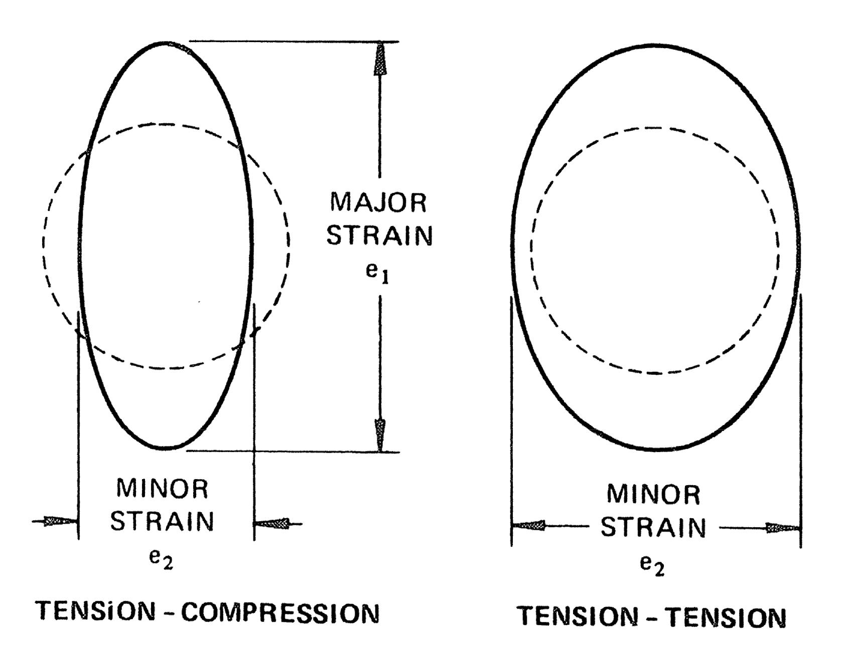

Figure D.2 — Measurement of strain after forming

© EAC 2019 – All rights reserved | 21

CD/ 196: 2014

D.4.2 There are several methods for determining the major and minor strains of the formed panel. Typical tool: are a pair of dividers and a scale ruled in 0.5 mm. For sharp radii, a thin plastic scale that can follow the contour of the stamping can be used to determine the dimensions of the ellipses (scales are available to read the percent strain directly).

D.5 Evaluation of strain measurements

D.5.1 The strain is always positive while the e2 strain may be zero, positive, or negative, as indicated on the forming limit curve chart (Figure D.1). The maximum e1 and associated 2, values measured in critical areas on the formed part are plotted on the graph paper containing the formic: limit curve by locating the point of intersection of the e1, e2 strains.

D.5.2 If this point is on or below the "safety band" of the forming limit curve, the strain should not cause breakage. Points further below the curve indicate that a less ductile material of a lower grade may be applied. Points above the safety band show that fabrication has induced strains that could result in breakage. Therefore, in evaluation on stampings exhibiting these strains, efforts should be made to provide an e1, e2 strain combination that would lie on or below the "safety band" of the forming limit curve. A different e1,e2 strain combination can be obtained through changes of one or more of the forming variables such as die conditions, lubricants, blank size, thickness, or material grade: it should be: noted at this time that these conclusions are derived from a reference base being the steel "quality" used to fabricate the grid stamping.

D.5.3 When attempting to change the relationship of e1 and e2 strains, it should be noted that on the forming limit curve the most severe condition for a given e1 strain is at 0 % e2. This means the metal works best when it is allowed to deform into two dimensions, e1 and e2, rather than being restricted in one dimension. A change in e to decrease the severity can be made by changing one of the previously mentioned forming variables of the die design, for example, improving lubrication on the tension-tension side will increase e2 and decrease the severity.

D.5.4 In addition to the forming limit curve, the e1 e 2, strain measurements may be used to evaluate the material requirements on the basis of strain gradients, as illustrated in Figure D.3, or by plotting contours of equivalent strain levels on the surface of the formed part. Even when the level of strain is relatively low, parts in which the e1 2 strain is changing rapidly either in magnitude or direction over a short span on the surface may require more ductile grades of sheet metal, change in lubrication, orchange in part design.
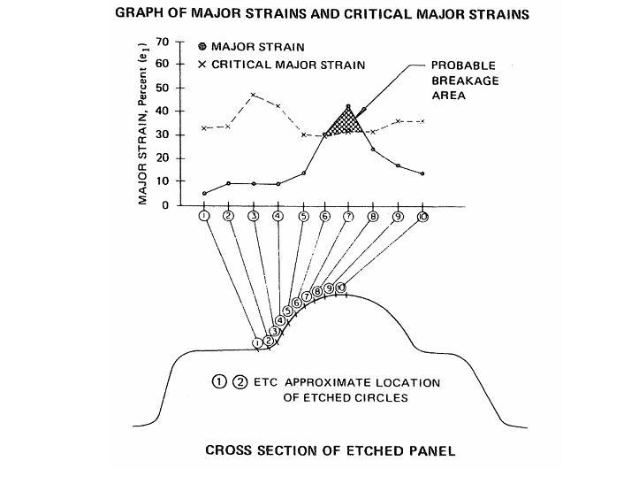

Figure D.3 — Graph of major strains and critical major strains and cross section of etched panel

22 © EAC 2019 – All rights reserved
CD/ 196: 2014

D.6 Example of major and minor strain distribution

D.6.1 A formed panel (Figure D.4) with a cross section as shown in Figure D.3 is used to illustrate major and minor strain combinations. A plot of the major strain distribution should be made by finding the ellipse with the largest major strain (circle 7) and measuring both the major and minor strains in the row of ellipses running in the direction of the major strain. The solid dots (Figure D.3) are the measured major strains for each ellipse. The Xs are the critical major strains as determined from the forming limit curve at the corresponding minor strain (intersection of the measured minor strain and the severity curve).
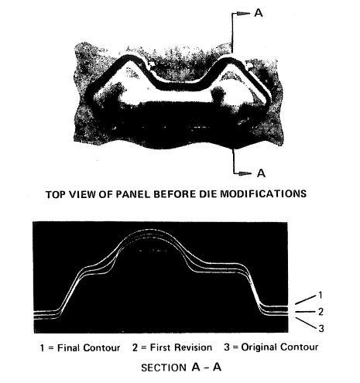

Figure D.4 — Formed panel and cross section

D6.2 Usually a single row of ellipses will suffice to determine the most severe strain distribution. The resulting strain distribution plot (Figure D.3) illustrates both severity of the strain compared to the critical strain limits and the concentration of strain in the stamping. Steep strain gradients should be avoided because they are inherent to fracture sites.

D.7 Example for reducing splitting tendency

D.7.1 If the radius of the pan in the region of circle 1 is increased, some strain can be induced to take place in this area which will allow the major strain in circle 7 to be reduced sufficiently to bring the strain combination below the critical limit. Thus course of action requires no binding or reshaping of the punch, only grinding in the radius.

D.7.2 The total average major strain required to make this formation is only 17.5 %; yet in a 5.0 mm circle the strain is as high as 40 %. The strain distribution curve puts forth graphically the need to distribute the strain over the length of the line by some means as described above.

© EAC 2019 – All rights reserved | 23

CD/ 196: 2014

D.7.3 Change in lubrication can also improve the strain distribution of a stamping. If the strain over the punch is critical, the amount of stretch (strain) required to make the shape can be reduced by allowing metal to flow in over the punch by decreasing the friction through the use of a more effective lubricant in the hold-down area.

D.7.4 If the part is critical, a change in material may help. That is, a material having a better uniform elongation will distribute the strain more uniformly or a material having a higher "r" value will make it possible to "draw" in more metal from the hold-down area so that less stretch is necessary to form the part.

D.8 Scribed square method

D.8.1 The basic technique is to draw a panel from a blank that has been scribed both longitudinally and transversely with a series of parallel lines spaced at 25.0 mm intervals. The lines on the panel are measured after drawing and the stretch or draw calculated as the percent increase in area of a 25.0 mm². This is a fairly simple procedure for panels having generous radii and fairly even stretch or draw. Many major panels fall in this category, and in these instances it is quite easy to pick out the square area exhibiting the greatest increase.

D.8.2 If the square or line to be measured is no longer a flat surface, place a narrow strip of masking (or other suitable tape) on the formed surface and mark the points, which are to be measured. Remove the tape, place on a plane surface, and determine the distance between the points with a steel scale.

D.8.3 There will be cases of minor increase in area with major elongation in the one direction. In these instances, the percent elongation should be recorded.

D.9 Thickness method

There are instances when the maximum stretch is continued to an area smaller than 645 mm or the shape of the square has been distorted irregularly, making measurement difficult and calculation inaccurate. When either of these conditions exists, an electronic thickness gage may be used at the area in question or this area may be sectioned and the decrease in metal thickness measured with a ballpoint micrometer. The increase in unit area can be calculated by dividing the original thickness by the final thickness.

For example, assuming the blank thickness to be 0.80 mm and the final thickness to be 0.60 mm, the increase in unit area would be a [(0.80 - 0.60)/0.80] ⋅ 100 = 25 % increase.

24 © EAC 2019 – All rights reserved
CD/ 196: 2014

Bibliography

- KS 1513, Specification for steel sheet and strip, heavy thickness coils, carbon, hot-rolled

- ISO 14284, Steel and iron — Sampling and preparation of samples for the determination of chemical composition

© EAC 2019 – All rights reserved | 25

CD/ 196: 2013
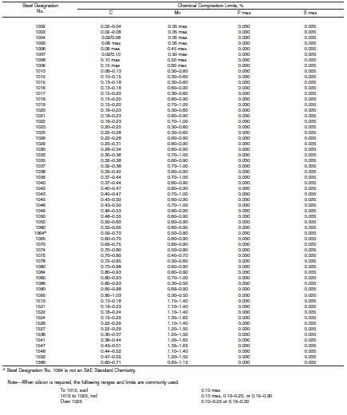

© EAC 2013 – All rights reserved

