DRAFT EAST AFRICAN STANDARD
Crown closures — Specification

EAST AFRICAN COMMUNITY

Copyright notice
This EAC document is copyright-protected by EAC. While the reproduction of this document by participants in the EAC standards development process is permitted without prior permission from EAC, neither this document nor any extract from it may be reproduced, stored or transmitted in any form for any other purpose without prior written permission from EAC.
Requests for permission to reproduce this document for the purpose of selling it should be addressed as shown below or to EAC’s member body in the country of the requester:
© East African Community 2021 — All rights reserved
East African Community
P.O. Box 1096,
Arusha
Tanzania
Tel: + 255 27 2162100
Fax: + 255 27 2162190
E-mail: eac@eachq.org
Web: www.eac-quality.net
Reproduction for sales purposes may be subject to royalty payments or a licensing agreement. Violators may be prosecuted.
Foreword
Development of the East African Standards has been necessitated by the need for harmonizing requirements governing quality of products and services in the East African Community. It is envisaged that through harmonized standardization, trade barriers that are encountered when goods and services are exchanged within the Community will be removed.
The Community has established an East African Standards Committee (EASC) mandated to develop and issue East African Standards (EAS). The Committee is composed of representatives of the National Standards Bodies in Partner States, together with the representatives from the public and private sector organizations in the community.
East African Standards are developed through Technical Committees that are representative of key stakeholders including government, academia, consumer groups, private sector and other interested parties. Draft East African Standards are circulated to stakeholders through the National Standards Bodies in the Partner States. The comments received are discussed and incorporated before finalization of standards, in accordance with the Principles and procedures for development of East African Standards.
East African Standards are subject to review, to keep pace with technological advances. Users of the East African Standards are therefore expected to ensure that they always have the latest versions of the standards they are implementing.
The committee responsible for this document is Technical Committee EASC/TC 066, Packaging.
Attention is drawn to the possibility that some of the elements of this document may be subject of patent rights. EAC shall not be held responsible for identifying any or all such patent rights.

Crown closures — Specification

1 Scope
This Draft East African Standard specifies the requirements, sampling and test methods for intermediate crown closures used on glass bottles.

2 Normative references
The following documents are referred to in the text in such a way that some or all of their content constitutes requirements of this document. For dated references, only the edition cited applies. For undated references, the latest edition of the referenced document (including any amendments) applies.
ISO 11949, Cold-reduced tinmill products — Electrolytic tinplate
ISO 11950, Cold-reduced tinmill products — Electrolytic chromium/chromium oxide-coated steel
ISO 15512, Plastics — Determination of water content

3 Terms and definitions
For the purposes of this document, the following terms and definitions shall apply.
ISO and IEC maintain terminological databases for use in standardization at the following addresses:
— IEC Electropedia: available at http://www.electropedia.org/
— ISO Online browsing platform: available at http://www.iso.org/obp
3.1
crown closures
metal cap lined with lcork or plastic used for sealing neck bottles
3.2
crown shell
metal cap which is formed from a sheet without a liner
3.3
liner
disc or gasket made from cork or PVC plastisol compound or PVC dry blend compound or PVC free dry blend compound lined inside the crown shell for sealing purposes

4 Requirements

4.1 General requirements

4.1.1 Workmanship
4.1.1.1 The crown shell shall be manufactured from tinplate or tin free steel (TFS).
4.1.1.2 Standard type crown shell shall be lined with cork or spun or molded PVC plastisol compound.
4,1.1.3 Intermediate type crown shell shall be lined with 'spun or moulded PVC plastisol compound.
4.1.1.4 In case of cork lined standard crown-shell, the cork liner may be faced with a suitable food grade spotting material such as vinylite aluminium foil if required.
4.1.1.5 The adhesive used for bonding the spotting material to. the cork disc shall be of hot melt type and shall be of non-toxic quality.
4.1.1.6 The liner shall firmly adhere to the shell so that it cannot be removed easily.
4.1.1.7 The liner shall;
- be free from pits and pinholes or any other defect that may impair its function or serviceability or both;
- have no adverse effect on the food product (e.g. through chemical reactions, leaching of liner materials or absorption);
- neither be affected by the foodstuff packed nor altered by the ingredients of the food in its final form in terms of its properties and protective function;
- not result into changes in the organoleptic characteristics of the foodstuff; and
- not be manufactured using post-consumer recycled materials.

4.1.1.8 Internal finish
The inside surface of the crown shall be given a suitable protective coating of lacquer of non-toxic quality. In case of PVC plastisol lined crowns, an adhesive type of lacquer shall be used. Adhesion between lacquer and compound shall be such that the liner disc does not fall or displace from the shell during transportation or during crimping.

4.1.1.9 External finish
The outside surface of the crown shall be given a protective and decorative finish including print as agreed to. between the purchaser and the supplier. The finish shall be such that the crowns flow in chutes of high speed bottling machines without frequent interruption.

4.2 Specific requirements

4.2.1 Dimensions and tolerances
4.2.1.1 The standard and intermediate skirt crown shells shall be manufactured to the dimensions and tolerances shown in Figure 1. The overall height and diameter of the closures shall be checked with gauge shown in Figure 2.
- Thickness: 0.18 mm to 0.24 mm with E1[2.8/2.8m²] or TFS
- Hardness: TH415 to T4(61 ± 5); TH435 to T5 (65 ± 5); TH550 to DR8 (73± 5) on the Rockwell 30T scale
- Finish metal crown: - Shall be free of sharp edge and excessive burrs.
Figure 1 — Dimensions of Standard and intermediate type crown shells
Table 1 — Dimensions of Standard and intermediate skirt crown shell
Type | Height  mm
Standard skirt crown shell | 6.7 ±0.2
Intermediate skirt crown shell | 5.95 ±0.2

Figure 2 — Outside diameter and height checking gauge

Table 2 — Outside diameter and height checking gauge
Type | Diameter  mm
Type | A  GO | B  NO GO
Standard skirt crown shell | 6.89 - 6.87 | 6.50 - 6.48
Intermediate skirt crown shell | 6.14 - 6.12 | 5.75 - 5.73

4.2.2 Boiling test
The gelatine composition cork disc, when subjected to a boling test in water for 1 h, shall not show any sign of disintegration.

4.2.3 Air pressure test
When tested in accordance with Annex A, the crowns shall not show any leakage below 7.03 kg/cm²

4.2.4 Performance requirements of crown shell
The crown shell shall be made from Tin Free Steel (TFS) also known as Electrolytic chromium/chromium oxide-coated steel (ECCS) ECCS complying with ISO 11950 or Electrolytic Tinplate complying with ISO 11949 when tested in accordance with the test methods specified therein.

4.2.5 Chemical composition
In addition to the requirements of ISO 11949 and ISO 11950, the steel base type L that is food grade shall comply with the chemical composition requirements given in Table 3.

Table 3 — Chemical composition of the base steel for metallic crown caps
S/N | Element | Cast composition  %, max.
 | Carbon | 0.13
 | Manganese | 0.60
 | Phosphorus | 0.020
 | Sulfur | 0.03
 | Silicon^{a,b} | 0.020
 | Copper | 0.06
 | Nickel | 0.04
 | Chromium | 0.06
 | Molybdenum | 0.05
 | Aluminium^{c} | 0.10
 | Other elements, each | 0.02
ª When steel produced by the silicon killed method is ordered, the silicon maximum may be increased to 0.080 %.
^{b} When strand cast steel produced by the aluminium killed method is ordered or furnished, the silicon maximum may be increased to 0.030 % when approved by the purchaser.
^{c} Types L may be supplied as non-killed or killed, which would respectively be produced without and with aluminium additions.

4.2.6 Liner
When tested in accordance with Annex B the overall migration limit of the liner constituents shall not exceed 60 milligrams per kilogram of the simulant, equivalent to 10 milligrams of total non-volatile substances released into food simulant per square decimetre of surface area of the liner.

4.2.7 Leakage
Lined crown closures shall be fitted with the liner and shall be well-matched with the bottle they are intended to seal. When tested in accordance with EAS 354, the lined crown cap shall not leak, nor allow diffusion and permeation.

4.2.8 Moisture content
For satisfactory assembly and to avoid excessive sweating in the lined crown caps, the initial moisture content in the composite cork shall be 4% to 6% when tested in accordance with ISO 15512.

6 Packaging
The crown closures shall be packaged in a manner that prevents damage, contamination during handling, storage and transportation.

7 Labelling

7.1 Labelling on the crown shell
The crown shell shall be legibly and indelibly marked with manufacturer’s logo or trade mark and mould number.

7.2 Labelling on bulk package
Each unit of packaging shall carry the following information
- manufacturer name and address;
- brand identification;
- crown type/specification number;
- batch number;
- date of production;
- expiry date
- number and weight of crown closures in a package;
- country of manufacture or origin; and
- instructions for use and disposal.

8 Sampling
Sampling shall be done in accordance with ISO 2859-1.
Annex A
(normative)
Air pressure test
A.1 Apparatus
A.1.1 Dummy bottle top, made from mild steel
A.1.2 Dummy bottle, as shown in Figure A.1
A.1.3 Pressure gauge
A.2 Procedure
A.2.1 Fit the dummy with a non-return air valve and a pressure gauge as shown in Figure A.1.
A.2.2 The crown closure shall be crimped on the dummy and the uniformity of the sealing shall be examined by using a 'GO' and ‘NO GO’ ring gauge as shown in Figure A.2. A crown closure found improperly sealed shall not be used for the purpose of this test.
A.2.3 Pump air-pressure up to 6.5 kg/cm³ as indicated pressure gauge through a non return air valve. Immerse the bottle in water for 15 s. There shall be no leakage of air.
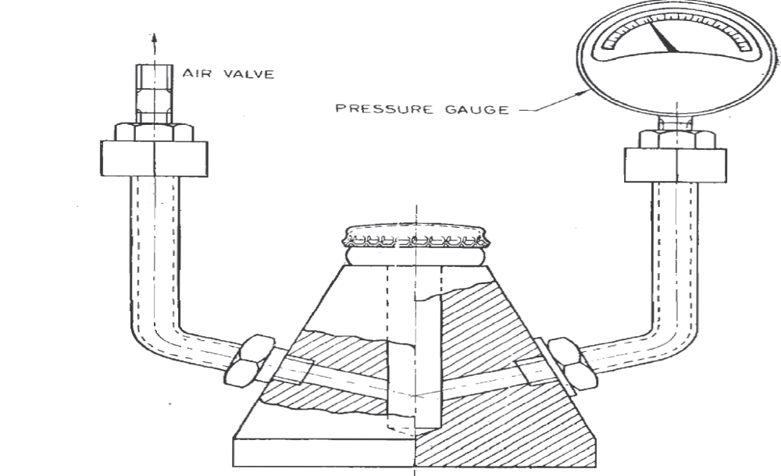
Figure A.1 — Air pressure test
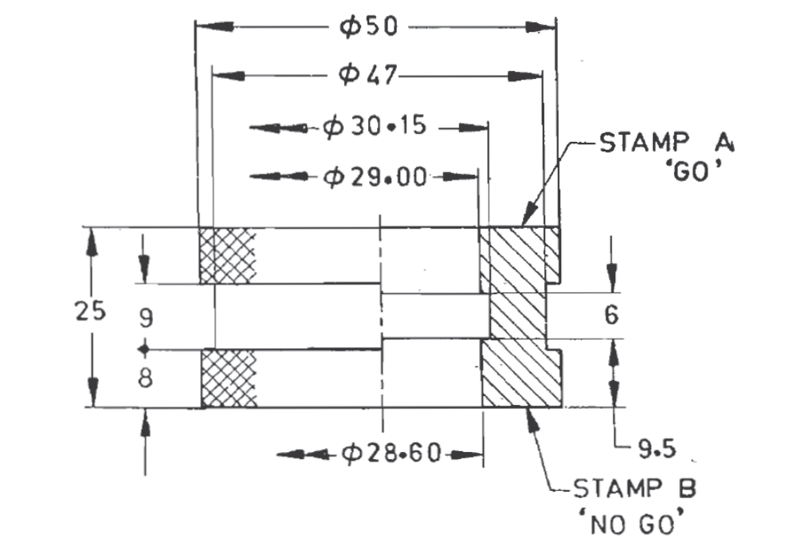
Figure A.2 —Ring gauge for crimped crown closures
Annex B
(normative)
Determination of overall migration of constituents of liner
B.1 General
This Annex specifies the method of analysis for determination of overall migration of constituents of liner.
B.2 Simulants and test conditions
Determination of migration is carried out using the following simulants at 40 ºC for 10 days:
a) Simulant ‘A’ – Distilled water or water of equivalent quality.
b) Simulant ‘C¹’ – 10 % ethanol (v/v) in aqueous solution for foodstuffs having alcohol less than 10 % (v/v) (using the simulant ‘A’)
B.3 Method
B.3.1 Apparatus
B.3.1.1 Electric oven/water bath, equipped with thermostat to maintain the desired temperature within ± 1 ºC accuracy
B.3.1.2 Electric hot plate, with temperature control regulator
B.3.1.3 Analytical balance, with a sensitivity of 0.1 mg
B.3.1.4 Glass beakers, Pyrex of 1 000 ml capacity or equivalent
B.3.1.5 Stainless steel evaporating dish, of 100 ml capacity
B.3.1.6 Stainless steel tongs
B.3.2 Selection of samples
Minimum triplicate samples representing the lot/batch shall be selected.
B.3.3 Preparation of test specimen
The liners used shall be carefully rinsed with water at 25 °C - 30 °C to remove extraneous materials prior to actual migration test.
B.3.4 Simulant quantity
Equal to at least 1 ml/cm² of contact area.
Glassware, laboratory apparatus which come into contact with simulants and/or the sample during the test shall be thoroughly washed and dried prior to the test.
B.3.5 Procedure
Fill the crown to its filled capacity with preheated simulant at test temperature and close it. Exclude air as much as possible before sealing and expose the filled crown closures to specified temperature maintained in oven/water bath/pressure cooker/autoclave for the specified duration of time. After exposure for the specified duration, remove the pouch and transfer the contents immediately into a clean Pyrex beaker along with three washings of the specimen with small quantity of the fresh stimulant.
B. 3.6 Determination of amount of extractive
Evaporate/distil the contents in Pyrex beaker to about 50 ml – 60 ml and transfer into a clean tared stainless steel dish along with three washings of Pyrex beaker with small quantity of fresh stimulant and further evaporate the concentrate in the dish to dryness in an oven at 100 °C ± 5 °C. Cool the dish with extractive in a desiccator for 30 minutes and weigh to the nearest 0.1 mg till constant weight of residue is obtained. Calculate the extractives in mg/dm² and mg/kg or mg/l of the foodstuff with respect to the capacity of pouch to be used.
Carry out the blank test using the same procedure.
Amount of extractive (Ex) =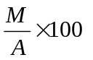mg/dm²; and
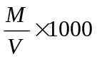mg/kg or mg/l
where
M is the mass in milligrams of residue minus blank value;
A is the total surface area in square centimetres exposed in each replicate; and
V is the total volume in millilitres of simulant used in each replicate.
B.4 Evaluation of results
The materials and articles are regarded as conforming to the specifications if in the migration tests for each simulant used, the average of at least three results does not exceed the value of overall migration limit.
NOTE Before carrying out the test, ensure that the sample is free from all traces of dust, fats and other impurities. If necessary, it should be thoroughly wiped with filter paper. The sample should be handled carefully to avoid any contamination.
B.5 Colour migration
In the case of coloured liner(s), colour migrated to simulant or dried food products shall not be apparent to the naked eye. If the colour migrated is clearly visible, such liners are not suitable for food contact applications, even though the extractive value is within the limit.

