Ref.: KEBS/STA/16/11/1 Date: 10 – 12 – 2019

Title: | - DEAS 1010: 2019 Cottage cheese- Specification  - DEAS 1013: 2019 Cream Cheese- Specification  - DEAS 1011: 2019 Cheddar cheese -Specification (Second Edition)  - DEAS 1008: 2019 Fermented (Cultured) milk- Specification  - DEAS 1012: 2019 Mozzarella cheese- Specification  - DEAS 1009: 2019; Gouda cheese- specification
Document Type: | PUBLIC REVIEW DRAFT
Dates: | CIRCULATION DATE | CLOSING DATE
Dates: | 10– 12 – 2019 | 10 – 02 – 2020

PUBLIC REVIEW DRAFTS;
DEAS 1010: 2019 Cottage cheese- Specification
DEAS 1013: 2019 Cream Cheese- Specification
DDEAS 1011: 2019 Cheddar cheese -Specification (Second Edition)
DEAS 1008: 2019 Fermented (Cultured) milk- Specification
DEAS 1012: 2019 Mozzarella cheese- Specification
DEAS 1009: 2019; Gouda cheese- specification

This Draft Kenya Standards has been prepared by the MILK AND MILK PRODUCTS Technical Committee in accordance with the procedures of the Bureau, and is now being circulated for public comments.

The Committee would appreciate any comments on this Draft Standard, which should be submitted before 10-02-2020 using the attached template. It will also be appreciated if those who have no specific comments to make but find the draft standard generally acceptable can notify us accordingly. Absence of any reply or comments shall be deemed to be an acceptance of the technical contents of the draft Kenya standard and shall constitute an approval vote.

Suggestions entailing amendments of the text should include wording preferred and the relevant clause number quoted against any comments made.

This draft standard is subject to change and should not be referred to or used as a Kenya Standard.

All correspondence pertaining to this draft standard should be addressed to the Managing Director, Kenya Bureau of Standards for the attention of NAOMI MARIACH

Yours faithfully,
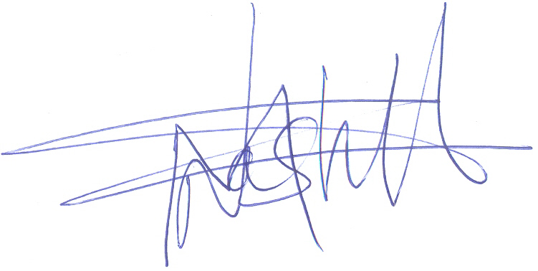
NAOMI MARIACH
For: DIRECTOR
STANDARDS DEVELOPMENT AND TRADE

