Ref.: KEBS/STA/16/11/13 Date: 23 – 12 – 2021

Titles: | - DKS 2954:2021 Cake mixes - Specification
Document Type: | PUBLIC REVIEW DRAFT
Dates: | CIRCULATION DATE | CLOSING DATE
Dates: | 04– 01 – 2022 | 04 – 03– 2022

This Draft Kenya Standards have been prepared by the processed cereals and pulses Technical Committee in accordance with the procedures of the Bureau, and is now being circulated for public comments.

The Committee would appreciate any comments on this Draft Standard, which should be submitted before 04-03-2022 using the attached template. It will also be appreciated if those who have no specific comments to make but find the draft standard generally acceptable can notify us accordingly. Absence of any reply or comments shall be deemed to be an acceptance of the technical contents of the draft Kenya standard and shall constitute an approval vote.

Suggestions entailing amendments of the text should include wording preferred and the relevant clause number quoted against any comments made.

This draft standard is subject to change and should not be referred to or used as a Kenya Standard.

All correspondence pertaining to this draft standard should be addressed to the Managing Director, Kenya Bureau of Standards for the attention of NAOMI MARIACH

Yours faithfully,

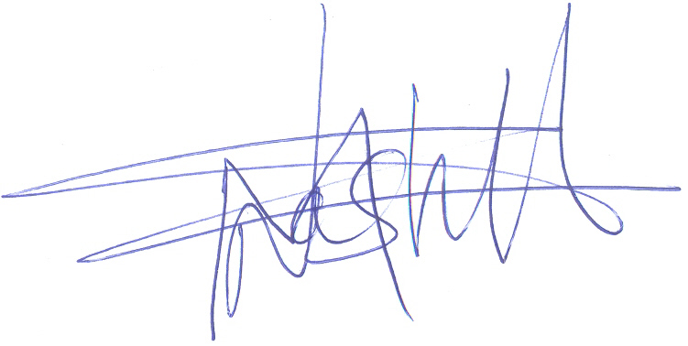

NAOMI MARIACH

For: DIRECTOR
STANDARDS DEVELOPMENT AND INTERNATIONAL TRADE

