curriculum vitae for OSEKO EDWIN
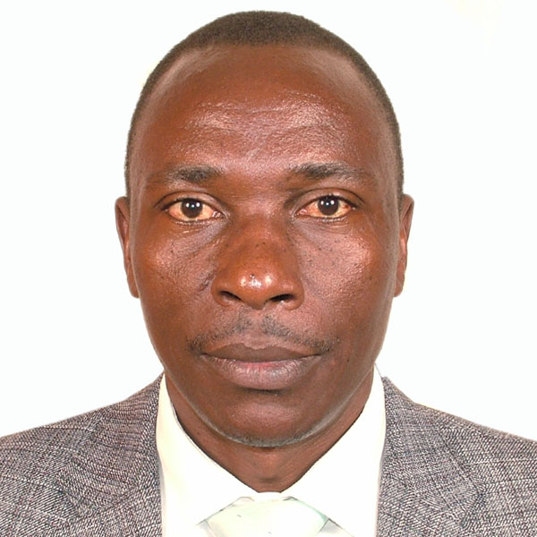
OMBUI
mINISTRY OF AGRICULTURE
kilimo HOUSE
P.O. bOX 30028-00100
nAIROBI.
CELL Phone +254725766082,
E-mail: ombuioseko68@yahoo.com

PERSONAL DETAILS

Date of Birth: 15th July 1968
Nationality: Kenyan
Gender: Male
Marital status: Married
Religion: Christian

PROFESSIONAL SUMMARY

I have over twenty five years’ experience working in Kenya in the field of agriculture development. I am passionate about building and improving rural livelihoods and empowering communities to achieve food security through the promotion of good use of agricultural inputs.
I am a Principal Agricultural Officer in the Kenyan Ministry of Agriculture, Livestock and Fisheries responsible for all issues related to farm inputs, with a major focus on fertilizer. This role ensures a good understanding of government processes, people and requires strong relationships with private sector players in the fertilizer industry. The activities undertaken include:-
- Managing the interface between the Government and private sector on issues relating to government procurement, government subsidy program, including the recent upgrading of the electronic subsidy program.
- Collection and reporting on industry statistics, including fertilizer import data and fertilizer use data.
- Kenyan representation on the EAC and COMESA directorate for Farm inputs.
- Participation and leadership in fertilizer initiatives in Kenya such as government representative in the feasibility assessment on fertilizer production opportunities in Kenya and the recently announced Toyota Tsusho Africa Fertilizer project being implemented in Western Kenya
I am well respected for my knowledge, diligence and outputs by both my internal peers and the extensive network of private sector agricultural input players in the Kenyan and East African community.

WORK EXPERIENCE
2007 to Date: Principal Agricultural Officer (PAO). Fertilizer Unit, Crop Resources and Market Development Directorate Ministry of Agriculture, Livestock, Fisheries and Irrigation, Headquarters, Nairobi Kenya

Specific Responsibilities:-
- Managing the Fertilizer where the key role is to promote farm inputs including fertilizers in the country as well as administering the Fertilizer Price Stabilization Program being implemented by the National Government.
- Providing government input to the Fertilizer Technical Committee on the development of fertilizer standards bases at Kenya Bureau of Standards.
- Monitoring and documenting the importation of fertilizers into the country.
- Liaising with the user Departments on all issues related to type, quantity, timing, distribution and the availability of fertilizers and other agricultural inputs to the farmers.
- Participating in the development of Farm Business guidelines
- Supervision, monitoring and evaluation of fertilizer and other agricultural inputs use in the field.
- Developing indicators for monitoring, implementation and adoption of fertilizer use and other agricultural inputs.
- Advising on institutional improvements for all participants in the fertilizer and other agricultural input value chains.
- Assisting in formulating procurement plans and advising senior bureaucrats and Government officials on all issues relating fertilizer forecast demand (product and volume), stock levels and promotional issues.
- Promoting the use of inputs in the country in collaboration with other stakeholders.
- Monitoring and reporting on all fertilizers, seeds and pesticides traded in the country.
- Representing Kenya’s interests as a Farm Inputs Expert, at East African Community Secretariat.

2006-2007:- District Agribusiness Development Officer, Murang’a North district.
1998-2005:- Divisional Agriculture and Livestock Extension Officer, Ileho Division, Kakamega District, Kenya
1993-1998:- District Farm Management Officer/Farm Inputs Officer Keiyo Marakwet District

EDUCATION
2004- To date: Egerton University, Njoro, Kenya.
Currently pursuing Postgraduate studies (Master of Science in Agricultural Extension). Successfully completed course work and ongoing with Msc thesis writing
Thesis: The factors influencing the effectiveness of National Agriculture and Livestock Extension program (NALEP) focal area approach in the transfer of improved dairy management technologies among smallholder farmers in Kakamega District.
1987-1990: Egerton University, Njoro, Kenya
Bsc Degree in Agricultural Economics (Second Class Honours Lower Division)
1985-1986: Moi High School, Kabarak, Nakuru, Kenya
Kenya Advanced Certificate Examination (KACE)
1981-1984: Gesusu Secondary school, Kisii, Kenya
Kenya certificate of secondary education (KCE)
1973-1980: Nyakegogi primary school. Kisii, Kenya
Certificate of Primary Education (CPE)

LANGUAGES
Excellent communication skills of both oral and written English, Ekegusii and Kiswahili

TECHNICAL CONSULTANCIES
- On a yearly basis since 2009, I have done farm input surveys in the country to know fertilizers and other farm inputs quality, quantity and prices.
- I was the key person when the government was procuring fertilizers in bulk to cushion farmers from escalating prices in 2008 to 2015.
- Nominated in several task forces by the Principal Secretary, Ministry of Agriculture, Livestock and Fisheries, Kenya in the development of farm inputs policies and fertilizer promotion programmes and more recently, the development of the Kenya Electronic Inputs Subsidy Management Programme in 2014.
- Involved in the organization of the 6th and 7th Kenya National Fertilizer Conferences held in 2009 and 2011
- Was the key contact person when Maxwel Stamp PLC conducted a feasibility study for fertilizer manufacturing in Kenya and the East African Region in 2012
- Was the key contact person when Toyota Tsusho of Japan conducted a feasibility study for fertilizer manufacturing in Kenya in July 2014
- Recruited as a national consultant for Kenya by COMESA for compiling issues on fertilizer policy in Kenya in August 2014
- Was hired as a consultant by IFDC/AfricaFertilizer.org in December 2014 to carry out a study on fertilizer use per crop for all crops grown in Kenya
- Was hired as a consultant by IFDC/AfricaFertilizer.org in December 2017 to carry out a study on fertilizer use per crop for all crops grown in Kenya

ASSOCIATIONS
I am a member of the following associations:
  - Kenya Society of Agricultural Professionals,
  - Catholic Men Association (CMA)

REFEREES
- Prof. C.A Onyango
Department of Agric. Education & Extension
Egerton University
Box 536
NJORO
Tel: +254-51-6248/91
Mobile: +254722799468

- Paul Makepeace
Senior Fertilizer Specialist
AFAP
Mobile: +254711326754
Email: paul.makepeace01@gmail.com

- Mr. Zakayo Magara
Deputy Director of Agriculture,
P.O. Box 30028- 00100
Nairobi
Mobile: +254722683605
Email: zmmagarah@yahoo.com

- Henry Ogola
Chemagro International Ltd
P. O Box Nairobi
Mobile: +254721738636
Email: henry.ogola@chemagro.co.ke

