CURRICULUM VITAE 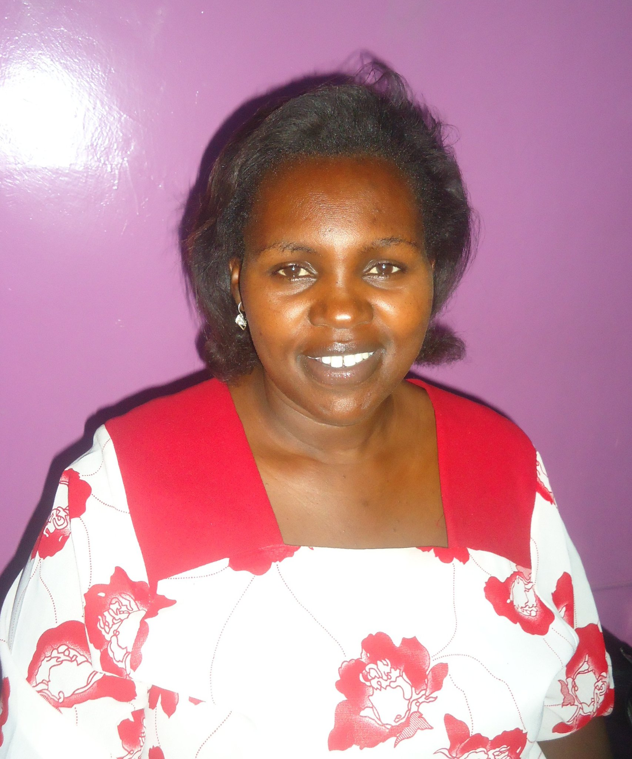

Personal Detail
Names Teresia Waikuru Mwangi
Date Of Birth April 1972
Gender Female
Telephone No 0721381008
Nationality Kenya
Language English , Kiswahili
Marital Status Single
Religion Christian
Id Number 11590217
Email barakawomen2015@gmail.com
Email 2 informalwomen2015@gmail.com
Baraka Website Barakawomenscenter.Org/Media
Website 2 womensnentersintl.org/ Baraka women

PERSONAL PROFILE
- Enthusiastic and self motivated with an eye for accuracy and attention to detail.
- Ability to remain calm and focused under pressure and work within strict deadlines.
- Welcome challenges, learns and adapts well to new situations and opportunities.
- Driven to achieving set goals, reaching deadlines and exceeding expectations.
- Ability to lead motivates and inspires others, a committed team player.
- Friendly, approachable, outgoing personality with a positive outlook.

LANGUAGE

- English.
- Kiswahili.

ACADEMIC PROFFESSIONAL.

- Certificate Kenya Certificate Of Secondary
School: Kihumbu-Ini Secondary School
Period: 1990-1991
Attained: D+

- Certificate: Kenya Certificate Of Primary Education
School Gitugu Primary School
Period 1979-1987
Attained C+

- Diploma In Sales And Marketing Division 2 in 1993.

- Certificate In Measurement In Consumer Products By Kebs For Small Scale Traders.

- Certificate In Treatment And Rehabilitation For Addicted
Persons With Substance Abuse By Bureau For
International Narcotis And Law Enforcement Affairs By
United States Department and Nacada Authority In 2009.

- Certificate Of Training Of Trainers For Drug And Substance Of Abuse, Stress Management, Depression And Addiction Conseling.[Nacada]

- Certificate In Theology[ Miracle Schoolof Ministry] By Mmc/Dr.Mitch.[Israel]

- Certificate Of Trainer Of Trainers Hiv/Aids By National Aids Contol Council.

- Certificate By Unodc [Screaning, Assessment, Treatment Plan, Counseling] Of Addicted Persons.

- Certificate In Computer Package.

- Certificate In Good Leadership And Governance In Project Management By Nacc/Fke

- Certificate In Peer Education Hiv/Aids.

- Certificate In Family Matters

- Certificate In Entrepreneurship And Leadership In Baraka Women Center

- Certificate For Gender Based Violence [Sexual Harassment And Legal Rights By Megen.

- Certificate from Interior and coordination of national Government on Participation in Security.

WORK EXPERIENCE

1994- 1995: Worked For Karen Flowers Company As Assistant
Manager.

1996-2007: Owned My Own Business.

2008: Worked For Kirinyaga Road Jua Kali Association As A Chairlady For The Small And Medium Entrepreneurs.

2009: Worked For Nacada Authority In The Help Desk Treatment And Rehabilitation For Drugs And Substance Abuse Addicted Persons, Counseling And Referrals To Treatment Centers.

2010: Worked In Good Hope Rehabilitation Centre For Drug Addicted Persons As A Treatment Co-Coordinator And A Trainer

2010/11 Trained Kenya Forces Defense On Contract Sensitization On Drugs Abuse Related To Hiv Prevention Amongst Soldiers.

2011/12: Voluntary Sensitizing, Counseling The Drugs Addicted Persons/ Hiv/Aids Patients And Referrals To The Treatment Centers.

2008/2012 Volunteer Program Officer Nairobi Metropolitan Jua Kali Associations.

2012 November Nominated To Represent And Sit In The National Hiv Prevention Task Force In Nacc By Kenya Private Sector Advisory Network.[Kpsan

2012 Working Half Time for Women Centers International As Baraka Center Program Coordinator.

2013-2016; working For Baraka Women Center as a Center Manager, Business entrepreneur to the marginalized and most vulnerable women.

2016; volunteer in women transformation and empowerment for Katutula Osirai Samburu Laikipia.

2017-2018 Nominated by National Training Authority to sit in Technical committee for Manufactures and allied agencies.

2014-2018 I am also an entrepreneur for the beadwork and arts and crafts products from Jua Kali and Organizational women’s trainings

HOBBIES, INTERESTS AND ACTIVITIES
- Socializing.
- Entrepreneurship
- Dancing.
- Mentorship

REFEREES
- Richard Muteti
C.E.O.National Federation of Jua Kali
Tel;0722528273

2. Susan Burges
Director
+5105074424
Women Centers International.
email. susanblt@gmail.com

