PETER SIBALE MUSAKHI. 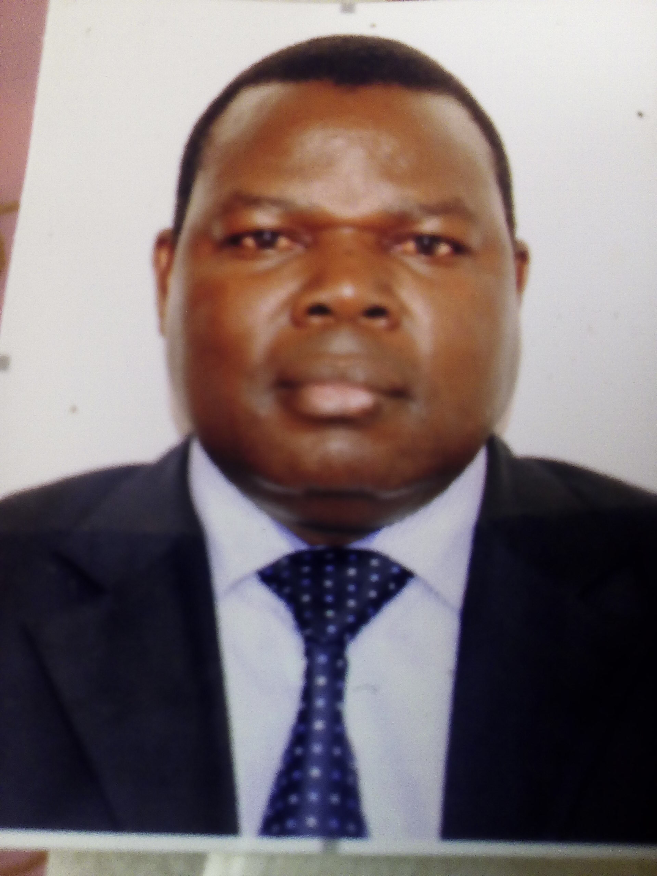
P.O. Box 122-0068, Ruaraka, Nairobi, Kenya
Contact details- Mobile: +254 722 453257, Email: psmusakhi18@gmail.com

PROFILE:
Peter Sibale Musakhi is a passionate local and International Social Development expert with diverse experience including in Education and Social leadership and proven ability to strengthen a wide range of programs particularly Disability through his leadership, innovation and strategic thinking. For the last 26 years he has worked in Government, INGO and Philanthropy leading strategic development, program designs, implementation of projects and proposal development and grants management of social development programs. He ensures programs are delivered to the highest quality and accountable to those they are serving. His focus has been in development, implementation, monitoring and evaluation and sometimes reporting and advocating for policies which champion for Persons with disability and community driven programs that emphasize sustainable livelihoods and work force skills development, civic education, rights-based approaches and capacity development. Being a programmatic and diplomatic, effective communicator and skilled social worker, Peter can facilitate the participation of diverse stakeholders – from Persons with disabilities - led community based organizations, Government, and Intergovernmental relations major bilateral and multilateral agencies– in collaborative initiatives. He is inspired by the potential of young Persons and youth with disabilities and is an advocate for providing platforms for that potential to be realized.

Peter is an expert in Programme Development, Research and Evaluation with a lot of background in Economics and greatly self-motivated, success-oriented, with stamina and positive attitude, and versed in grassroots capacity building approaches and Action research and Evaluation methodologies, teamwork and very sociable, with highly developed analytical, writing and communication skills.

PROFESSIONAL EXPERIENCE

The Ministry of devolution and ASAL
Deputy Director - Intergovernmental Relations
September 2018 to date
Responsibilities:

- Head of Division and Managing the performance of assigned Staff.
- Designing, developing policies for Intergovernmental Relations
- Identifying the County / Local Governments capacity needs and designing intervention programme in liaison with relevant institutions
- Liaising with Relevant Training institutions including Kenya School of Government to design training content for capacity development of county officials for effective delivery of services / devolved functions
- Soliciting, reviewing, and responding to grant proposals and develop grant making activities in a team-oriented context that are aligned to the strategic goals of devolution.
- Guiding implementation of Alternative Dispute Resolution Mechanism for enabling reduced litigations between National and County Governments and between County Governments for smooth implementation of devolution
- Responsible for Social Protection and Education Intergovernmental Sector Forums
- Tracking the Implementation of Summit resolutions by National Governmental Institutions
- Responsible for managing the review of Intergovernmental relations structures for effective delivery of Devolution
- Responsible for Managing Strategic Partnerships for urban Areas and cities development
- Responsible for tracking the uptake of Sustainable Development Goals (SDGs) by the County governments
- facilitating implementation of GIZ Renewable Energy programme by Ministry of energy, County governments and other development partners

Disability Sub sector:

- Rapporteuring for Social Intergovernmental Sector Forum where disability is domiciled
- Trainer and facilitator in Disability Mainstreaming for Government targets in Performance contracting
- Expert in guiding development and implementation of innovations in disability sub- sector
- Expert in disability employment matters, Disability Accessibility and Usability Audits
- Expert in disability education particularly for persons with developmental disability
- Panelist for recruitment of Professional Fellows Program on Inclusive Disability Employment in Kenya from 2017 to 2019., The program was sponsored by the Bureau of Educational and Cultural Affairs of the U.S. Department of State and implemented by the Association of University Centers for Disabilities (AUCD) in partnership with the Institute for Community Inclusion (ICI) at UMass Boston and locally coordinated by Humanity & Inclusion (formerly Handicap International).

The Ministry of Labour and Social Development,
State Department for Social Protection
Assistant Director, Social Development: Head: Persons with Disability Division: May 2010 to Sept 2018:

Responsibilities

Strategic Leadership and Planning
- Providing senior level strategic leadership, direction and representation of Disability Programmes
- Facilitating Disability Mainstreaming in Government at all levels
- Facilitating engagement with multi and bilateral Partnerships

Policy Leadership
- Coordination of preparatory activities for observance of the annual UN day of- Persons with Disabilities
- Coordination of Kenya State participation in International obligation conferences including the Conference of State Parties to the United Nations Convention on Rights of Persons with Disabilities (CRPD), to report on National disability progress and share good / best practices
- Oversight of the country performance and delivery, ensuring key performance and quality indicators are achieved in disability sector
Programming Leadership
- Coordination of the National Cash Transfer programme to Persons with Severe Disabilities Programme, 2010 to 2015
- Work with NCPWD in development of indicators for Monitoring and Evaluation of the Disability Programmes for National reporting
- Responsible for development and implementation of Disability Policy, Disability strategy and its Action Plan
- Responsible for ensuring achievement of set targets in Performance contracting on Disability
- Responsible for inclusive disability budgeting
- Secretary to the National Steering committee for implementation of recommendations by CRPD committee on Kenya

Partnerships, Investment & Grant Management
- Provide ultimate oversight of the partnership and grant portfolio in line with the disability’s strategic ambitions.
- Ensure all major grants exceed contract deliverables, while ensuring priority partnerships are developed and sustained
- Coordination of partnerships for strengthening capacity for disability implementation

Achievements

- Led in the development of Framework for implementation of Cash transfer for Persons with severe disabilities in 2010
- Led in development of the National Disability Mainstreaming Strategy
- Led in development of the National Action Plan for Disability Accessibility Rights
- Led the development / review of the National Persons with Disability Policy (2011 to 2018)
- Led in Mobilizing resources for development of the National Volunteer Policy
- Chaired the Technical Committee on the Review of Persons with Disabilities Income Tax Order, 2010:
Hosted by National Gender & Equality Commission (NGEC)
- Facilitated / coordinated the review of the Disability Act 2003 through the Persons with Disability Bill 2018
- Facilitated the work on the Legal capacity for Persons with Disabilities by the Survivors of psychiatry Kenya and Kenya National Commission on Human Rights
- Guided several Ministries, State Departments and Agencies to develop their work place Disability Mainstreaming Policies and Strategies
- Oversaw recruitment and employment of over 20 youth with disability
- Coordinated writing of the Initial Kenya Country Report on United Nations Convention on the Rights of Persons with Disabilities (UN-CRPD) 2011/2012.
https://dredf.org/web-log/tag/peter-musakhi/.
- Participated in Developing the Training Manual for Disability mainstreaming for Women with Disabilities in Africa.
- By East African Federation for disabled organizations (EAFOD) and Disabled women in Africa (DIWA).
Led in Developing training / sensitization manual for Persons with Albinism programme in Kenya. www.socialprotection.or.ke.

- Have trained over 2000 Public servants on Disability mainstreaming
- Participated in Drafting country concept papers to address Legal capacity for persons with disability in Kenya
- Represented the Government of Kenya on the committee of Ministers of seven in Addis Ababa October to November, 2013, towards establishment of the African Union Disability Institute as an African Union programme
- Was Board member of the African Rehabilitation Center for African Union 2010 to 2014
- Participated in the Wheelchair Services and Use Outcomes: A Cross-sectional Survey in Kenya and the Philippines: African Journal of Disability, http://www.ajod.org
- Represented the Government of Kenya in discussion towards establishment of Social Protection Policy in Ethiopia under IGAD 2010.
- Coordinated the State delegation to the review of Kenya’s initial report on disability by the UNCRPD committee of experts in Geneva August 2015 and later developed the National Plan of Action to implement the recommendation
- Coordinated the writing of Kenya state statement to UN Conference of state parties to the Convention on the rights of Persons with disabilities (2011 to 2018)

Ministry of Youth Affairs and Sports, Department of Youth Development
Head of Section -Youth Empowerment - 2007 to 2010
Achievements:

- Was head of the division responsible for Action Based Research to guide development of Youth in development of projects and programmes.
- Researched widely on youth groups, their activities and related Information and Data management.
- Designed, initiated and piloted the National Youth Empowerment Programme
- Participated in the development of joint UNDP, Government and Civil Society Youth Empowerment Manual
- Coordinated the dissemination of the African Youth Charter and Commonwealth Youth Program
- Developed and implemented different concept notes on youth employment/entrepreneurship, notably Trees for Jobs - Kenya National Talent Academy and internship scheme
- Participated in the Development of National Plans of Action on the strategic thematic areas of the Kenya National Youth Policy I.e. Youth and Health; Youth and Employment; Youth Leisure, Recreation & Community Service, Youth Empowerment & Participation, Youth and Environment and Youth Training, Youth and ICT
- Secretary to the Inter-Ministerial Grants Committee (2007 to 2010)
- Prepared several vital Ministry documents including performance contracts forms, periodic reports and functioning proposals.
- Preparation of budgets and financial management systems for specific programmes and projects.
- Led in Monitoring and Evaluation of youth programs, projects and activities.
- Initiated and managed collaborations with stakeholders and Development partners on a number of initiatives.

Ministry of Education, Teachers Service Commission, Kenya
Graduate Teacher & Deputy Head Teacher 1994 to 2006: Head of Discipline and High school teacher of Economics and Business Studies

Awards and Achievements:
- Awarded several Certificates for meritorious teaching, which saw the school Excel in National Examinations
- Was Examiner in the national Examination for over 5 years
- Was awarded certificate of excellence for dedication in teaching Economics
- Initiated students’ straight talk club to enhance open dialogue among students
- Transformed the students discipline to an admirable standards and left good legacy on my departure

EDUCATION AND CERTIFICATES

- Catholic University of East Africa: 2017 To date: Candidate: Ph.D. in Education (Research and Evaluation of Programmes): comparing the Learning Experiences of Children with Autism in mainstream and special units in Kenya.

- Catholic University of East Africa, Nairobi, Kenya: MA in Education (Curriculum Development and Monitoring and Evaluation Studies)

Kenyatta University, Nairobi, Kenya: Bachelor of Education (Bed) Arts: Economics and Business Studies

- HIV/AIDS and Epidemiology-at the school of Health sciences- Kenyatta University.

- Kenya Sign Language Education (Basic Interpretation Levels): University of Nairobi

- Tokyo Japan, and Bankok, Thailand: Certificate in Disability Mainstreaming and Policy Development, by JAICA
- Disability Reporting: International and Programme Reporting. Nairobi, by Kenya National Commission on Human Rights
- Certificate in Computer (BACET Computer College), Mombasa, Kenya.
- Kenya School of Government: Project planning and Management:
- Kenya School of Government: Strategic Leadership Development Programme Course (SLDP); Strategic Leadership Perspectives in Organizations
- Communicating Population and Health Research to Policymakers, by both National Coordinating Agency for Population and Development (NCAPD), Population Studies and Research Institute (UoN) and Population Research Bureau (USAID), May 28thto June 8th2008 at school of Monetary Studies, Nairobi.

PROFESSIONAL COURSES AND WORKSHOPS ATTENDED.
Abroad:
- Organization Leadership strategy: (2009), Kampala, Uganda
- Statistics / Measurement of Disability: Workshop by the Washington group on Disability statistics; June 2018, Church Centre for the United Nations, UN Plaza, New York, USA
- Seventh Session of state parties to UNCRPD, New York, USA, (June, 2014 to 2019)
- Disability Assessment for Developing Countries (Ethiopia Addis Ababa, 2013)
- Social Protection policy: Good practices in Africa, (Ethiopia Addis Ababa, 2010)
- Rights - Now Programme: Barriers to Employment. In Washington DC, September 2016.
- Statistics and data for persons with disability: Kigali, Ruanda, by JICA
- The inaugural Harkin International Disability Employment Summit: December 8-9, 2016 at the Renaissance Hotel in Washington DC, USA. The summit provided platform for sharing the common / global goal of increasing competitive employment opportunities for Persons with disabilities
- The Global Disability Summit 24th July, 2018 1000- 1100 At Queen Elizabeth Olympic Park London, Uk
- The ATscale Forming Committee for Assistive Technology: September 26-27, 2018 Bethesda, Maryland. USA

Local:
- Post 2015 disability development agenda (Maanzoni Lodge, Nairobi, Kenya, 2014)
- Disability Access in Africa: KICC, 2012, Nairobi, Kenya
- Disability Report Writing: For Local and International Obligation: By Kenya National Commission on Human Rights, Nairobi, Kenya 2014
- Managing for Results Training by Kenya Institute of professional studies, organized by Department of Personnel Management, (DPM), Office of the president- attained certificate in managing for results, April 2007.
- Certificate in Educational Administration Management, (May 2000). National Promotion Course for Head teachers of Secondary schools in Kenya, by Kenya Educational Staff Institute-(KESI)
- School Safety Control, Adolescence problem management, and peace from classroom. Workshop at Tangazo College of Theology
- Four week course in Natural Family Planning organized by Family Life Education Programme(NFP); SEP.2000 to July2002

CONSULTANCY WORK COMPLETED
- Lead consultant in a baseline survey on Inclusive wash and disability project in dadaab, 2014 under World Vision
- Lead Consultancy to develop Disability Mainstreaming Strategy and costed- Action Plan for addressing HIV/ AIDS among Persons with disability (NACC,2013)
- Developed draft Gender Mainstreaming Policy for National Council for Persons with disability (NCPWD 2013)
- Carried out Consultancy to Develop Disability Mainstreaming Policy in Kenya Institute of the Blind (KIB), 2013
- Developed Disability Mainstreaming Policy in Office of Prime Minister (2011)
- Developed Disability Mainstreaming Policy for Kiambu Technical Institute 2011
- Carried out a study on Child Labor withdrawal from fishing industry and Re- routing into formal and non- formal Education under the Center for Education, Population and Development (CEPED)’S NGO.
- Carried out Consultancy with BUHEDE –Kenya (center for community Empowerment and Development) in developing a training module for training members of Kenya Fisher’s Network (KEFPEN).
- Provided seminars on Fundraising, basic book-keeping and project management skills to CEPED’S divisional child labor committee members and care-givers.
- Carried out Needs Assessment for ILO/IPEC action programmes on Elimination of Child labor in Kenya; 2002 Budalang’i and Uranga Divisions, Busia and Siaya Counties respectively.
- Research Assistant in a study undertaken by UN-HABITAT in conjunction with Catholic university of Eastern Africa’s center for justice and peace to establish the Housing and training needs and property rights of the people living in Kuindwa Estate, Kibera slums Nairobi, November 2004.
- Research Assistant; (2004-2005); with the Center of Justice and Peace, (catholic university), where my assignments included Development and Pre-testing the questionnaires, Coordinating Data collection, Coordinating Data entry and analysis, Report writing
- Lead Consultant: WIKA consultants (John Snow International Research on Making Medical Injection Safe. (Nyanza and Western Kenya), 2005
________________________________________________________________________________

SELECTED UNPUBLISHED STUDY REPORTS:
- Baseline Survey on Knowledge, Attitude and Practice on HIV/AIDS among youth in Busia District:
- Water and Sanitation Situation in the Fishing Community of Bunyala South, Bunyala District (2005).
- Mapping of the youth groups and organizations, for economic empowerment: Ministry of Youth Affairs and Sports (2007)
- Mapping of economic Resources for Youth Development Programming (2008)

Achievements
- Promoting Regional Development through Organized Groups
- Formulation, Implementation and evaluation of Projects. A handbook for Rural/Regional Focused Development Groups
- Awarded the Best winner for the most inclusive crusader for disability mainstreaming by Gender and Disability Centre 2017
- Oversaw establishment of over 50 Youth Empowerment Centers
- Initiated and fundraised for development of the National Volunteer Policy

MEMBERSHIP TO PROFESSIONAL SOCIETIES AND COMMITTEES;
- Member of the Kenya Association for Public Administration and Management (KAPAM)

- Member of the Assistive Technology Scale (ATscale) Forming Committee, responsible for the development of AT scale Public-Facing Strategy (July 2018 to 2019)

- Member of the Global Disability Innovation (GDI) Hub: a forming partner of ATscale, the new Global Partnership for Assistive Technology. The key objective of the global partnership is to reach 500m people globally by 2030 with the life-changing assistive technology that they need.
- Member of the Interviewing Panel for the Annual Professional Fellows Program on Inclusive Disability Employment which supports about 20 Professional Fellows from Kenya, Uganda and Tanzania to participate in a five- week intensive fellowship program at a university-based research and education center for disabilities in the United States. The programme targets professionals working in inclusive employment in the Kenya, Uganda and Tanzania
- Member of the Global Disability Summit (GDS18) Key Accountability Stakeholder that helps to strengthen the accountability mechanism towards effective implementation of the GDS18 Outcomes and Kenya Country Commitments. (July 2018 to 2019)

- Served as member of the defunct Regional Disability Technical Advisory Committee (RDTAC) housed by the African Rehabilitation Institute (ARI) Nairobi, Eastern Africa Regional Office.

- Member of Trustee Board of Bunyala Institute of Technology

- Member of Board of Governors, Bukoma Secondary School, Busia County

- Board member Kenya Society for the Blind (KSB) 2015 - 2019
____________________________________________________________________________

LANGUAGES
- English (Fluent – spoken and written), Swahili (Fluent- spoken and written

VOLUNTEER EXPERIENCE
- Sense International Programme for Deaf community in Kenya, 2018 to 2019
- 2017 to date: volunteer as Interview Panelist for the professional fellows programme on inclusive disability employment (PFP-IDE) sponsored by the US Department of State of State Bureau of Educational and Cultural Affairs, targeting young professionals from Kenya, Tanzania and Uganda, under HI, Kenya
- 1998- 2009 -A range of mentorship roles with young people in the then Bunyala District on self employment programmes

PAPERS PRESENTED:
- The role of International partnerships in volunteering for development: examples from Kenya, European Volunteer Centre Symposium, Brussels, Belgium organized by ECV: ‘’Volunteering as a means of empowerment and social inclusion-’’A bridge between the European Years 2010 and 2011

National, Regional and International Assistance in addressing Youth Development issues, Durban, South Africa during the International Youth Crime Prevention Summit

Sharing Good Practices, Rights Promotion, Advocacy, Inclusive Planning and Evidence Collection Around the Convention on the Rights of Persons with Disabilities (CRPD): October, 2014, Arusha Tanzania. Bilateral Symposium by Handicap International

Understanding and the Implementation of the Convention on the Rights of Persons with Disabilities (CRPD) in Government: workshop for DPOs by UDPK, April, 2015, Nairobi, Kenya

Position Paper on Advancing the Rights of Persons with Psychosocial Disability in Kenya during workshop organised by Users and Survivors of Pyschiatry- Kenya, on the June, 2017 at the Monarch Hotel, Nairobi

Decent work for Persons with disabilities: Promoting Rights in the Global Disability Agenda: workshop for public and private sector Human Resource managers by Youth Disability Organization (ANDY), Nairobi, 2019

Access to Education as a Right for Persons with Disabilities: by Youth Disability Organization (ANDY), Nairobi, 2019
- Access To Health As a Human Right For Persons With Disabilities: Workshop By Youth Disability Organization (ANDY) For Duty Bearers And Persons With Disabilities, Nairobi, 2019

Mainstreaming Human Rights of Persons with disabilities in all policies: workshop for organizations for and of Persons with disabilities, by UDPK, November, 2017, Nairobi, Kenya

The Government perspectives on disability & Gender progress: Facilitated at a UN Human Rights Workshop on Disability & Gender in Mombasa, 2011, Nairobi, Kenya

Disability Mainstreaming Policy at Work Place: Workshop for Ministries and Departments: October, 2018 Naivasha, Kenya
- Inclusive Urban areas and Cities in the emergence of devolution in Kenya: During the International Conference on disability Rights and Awareness hosted by University of Nairobi, Kisumu campus December 2019
- Jukumu Langu-Me and the County Government: An Exposition- Opportunities for organizations for Organizations of and For Persons with Disabilities, organized by United Disabled Persons of Kenya- Umbrella organizations of persons with disability in Kenya, October 2019, Nairobi
- The Big Four Agenda for the Government of Kenya up to 2022: Inclusion of Persons with Disabilities: October 2019, Nairobi
- Presented a paper on Climate Change: The Case for Persons with Disabilities: November 2019, Nairobi
- Presented a paper on Labour Market Characteristics of persons with disabilities and disability data for policy making and intervention in the labour market, during a workshop on: “Innovation to Inclusion (i2i)”. This being a 3-year programme funded by the UK Department for International Development (DFID). January, 2020, Nairobi, Kenya:

INTERESTS:
Extensive reading, volunteering towards social justice, inclusion, coaching and mentoring young persons with disabilities in vulnerable situations

REFEREES:
MS ANGELINE HONGO  Director, Intergovernmental Relations Department  State Department for Devolution  Ministry for Devolution & ASAL  P.O. 30040-00100.  Nairobi, Kenya  Email: angelinehongo@gmail.com | MARGARET WAWUDA MLIWA.  The Ford Foundation  Program Officer, Eastern Africa, Youth Opportunity & Learning  P.O. Box 19223-00100, Nairobi, Kenya  Contact details- Mobile: +254 722 566 226, Email: mwmliwa2011@gmail.com | EDWIN OSUNDWA  Country Director,  Sense International  P.O. Box 30004-00100,  Nairobi, Kenya  Email: edwin@senseint-ea.org

