Meter for dispensing liquefied petroleum gas (LPG) from cylinder — Specification

© KEBS 2022 Second Edition 2022

NATIONAL WORKSHOP REPRESENTATION

The following organizations were represented on the National Workshop Agreement Meeting:

Envirofit International
Paygo Energy Ltd.
Energy and Petroleum Regulatory Authority (EPRA)
Merchant Technical Services (MTS)
M-Gas Limited
Galana Oil (K) Ltd.
Nuclear Power Energy Agency (NuPEA)
Onstream Technologies Ltd.
Kenya Industrial Property Institute (KIPI)
Kenya National Accreditation Service( KENAS)
Petroleum Institute of East Africa
Technical University of Kenya
Kenya Bureau of Standards — Secretariat

REVISION OF KENYA STANDARDS

In order to keep abreast of progress in industry, Kenya Standards shall be regularly reviewed. Suggestions for improvements to published standards, addressed to the Managing Director, Kenya Bureau of Standards, are welcome.

© Kenya Bureau of Standards, 2022

Copyright. Users are reminded that by virtue of Section 25 of the Copyright Act, Cap. 130 of 2001 of the Laws of Kenya, copyright subsists in all Kenya Standards and except as provided under Section 25 of this Act, no Kenya Standard produced by Kenya Bureau of Standards may be reproduced, stored in a retrieval system in any form or transmitted by any means without prior permission in writing from the Managing Director.

Meter for dispensing liquefied petroleum gas (LPG) from cylinder — Specification

KENYA BUREAU OF STANDARDS (KEBS)

Head Office: P.O. Box 54974, Nairobi-00200, Tel.: (+254 020) 605490, 602350, Fax: (+254 020) 604031
E-Mail: info@kebs.org, Web:http://www.kebs.org

Coast Region Lake Region Rift Valley Region
P.O. Box 99376, Mombasa-80100 P.O. Box 2949, Kisumu-40100 P.O. Box 2138, Nakuru-20100
Tel.: (+254 041) 229563, 230939/40 Tel.: (+254 057) 23549, 22396 Tel.: (+254 051) 210553, 210555
Fax: (+254 041) 229448 Fax: (+254 057) 21814

Foreword

This Draft Kenya Standard was prepared by a Joint Technical Committee of KEBS TC 105 Instrumentation and Calibration Coordination and KEBS TC 117 Liquefied Petroleum Gas installations, comprising of Key Stakeholders under the guidance of the Standards Projects Committee, and it is in accordance with the procedures of the Kenya Bureau of Standards.

This meter is a device used for dispensing controlled amounts of liquefied petroleum gas (LPG) from cylinders. Measurement of small quantities of vapour LPG and the ability to remotely control access to the LPG is a critical function of the meter. The meter is designed for low pressure applications.

This standard cancel and replaces KNWA 2885: 2019.

Meter for dispensing liquefied petroleum gas (LPG) from cylinder — Specification

1 Scope and field of application

1.1 This draft Kenya Standard specifies functional and safety requirements for meter used for dispensing metered amounts of LPG from gas cylinders.

1.2 This standard applies to low pressure applications only.

1.3 This standard does not cover meters for reticulated or autogas applications.

2 Normative references

The following documents are referred to in the text in such a way that some or all of their content constitutes requirements of this document. For dated references, only the edition cited applies. For undated references, the latest edition of the referenced document (including any amendments) applies.

KS 91, Petroleum and petroleum products — Liquefied Petroleum Gas (LPG) — Specification

KS 2189, Low pressure liquiefied petroleum gas (LPG) regulator for use with unified valve ― Specification

KS IEC 60079-10-1, Explosive atmospheres, ― Part 10-1: Classification of areas ― Explosive gas atmosphers

3 Terms and definitions

For the purposes of this document, the terms and definitions given in KS 91 and the following apply:

3.1
telemetry
process of recording and transmitting the readings of the meter

3.2
low pressure applications
applications in which the pressure has been regulated in accordance with KS 2189

3.3
liquefied petroleum gas (LPG)
as specified in KS 91

3.4
qualified installer
person with prerequisite training and knowledge on LPG meter installations

4 Requirements

4.1 Components

4.1.1 Low pressure regulator

The low pressure LPG regulator incorporated in the meter assembly shall meet the requirements specified in KS 2189.

4.1.2 Flow measurement device

4.1.2.1 The flow measurement device shall be compatible with the LPG and meet the accuracy and safety requirements as given in 4.4.3 and 4.3 respectively.

4.1.2.2 The device shall be calibrated to measure the mass flow of the LPG. The measurements shall be traceable to the International System of Units (SI Units).

4.1.3 Gas shut-off valve

4.1.3.1 Gas shut-off valve is an electronically controlled valve that controls gas flow.

4.1.3.2 The gas shut-off valve shall be rated for LPG and shall be suitable for use in Zone 2 hazardous areas according to KS IEC 60079-10-1.

4.1.3.3 The gas shut-off valve shall have the following:

a) Flow range shall be ≤ 4 m³/h;

b) Working pressure shall be 6 kPa maximum; and

c) External seal shall ensure that there is no leakage at 10 kPa.

4.1.4 Power supply

4.1.4.1 The batteries shall be used in accordance with the requirements of regulations for Zone 2 explosion-proof equipment by the intrinsic safety protection method.

4.1.4.2 Batteries shall be securely mounted and protected by the physical enclosure such that safety cannot be impaired by any possible leakage of their electrolyte.

4.1.4.3 Battery polarity shall be guaranteed by single direction connectors.

4.1.4.4 The batteries shall be installed, replaced or recharged in accordance with the manufacturer’s instructions.

4.1.4.5 Any other power supply other than batteries shall comply with applicable safety requirements.

4.2 Materials

4.2.1 All components of the meter that come in contact with the LPG shall be compatible for use with the LPG.

4.2.2 The meter outer enclosure shall be made from flame retardant material.

4.3 Safety

4.3.1 The meter shall be designed and certified by an accredited third party for use in Zone 2 hazardous areas in accordance with KS IEC 60079-10-1.

4.3.2 The meter shall be installed by a qualified installer. Installations shall be done at the end consumer’s premises.

4.3.3 Safety checks, user training and safety awareness for the consumer shall be provided.

4.3.4 In the event of a fire breakout, the LPG cylinder together with the meter shall be quickly disconnected from the LPG appliance, to move the unit away from the fire.

4.4 Performance

4.4.1 Coupling

The meter shall be able to be coupled to domestic cylinders with unified spindle-type valve. However, the meter may also be used on higher capacity cylinders for low pressure applications in compliance with the applicable LPG regulations.

4.4.2 Compatibility with LPG

The meter components that come into contact with the LPG shall be compatible with LPG composition specified in KS 91.

4.4.3 LPG measurement accuracy

The allowable measurement error shall be ± 3 % of amount of LPG in the cylinder for type approval,and ± 6 % for subsequent verification in service with a flow rate ranging from 0.1 m³/h to 0.5 m³/h when tested in accordance with Annex A.

4.4.4 Disconnection and reconnection

In the event of power or connectivity failure within the meter, disconnection and reconnection of the meter from the cylinder shall be done by qualified installer authorised by the meter owner.

4.4.5 Re-opening the valve after shut-off event

In the event of the automatic valve shutting off, the re-opening of the valve shall only occur with the physical pushing of the button on the meter or any other suitable method.

4.4.6 Credit/mass display

The meter screen or other display available to the consumer shall display the credit and/or mass balance.

4.4.7 Meter alerts

The meter shall generate alerts to the consumer on but not limited to the following:

a) when the credit is running low; and

b) when the LPG is running low.

4.4.8 Calibration security

4.4.8.1 The meter software shall be encrypted to avoid tampering.

4.4.8.2 The calibration of the meter shall only be altered by use of the manufacturers’ calibration testing procedures.

5 Marking

5.1 The meter shall be indelibly and legibly marked with the following Information.
- manufacturers’ name;

- registered intellectual property assets such as patents, utility models, industrial designs, trade marks or brands;

- serial number and year of manufacture;

- minimum and maximum gas flow rate in m³/ h;

- type of gas for use (LPG only);

- maximum working pressure bar;

- working temperature range;

- maximum outlet pressure in kPa; and

- country of origin.

5.2 Safety literature and instructions for use shall be provided.

Annex A
(Normative)

Meter accuracy testing

A.1 Principle

A.1.1 To check the accuracy of the meter by comparing the flow rate reading on the meter and the flow rate reading on a mass flow controller used after the meter.

A.2 Procedure

A.2.1 Assemble the test unit as shown in fig A1 below.

A.2.2 Set the flow rate of the mass flow controller to a fixed amount between 0.1m³/h-1m³/h

B.2.3 Switch on the LPG and burn/discharge the flow for few minutes to allow for the flow rate to stabilize

A.2.4 Carry out at least three gas burning/discharge sessions to decrease random component of error, then calculate the average value of the flow rate burned/discharged.

A.2.5 The variance between the reading on the mass flow controller and the reading from the meter shall be as indicated in 4.4.3.

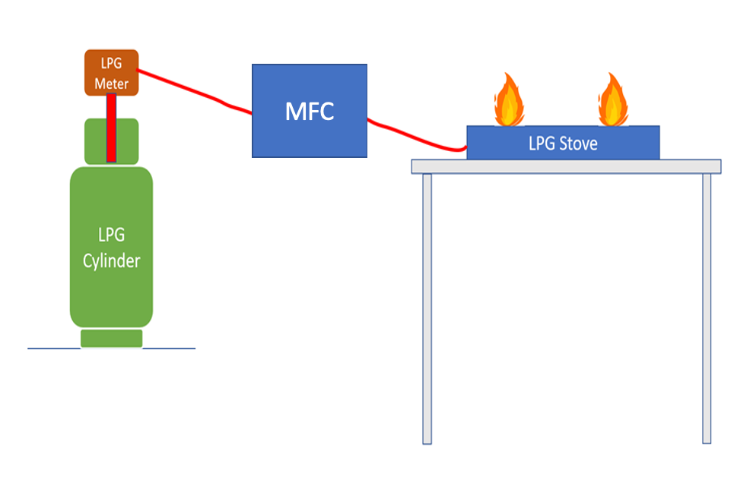
Figure A1

Annex B
(Informative)

Additional methods for Meter accuracy testing
B.1 Principle

To check the accuracy of the meter by comparing actual discharge of LPG by weighing scale measurement against the discharge displayed on the meter.

B.2 Procedure

B.2.1 Weigh the LPG cylinder with its contents before the start of the experiment and record the mass as M₁.

B.2.2 Switch on the LPG and discharge/burn about 500 g of the LPG as indicated on the meter.

B.2.3 Carry out at least three LPG discharging.burning sessions to decrease random component of error, then calculate the average value of the mass discharged/burned.

B.2.4 The variance between the sum value of the discharged/burned LPG and the reading from the meter shall be as indicated in 4.4.3.

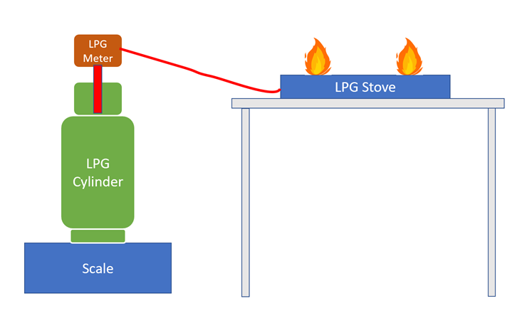

Figure B.1 ― Illustration of testing set-up

Figure B1

