Personal address | For all official correspondences, kindly forward through the address below for Administrative concurrency;
Mr. Boniface Otieno Ojalah | The Inspector General,  National Police Service
Seconded to; | The Inspector General,  National Police Service
Nairobi Metropolitan Services | Jogoo House “A”
Enforcement and Compliance Department | P.O. Box 44249-00100
City Hall Annex | Nairobi.
P.O. Box 30075-00100 | E mail; nps@nationalpolice.go.ke
Tel 020-344194
Nairobi.

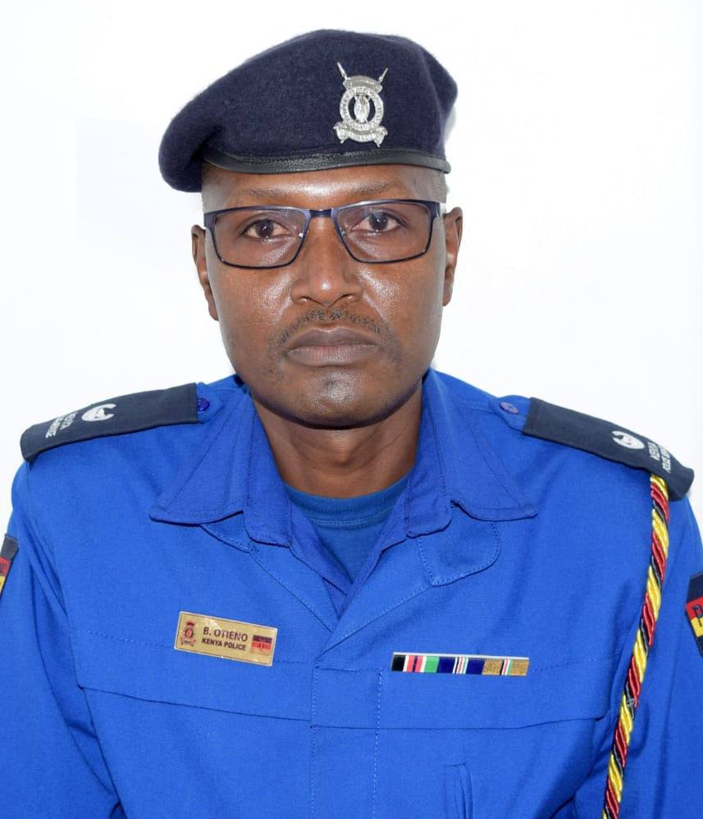
PROFILE SUMMARY

MR. BONIFACE OTIENO OJALAH

Mr. Boniface Otieno holds MA in Armed Conflict and Peace Studies(UoN), BA Political Science & Sociology (UoN) and a Diploma in Private Investigation (Penn Foster Career School-USA). In addition, he has undergone various specialized training both locally and internationally such as Global Training Programme for Rally Marshals and Technical Intervention/Medical Intervention vehicles (TIV/MIV) crew e-Leaning course for Hybrid cars by World Rally Championship (WRC) in conjunction with International Automobile Federation (FIA). Attended Microcomputer Accident Analysis Package (iMAAP) training by Transport Research Laboratory (TRL-UK) and Road Safety Audit & Inspection training by World Resources Institute (WRI-US), Traffic Management & Road Safety at Zhejiang Police College-China and Fleet Management, Road Safety & Defensive Driving at Jomo Kenyatta University of Agriculture and Technology (JKUAT) among other career based courses.

He has also participated in several committees and task forces dealing with road transport safety and management as well as lecturing in several government agencies such as Directorate of Criminal Investigation (DCI) Academy, Kenya Defence Forces (KDF) School of Military Police, General Service Unit (GSU) Training School, National Transport & Safety Authority (NTSA), Kenya National Highways Authority (KeNHA) and Nairobi City County Inspectorate Training School among other state and non-state organizations.

A member of International Police Association-Kenya (IPA) and Kenya Transport Research Network (KTRN). Voted Road Safety Officer of the Year in 2014 by Association of Kenya Insurers (AKI) and recipient of Inspector General of the National Police Service Meritorious Service Award 2018. Has generated several research papers and reports including presentation during the International Conference on Transport and Road Research (iTRARR-2018) in Mombasa (check: http://www.transportconferencekenya.org/Presentations.zip or http://www.transportconference
kenya.org/Full papers.zip.)

Boniface Otieno is passionate about road safety subject and in 2018, he registered a company namely African Centre for Road Safety and Security Ltd to enable him reach more stakeholders. He is currently working with Nairobi Metropolitan Services (NMS) as an enforcement officer dealing with training and traffic operations.
CV

Preliminaries
Position Title : | Road Transport Safety and Traffic Law Enforcement Expert
Name of Expert: | Mr. Boniface Otieno Ojalah
Date of Birth: | 1974
Gender | Male
Employment | Superintendent of Police (SP) at NPS
County of Birth | Homa-Bay
Ethnicity | Luo
Country of Citizenship/Residence | Kenya

Education
Institution, date | Degree obtained
University of Nairobi, Kenya | MA. Armed Conflict and Peace Studies –UoN, 2021
University of Nairobi, Kenya, 2009. | BA. Political Science & Sociology-UoN, 2009
Penn Foster Career School, USA (Distance learning) | Diploma - Private Investigations, 2006

Other Trainings:
- International Automobile Federation (FIA) approved Marshals training and Hybrid Car safety course conducted by FIA Medical and e-Safety Delegates, Kenya 2022.
- Certificate, (Road Crash Database System Senior Police Training), TES Technologies Ltd-Canada & TIMCON Associates Inc.-Kenya 2021.
- Certificate, (Training and Assessment as County Traffic Marshal in Kenya), Institutional Support on Kenyan Transport Sector- EU project and MOTIHUD&PW, Kenya 2020.
- Certificate, (Higher Training Course) and Critical Incident Management, National Police College Main Campus-Kiganjo, Kenya 2019.
- Certificate, (Road Safety Strategy & Safety Audits and Inspection Training), MOTIHUD&PW, Kenya 2018.
- Certificate, (Microcomputer Accident Analysis Package Training (iMAAP), MOTIHUD&PW, Kenya 2018.
- Certificate, (Fleet Management, Defensive Driving and Road Safety Training), JKUAT, Kenya 2017.
- Certificate, (Police Officers Middle Management Course), Kenya School of Government, Mombasa, Kenya, 2017.
- Certificate, (Binar Speed Gun Operation Course), Kenya Police Staff College-Loresho, Kenya 2015.
- Certificate, (Road Safety and Traffic Management Training), Zhejiang Police College, China, 2015.
- Certificate, (Advanced Criminal Investigations), Directorate of Criminal Investigations Academy, Nairobi, Kenya, 2013.
- Certificate, (Strategic Homicide Investigations), Directorate of Criminal Investigations Academy, Nairobi, Kenya, 2012.
- Certificate, (Basic Traffic Management), Traffic Training School, Ngong, Kenya, 2008.

Employment Record relevant to the Assignment:
Period | Employing organization and your title/position. | Country | Summary of activities performed relevant to the Assignment
2020-to date | Nairobi Metropolitan Services, Assistant Director of Training and Traffic Management  Contact information for references  Mr. CHRISPINE O. CALEB  Director of City Inspectorate  City Hall Annex  P.O. Box 30075-00100  Tel 020-344194  Nairobi.  Cell phone: - 0722 754 852  Email:- chrisocaleb@yahoo.com | Kenya | -Member of Nairobi city decongestion committee-ongoing.  -Deploy and supervise Traffic Marshals in the city to perform traffic control duties  -Deploy and supervise Parking Bay operators in the city for parking control duties  -Research activities on road transport management  -Liaison duties in traffic management matters with other stakeholders such as; -  -Ministry of Transport (MOTIHUD&PW)  -Nairobi City County Government (NCC)  -Matatu Owners Association (MOA)  -Boda Boda Safety Association of Kenya (BAK)  -Matatu Welfare Association (MWA) among others
2015-2019 | Traffic Police Department Headquarters, Deputy Officer in charge of Research, Training & Road Safety Unit  Contact information for references  Mr. GILFINAS BARASA(CP)  Traffic Headquarters  P.O. Box 10742-00100  Nairobi.  Cell phone: - 0725 576 199  Email:- trafficheadquarters@gmail.com | Kenya | -Keep statistical data of all recorded accidents countrywide  -Plan and conduct road safety awareness campaigns targeting all road users Countrywide  -Carry out and guide accident investigations  -Formulate and plan trainings, courses and seminar programmes for Traffic Officers including other security and law enforcement agencies.  -Conduct snap speed checks on public roads countywide.  -Conduct snap speed checks on public roads countywide.
2011-2014 | Maragua and Kibichoi Police Stations. General Duties as Deputy Officer Commanding Station (OCS) and Officer in Charge Anti-Crime.  Contact information for references  Miss. WILKISTER VERAH-CP  Regional Headquarters  P.O. Box 30051-00100  Nairobi.  +254 720 456 941  Email,wilverah@gmail.com | Kenya | -General police station administration and personnel management duties.  -Plan, organize and lead specialized security operations to deal with any criminal outbreak and lawlessness  -Coordination of community policing and road safety campaign activities:  -As the secretary of police station community policing committee, organized seventeen (17) successful meetings between 2010- 2013  -Successfully led a team of traffic police officers who lectured more than 50 Boda Boda taxi Sacco operators on road safety tips in Maragua Township and neighboring market centers between 2010- 2012.
2006-2010 | Traffic Training School-Ngong as an Instructor  Contact information for references  Mr MOSES OWITI-SSP  RAILWAYS & PORTS POLICE  P.O. Box 30083  NAIROBI  Tel. +254 720 588 531  Email, owitimos@gmail.com | Kenya | -Instructor of traffic and general criminal law. Major topics taught over the period include;  -Traffic and paralegal documents  -Investigation of accidents involving Diplomats  and state vehicles  -Operation of un-roadworthy motor vehicles  -Accident statistics and returns.  -Co-ordination and accompanying trainees during practical attachments.  -Organizing educational tours for trainees to departments of interest such as Vehicle Inspection Centre Axle Load Examination Unit among others.
1997-2005 | Kenya Police College-Kiganjo as an Instructor  Contact information for references  DONATHA KIPLANGAT-CP  CHIEF INSRTUCTOR  NPCM-Kiganjo  P.O. BOX P/BAG-KIGANJO  +254 724 029 359  Email, charidonathagmail.com | Kenya | -First Aid trainer and team First Aider for Police sporting contingents, police calendar of events such as; Annual Force Rifle Meeting (AFRM), Annual Force Denham Drill Competition, Annual Inter-Provincial First Aid Competition and Endurance and Maneuver courses/exercises for officers aspiring for postings to senior positions.  -Recruitment activities for initial enlistment of qualified and legible individuals to join Kenya Police Service.

Membership in Professional Associations and Publications:
- Member of International Police Association (IPA) –Kenyan Chapter
- Member of Kenya Transport Research Network (KTRN) - University of Nairobi

Publications and pressers
- https://fb.watch/6dyMftAoa_/ (Third test run of the Green Park Terminus, Nairobi by NMS. #TV47News)
- (A joint training between Kenya National Highways Authority (KeNHA), National Transport and Safety Authority (NTSA) and Nairobi Metropolitan Services (NMS) on Work Zone Safety along Thika Superhighway.
- KTN Business News #Kenya#KTNNews#KTNPrime or https://youtu.be/GOT41ffh97E on 29th January 2020. “Digital Insurance: New certificates to be issued online”. A joint training of police officers on the roll-out of Digital Insurance Certificates by Association of Kenya Insures (AKI) and the Kenya Police Service (KPS).
- The National Assembly-Transport and Public Works Committee Session on 17th January 2018. Panelist:-In the company of Commandant Traffic Department answering and outlining the state of road traffic crashes and traffic management in Kenya.
- The Star Newspaper on 8th January 2018 page 18. Commentary story: - Carnage: Cops as Social Engineers.
- The Kenya Police Review, a Magazine of the Kenya Police Service. April 2017 edition page 14. Story: - Chinese Police Systems; A comparison with Kenya and what we can Borrow.
Language Skills
Speaking Reading Writing
English √ √ √
Kiswahili √ √ √
Travel eligibility
- E-Passport No. A173048 – Valid
- Smart Driving License (Class BCE) C of C No. LBC-81- Valid
Adequacy for the assignments:
Tasks undertaken in the past | Assignments that Best Illustrates Capability to Handle the Assigned Tasks
Name of Assignment | Drivers Induction training course
Year | 7/10/2021-22/10/2021
Location | Green Park Terminus
Client | Nairobi Metropolitan Services (NMS)
Main Project Features | Nairobi Metropolitan Services (NMS) recruited 100 drivers, 30 plant operators and 15 ambulance drivers divided in early 2021. Because majority of them came from private background, there was an immediate need to train them on how to drive and maintain Government vehicles in accordance to existing transport regulations.
Position Held | Chief Traffic Training Officer
Activities Performed | Class presentations and practicals, topics:  -Traffic management in Kenya  -Government vehicle regulations and Work Ticketing  -Highway code and Defensive driving  -Disaster, incidences and accident management  -Simulations and practical demonstrations
Name of Assignment | Basic Traffic Management Course
Year | 15/6/2020 – 10/7/2020
Location | Police Regional Training Centre -Nairobi
Client | The National Police Service (NPS) through Regional Police Commander – Nairobi County
Main Project Features | The National Police Service (NPS) through Regional Police Commander – Nairobi deployed 60 police officers from the general duties to traffic duties. The basic course was to equip them with skills to professionally and effectively manage traffic control duties in Nairobi city.
Position Held | Chief Training Officer
Activities Performed | Class presentations and practicals, topics:  -Traffic management, laws and regulations in Kenya  -Simulations and practical demonstrations
Name of Assignment | Training of County Traffic Marshals
Year | 3/2/2020 – 19/2/2020
Location | City Hall
Client | Nairobi City County Government
Main Project Features | Traffic control by the Nairobi City County Government has been facing challenges to ensure free flow of traffic within the city. The EU under Institutional Support to Kenyan Transport Sector (ISKTS) funded a programme named “Demonstrate knowledge and Understanding of the role and functions of a Traffic Marshall” in the city. EU contracted a Short Term Expert (STE) for Traffic Control and Enforcement Training for 100 Marshals staggered in phase A and B.  The objective was to engage members of the National Traffic Police to enable them to also share and impart their experiences and knowledge with the Traffic Marshalls as they had little form of training in regard to conducting point duty control or parking management.
Position Held | Chief Police Training Expert
Activities Performed | Class presentations and practicals, topics:  -Simulations and practical demonstrations
Name of Assignment | Military Police Basic Traffic Course
Year | 2/12/2019- 6/12/2019
Location | School of Military Police-Embakasi
Client | Kenya Defence Forces (KDF)
Main Project Features | The Kenya Defense Forces (KDF)-School of Military Police (SOMP) normally conducts a four-week course on Traffic management for their Military Police. They subsequently seek the support of the National Police Service, Traffic Department to lecture their trainees on general traffic management regime in Kenya. The programme include educational tours and practical attachment.
Position Held | Chief Police Training Expert
Activities Performed | Class presentations and practicals, topics:  -Traffic management, laws and regulations in Kenya  -Educational tour to traffic registry, motor vehicle inspection centre and government vehicle investigation section and traffic courts in Nairobi.

CERTIFICATION:
I, the undersigned, certify that to the best of my knowledge and belief, this CV correctly describes myself, my qualifications, and my experience, and I am available to undertake the assignment in case of an award. I understand that any misstatement or misrepresentation described herein may lead to my disqualification or dismissal by the Client.
Boniface Otieno |  | 07/10/2022
Name of Expert | Signature | Date (day/month/year)

