**COMMENTS FROM ICL FERTILIZERS FOR THE STANDARD KS 2427 SOLUBLE COMPOUND FERTILIZER SPECIFICATION**

Paragraph 2.3 - Table 1 with tolerances: the proposed tolerances are too low and not in line with acceptable analytical accuracy in standard test methods where the test deviation can be as high as 0.4% absolute.

I suggest to keep it 1.1 as negative deviation as it was before and also as required by the current European regulation on fertilizers 2003/2003, for reference.

Paragraph 2.5 - pH value not less than 4.5. I suggest to delete this requirement. It doesn't appear in other international regulations.

Paragraph 3.1 (ii) – can you please send us act CAP 513 mentioned here.

Paragraph 3.2 (m) – A cautionary statement on any micronutrient toxicity. This is wrong. A cautionary statement must be for the whole product and all nutrients, not only micronutrient and in accordance with international standard like GHS or CLP.

Also, please remove the moisture limit or increase the limit for most of the fertilizer standards and in particular, for soluble fertilizers and foliar fertilizers.

**NOVACID REASON WHY ITS LOW PH**

Here is the explanation from Matan regarding the impact of low pH fertilizers –

1. Pekacid used in the products helps to increase solubility of fertilizers, prevent caking and increasing product shelf life.
2. It enables to reach maximum solubility when adding such important nutrients as calcium.
3. Important especially when using high pH water. Low pH fertilizers decrease water hardness, increase nutrients' availability  for plants and therefore cause to lower use of fertilizers, improving environment.

Regarding NPK tolerances, there are few references:

1.           European standard on fertilizers EC 2003/2003, Annex II  allows 1.1% absolute negative deviation for each primary nutrient and not more than 1.9 for sum of deviations, as can be seen below:

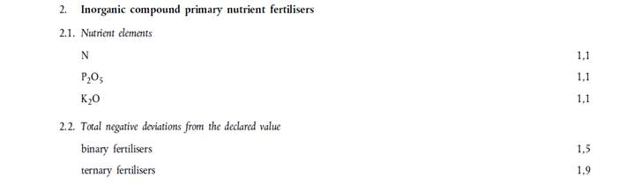

2.           From Australian Code of Practice for Fertilizer description and labelling:

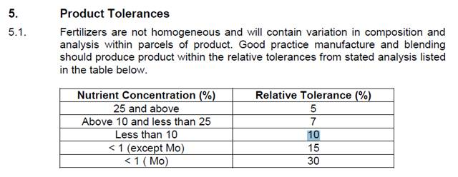

1. From Vietnam Decree on Fertilizers:

