**CURRICULUM VITAE**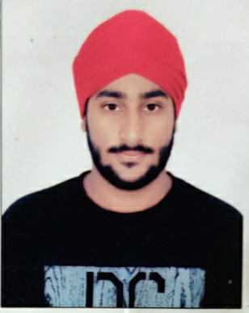

**BHAVRAJ SINGH PANESAR**

**P.O BOX 26131 – 00504**

**Email:** [**bhavrajpanesar18@gmail.com**](mailto:bhavrajpanesar18@gmail.com)

**Tel: (+254)783524720**

PROFILE SUMMARY:

* Self-driven and motivated individual, with strong personal integrity and work ethics
* A strong academician
* An unquenchable desire for knowledge and ever willing to learn
* Excel within highly competitive environments
* Able to work under minimum supervision

PERSONAL PROFILE:

Name : Bhavraj Singh Panesar

Gender: Male

Date of Birth: 18/06/1995

Citizenship: Kenyan

I.D No: 33770204

EDUCATIONAL BACKGROUND:

O-level: Nairobi South Preparatory and Secondary School (Graduated 2012)

Achieved an overall grade of ‘A’ (80%) in I.G.C.S.E, Cambridge International

A-level: Saint Soldier International Convent School (Graduated 2014)

Achieved an overall score of 73.4% in C.B.S.E (Delhi)

University: BBSBEC, Punjab Technical University (Graduated 2018)

Attained a ‘First Class’ degree in Electronics and Communication Engineering

EXPERIENCE:

JUN –JUL 2017

SASMOS HET Technologies, Bengaluru – worked as a developer with the R&D team.

JAN-JUN 2018

TELCOCRATS PVT LTD, Chandigarh – worked as a trainee.

Worked with RF communication, 4G optimisation, worked with ATOLL and TEMS software.

JUL-AUG 2018

AMAZON INC, Noida – worked in technical support department

AWARDS AND ACHIVEMENTS

* First Class Pass in spread sheet processing – City & Guilds U.K
* Achieved a pass in Embedded Systems with Eureka Electrosoft soln.Pvt.Ltd
* Participated in Western Dance and achieved 2nd position in University

CO-CURRICULAR ACTIVITIES

Playing football, Swimming, Watching Sci-Fi, Listening to music, Drawing and Sketching.

REFEREES:

* Prof. R.S.Uppal

Head of Department Electronics and Communication

BBSBEC

Rs.uppal@bbsbec.ac.in