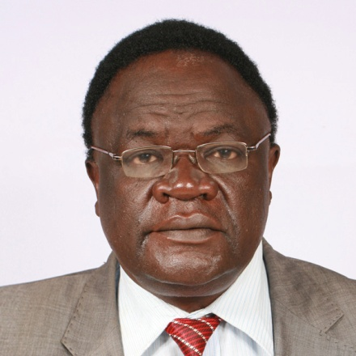

B.SC(Industrial Engineering ) Missouri Columbia USA,

Registered Engineer Kenya

Fellow Institute of Materials (IOM3) UK

CEO and General Secretary IOPPK

Profile

1.Director WPO(World Packaging Organisation)

2.World Packaging World Star Judge

3.Fellow of Institute of Materials IOM UK

4.General Secretary APO(Africa Packaging Organisation

5.Secretary General and CEO Institute of Packaging Professionals Kenya

6.National and International Packaging Consultant and Trainer.

7.First President Africa Packaging Organisation 2012-2018

Joseph Nyongesa Brief Profile

Currently CEO/Secretary General IOPPK ,Joseph Nyongesa is a trained professional registered Industrial Engineer with a combined 37 years experience in Packaging ,General and Project Management ,Engineering, Manufacturing, Retail and Product and Packaging Development. He has held various positions as Technical Trainer, GS1 Kenya, General Manager/Chief Executive GS1 Kenya, and the following within Unilever Kenya(Company Industrial Engineer, Production Manager, Company Development Manager, Packaging Development Manager) and Consultant to many organizations for productivity measurements, improvements, Bar-coding in relation to ERP(Enterprise Resource Planning) Implementation at Point of sale and Supply chain, own label brands and productivity improvement programmes. He has trained and supported many SME(Small and Medium Enterprises) in the area of Packaging and application of Bar-coding standards. He has carried out several training programmes and activities in the area of Packaging and Traceability in Africa and beyond. He is a consultant to Kenya National Traceability Horticultural project and other Traceability Programmes in Zambia and Mozambique.

In his career, he has led major product launches, packaging, sourcing and development projects for Unilever Industries. He has also been at the forefront of advancing the art and science of packaging in Africa. He has been awarded Fellowship of the Institute of Packaging (UK). He is also a member of Institute of Packaging Professionals USA/South Africa/Australia/India. He has been actively involved in the fight against Counterfeit Packs in the country by utilization of enabling technologies like packaging and traceability with other stakeholders.He is an International Packaging Consultant with ITC(International Trade Centre) ,UNIDO, ITC National Consultant. He has organized many ITC activities in Kenya including compiling The ITC packaging information kit for the country .He carries out ITC functions outside the country as necessary. He is also a consultant to Competitive Options on operations, strategy, training and Projects design, execution and General Management. He has been elected The First President of APO(African Packaging Organisation) a continental organization that is building packaging capability in Africa. The theme of the organization is A World of Quality Packaging for Africa. He is also a Board Member at WPO(World Packaging Organisation) based in Vienna .