CURRICULUM VITAE

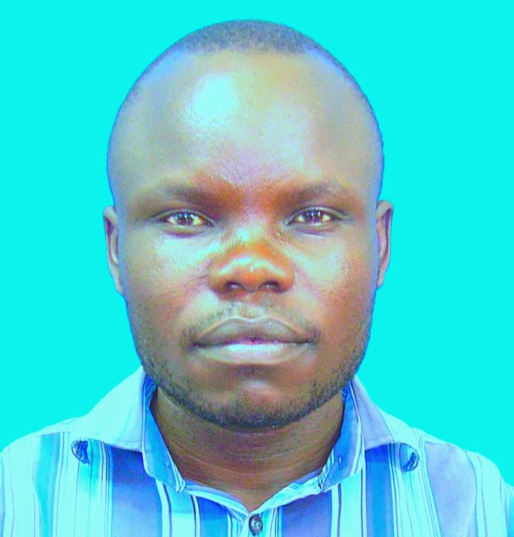

# PERSONAL DETAILS – AWUOR OCHIENG ADERO

Work Address: 52428-00200 Haile Selassie Avenue, Nairobi, KENYA

Mobile: +251-737117704

Date of Birth: 10 March 1982

Nationality: Kenyan

# CAREER OBJECTIVES

* To work in an institution that upholds the core values of integrity and transparency in research, teaching and leadership in order to become a distinguished scholar, researcher and leader able to take the institution to greater heights in the future.
* To be at the forefront of Astronomy and Space Science development in Kenya
* To be a good ambassador and outreach campaigner for science development, especially among the young minds, in Kenya.

# EDUCATION HISTORY

**Sept 2015 – Current** **Technical** **University of Kenya**, Nairobi, KENYA,

*PhD (Space Physics) Candidate*

*Expected graduation: Dec 2019*

**Oct 2009 – Nov 2011** **University of Nairobi**, Nairobi, KENYA

*MSc (Space Physics)*

**Oct 2004 – Nov 2008** **University of Nairobi**, Nairobi, KENYA

*Bachelor of Science in Physics (2nd Class, Upper Division)*

**1998 – 2002** **Akoko Mixed Secondary School**, Siaya, KENYA

*Kenya Certificate of Secondary School-Mean Grade* **B+**

**1990 - 1997** Wambarra Primary School, Siaya, KENYA

*Kenya Certificate of Primary Education*-*Mean Grade* **B**

# WORK EXPERIENCE

|  |  |
| --- | --- |
| **Sept 2014 – Current**  **Aug 2013 - 2016**  **Oct 2011-Sep 2014**  **Sept 2011 – Sep 2014**  **Oct 2008 – Oct 2009**  **July 2007 – Oct 2007**  **Sept 2006 – Nov 2006**  **Sept 2005 – Nov 2005** | **TECHNICAL UNIVERSITY OF KENYA**, **Nairobi,**  KENYA **http://www.tukenya.co.ke**  *Tutorial Fellow –Department of Physics and Space Science*  **Responsibilities and achievements:**   * Examination and timetabling officer * Coordinator **ASTROLAB**   **MOUNT KENYA UNIVERSITY**, Thika, KENYA.  ***http://www.mku.ac.ke***  *Part-time Lecturer – Department of Physical Sciences*  **Responsibilities and achievements:**   * Assisted in the development of curriculum for Bachelor of Education Science. * Teaching and Invigilation of departmental examinations   **FOCUS TUTORS-Director**  Home Base tuition for IGCSE, IB, 8-4-4  **TECHNICAL UNIVERSITY OF KENYA**, **Nairobi,**  KENYA **http://www.tukenya.co.ke**  *Part-time Lecturer – Department of Physics and Space Science*  **Responsibilities and achievements:**   * Assisted in the development of Bachelor of Technology in Technical and Applied Physics curriculum. * Teaching and Invigilation of departmental examinations   **BISHOP OKOTH GIRLS’ SCHOOL, OJOLLA**, Kisumu, KENYA  *Mathematics and Physics Teacher*  **Responsibilities and achievements:**   * Assistant Games Master * Patron Physics Club   **DEPARTMENT OF PHYSICS, UNIVERSITY OF NAIROBI**,  *Student Research Assistantship*  **Responsibilities and achievements:**   * Theoretical and mathematical modelling heat flow in metallic conductors   **NYANGOMA BOYS’ HIGH SCHOOL**, Siaya, KENYA  *Mathematics and Physics Teacher*  **AKOKO MIXED SECONDARY SCHOOL**, Siaya, KENYA  *Mathematics and Physics Teacher* |

# PUBLICATIONS

1. **Awuor Ochieng Adero1, P. Baki2, P. Kotze3 and C. Mito4:** Features of the night-time F-

region currents over equatorial Africa on August, 2001, *International Journal of Fundamental, Vol 4, No 4, pp 101-104, Dec , 2014.*

1. **Awuor Ochieng Adero:** M.Sc. dissertation; Identification of the Night-time F-region currents from CHAMP satellite observations over equatorial Africa, Lambert *Academic Publishers, Germany, June, 2013*
2. **Adero Ochieng1, P. Baki2, P. Kotze3 and C. Mito4**: Identification of the Night-time F-region currents from CHAMP satellite observations over equatorial Africa, *International Journal of Fundamental Physical Sciences, Vol. 3, No.1, pp. 9-14, March, 2013*

# INTERNATIONAL CONFERENCES AND WORKSHOPS

1. **21st- 25th Sept, 2015:** 2015 African Geophysical Society conference held at Kenya Institute of education, Nairobi, Kenya
2. **19th- 25th July, 2015:** 2015 Incoherent Scatter Radar Summer School held at Jicamarca Radio Observatory in the city of Lima, Peru.
3. **8th- 12th June, 2015:** Satellite Communications Training Workshop held at African Advanced Level Telecommunications Institute (AFRALTI) Nairobi, Kenya.
4. **21st Oct-1st Nov, 2013:** ISWI/SCOPTEC School on Space Science held at Kenya Institute of education, Nairobi, Kenya
5. **18th-21st Sept, 2012:** UN/Austria Symposium on Data Analysis and Image Processing for Space and Sustainable Development-Space Weather, held in Graz, Austria.
6. **10th -14th Oct, 2011:** International Reference Ionosphere (IRI) 2011 Conference, Hermanus, South Africa.
7. **15th -21st Aug, 2011:** Participated in The ISWI/MAGDAS School on Litho-Space Weather Held at Redeemers’ University, Mowe, Nigeria.
8. **19th -23rd July, 2010:** East, Central and Southern Africa GNSS and Space Weather Workshop, Six-Eighty Hotel, Nairobi, Kenya.
9. **29th -31st April, 2010:** Workshop on Application of High Level Computing in Scientific Research, Hermanus Magnetic Observatory, South Africa.
10. **15th -16th May, 2008:** Young Scientist and Vision 2030, U.N Headquarters, Nairobi, Kenya.
11. **25th -26th Nov, 2005:** Harnessing Science, Technology and Research in Africa, Chiromo Campus, University of Nairobi.

# PROFFESIONAL AFFILIATIONS

1. Physics Society of Kenya
2. African Geospace Society

# FELLOWSHIPS

1. **Jan.-April, 2016:** South Africa National Space Agency- Visiting Researcher
2. **Sept., 2017- April, 2018:** Prestigious C.V. Raman fellowship for African Researchers, Indian Institute of Geomagnetism, India

# INTERNATIONAL COLLABORATIONS

1. A member of Prof. Paul Baki’s Space Physics Research Group and collaborated with South African National Space Agency (SANSA- Space Science) for my M.Sc. research under the Kenya-South Africa Joint Research Funding

# SKILLS AND COMPETENCES

* Basic Earth Sciences
* electromagnetics
* Statistical physics and thermodynamics
* Satellite mapping of natural resources
* Data Analysis
* Soil Physics

# HONORS AWARDS & RESEARCH GRANTS

**July 2015** National Commission for Science, Technology and Innovation research

Grant worth Ksh. 500,000.

**Sept 2009** University of Nairobi Scholarship for Master Studies- Second best student in the

Department ofPhysics, Class of 2008

**2004-2008** Government of Kenya University Undergraduate Bursary

# COMMUNITY INVOLMENT & RECOGNIZED ACHIEVEMENTS

**2011- Current** Chairman, Akoko High School Alumni Association

**2008- Current** Alumni, Youth Agency for Development in Science Technology &

Innovation (YADSTI)

**2008- Current** Astronomy& Education- Volunteer outreach member

**2007-2008** Chairman, University of Nairobi Catholic Student Community

**2007-2008** Organizing Secretary, Nairobi University Physics Association (NUPA)

# OTHERS SKILLS AND CERTIFICATES

* Microsoft XP applications (Word, Excel, Office, PowerPoint, Outlook, Access) – Advanced
* R – Programming
* Data Analysis in Python.
* Investigative research

# PERSONAL COMPETENCES

* Ability to work in a fast-paced environment to set deadlines
* Excellent oral and written correspondence with an exceptional attention to detail
* Highly organised with a creative flair for project work
* Enthusiastic self-starter who contributes well to the team

# REFFEREES

|  |  |
| --- | --- |
| **Prof. Paul Baki, PhD, FKNAS**  Professor of Physics  Department of Physics and Space Sciences  Technical University of Kenya  P.O Box 52428, 00200, Nairobi, Kenya  **+254-713784534**, [paulbaki@gmail.com](mailto:paulbaki@gmail.com) | **Dr. Collins Mito**  Senior Lecturer, Department of Physics  University of Nairobi  P.O Box 30197-00100, Nairobi, Kenya  **+254-721105061**, [collins@gmail.com](mailto:collins@gmail.com) |
| **Mr. George Ochieng**  Chairman,  Department of Physics and Space Sciences  Technical University of Kenya  P.O Box 52428, 00200, Nairobi, Kenya  **+254-711581017** [georgeochieng08@yahoo.com](mailto:georgeochieng08@yahoo.com) |  |