|  |  |
| --- | --- |
| **Curriculum**  **Vitae** | **PATRICK GITAARI KABERIA**  *P.O. Box 62000 - 00200*  *Nairobi, Kenya,*  *Mobile No:* ***+254 724 081 918***  *Email:* [*kaberia1746@gmail.com*](mailto:kaberia1746@gmail.com) |
| **Personal Data**  **Academic**  **Qualifications**  **Work**  **Experience**  **AWARDS:**  **Other Training, workshops/ Conferences**  **SKILLS ACQUIRED**  **Extra-Curricular activities**  **HOBIES**  **REFFEREES** | |  |  | | --- | --- | | **ID Number** | 22319488 | | **Gender** | Male | | **Marital Status** | Single | | **Religion** | Christian | | **Nationality** | Kenyan | | **Mobile no.** | +254 724 081918 | | **Languages** | English and Kiswahili (fluent- oral and written) |   **2017: LEADERSHIP AND MANAGEMENT**   * YALI – ( Young African Leadership Initiative ) .   Regional leadership Center- East Africa / Kenyatta University , Nairobi -Kenya.    **2014 – 2017: JOMO KENYATTA UNIVERSITY OF AGRICULTURE AND**  **TECHNOLOGY ( JKUAT ).**   * *BSC – INFORMATION TECHNOLOGY.*     **2010 - 2013:** DIPLOMA IN INFORMATION TECHNOLOGY.   * **JKUAT , Grade - Credit**   **2015: STRATHMORE UNIVERSITY.**  - MCSA ( MICROSOFT CERTIFIED SYSTEMS ADMINISTRATOR )  - MCSE ( MICROSOFT CERTIFIED SYSTEM ENGINEER.)**.**    **2014:** **CCNA** (Cisco Certified Network Associate)   1. **- 2013: JKUAT ENTERPRISES LEARNING CENTER:**   -Agri-business , innovation and management ,Mobile Application  Development, Project Management, Human Resource Management,,  Conflict resolution, Youth empowerment, Local, Regional ,  International and Intra-Regional trade and integration.  1995 – 1999 : **ST. JOSEPH ALLAMANO BOYS’ HIGH SCHOOL, MERU**  - KCSE , MEAN GRADE B-  **1988 – 1995:**  **ATHIMBA PRIMARY SCHOOL**  - KCPE , MEAN GRADE B+  **2016 to Date: DIRECTOR,**   * PAWA AFRICA FOUNDATION.   **2015 – Date: MANAGING DIRECTOR / CEO**,   * TOPCHOICE ENTERPRISES LTD   **2012 TO 2015: JKUAT**   * ICT DIRECTORATE. * JKUAT ENTERPRISES LTD.   **2010 – 2011: BARCLAYS BANK OF KENYA**  **Responsibilities and tasks:**  Business development , Agricultural Financing , Credit Operations administration, Financial consultancy , Sales and Marketing of Banks’ products including Loans, Accounts, Mortgage, Mobilizing deposits, Insurance and Credit cards.  **2007 -2009: CO-OPERATIVE BANK OF KENYA**  **Responsibilities and tasks:**  Business development , Agricultural development and value chain financing , Credit Operations administration, Financial consultancy , Sales and Marketing of Banks’ products including Loans, Accounts, Mortgage, Mobilizing deposits, Insurance and Credit cards.   1. TONY ELUMELU FOUNDATION PROGRAM ENTERPRENEURSHIP / INNOVATIONS AWARD, 2017. 2. IREN/ USAID - YOUNG INNOVATORS IN AGRIBUSINESS AWARD 2015 . 3. NETFUND GREEN INNOVATIONS AWARD 2016 4. IREN/ USAID - POST-HARVEST TECHNOLOGIES INNOVATIONS AWARD 2016 . 5. LIONS OF SCIENCE AWARD , 2016 6. JKUAT TECH-EXPO AWARD 2013 ( SOFTWARE ENGINEERING CATEGORY ) 7. FINALIST, CLINTON GLOBAL INITIATIVE UNIVERSITY , 2017 8. JKUAT / JKUSO INNOVATION AND ENTERPRENEUR OF THE YEAR 2015. 9. Leadership and Management - (YALI) Young African Leadership   Initiative - **Regional Leadership Centre ( RLC – East Africa).**   1. Agribusiness Development , Value addition and international Trade   – IREN / East Africa Trade and Investment Hub / USAID.   1. Afri-capitalism , Entrepreneurship and mentorship- Tony Elumelu   Foundation Program / USAID   1. International relations, Politics and Governance – Institute for Economic   Affairs – Kenya / Young African Leadership Initiative ( YALI ).   1. Leadership Training - (African Leadership Ministries / JKUAT). 2. Finance , Resource mobilization, Audit and Accountancy – Kenya Institute of Management ( KIM) 3. TOT ( Trainer of Trainers) in Agribusiness , value development , Business Enterprise Development , Funding and capacity development. - IREN / USAID . 4. Training of Trainers (T.O.T) Training on Peer Education, Guidance   and Counseling Psychology. (Ministry of Health, NASCOP / JKUAT).   1. Human Resource Management – ( Institute of Human Resource Development) 2. Private sector development, public policy development and conflict   Resolution (Kenya School of Government / Kenya private sector Alliance - KEPSA)   1. JEMA (JKUAT Environmental Management Authority) Training on   Climate Change, Environmental conservation and Waste Management .   1. Rwanda international Trade Expo 2015 (Representing Jomo Kenyatta   University of Agriculture & Technology ( JKUAT), and Exhibiting  innovations in Farmers’ Co-operative Development, SACCONET  and Agribusiness.   1. IREN/ USAID Young Innovators in Agribusiness Training and competition -2016:– Arusha – Tanzania. 2. IREN/ USAID Young Innovators in Post-Harvest technologies Training   and competition – 2017: – Windsor , Nairobi - Kenya.   1. JKUAT Scientific Conference 2014, 2015 AND 2016.  * Agribusiness Management, Leadership, Entrepreneurship and Innovations development, management and administration. * Technological advancements in Agricultural, Agribusiness, value addition and Trade. * Farmers welfare , Value addition, Diversification, Funding , Linkages, partnerships and inter-region advancements in Agriculture. * Food value chain, Food security , Food quality and sustainability. * Policy development, quality management, Political administration, Food value chain administration, stability and sustainability. * Post-harvest technologies , value addition and Agricultural Enterprises development * International Trade and Regional integration, policy issues and quality management, market analysis and diversification. * Risks mitigation, Planning and conflict resolution. * Youth advocacy, Civic leadership and Rural Agricultural development. * Strategy and policy development, direction and execution. * Communication, Pitching, analytical and presentation skills. * Private sector development, Finance , audit and accountancy * Negotiation, Trade promotion and International trade relations * Human resource management, Conflict resolution, Politics and governance * Community development, value addition and market development. * Mentorship and Talent development, International market quality standards, Intra-regional trade and market orientation. * Good Scientific research skills, Project management and writing skills * Self-motivation, creativity, and ability to work with a variety of people, singly or as part of a team. * Independence decision making, Team work, stakeholder involvement and administrative framework management. * Playing Foot ball, Badminton and swimming. * Script writing , acting and Debating. * Participating in community based activities. * Travelling . * Playing football and Badminton. * Reading leadership and thought provoking books. * Participating in Community projects. * Meeting New Friends. * Watching football.  |  |  |  | | --- | --- | --- | | **1** | MR. DAVID KAMAU  CHIEF OF PARTY,  YALI – Young African Leadership  Initiative , Regional Leadership Center ( East Africa ) | P.O BOX 43844,00100, NAIROBI.  TEL: +254 719 030000  EMAIL:david.kamau@yalieastafrica.org | | **2** | REV. FR. PROF. LAWRENCE NJOROGE ,  CHAPLAIN , LECTURER AND  FATHER IN CHARGE, ST. AUGUSTINE /JKUAT CHAPLAINCY . | P.O BOX 62000, 00200 ,  NAIROBI.  TEL: +254 7 24 603 851 | | **3** | MR. IAN MARANYA,  DIRECTOR , TIMELINE LTD | P.O BOX 590 , NANYUKI  TEL: +254 715 527 482  E-MAIL: ianomayan@gmail.com | | **3** | MR. KIMATHI KABURU,  PRINCIPAL ,  ST. JOSEPH HIGH SCHOOL, MERU | P.O BOX 29 ,  MAGUMONI – MERU . | |

**REFFERENCES AND LINKS:**

* <http://www.eatradehub.org/patrick_kaberia>
* <https://alumni.yalieastafrica.org/profile/view/patrick-kaberia>
* http://www.jkuat.ac.ke/jkuat-kigali-campus-shines-at-rwanda-expo-2015/
* <http://www.jkuat.ac.ke/departments/it/student-invents-software/>
* <http://www.jkuat.ac.ke/departments/it/completed-projects/>

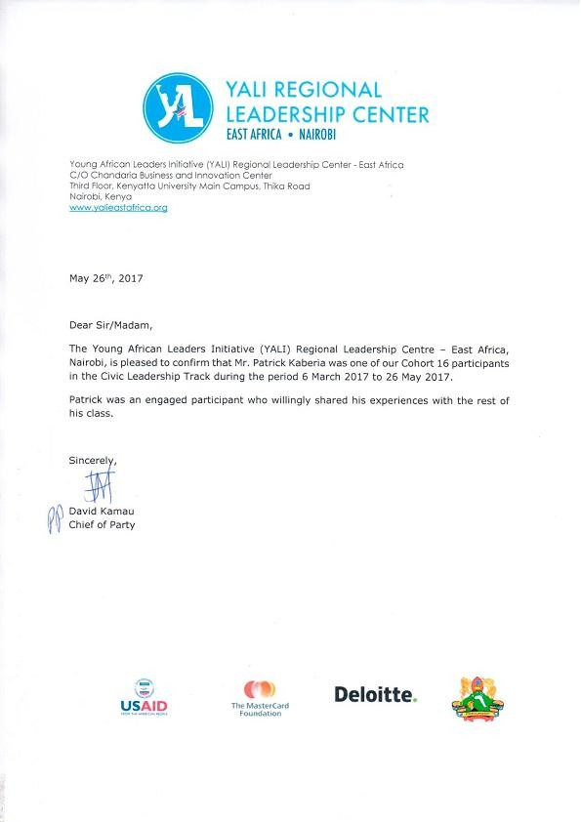

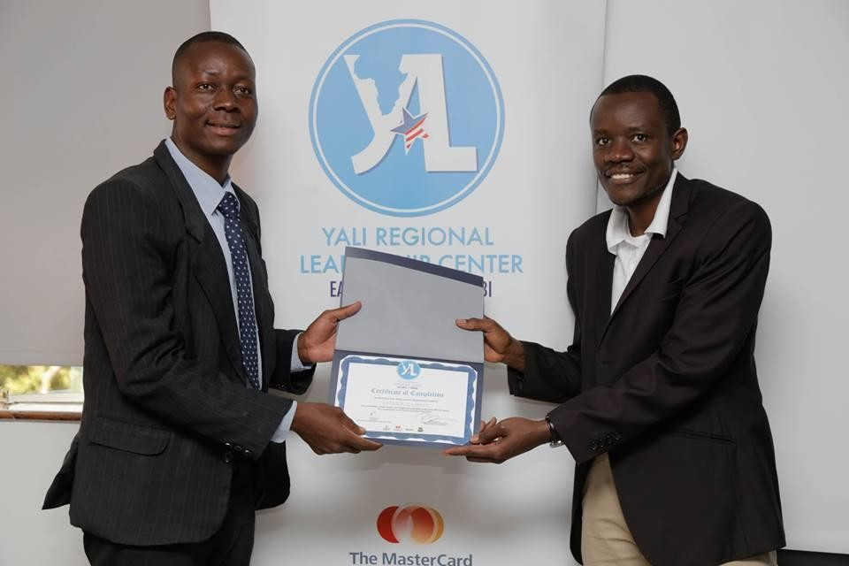

**During Graduation at YALI East Africa cohort 16 , Held at kenyatta university.**

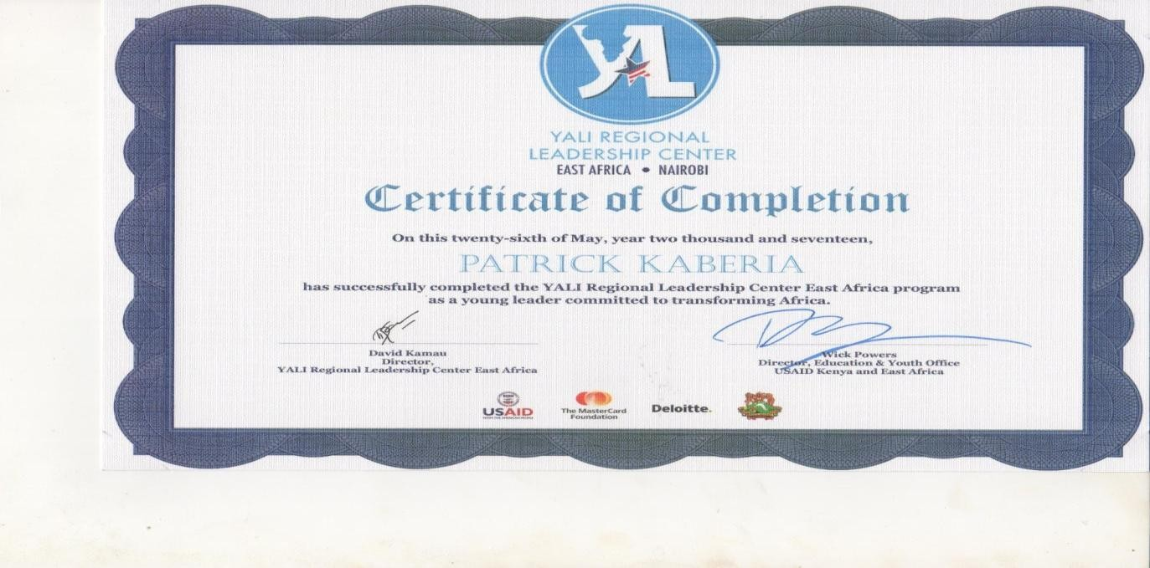

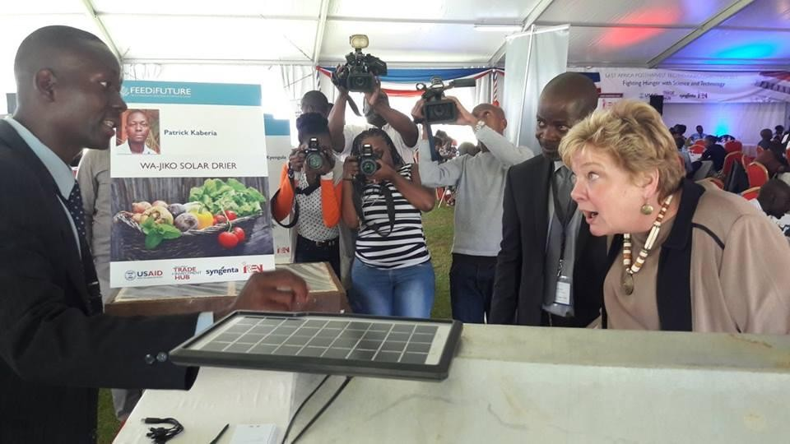

**Patrick Kaberia , Showcases his innovation Technology to the USAID Director for Kenya and East Africa, Karen Freeman, IREN Director James shikwati and Esteemed guests at the USAID / IREN Post-harvest Technologies Training, Competition and Expo at the Windsor Hotel, Nairobi.**

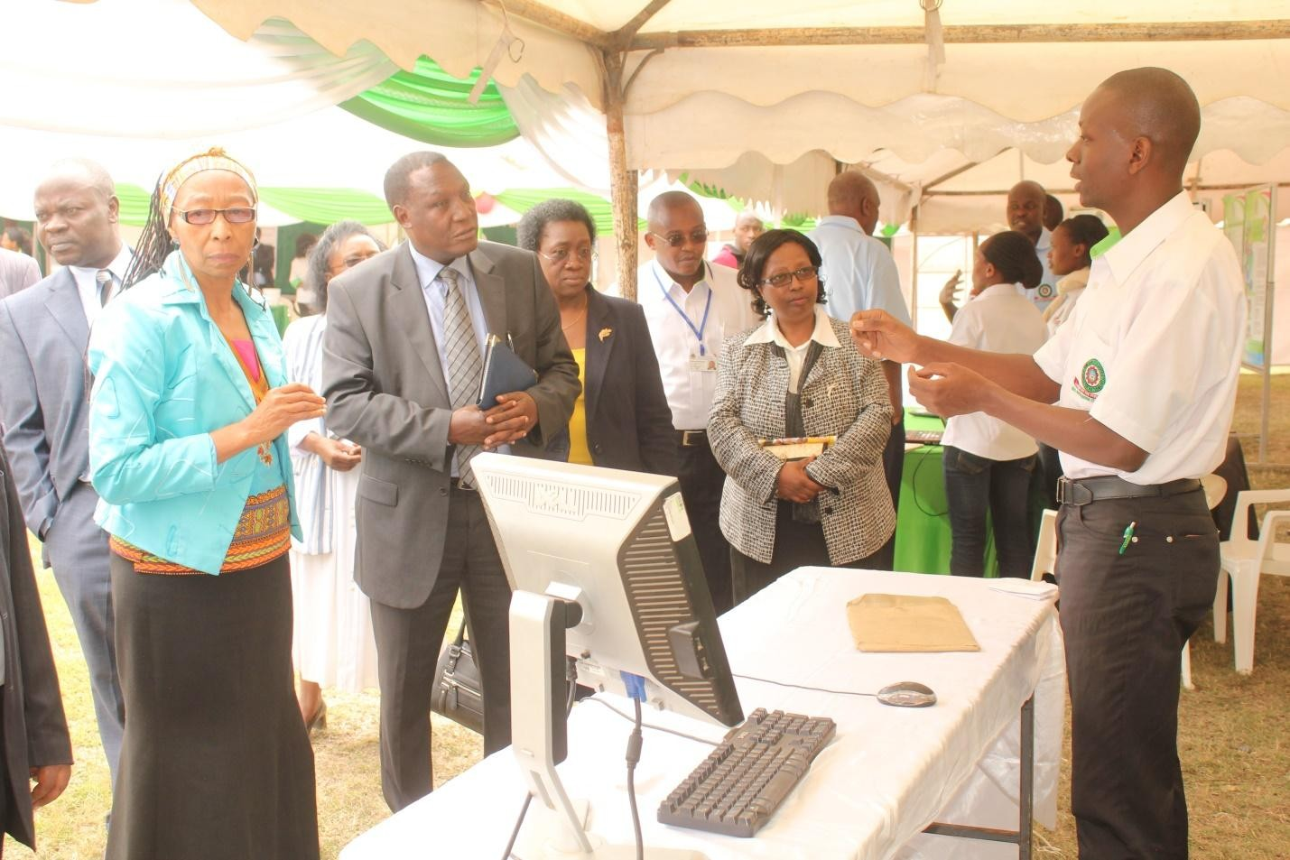

***Mr. Patrick Kaberia makes a presentation on his innovation and Agricultural challenges solution / Technology to the members of the University management and government officials***

**REFFERENCE:**

1. JKUAT website : [www.jkuat.ac.ke/departments/it/student-invents-software](http://www.jkuat.ac.ke/departments/it/student-invents-software)
2. <http://www.jkuat.ac.ke/departments/it/completed-projects/>
3. <http://www.jkuat.ac.ke/jkuat-kigali-campus-shines-at-rwanda-expo-2015/>
4. [www.allafrica.com/student-invents-software](http://www.allafrica.com/student-invents-software)
5. [www.thestar.co.ke/](http://www.thestar.co.ke/) student invents software
6. The star newspaper , 30th January , 2014.
7. The standard newspaper, 2nd February , 2014
8. JKUAT library , e-resources