**8th June 2021**

**PURPOSE AND JUSTIFICATION OF ESTABLISHMENT OF B7 STANDARD**

**INTRODUCTION**

This document describes the rationale and justification for a Kenya/East Africa code for the blend stock of 7% biodiesel and 93% petroleum diesel. The standard will support the increasing use of blends up to 7% of fatty acid methyl ester (FAME) in diesel fuel.

Outlining the specific aims and reasons for standardisation in this area and the main interested parties, (Industry, Consumer, National Authorities, Standard Organizations and distributors) The specifications will cut across; quality systems that includes storage, sampling, testing, blending, shipping, distribution and fuel management practises. This will help in ensuring consumers have a high level of confidence in the biodiesel blend they purchase and a key element in the industrial growth.

**Biodiesel and Biodiesel Blends**

Biodiesel is a carbon emission neutral fuel produced from the Trans esterification Process of oil and Fats.

**Transesterification Process & Reaction**

Transesterification of vegetable oils, animal fats or used cooking oils is the process behind conventional biodiesel. In this process a glyceride reacts with an alcohol (typically methanol) in the presence of a catalyst (usually Strong Base such as Sodium Methoxide or Potassium Methoxide) forming fatty acid alkyl esters and an alcohol.

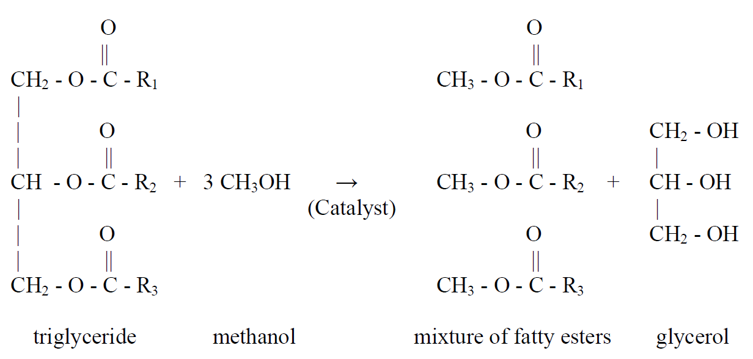

**Basic Diagram of Biodiesel Production**

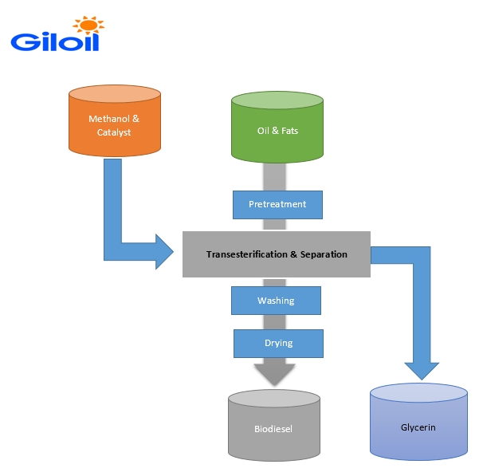

Biodiesel can be blended and used in many different concentrations. The most common are B5 (up to 5% biodiesel) and B7 (7% biodiesel) and B100 (pure biodiesel).

**Biodiesel and Biodiesel Blends in US and EU Countries**

Some States in US and EU countries have a biodiesel content mandate statute. Whereby, it is a statutory requirement for all diesel sold or offered for sale to have a minimum content eg. Minnesota State in US, blended requirement is 2%, 5%, 10% & 20% (B2, B5, B10 and B20)

The diesel blend standards specifications from US and EU countries are; United States; ASTM standards (ASTM D975-08a and ASTMD6751-12) and EU Countries; EN Standards (EN 590:2009 and EN 14214:2012)

We propose adoption of European Union specifications; **EN 590:2009** for the **KS EAS B7 standard.** The KEBs technical committee can use this reference as a guideline.

**Advantages of Biodiesel and Biodiesel Blends**

1. Environmental friendly

If we talk about the Clean Air Act, biodiesel is the only biofuel which has successfully passed emissions testing thresholds. Biodiesel is biodegradable which means that even if it’s spilled, it would have less damage to the environment and would be easier to clean up. Most importantly, biodiesel is renewable. Environmental Protection Agency (EPA) has suggested that Biodiesel emits 11% lower carbon monoxide and as much as 10% lower particulate matter than conventional diesel fuel.

1. **Less greenhouse gas emissions like Carbon Dioxide**

The Paris Agreement's long-term temperature goal is to keep the rise in global average temperature to well below 2 °C (3.6 °F) above pre-industrial levels; and to pursue efforts to limit the increase to 1.5 °C (2.7 °F). Biodiesel/ Biodiesel Blends will play a great role to achieve these targets.

1. Renewable source of energy-

Biodiesel is sourced from natural organic matter like plants and animal oils which, if produced in a sustainable manner, could last forever.

1. **Recycling waste cooking oil**

**Conversion of waste cooking oil into biodiesel.** Significant volumes of biodiesel are also produced from waste vegetable oil gathered from fast food outlets, restaurants, and food manufacturers hence minimizing environment pollution.

1. **Incredibly safe-**

B5 is a non-toxic fuel producing lower emissions as compared to fossil fuels when burnt. This lessens the risk of respiratory illnesses due to reduced air pollution. B5 is actually just as biodegradable as sugar and [ten times](http://www.esru.strath.ac.uk/EandE/Web_sites/06-07/Biodiesel/faq.htm) less toxic when compared with table salt. Moreover, B5 has a lower flashpoint than conventional diesel.  This makes transportation and storage easier and much safer.

1. Ready to use-

Biodiesel blends can straight away be used in diesel engines made after 1987.

Biodiesel can also be used at homes as an alternative to petroleum.

Off-grid homes that have to depend on generators for electricity should use blended biodiesel instead of conventional diesel fuel. All you have to do is fill up and you’re good to go.

For engines, EPA recommends a fuel pump replacement after the first fill-up of bio-diesel.

1. **Biodiesel helps extends Engine Lifespan**.

It helps to ease the movement of engines as it has a greater lubricating effect. According to many estimates, with just 1% of biodiesel blend fuel lubricity can be increased by 65%. It basically acts like a solvent and helps to loosen the gunk and deposits in the engine.

Furthermore, because of its lubricity, it doesn’t allow accumulation of more deposits inside the engine. This improves the overall working life of the engine because there is less wear and tear.

**CONCLUSION**

The need for the standard is examined also in consideration of the position of Kenya/ East Africa biodiesel/biodiesel blend producers and petroleum industry in the global market. This will enhance development in energy sector in Kenya/East Africa countries.

Finally, this document provides a proposal for the consultation and initiation strategies for the new standard.

**REFERENCES**:

<https://www.ezoil.com/resources-diesel-biodiesel-basics>

<https://en.wikipedia.org/wiki/Biofuel_in_the_United_States>

<https://afdc.energy.gov/fuels/biodiesel_benefits.html>

<https://www.conserve-energy-future.com/advantages_disadvantages_biodiesel.php>

<https://dieselnet.com/tech/fuel_biodiesel_std.php>

<https://dieselnet.com/standards/us/fuel_biodiesel.php>

<https://cdn.crownoil.co.uk/wp-content/uploads/2019/09/Biodiesel-Spec-Sheet.pdf>

<https://www.mda.state.mn.us/sites/default/files/inline-files/legrpt-biodiesel18.pdf>