Beds made from corrugated fibre board —Specification



TECHNICAL COMMITTEE REPRESENTATION

The following organizations were represented on the Technical Committee:

African Cotton Industries Ltd

BillerudKorsnas AB

Chandaria Industries Ltd

Dune Packaging Ltd

East African paper mills

Allpack Industries ltd

East African Packaging Industries Limited

Kapa Oil Refineries Ltd

Kartasi Industries Ltd

Kenafric Manufacturing Limited

Kenya Chemical Society

Kenya Industrial Research and Development Institute (KIRDI)

Kenya National Cleaner Production Centre (KNCPC)

Kimfay East Africa Limited

Pelikan Middle East & Africa

Silpack Industries Limited

Technical University Of Kenya

Twiga Stationers And Printers Limited

Kenya Bureau of Standards — Secretariat

REVISION OF KENYA STANDARDS

In order to keep abreast of progress in industry, Kenya Standards shall be regularly reviewed. Suggestions for improvements to published standards, addressed to the Managing Director, Kenya Bureau of Standards, are welcome.

© Kenya Bureau of Standards, 2020

Copyright. Users are reminded that by virtue of Section 25 of the Copyright Act, Cap. 130 of 2001 of the Laws of Kenya, copyright subsists in all Kenya Standards and except as provided under Section 25 of this Act, no Kenya Standard produced by Kenya Bureau of Standards may be reproduced, stored in a retrieval system in any form or transmitted by any means without prior permission in writing from the Managing Director.

Beds made from corrugated fibre board —Specification

|  |  |
| --- | --- |
| Kenya Bureau of Standards, Popo Road, Off Mombasa Road, P.O. Box 54974 - 00200, Nairobi, Kenya | |
|  | +254 020 6948000, + 254 722202137, + 254 734600471 |
|  | info@kebs.org |
|  | @KEBS_ke |
|  | kenya bureau of standards (kebs) |

Foreword

This Kenya Standard was prepared by the Paper and paper products Technical Committee under the guidance of the Standards Projects Committee, and it is in accordance with the procedures of the Kenya Bureau of Standards

Bed made from corrugated fibre board are manufactured to address the shortage of beds in isolation centres such as hospitals and homes. Paper and board manufactures have come up with a recyclable, lightweight and cost-effective solution of beds made of corrugated fibreboard.

The bed can withstand up to 300 kgs, and can be assembled easily. The bed can also be sanitized and withstand daily moping.

This standard shall be useful to manufacturers of beds made from corrugated fibre boards, hospitals, isolation centers, other relevant stakeholders.

The parameters covered in the Standard, include the, the grammage, dimension, load capacity, moisture content among others.

In the preparation of this Kenya standard, reference was made to the following document:

KS EAS 865 Specification for corrugated fibre boxes

Acknowledgement is hereby made for the assistance derived from this (these) source

Contents Page

Foreword iv

1 Scope 1

2 Normative references 1

3 Terms and definitions 1

4 Requirements 3

4.1 General 3

4.1 Specific requirements 4

6 Dimension 5

Annex A (normative) Determination of the load capacity 8

A.1 General 8

A.2 Apparatus 8

A.2.1 Weighing balance 8

A.2.2 300kg weight of sand 8

A.3 Procedure 8

A.3.1 Assemble the l bed as per the manufactures instruction. 8

A.4 Report 8

Beds made from corrugated fibre board —Specification

# 1 Scope

This Kenya Standard specifies the requirements and methods of sampling and test for Beds made from corrugated fibre board.

# 2 Normative references

The following referenced documents referred to in the text in such a way that some or all of their content constitutes requirements of this document. For dated references, only the edition cited applies. For undated references, the latest edition of the referenced document (including any amendments) applies

*ISO 187, Paper, board and pulps — Standard atmosphere for conditioning and testing and procedure for monitoring the atmosphere and conditioning of samples*

*ISO 186 Paper and board -- sampling to determine average quality*

*ISO 216 Writing paper and certain classes of printed matter -- Trimmed sizes -- A and B series, and indication of machine direction*

*KS 948 Specification for corrugated fibreboard boxes for export of horticultural produce*

*KS ISO 9895 Paper and board — Compressive strength — Short-span test*

*ISO 3035 Corrugated fibreboard — Determination of flat crush resistance*

*ISO 16945 Corrugating medium — Determination of the edge crush resistance after laboratory fluting*

*EAS 865 Corrugated fibre board boxes for general packaging — Specification*

*ISO 5637 Paper and board — Determination of water absorption after immersion in water*

*ISO 536, Paper and board — Determination of grammage*

*ISO 3035, Corrugated fibreboard — Determination of flat crush resistance*

*ISO 3037, Corrugated fibreboard — Determination of edgewise crush resistance (unwaxed edge method)*

*[ISO 4046-1](http://www.iso.org/iso/home/store/catalogue_tc/catalogue_detail.htm?csnumber=29836) Paper, board, pulps and related terms -- Vocabulary -- Part 1: Alphabetical index*

# 3 Terms and definitions

For the purposes of this standard the terminologies given in KS ISO 4046 part 1 to 5 and others below shall apply.

**3.1**

**manufacturing joint**

that part of the bed where the ends of the sheet are joined together by taping, stitching or gluing

**3.2**

**corrugated fibreboard**

board consisting of one or more sheets of fluted paper stuck to a flat sheet of paper or board or between several liners

**3.3 Double-Wall Corrugated Fibreboard**

Board composed of two corrugated sheet separated by a flat sheet and faced on each other surface,

*see* Figure 1.

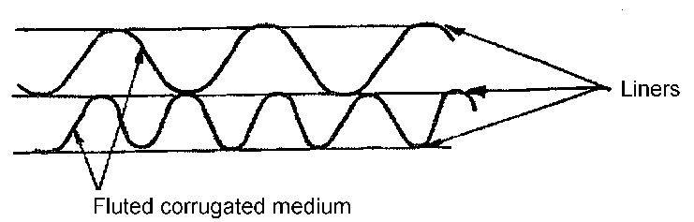

Fig. 1 — Double-wall corrugated fibreboard

**3.4**

**triple-wall corrugated fibreboard**

board composed of four flat liners and three corrugated sheets, in combination (see Figure 2)

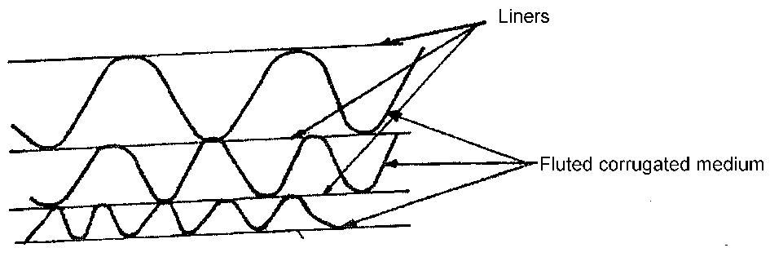

**Figure 2 — Triple-wall corrugated fibreboard**

**3.5**

**seam**

part of bed where the user in closing the bed brings together or overlaps the edges of the outer flaps

**3.6**

**flat crush**

maximum crushing force, applied perpendicular to the surface of the fluting structure, sustained before complete collapse of the structure

**3.7**

**collapse**

point where the sidewalls of the flutes are no longer able to support load because they have suffered compression damage

NOTE At this point, the fluting profile appears similar to that of a mushroom.

**3.8**

**flat crush resistance**

flat crush divided by the area of the test piece under the condition of test

**3.9**

**compressive strength**

maximum compressive force per unit length that a test piece of paper or board can withstand until the onset of failure

NOTE 1:The compressive strength is expressed in kilo newtons per metre.

**3.10**

**Edge crush resistance**

maximum compressive force per unit length that a narrow test piece bent into the form of a cylinder (ring) can withstand on its edge without failure under the conditions defined in this Standard

NOTE 2: The ring crush resistance is expressed in kilo newtons per metre squared.

# 4 Requirements

## 4.1 General

**4.1.1** The corrugated fibreboard used shall not crack or delaminate on bending or creasing. The outer liner shall be hard sized and shall have good printability. The liners shall be firmly glued to the fluting.

**4.1.2** The corrugated fibreboard shall be machine glazed (MG) or machine finished (FM). It shall be of uniform formation, thickness and substance, and shall be evenly finished, free from conspicuous specks, holes and other blemishes. The faces of the beds shall not contain visible defects like tears, punctures and shall not be swollen or bent.

**4.1.3** The corrugated fibreboard shall be Varnished or Coated to allow for sanitization.

**4.1.4** Materials used in manufacture of the beds shall be odourless, and shall not be harmful to the skin.

## 4.1 Specific requirements

The Chemical and physical properties of the corrugated fibre board bed shall comply with the requirements listed in Table 1.

Table 1 — Chemical and physical requirements of the corrugated fibre board bed

|  |  |  |  |  |
| --- | --- | --- | --- | --- |
| **Item No.** | **Characteristic** | | **Requirement** | **Test method** |
|  | Combined Substance, gsm, min, ± 5 % | | 871 | KS ISO 536 |
|  | Moisture content, %, range | | 4 — 8 | KS ISO 287 |
|  | Edge crush resistance, N/m2,min | | 66,000 | ISO 16945 |
|  | Corrugated medium test (CMT) or concorra test value | | 133 N/10 flutes | KS EAS 865 |
|  | Comprehensive strength,kN/m, min | | 6 | KS ISO 9895 |
|  | pH, | | 6.5 —8 | KS ISO 6588- |
|  | Flat crush resistance, kN/m2 | Flute B | 66 | KS ISO 3035 |
| Flute C | 60 |
|  | Water absorption g/m2,max | | 30 | KS ISO 5637 |
|  | Weight of the bed, kg, min | | 30 | KS ISO 536 |
|  | Load capacity, kg, min | | 300 | Annex A |
|  | Substance outer liner, gsm, min | | 400 | KS ISO 536 |
|  | Substance of Inside Liner, gsm, min | | 400 | KS ISO 536 |
|  | Flute type | | B and C | KS EAS 865 |

# 6 Dimension



**Figure 3: Atypical example of assembled bed**



Dimensions in millimetres

Figure 4 — Details of fins showing groove

The dimensions of the bed shall be as indicated in table 5

Table 2— Dimensions of the bed made from corrugated fibre board

|  |  |  |  |
| --- | --- | --- | --- |
| **S.N0** | Dimensions in millimetres  Tolerance ±0.05 | | Test method |
| A | Length, min | 1800 | ISO 216 |
| B | Width, min | 900 |
| C | Height | 560 |

# 

7 **Packaging and Labelling**

**7.1 Packaging**

**6.1.1** The beds shall be packed in suitable materials that prevents them from damage, contamination during handling, storage and transportation.

**7.2 Labelling**

**7.2.1 Bulk package**

The bulk package l for beds shall be legibly and indelibly marked with the following information on the outer .

1. Manufacturer’s name, address and /or registered trade mark.
2. Description of goods, “corrugated fibre board beds”.
3. Dimensions.
4. Batch number or code
5. Instruction for correct use
6. Instruction for storage and disposal.
7. The declaration, ‘country of origin.

**6.2.2 bed**

The bed shall be legibly and indelibly marked with the following information

1. Manufacturer’s name, address and /or registered trade mark.
2. Batch number or code
3. Grammage
4. Instruction for correct use, assembling, storage and disposal.

**8 Sampling**

Sampling of the beds shall be done in accordance with ISO 186

Annex A  
(normative)  
  
Determination of the load capacity

A.1 General

The bed assembled as per manufactures instruction is tested for load capacity.

A.2 Apparatus

A.2.1 Weighing balance

A.2.2 300kg weight of sand

A.3 Procedure

A.3.1 Assemble the l bed as per the manufactures instruction.

A.3.2 Load the bead with a load of Sand of 300kg uniformly on the assembled bed.

A.4 Report

The bed will have met the requirement if it does not yield to the mass of 300kg of sand for a period of two hours.