Masonry cement

Part 2:

Test method



TECHNICAL COMMITTEE REPRESENTATION

The following organizations were represented on the Technical Committee:

1. Apex Systems Consulting Group Limited
2. Aurecon Kenya
3. Bamburi Cement
4. Blackberry House Ltd
5. Drychem Kenya Solutions Ltd.
6. East African Portland Cement Company Plc
7. Institution of Engineers of Kenya
8. Institute of Quantity Surveyors of Kenya
9. Institution of Engineers Of Kenya
10. Jiangxi Youse
11. Kenya Builders & Concrete Co Ltd
12. Ketraco
13. KTDA Power Company Limited
14. Moi University
15. Mombasa Cement Ltd.
16. Multimedia University of Kenya
17. Nairobi Western Bypass Project
18. Roads Division, State Department of Infrastructure, Ministry of Transport, Infrastructure, Housing, Urban Development and Public Works
19. Royal Automation Systems
20. Technical University of Kenya
21. Technical University of Mombasa
22. University of Nairobi
23. Kenya Bureau of Standards — Secretariat

REVISION OF KENYA STANDARDS

In order to keep abreast of progress in industry, Kenya Standards shall be regularly reviewed. Suggestions for improvements to published standards, addressed to the Managing Director, Kenya Bureau of Standards, are welcome.

© Kenya Bureau of Standards,2020

Copyright. Users are reminded that by virtue of Section 25 of the Copyright Act, Cap. 130 of 2001 of the Laws of Kenya, copyright subsists in all Kenya Standards and except as provided under Section 25 of this Act, no Kenya Standard produced by Kenya Bureau of Standards may be reproduced, stored in a retrieval system in any form or transmitted by any means without prior permission in writing from the Managing Director.

Masonry cement

Part 2:

Test method

|  |  |
| --- | --- |
| Kenya Bureau of Standards, Popo Road, Off Mombasa Road, P.O. Box 54974 - 00200, Nairobi, Kenya | |
|  | +254 020 6948000, + 254 722202137, + 254 734600471 |
|  | info@kebs.org |
|  | @KEBS_ke |
|  | kenya bureau of standards (kebs) |

Foreword

This Kenya Standard was prepared by the Cement and Lime Technical Committee under the guidance of the Standards Projects Committee, and it is in accordance with the procedures of the Kenya Bureau of Standards

This second edition cancels and replaces the first edition which has been technically revised

KS 2168 consists of the following parts, under the general title Introductory element — Main element:

* Part 1: Composition, Specifications and conformity criteria
* Part 2: Test method

During the preparation of this standard, reference was made to the following documents(s):

EN 413 Masonry cement Part 2: Test method

|  |  |
| --- | --- |
| KENYA STANDARD | KS 2168-2:2020 |

**Masonry cement**

**Part 2:**

**Test methods**

1. **Scope**

This Standard describes reference and alternative test methods to be used when testing masonry cements to assess their conformity to KS 2168-1. It gives the tests on fresh mortar for consistence, water retention and air content.

In the event of a dispute, only the reference methods are used.

1. **Normative references**

The following documents, in whole or in part, are normatively referenced in this document and are indispensable for its application. For dated references, only the edition cited applies. For undated references, the latest edition of the referenced document (including any amendments) applies.

KS EAS 148-1, Methods of testing cement - Part 1: Determination of strength

EN 196-3:2005 + A1:2008, Methods of testing cement - Part 3: Determination of setting times and soundness

EN 459-2:2010, Building lime - Part 2: Test methods

1. **General requirements for testing** 
   1. **Laboratory**

Unless specifically stated to the contrary, all the tests described in this document shall be carried out in a laboratory where the air temperature is maintained at (20 ± 2) °C and the relative humidity at not less than 50 %.

* 1. **Manufacturing tolerances for test equipment** 
     1. **Dimensions**

Figures indicating the specified requirements for apparatus used in the tests described in this document shall include essential dimensions for which manufacturing tolerances are given. Unless otherwise stated, tolerance class m according to ISO 2768-1should be applied.

NOTE Other dimensions are given for guidance.

* + 1. **Mass**

Specified masses shall have manufacturing tolerances within ± 1 % of the mass unless otherwise stated.

* 1. **Tolerances for test equipment in use**

Tolerances applying to apparatus, which has been subjected to wear in use shall not exceed twice the corresponding manufacturing tolerance unless alternative requirements are specified.

* 1. **Number of tests**

Where the test is one of a series subject to statistical control, determination of each property by a single test shall be the minimum required. Where the test is not part of a series subject to statistical control, two tests shall be performed to determine each property.

1. **Determination of setting time**
   1. **General**

The setting time is determined by observing the penetration of a needle into a cement paste of standard consistence until it reaches a specified value.

The setting time is determined in accordance with either method A (4.2) or method B (4.3). Method B is the reference method.

* 1. **Method A**

The setting time is determined in accordance with EN 196-3:2005 + A1:2008.

NOTE Experience has shown that the method specified in KS EAS 148–3, in which the specimens are tested under water, is not suitable for some masonry cements which have low clinker contents.

* 1. **Method B** 
     1. **Test principle**

The equipment used and the specimen preparation procedures are as described in EN 196-3:2005 + A1:2008 but with the additional requirement for a room or a humidity cabinet of maintained at (20 ± 1) °C and not less than 90 % relative humidity.

* + 1. **Initial setting time procedure**

Calibrate the Vicat apparatus with the needle, attached in advance of the test, by lowering the needle to rest on the base-plate to be used and adjusting the pointer to read zero on the scale.

Raise the needle to the stand-by position.

Fill a Vicat mould in accordance with EN 196-3:2005 + A1:2008, 5.2.2 with paste of standard consistence mixed in accordance with EN 196-3:2005 + A1:2008, 5.2.1

Place the filled mould and base-plate in the room or humidity cabinet and after a suitable time, position the mould and base-plate under the needle of the Vicat apparatus. Lower the needle gently until it is in contact with the paste. Pause in that position for between 1 s and 2 s in order to avoid initial velocity or forced acceleration of the moving parts. Then release the moving parts quickly and allow the needle to penetrate vertically into the paste. Read the scale when penetration has ceased, or 30 s after the release of the needle, whichever is the earlier.

Record the scale reading, which indicates the distance between the end of the needle and the base-plate, together with the time from zero. Repeat the penetration on the same specimen at conveniently spaced positions, not less than 8 mm from the rim of the mould or 5mm from each other and at least 10 mm from the last penetration position, at conveniently spaced intervals of time, e.g. at 10 min intervals. Between penetrations keep the specimen in a room or humidity cabinet. Clean the Vicat needle immediately after each penetration. Retain the specimen if determination of the final setting time is to be made.

* + 1. **Report – initial setting time**

Report the elapsed time measured from zero to the time at which the distance between the needle and the base-plate is (6 ± 3) mm as the initial setting time of the cement to the nearest 5 min. If the initial setting time exceeds 6h determine the final setting time.

* + 1. **Final setting time procedure**

Invert the filled mould and follow the procedure described in EN 196-3:2005 + A1:2008: 6.3 with the specimen held in the room or humidity cabinet at controlled humidity rather than under water.

* + 1. **Report – final setting time**

Report the elapsed time measured from zero to that at which the needle first penetrates only 0,5 mm into the specimen as the final setting time of the cement, to the nearest 15 min. 4.3.6 Repeatability and reproducibility The standard deviation of repeatability is 4 min for initial setting time and 7 min for final setting time. The standard deviation of reproducibility is 20 min for initial setting time and 24 min for final setting time. These precision data take into account uncertainty of measurement.

1. **Preparation of standard mortar** 
   1. **Principle**

The properties of fresh mortar made with masonry cement are assessed on standard mortar prepared in accordance with KS EAS 148-1, but with the water content necessary for the standard consistence.

The consistence is measured using the plunger apparatus (see 5.2) as the reference method to achieve the required value of penetration.

A flow table test (see 5.3) is allowed as an alternative to the plunger test but it is important that the flow table spread equivalent to the required value of penetration is established, using the same type of masonry cement as that which shall be tested.

* 1. **Consistence of fresh mortar by plunger apparatus (reference method)** 
     1. **Apparatus**

The mixer and ancillary equipment shall be as described in KS EAS 148-1.

The plunger apparatus shown in Figure 1 shall conform to the dimensions specified. The shape of the baseplate (1) shall enable the mortar container (8) to be placed centrally below the plunger (7).

The plunger shall have a hemispherical lower end, be resistant to corrosion and not attacked by mortar. The total mass of the rod (6) and plunger (7) shall be (90 ± 2) g. A release mechanism (5) holds the measuring rod in its initial position so that the lower end of the plunger is (100 ± 0.5) mm above the mortar surface prior to commencing the test (the initial position in 5.2.2).

The tamper (see Figure 2) shall consist of a round rod made of impermeable material with sheet metal protection and shall weigh (250 ± 15) g.

* + 1. **Procedure**

Prepare the mortar according to the procedure described in KS EAS 148-1 except that the water content shall be that determined to give the consistence required.

Before the start of each test wipe the plunger with a damp cloth.

Fill the container in two layers immediately after completing the mixing procedure. Compact each layer with 10 light strokes of the tamper.

Strike off the excess mortar, within 1 min of completion of mixing, by a gentle sawing action using the straightedge held at an angle of about 45 degrees. Then at a slightly flatter angle smooth the surface in a single direction in the reverse direction. After placing the container on the base-plate, release the plunger from its initial position (150 ± 15) s after the completion of mixing and determine the value of penetration into the mortar by reading the scale.

A value of penetration of (35 ± 3) mm is required for the mortar to be of standard consistence. If the mortar does not achieve the standard consistence required then mix a new batch of mortar using a different quantity of water. Repeat the test on new batches of mortar until the value of penetration of (35 ± 3) mm is obtained in two consecutive tests.

Record the mass of water required in grams to obtain standard consistence and the value of penetration in millimetres.

* + 1. **Reproducibility**

The reproducibility which can be expected, expressed as the standard deviation of the results of the penetration test obtained by different, well-experienced, laboratories is 3.0 mm.

* 1. **Consistence of fresh mortar by flow table (alternative method)** 
     1. **Method**

NOTE The flow table method has been retained as an alternative to the plunger method (reference method) as it is still widely used.

* + 1. Apparatus
       1. Flow table, as described in EN 459-2:2010, 6.8.2.1.2.
    2. **Calibration**

Calibrate the flow table, using the same type of masonry cement as that to be tested, against the plunger used for the consistence test described in 5.2. Carry out a minimum of three pairs of tests at different water contents in order to establish the spread range on the flow table which is equivalent to a (35 ± 3) mm value of penetration using the plunger apparatus. Then adopt this spread in order to achieve the defined level of consistence required. The relationship between the values using the flow table and the plunger apparatus shall be established for all products and updated at least once every 12 months.

It is recommended to establish a relationship between flow and penetration over the range 30mm to 40mm penetration.

* + 1. **Procedure**

Before the start of each test, ensure that the plate and inner surface of the mould are clean and dry.

If the flow table has not been used during the hour prior to the test, the empty table shall be jolted several times. There shall be neither fluid nor dirt between the bearing (6) and the boss (8) (see EN 459-2:2010, Figure 16).

In order to determine the flow diameter, place the mould in the centre of the clean, dry surface of the flow table (5.3.2.1). Fill it with two layers of mortar (prepared just before in accordance with 5.2.2) during which operation the mould with the mounted hopper shall be held firmly onto the plate with one hand in such a way that its edge coincides with the circle engraved on the plate. Spread each layer of mortar by tamping it lightly 10 times with the tamper (Figure 2) so that the mould is filled uniformly.

Remove the hopper without delay, and strike off the excess mortar, within 1 min of completion of mixing, by a gentle sawing action using the straightedge held at an angle of about 45 degrees. Then at a slightly flatter angle smooth the surface in a single direction in the reverse direction. Clean the flow table and remove any water in the proximity of the mould. After 10 s to 15 s have elapsed from the time the mortar has been struck off, lift the mould slowly and vertically from the plate (150 ± 15) s after the completion of mixing. Spread the mortar by jolting the plate 15 times at one jolt per second. Measure the diameter of the pat with a calliper in two directions at right angles to one another. Report the mean value of these measurements to 1 mm as the flow.

A value of flow corresponding to a plunger penetration of (35 ± 3) mm is required for the mortar to be of standard consistence. If the mortar does not achieve the standard consistence required then mix a new batch of mortar using a different quantity of water. Repeat the test on new batches of mortar until the required value of flow is obtained.

Record the mass of water required in grams to obtain standard consistence and the value of flow in millimetres.

1. **Determination of water retention** 
   1. **Principle**

The fresh mortar, of standard consistence, is subjected to a suction treatment under defined conditions using filter paper as a substrate. The water retention of the mortar is the mass of water retained in the mortar after the suction treatment and is expressed as a percentage by mass of its original water content.

* 1. **Preparation**

Having completed the consistence test described in 5.2 or 5.3, remix the mortar remaining in the mixing bowl on low speed for 15 s and then carry out the water retention test. Should the time interval between the commencement of mixing and the start of the suction period of the water retention test exceed 10 min, then a fresh batch of mortar shall be prepared.

Dimensions and tolerances in millimetres

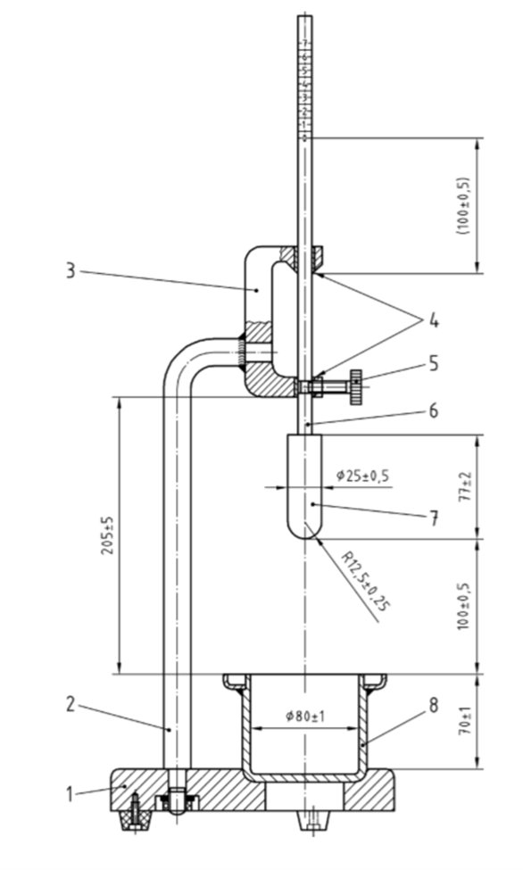

Key

1 base-plate

2 support

3 holder

The use of apparatus in which the height of the holder above the base-plate can be varied, is acceptable, provided that for tests to this standard the height shall be set to the value specified in Figure 1

4 guide bushes

5 release mechanism

6 aluminium measuring rod (scale with 1 mm graduations)

7 plunger

8 container (with drip protection)

**Figure 1 — Plunger apparatus for measuring consistence**

Dimensions and tolerances in millimetres

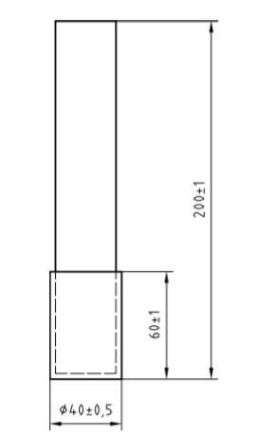

**Figure 2 — Tamper**

* 1. **Apparatus** 
     1. Rigid mould of (100 ± 1) mm internal diameter and (25 ± 1) mm internal depth.
     2. Metal straightedge, as described in KS EAS 148-1.
     3. Mass, 2 kg.
     4. Rigid plate, non-porous (110 ± 5) mm diameter, (5 ± 1) mm thick.
     5. Cotton gauze or non-woven tissue1) two circles (110 ± 1) mm diameter or two squares of (110 ± 1) mm side, of nominal area weight 20 to 90 g/m2 dry gauze or tissue, each piece having a nominal thickness of 0.06mm to 0.19mm and nominal permeability to air of 1 000 to 2 500 l/m2s.
     6. Balance, with a capacity of at least 2 kg and capable of weighing to 0.1 g.
     7. Filter paper, eight circles, (110 ± 1) mm diameter of 180 g/m2 to 200 g/m2 dry paper, each circle having a nominal thickness of 0.40 mm and having a nominal particle retention size of 6 μm. Discard all used filter papers.
     8. Palette knife, with a blade 150 mm to 200 mm long and 20 mm to 30 mm wide.
  2. **Procedure**

Weigh the empty and dry mould (6.3.1) to the nearest 0.1 g (u). Weigh the eight circles of unused filter paper to the nearest 0.1 g (v).

Fill the mould with the mortar in about 10 increments using the end of the palette knife until the mortar is slightly above the edge of the mould. Strike off the excess mortar by a gentle sawing action using the straightedge held at an angle of about 45°. Then at a slightly flatter angle smooth the surface in a single direction in the reverse direction.

Weigh the mould and its contents to the nearest 0.1 g (w). Cover the surface of the mortar with the two pieces of cotton gauze and place the eight circles of filter paper on top of the gauze. Place the non-porous plate on top of the filter papers, invert the mould on to a flat surface and place the 2 kg mass on the inverted base of the mould.

After (300 ± 5) s remove the 2 kg mass, re-invert the assembly, remove the rigid non-porous plate, filter papers and the cotton gauze and weigh the filter papers to the nearest 0.1 g (x).

Calculate the mass of mortar involved in the test as (w – u), then the mass of water present (z),

$$z=\frac{y\left(w-u\right)}{1350+450+y}$$

where:

u is the mass of the empty mould, in grams;

w is the mass of the mould and its contents, in grams;

y is the mass of the water used to produce mortar having a penetration of (35 ± 3) mm, in grams.

The mass of water taken up by the filter papers is given by (x – v).

Calculate the water retention as a percentage by mass of the total water from:

$$R=\frac{\left[z-\left(x-v\right)\right]100}{z}$$

where:

v is the mass of the eight filter papers before absorption, in grams;

x is the mass of the eight filter papers after absorption, in grams;

z is the mass of water present in the mortar before absorption, in grams.

Where the test is not part of a series subject to statistical control and two individual test results differ by more than twice the standard deviation of repeatability (1 %), repeat the test and take the mean of the two closest test results. Report the water retention value, which is expressed to the mean of the two closest test results. Report the water retention value, which is expressed to the nearest 1 %.

* 1. **Repeatability and reproducibility**

The standard deviation of repeatability is 0.5 %.

The standard deviation of reproducibility is 3.1 %.

These precision data take into account uncertainty of measurement.

1. **Determination of air content** 
   1. **General**

Two methods for determining the air content are included in this document. The pressure method (7.2) is the reference method and the alcohol method is the alternative method (7.3). Other methods may also be used provided that prior to use they have been shown to give similar results to the reference method.

This test shall be carried out on a fresh batch of mortar of standard consistence prepared as in 5.2.2.

* 1. **Pressure method (reference method)** 
     1. **Principle**

The air content of the fresh mortar is determined from the reduction in volume when a pressure is applied.

* + 1. **Apparatus**

The test apparatus (see Figure 3) consists of a metal cylinder (sample container) with a capacity of (0.75 ± 0.05) L or (1.00 ± 0.05) l[1]). The sample container (1) and the cover (2) are sealed airtight together by means of clamps (3). The valve (7) is provided to enable filling with water and venting of air. The air is compressed by means of a pump (4). The pressure gauge (8) has a scale to measure the air content with divisions not greater than 0.5 %.

* + 1. **Calibration**

Calibration shall be carried out, in addition to the manufacturer's instructions, in accordance with the following procedure:

a) Measure and record the total weight of the air content meter on a dry basis.

b) Fill the air content meter 100 % with water, close the valve and take a calibration reading at zero air content.

c) Measure and record the total weight of the air content meter as filled in b).

d) Calculate the difference between c) and a), d,

e) Take calibration readings at 5 approximately equally spaced values within an approximate range of 5% to 25% air content using the calculated difference, d.

The calibration test values obtained shall be used in conjunction with the pressure gauge readings to derive a relationship that can be used to correct the values when read from the pressure gauge (see 7.2.4).

* + 1. **Procedure**

Record the weight of the empty sample container (a).

Immediately after mixing has been completed, place the mortar into the sample container in two approximately equal layers. The final layer of mortar shall slightly overfill the sample container. To remove air bubbles lightly touch each layer using 10 strokes of the tamper (Figure 2), evenly distributed over the surface of the mortar. Strike off the mortar level with the top edge of the container as described in 6.4.

Wipe the edge of the container clean with a moist cloth or with a sponge.

Record the weight of the filled container (b)

The air content shall be determined between 5 and 10 min after the test mortar has been mixed.

Place the cover (2) onto the container. Seal the cover and the container airtight together by closing the clamps (3).

Allow both the valves (5) and (7) to remain open.

Use a squeeze bottle to squirt water into the valve (7) until all air still remaining in the meter has been evacuated through the overflow valve (5) [the water which flows out through the valve (5) shall be without air bubbles].

Operate the air pump until the pressure indicator has reached the initial prescribed level.

Should the pressure fall slightly after a few seconds, increase the pressure by pumping again until the pressure indicator has again reached the mark. If the indicator goes past the mark then this shall be corrected by partially opening correction valve (6) until the pressure indicator has returned exactly to the mark.

Shut both valves (5) and (7). Open the correction valve (6) until the pressure equalization has been achieved. Tap lightly on the gauge until the indicator comes to rest and read the air content of the mortar as indicated. Correct this reading using the calibration relationship derived in 7.2.3.

After testing, open both valves (5) and (7) slowly to relieve the pressure in the sample container (1) and then repeat the test.

Where the test is not part of a series subject to statistical control and two individual test results differ by more than twice the standard deviation of repeatability (0,5 %), repeat the test and take the mean of the two closest test results.

The plastic density of the mortar is calculated from the difference between (a) and (b) divided by the nominal volume of the container (7.2.2).

Report the plastic density, which is expressed to the nearest 10 kg/m3.

Report the air content value, which is expressed to the nearest 0.5 %.

Variations to this procedure may be found between apparatus supplied by different manufacturers. However, the manufacturers’ instructions have to be followed to obtain a calibration

* + 1. **Repeatability and reproducibility**

The standard deviation of repeatability is 0.5 %.

The standard deviation of reproducibility is 1.0 %.

These precision data take into account uncertainty of measurement.

* 1. **Alcohol method (alternative method)** 
     1. **Principle**

The air content of the mortar is determined from the reduction in volume which occurs when the air is expelled by a liquid.

* + 1. **Apparatus** 
       1. Measuring cylinder, approximately 50 mm in diameter, with a capacity of 500 ml and with 5 ml graduations.
       2. Rubber bung, fitting the measuring cylinder.
       3. Funnel, fitting the measuring cylinder and suitable for filling it with mortar.
       4. Mixture, of 60 % by volume alcohol (ethanol) and 40 % by volume water. A sufficient quantity of 2-octanol may be used in place of ethanol.
    2. **Procedure**

Place approximately 200 ml of mortar into the cylinder using the funnel, taking care to avoid cavities in the mortar. Tap the cylinder to level the mortar surface and release entrapped air. Record the mortar volume (Vm) to the nearest millilitre. Pour the mixture of alcohol and water carefully into the cylinder up to the 500 ml mark.

Seal the cylinder with the rubber bung and invert 20 times to obtain a complete dispersion of the mortar in the alcohol-water mixture. Let the dispersion settle for (5.0 ± 0.5) min and read the resulting liquid level to the nearest millilitre. Repeat this process until two successive readings do not differ by more than 1 ml. With this liquid level (Vv) calculate the air content (A) of each mortar sample as a percentage of the original mortar volume from the following formula to the nearest 0.1 %:

$$A=\left[\left(500-Vv\right)/Vm\right]100$$

where

Vm is the volume of mortar, in millilitres;

Vv is the volume of mortar plus liquid after shaking, in millilitres.

Calculate the average value of the two individual air contents to the nearest 0.5 %. If the two individual values deviate more than 10 % relatively from their average value, test two additional samples and calculate a new average value. Report the result as the air content to the nearest 0.5 %.

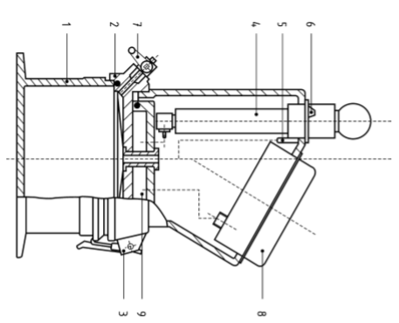

Key

1 sample container

2 cover

3 clamp

4 pump

5 discharge valve

6 correction valve

7 ball valve

8 pressure gauge

9 pressure chamber

Figure 3 — Schematic diagram of an air content meter

1. It may be necessary when using the 1.00 l container to increase the size of the batch of mortar.