**Oil filters — Specification**

©KEBS 2020 Third Edition 2020

###### TECHNICAL COMMITTEE REPRESENTATION

The following organizations were represented on the Technical Committee:

Toyota Kenya Ltd

D.T Dobie

Mitsumoto

Isuzu E.A

Kenya Association of Bus Manufacturers (KABM)

Kenya Motor Repairers Association (KEMRA)

Nissan

Numerical Machining Complex (NMC)

Gede Enterprises

Mobius Motors

KUMPIA

Kenya Industrial Research and development Institute (KIRDI)

Technical University of Kenya (TUK)

Motorwise Valuers

Kenya Auto Bazaar Association

Honda (Nairobi)

Egerton University

Olive Technical Services Ltd

Kenya Jua Kali Association

MCI Ltd

Kenya Bureau of Standards — Secretariat

# **REVISION OF KENYA STANDARDS**

In order to keep abreast of progress in industry, Kenya Standards shall be regularly reviewed. Suggestions for improvements to published standards, addressed to the Managing Director, Kenya Bureau of Standards, are welcome.

*© Kenya Bureau of Standards, 2020*

*Copyright. Users are reminded that by virtue of Section 25 of the Copyright Act, Cap. 12 of 2001 of the Laws of Kenya, copyright subsists in all Kenya Standards and except as provided under Section 26 of this Act, no Kenya Standard produced by Kenya Bureau of Standards may be reproduced, stored in a retrieval system in any form or transmitted by any means without prior permission in writing from the Managing Director.*

**Oil filters — Specification**

**KENYA BUREAU OF STANDARDS (KEBS)**

**Head Office:** P.O. Box 54974, Nairobi-00200, Tel.: (+254 020) 605490, 602350, Fax: (+254 020) 604031

E-Mail: info@kebs.org, Web:http://www.kebs.org

**Coast Region Lake Region Rift Valley Region**

P.O. Box 99376, Mombasa-80100 P.O. Box 2949, Kisumu-40100 P.O. Box 2138, Nakuru-20100

Tel.: (+254 041) 229563, 230939/40 Tel.: (+254 057) 23549, 22396 Tel.: (+254 051) 210553, 210555

Fax: (+254 041) 229448 Fax: (+254 057) 21814

**Foreword**

This Kenya Standard was prepared by the Road Vehicles Technical Committee under the guidance of the Standards Projects Committee, and it is in accordance with the procedures of the Kenya Bureau of Standards.

It covers performance requirements for oil filters.

Taking into consideration the views of consumers, it was felt desirable that this standard be prepared to improve the quality of filters manufactured in this country.

This Third edition cancels and replaces the 2010 edition which has been technically revised.

During the preparation of this standard, reference was made to the following document:

ISO 4548: Methods of test for full-flow lubricating oil filters for internal combustion engines.

Acknowledgement is hereby made for the assistance derived from this source.

**Oil filters — Specification**

**1 Scope**

* 1. This Kenya Standard specifies materials, performance requirements and methods of test for oil filters.
  2. This standard applies to oil filters for engine lube oil, hydraulic oil, transmission oil, gear oil, turbine oil, transformer oil and bypass oil. The standard applies for both the element filters and spin on filters.

##### Definitions

For the purposes of this standard, the definition given in KS ISO 11841-1: 2000 and KS ISO 11841-2: 2000 as well as Figure 1 and Figure 2 shall apply.

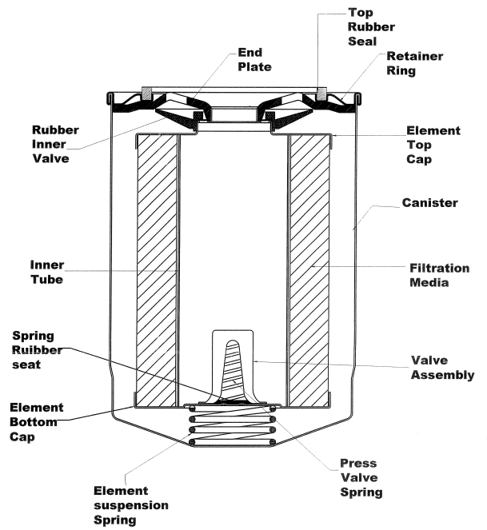

**Figure 1 a) Cross section view of a typical filter parts for a spin-on filter**

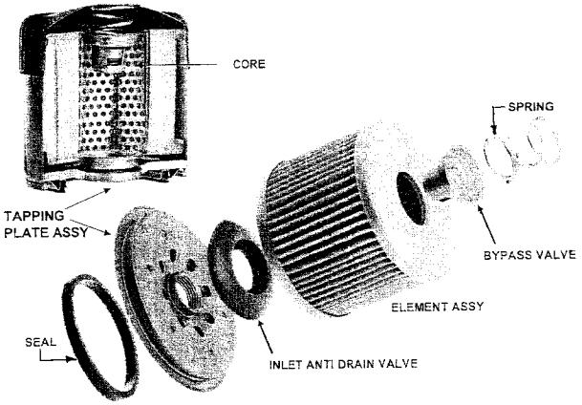

**Figure 1 b) — Typical filter parts for a spin-on filter**

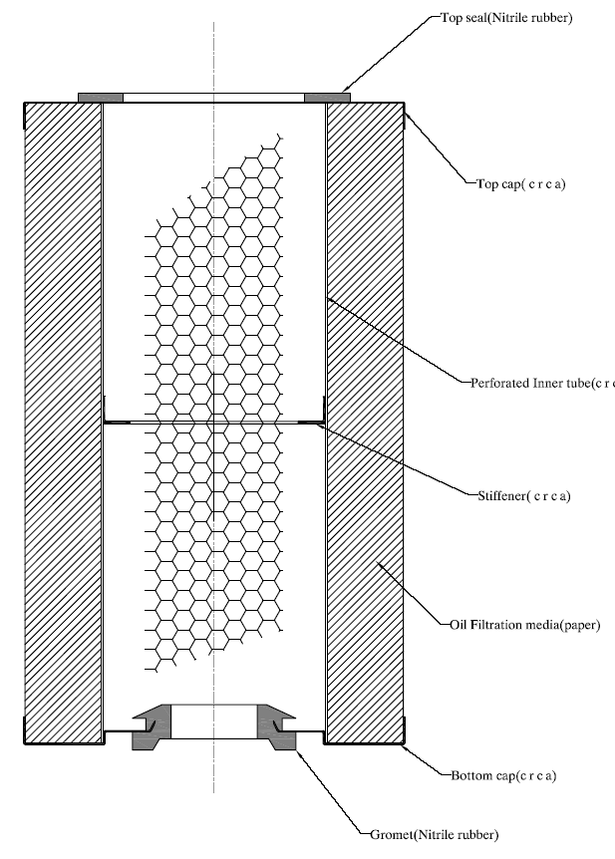

**Figure 2 — Typical cross section drawing of an element filter**

##### Construction

**3.1 General construction**

* + 1. The filter casing shall be capable of withstanding normal mechanical stresses encountered in service.
       1. The top and bottom caps for the element filters, shall be strong enough to hold the filtration media strongly in position while in service.
       2. For the spin on filters

1. The seam shall be strong enough and shall not break in service.
2. The end plate (base plate) shall be strong enough to hold the engine pressures.
3. If made of steel sheet, the minimum thickness shall be 2.8 mm and shall comply with the requirements of sub clause 3.1.6.
   * + 1. The inner tube shall remain intact without collapsing during the filter’s life.
     1. The filtering media shall be impregnated oil filter paper with a pore size of 5 to 8 microns (50 – 80 micrometers), wire gauze, felt material, reinforced impregnated paper (with wire gauze) or any other appropriate material that meets the performance requirements specified in this standard as per the particular type of application.
4. The burst strength shall be 2.5 – 3 kg/cm3
5. If the filtration media is made of paper then the minimum grammage for the filtration paper shall be 150 gsm.
   * 1. All seals shall be of rubber non-reactive with oil and with a minimum Shore A hardness of 65 International Rubber Hardness degrees.
     2. All gaskets required for mounting the filter element shall have a minimum Shore A hardness of 45 International Rubber Hardness degrees.
     3. Glue for bonding paper and other components shall withstand heat.
     4. All metal components of the filter assembly shall be corrosion resistant or properly treated to prevent environmental corrosion. They shall either be made from CRCA, electro-galvanized or appropriately treated. When tested in accordance with Annex F, they shall show no sign of corrosion.
     5. Thread size for the spin on filters shall be as specified by the original equipment manufacturer (OEM) for that particular application.
     6. All oil filters shall be fitted with a relieve valve thatshall only open at maximum pressure of the casing rated by original equipment manufacturer (OEM).

**4 Requirements**

**4.1 Pressure drop test**

When tested as described in Annex A,the pressure drop across the filter shall not exceed 0.03 MPa.

**4.2 By-pass valve opening pressure-test**

When tested as described in Annex B, the by-pass valve opening pressure shall be within the range specified, after observing that the leakage rate through the valve at a pressure equal to 0.7 of the minimum permissible opening pressure does not exceed 200 mL/min.

**4.3 Contaminant capacity ratio**

When tested as described in Annex C, the contaminant capacity ratio in g/mm shall not be less than 0.3.

##### 4.4 Resistance to high pressure differential

##### When tested as described in Annex C, the filter element shall withstand a minimum pressure differential of 0.5 MPa without evidence of failure.

* 1. **Burst pressure test**

The filter shall withstand a minimum proof pressure of 1.5 MPa without evidence of external leakage. This is achieved by holding 1.5 MPa pressure for five minutes.

* 1. **Instruments performance**

All flow meters and differential pressure gauges shall be ± 5 % accurate. Temperature controls shall be capable of stabilizing temperature at ± 3 %.

###### Marking

###### The filter and filter packaging shall be legibly and indelibly marked on the outer casing with the following:

1. Manufacturers’ name and/or registered trademark;
2. Country of origin;
3. Part number.
   * 1. Additional markings indicated on the filter or package shall necessitate additional verifications that the filters comply with the claims indicated.

# **Annex A**

(normative)

**Determination of pressure drop/flow characteristics**

**A.1 Apparatus**

The recommended test rig is shown diagrammatically in Figure A.1. It shall consist of an insulated sump capable of holding the required volume of oil and accommodating a thermostatically controlled heater capable of maintaining the required temperature to ± 2.00C. Local overheating of the oil shall be avoided.

A pipe shall connect the base of the sump with the inlet port of a motor driven pump. The outlet port of the pump shall connect by further pipework with the filter inlet.

The pump delivery is directed to a four-way connector, one limb of which accommodates an indicating thermostat, another the bypass return line to the sump. The fourth limb is connected to a flowmeter, which shall be suitable for use with oils of 24 cSt and 100 cSt kinematics viscosity and shall register the flow to an accuracy of ± 2 per cent, in the pipeline leading to the filter. As an alternative, the flowmeter may be installed in the filter outlet pipe. The bypass return to the sump and the filter outlet pipe shall terminate below the surface of the oil when the oil is in circulation.

Two regulating valves shall be provided for the purpose of flow control, one being situated in the filter bypass pipe (6) and the other in the filter outlet pipe (4) (*see* Figure A.1). An On-OFF valve (1) shall also be installed in the filter feed pipe. The pipes connecting the filter shall have a bore equivalent to that of the filter inlet and outlet ports or those incorporated in the engine block. A straight run of at least 12 pipe diameters shall be provided before the filter and 8 pipe diameters after the filter.

Tappings for pressure measurement shall be made at 1 pipe diameter and 4 pipe diameters from the filter inlet and outlet ports respectively. Pressure tappings shall also be made into the test filter in communication with the upstream and downstream sides of the filter element. Whenever practicable, the pressure gauge tappings shall be positioned to measure pressure in quiescent locations within the filter.

Differential pressure gauges, preferably of the mercury manometer type, are recommended, in addition to an inlet pressure gauges, calibrated in kN/m2.

The slurry addition vessel, quadrant and filtrate receptacle shown in Figure A1 are not necessary for the test in this section, but are required and referred to in subsequent sections.

**A.2 Test liquids**

**A.2.1** Straight mineral oils shall be used. The temperature of the oil shall be controlled to achieve kinematic viscosities of 24 cSt and 490 cSt, but it shall not exceed 100°C.

**A.3 Test procedure**

**A.3.1** The filter shall be unused and the test liquid and apparatus clean. The term clean implies that when the test liquid is circulated through the test rig and the filter at the rated flow for 5 min no increase in pressure across the filter occurs.

**A.3.2** The filter shall be installed for test as shown in Figure A.1 using connectors or adaptors in case of flanged and headless filters.

**A.3.3** The required quantity of clean test liquid shall be added to the sump and circulated through the test system via the bypass pipe only. No test liquid shall pass through the filter at this stage.

Organic contaminant feed device or quadrant

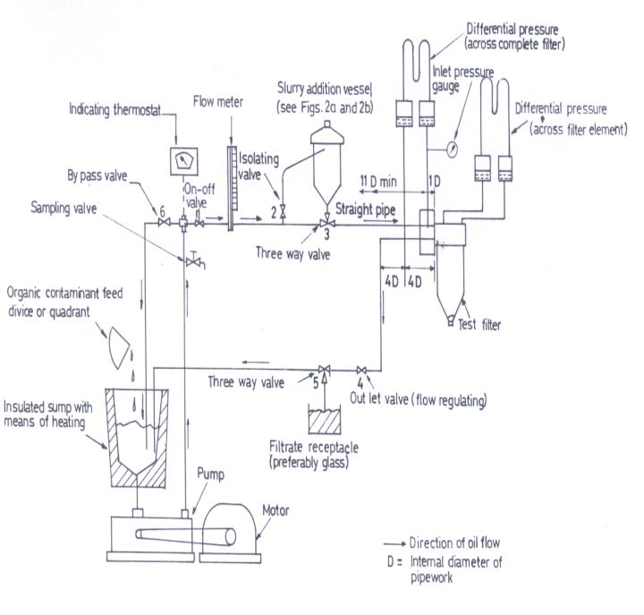

**Figure A.1 – diagrammatic arrangement of test rig for determination of pressure differential/flow characteristics, element by pass component performance, initial particle retention, variation in particle retention life and cumulative efficiency**

**A.3.4** The heater shall be switched on and the thermostat shall be adjusted to the required temperature to give correct viscosity.

**A.3.5** Upon stabilization of temperature, the test liquid shall be allowed to flow through the filter at approximately 50 per cent rated flow, and the temperature allowed to restabilize.

**A.3.6** Readings of flow rate against pressure differences across the filter and filter element shall then be obtained by adjustment to the bypass and outlet valves shown in Figure A.1.

The adjustment of these shall be such that the inlet pressure exceeds the indicated pressure difference, in order to ensure a positive pressure at filter outlet.

**A.3.7** At least eight readings shall be obtained at approximately equal increments of flow rate between 10 per cent and 110 per cent of the test flow rate. The flow rate shall be held constant for a minimum period of 10 s before taking each pressure differential reading across the complete filter and filter element only.

**Annex B**

(normative)

**Determination of element bypass component characteristics**

**B.1** Test rig as in A.1and test liquids as in A.2 apply. The filter shall be unused and the test liquid and apparatus clean. The term clean implies that when the test liquid is circulated through the test rig and the filter at the rated flow for 5 min no increase in pressure across the filter occurs.

**B.2** The filter element shall be removed from the filter and in its place a non-permeable dummy element of identical dimensions installed. In respect of sealed unit oil filters from which the element cannot be readily removed and replaced by a non-permeable dummy element, it is necessary to open the unit and remove the bypass component for testing in a separate housing.

**B.3** The filter shall be installed for test as shown in Figure A.1 using suitable connectors or adaptors in the case of flanged or headless filters.

**B.4** The required quantity of clean test liquid shall be added to the sump and circulated through the test system via the bypass pipe only. The heater shall also be switched on and the thermostat adjusted to required temperature.

**B.5** Upon stabilization of temperature, the test liquid shall be allowed to flow through the filter bypass component at approximately 50 per cent rated flow and the temperature allowed to restabilize.

**B.6** The flow rate through the filter bypass component shall be reduced to zero and the pressure difference shall be increased slowly, by adjusting the bypass valve. The pressure difference at which a continuous stream of oil starts to issue from the outlet shall be noted.

**B.7** Readings of pressure difference against flow rate at eight approximately equal increments of flow rate up to 110 % of the filter’s rated capacity shall be obtained. This is carried out by adjustment to the bypass and outlet valves. The adjustment of these shall be such that the inlet pressure exceeds the indicated pressure difference. The flow rate shall be maintained constant for a minimum period of 10 seconds before taking each reading.

**B.8** The flow rate shall then be decreased by the same increments as used in B.7 and the pressure difference noted in each case.

**B.9** The pressure difference shall be decreased to 75 % of the mean of the designed opening pressure range, and the rate of leakage, if any, shall be measured by means of a stopwatch and graduated measure. Valve (5), shown in Figure A.1, is a convenient place where this leakage can be collected. The pressure at the inlet shall be further reduced until a continuous stream of oil from the filter is just discontinued, and the pressure difference noted. If the flow from the filter ceases above 75 % of the designed opening pressure, the pressure difference at which this occurs shall be recorded.

**Annex C**

(normative)

**Contaminant capacity ratio test**

**C.1** Contaminants shall be inorganic such as fused aluminium oxide dust and organic such as carbon black.

**C.2** The recommended test rig and slurry addition vessel are shown diagrammatically in Figures A.1, C.1 and C.2

**Figure C.1 – Filter installation for particle retention test**

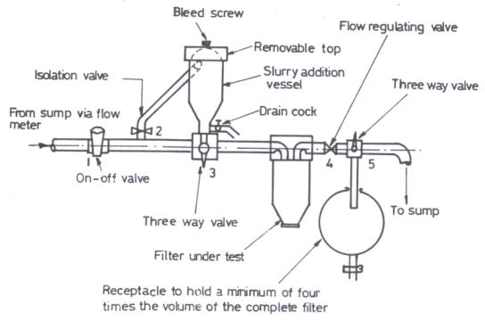

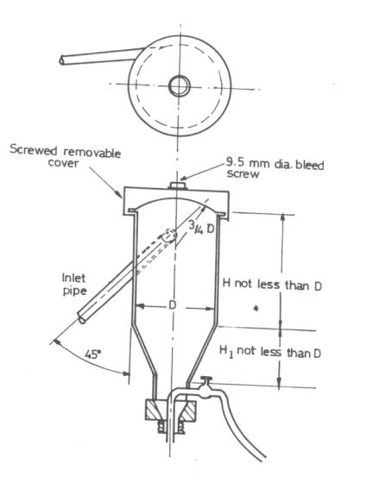**Figure C.2 – Details of slurry addition vessel**

**C.3**  A volume of clean test liquid shall be added to the sump and recirculated through the test system via the bypass pipe only. No liquid shall pass through the filter at this stage.

**C.4** Upon stabilization of temperature, the test liquid shall be allowed to flow through the filter with the valves set in such a position as to by pass the slurry addition vessel and re-enter the sump.

**C.5** The flow rate shall be adjusted through the filter with an inlet pressure of 0.35 Mpa and temperature allowed to stabilize.

**C.6** The dust not offered to the element shall also be collected as follows:

The beaker used for mixing the slurry shall be placed beneath the small drain cock situated in the base of the slurry addition vessel, the drain cock opened and the bleed screw removed.

**C.7** When the test liquid has drained from the slurry addition vessel, the domed top shall be removed and all internal surfaces rinsed with 100 mL of petroleum ether. The rinsing liquid shall be collected through the vessel drain cock into the beaker.

**C.8** The percentage of contaminants retained shall be calculated as below:

Contaminant capacity ratio (g/mm) = 

Where

*Wc is*  total weight of solids in test filter added during the entire test period to the filter, g;

*H* islength of filter housing, mm.

**Annex D**

(normative)

**Resistance to high pressure difference**

**D.1** The filter element shall be unused.

**D.2** The required volume of liquid shall be added to the sump and circulated through the test system via the bypass pipe only. No test liquid shall pass through the filter at this stage.

**D.3** The heater shall be switched on and oil temperature adjusted to obtain a viscosity of approximately 100 cSt.

**D.4** Having stabilized the oil viscosity conditions, the flow of oil shall be directed to the filter element, and the flow rate raised to a level sufficient to produce a pressure differential of 0.5 MPa. This pressure shall be maintained for a period of 5 min.

**D.5** The element shall be inspected for the following defects:

1. Permanent distortion of the configuration of the filter medium;
2. Deterioration of end seals;
3. Permanent distortion or partial collapse of any other component of the filter element; and
4. Element fracture.

Element fracture may not be visible and the immersion of the element in water and application of air pressure internally shall be used in detecting weakened areas by noting any voluminous emission of air bubbles. The applied pressure shall give a measurement on a water manometer of 76 mm and the element shall be placed horizontally not more than 6 mm below the surface of the water and rotated during the test.

**Annex E**

(normative)

**Burst pressure test**

The burst pressure test shall be performed as follows:

1. Gradually apply pressure to the filter of up to 1.5 Mpa.
2. Hold the pressure constant for 5 min.
3. Check the filter for external leakage or other defects as in D.5.

**Annex F**

(normative)

**Salt fog resistance test**

**F.1 Apparatus**

**F.1.1 Fog cabinet**

A fog cabinet having the following features:

1. Exposure chamber: The chamber shall be made from, or coated with a corrosion resistant material, and shall be so constructed that the spray circulates freely and equally about all test panels.
2. Racks for supporting the test panels: The racks shall be made from, or coated with a corrosion resistant material and shall be so constructed that the test panels are held at an angle of 15° from the vertical, without touching each other or any other metal and without any salt solution dripping from one panel to another.
3. Salt solution reservoir: The reservoir shall be of adequate size and shall be made from, or coated with a corrosion resistant material. It shall be so constructed that no condensation products of the spray can drip into the reservoir.
4. Atomizing nozzles: The nozzles shall be made from a suitable plastic and shall be so designed that they will produce a finely divided salt solution spray. The apparatus shall be fitted with baffles to prevent the salt fog striking the test panels directly.
5. Air supply: The compressed air entering the atomizers shall be filtered to remove all impurities. Means shall be provided to humidify and heat the compressed air as required. The air pressure shall be constant to within ± 700 Pa and sufficient to provide a finely divided salt solution fog.
6. Heating of chamber and temperature control: The exposure chamber shall be suitably heated and its temperature controlled by means of a thermostat. The use of an immersion heater is not permitted.

**F.2 Test specimen**

A test specimen, cut from a filter and having suitable holes for suspending them from the racks.

**F.3 Test conditions in the exposure chamber**

**F.3.1** The temperature in the exposure chamber shall be maintained at 33 – 36 °C.

**F.3.2** The degree of atomization shall be such that suitable fog collectors placed at any point in the exposure zone will collect, over an average running period of at least 16 h, from 0.5 – 3 mL of solution per hour for each 80 cm2 of horizontal collecting area. The solution so collected shall have a pH value of 6.5 – 7.2 when measured electrometrically.

**F.4 Procedure**

**F.4.1** Bring the exposure chamber to the test conditions. Mount the test specimens, by means of glass or plastic hooks, on the supporting racks according to F.1.1 b) and insert the racks in the exposure chamber.

**F.4.2** Close the exposure chamber and operate the cabinet continuously for a period of 48 h, using the test specimen in F.2, ensuring that the impact point is within the borders of the test specimen. Then examine the each specimen for defects (see clause 3.1.6).