**Stockings— Specification**

Part 1:

**School stockings**

© KEBS 2020 Fourth Edition, 2020

**TECHNICAL COMMITTEE REPRESENTATION**

The following organizations were represented on the Technical Committee:

Kenya Industrial Research and Development Institute

Egerton University — Department of Applied Community Development Studies

Consumer Information Network

Sumitomo

Pest Control Board of Kenya

Spin Knit Ltd.

Alpha Knits Ltd.

Kamyn Industries Ltd.

Sun Flag Textile & Knitwear Mills Ltd.

Ken Knit (K) Ltd.

Spinners & Spinners Ltd.

Kenya Textile and Training Institute

Multifacet Consulting Ltd.

Radbone Clark (K) Ltd.

Consumer Information Network

Topserve Ltd.

Ministry of Public Health and Sanitation — Department of Malaria Control

VestergaardFrandsen (EA) Ltd.

Ministry of Defense Research & Development

Fashion Council of Kenya

The National Training Institute (NITA)

Kenyatta University

Ministry of Health

Kenya Association of Manufacturers

Ministry of Industrialization and Enterprise Development

Kenya Bureau of Standards — Secretariat

**REVISION OF KENYA STANDARDS**

In order to keep abreast of progress in industry, Kenya Standards shall be regularly reviewed. Suggestions for improvements to published standards, addressed to the Managing Director, Kenya Bureau of Standards, are welcome.

*© Kenya Bureau of Standards, 2020*

*Copyright. Users are reminded that by virtue of Section 25 of the Copyright Act, Cap. 130 of 2001 of the Laws of Kenya, copyright subsists in all Kenya Standards and except as provided under Section 25 of this Act, no Kenya Standard produced by Kenya Bureau of Standards may be reproduced, stored in a retrieval system in any form or transmitted by any means without prior permission in writing from the Managing Director.*

**Stockings — Specification**

Part 1:

**School stockings**

**KENYA BUREAU OF STANDARDS (KEBS)**

**Head Office:** P.O. Box 54974, Nairobi-00200, Tel.: (+254 020) 605490, 602350, Fax: (+254 020) 604031

E-Mail: info@kebs.org, Web:http://www.kebs.org

**Coast Region Lake Region Rift Valley Region**

P.O. Box 99376, Mombasa-80100 P.O. Box 2949, Kisumu-40100 P.O. Box 2138, Nakuru-20100

Tel.: (+254 041) 229563, 230939/40 Tel.: (+254 057) 23549, 22396 Tel.: (+254 051) 210553, 210555

Fax: (+254 041) 229448 Fax: (+254 057) 21814

**Foreword**

This Kenya Standard was prepared by the Technical Committee on Knitted Fabrics under the guidance of the Standards Projects Committee, and it is in accordance with the procedures of Kenya Bureau of Standards.

Apart from fashion changes, stockings have become a necessary component of uniforms in several institutions, especially schools. It is with this view that this standard was revised so as to specify and harmonize size dimensions of stockings. The standard also stipulates the technical requirements of raw materials used in the manufacture of stockings and their performance requirements when worn as part of uniforms or casually.

This fourth edition cancels and replaces the Third edition (KS 584-1:2017) which has been technically revised.

During the preparation of this standard, references were made to the following documents:

MS 2.57, Specification for rib-knitted gents’ nylon stockings.

MS 2.54, Specification for rib-knitted cotton stockings.

IS 833, Specification for gents’ rib-knitted nylon stockings.

KS 08-415, Glossary of terms relating to hosiery.

Acknowledgement is hereby made for the assistance received from these sources.

**Stockings — Specification**

**Part 1:**

**School stockings**

**1 Scope**

This Kenya Standard specifies requirements and test methods for school stockings knitted in plain, rib or fancy stitches.

**2 Normative references**

The following documents are referred to in the text in such a way that some or all of their content constitutes requirements of this document. For dated references, only the edition cited applies. For undated references, the latest edition of the referenced document (including any amendments) applies.

KS 2659, *Packaging of textile products — Code of practice*

KS ISO 105 B02, *Textiles — Tests for colour fastness — Part B02: Colour fastness to artificial light: Xenon arc fading lamp test*

KSISO 105 B04, *Textiles — Tests for colour fastness — Part B04: Colour fastness to artificial weathering: Xenon arc fading lamp test*

KS ISO 105 C10, *Textiles — Tests for colour fastness — Part C10: Colour fastness to washing with soap or soap and soda*

KS ISO 105 E01, *Textiles — Tests for colour fastness — Part E01: Colour fastness to water*

KS ISO 105 E04, *Textiles — Tests for colour fastness — Part E04: Colour fastness to perspiration*

KS ISO 105-N02, *Textiles — Tests for colour fastness — Part N02: Colour fastness to bleaching: Peroxide*

KS ISO 105 X12, *Textiles — Tests for colour fastness — Part X12: Colour fastness to rubbing*

KS ISO 139,*Textiles — Standard atmospheres for conditioning and testing*

KS ISO 1833 (all parts), *Textiles — Quantitative chemical analysis*

KS ISO 7211-5 ,*Textiles —woven fabricsconstuction — Determination of linear density of yarn removed from fabric.*

KS ISO 2061,*Textiles — Determination of twist in yarns — Direct counting method*

KS ISO 2062, *Textiles — Yarns from packages — Determination of single-end breaking force and elongation at break using constant rate of extension (CRE) tester*

KS ISO 2076, *Textiles — Man-made fibres — Generic names*

KS ISO 3758, *Textiles — Care labelling code using symbols*

KS ISO 6938, *Textiles — Natural fibres — Generic names and definitions*

KS ISO 8388, *Knitted fabrics — Types — Vocabulary*

KS ISO 11827, *Textiles — Composition testing — Identification of fibres*

KS ISO 14362-1, *Textiles — Methods for determination of certain aromatic amines derived from azo colorants — Part 1: Detection of the use of certain azo colorants accessible with and without extracting the fibres*

KS ISO 14362-3, *Textiles -— Methods for determination of certain aromatic amines derived from azo colorants — Part 3: Detection of the use of certain azo colorants, which may release 4-aminoazobenzene*

KS ISO 16373-1, *Textiles — Dyestuffs — Part 1: General principles of testing coloured textiles for dyestuff identification*

KS ISO 16373-2, *Textiles — Dyestuffs — Part 2: General method for the determination of extractable dyestuffs including allergenic and carcinogenic dyestuffs (method using pyridine-water)*

KS ISO 16373-3, *Textiles — Dyestuffs — Part 3: Method for determination of certain carcinogenic dyestuffs (method using triethylamine/methanol)*

KS ISO 16549, *Textiles — Unevenness of textile strands — Capacitance method*

KS 415,*Glossary of terms relating to hosiery*

KS 529 *Specification for elastic flat braids*

KS 1113-1, *Specification for staple spun yarns— Part 1: Cotton yarns*

KS 1113-2, *Specification for staple spun yarns — Part 2: 100% wool (worsted) yarns*

KS 1113-3, *Specification for staple spun yarns — Part 3: Polyester/cellulosic blended yarns*

KS 1113-4, *Specification for staple spun yarns — Part 4: Polyester/wool blended yarns*

KS 1114-1, *Specification for textured filament yarns — Part 1: Polyester yarns*

KS 1114-2,*Specification for textured filament yarns — Part 2: Polyamide yarns*

KS 1829, *Labelling of products — General requirements*

**3 Terms and definitions**

For the purposes of this standard, the definitions given in KS 415 the following definitions shall apply:

**3.1**

**foot length**

the distance from the tip of the toe to the apex of the heel gore line, that is the distance between C and O Figure 1

Rib length

**3.2**

**leg length**

the distance from the top of the stocking to the apex of the heel gore line, that is the between A and O Figure 1

**3.3**

**batch of stockings**

more than one pair of stockings of the same type and size packed together

**3.4 Stocking** –These are socks whose length goes up to or above the knee.

**4 Requirements**

**4.1 Fibre composition and proportion**

**4.1.1** The stocking shall be manufactured from yarns made from textiles fibres described in KS ISO 6938 and KS ISO 2076.

**4.1.2** The fibre composition and proportion shall be determined in accordance with KS ISO 11827 and KS ISO 1833Parts, 1 to 28. Where the yarn used is a blend of two or more fibres, the fibre composition shall be declared with a maximum tolerance of ± 5%

**4.2 Yarns**

The yarns used to knit the stockings shall comply with the requirements of KS 1113 and KS 1114 including the following

**4.2.2 Breaking tenacity**

The breaking tenacity of the yarns used to knit the stocking, calculated as a ratio of the breaking strength to linear density in accordance with ISO 2062 shall be as given in Table 1.

**4.2.2.1 Linear density**

The linear density to be used to calculate the breaking tenacity of the yarn shall be determined from a yarn from the stocking in accordance with KS ISO 7211-5.

**4.2.3 Elongation at break**

The elongation of the yarns when tested at break shall be as given in Table 1.

**4.2.4 Yarn unevenness**

The yarn unevenness tested in accordance with 3yh shall comply with the requirements of

Table 2.

**4.2.5 Twist**

**4.2.5.1 Coefficient of variation**

The coefficient of variation, % of the yarn twist shall not be more than 5% when tested in accordance with

KS ISO 2061.

**5 Manufacture of stockings**

**5.1 Yarn**

**5.1.1 Yarn for knitting and splicing**

The yarn used in knitting and splicing of stockings shall be of fibre and composition complying with the requirements of Table 1.

**Table 1 — Tenacity and elongation requirements of yarns for stocking**

|  |  |  |  |
| --- | --- | --- | --- |
| **S/N** | **Yarn type** | **Requirements** | |
| **Minimum tenacity g/tex** | **Elongation at break %, min.** |
| i) | Nylon 6 and 6,6 | 35.0 | 30.0 |
| ii) | Polyester | 32.0 | 27.0 |
| iii) | Wool | 28.0 | 20.0 |
| iv) | Acrylic | 25.0 | 17.0 |
| v) | Cotton | 30.0 | 5.0 |
| vi) | Blends (See note 1) |  |  |
| vii) | Elastic yarn for top portion of the sock |  | ˃ 450 |
| Test Method | KS ISO 2076,KS ISO 11827 and KS ISO 1833,Parts 1,2,7,11,12,20,24 and 25 | ISO 2062 | ISO 2062 |
| NOTE The ratings of minimum tenacity (g/tex) and elongation at break (per cent) of the fibre blended yarn used in the blended stocking, shall not be less than those of the fibre component in the blend whose yarn has a lower rating in accordance with this Table i.e. in a nylon/wool or polyester/wool blend, the minimum tenacity and elongation at break of the yarn shall not be less than that of the woolen yarn as shown in this Table. | | | |

**Table 2 — Yarn unevenness**

|  |  |  |  |  |
| --- | --- | --- | --- | --- |
| **S/N** | **Yarn type** | **Linear Density, in Tex** | **CV%, max.** | **U%, max.** |
| i) | Nylon [6;6,6] | 10-70 | 3.5-0 | 2.8-0 |
| ii) | Polyester | 10-70 | 3-0 | 2.4-0 |
| iii) | Acrylic | 10-70 | 18-8 | 14.4-6.4 |
| iv) | Wool | 10-70 | 23.5 | 18.8 |
| v) | Cotton | 15-70 | 19-9 | 15.2-7.2 |
| vi) | Polyester/Wool | 10-70 | 23.5-14 | 18.8-11.2 |
| vii) | Polyester/Cotton | 10-70 | 15-12 | 12-9.6 |
| viii) | Other Blends | 10-70 | 23.5-12 | 18.8-9.6 |
| ix) | Elastic Yarns | 10-70 | 16-15 | 12.8-12 |

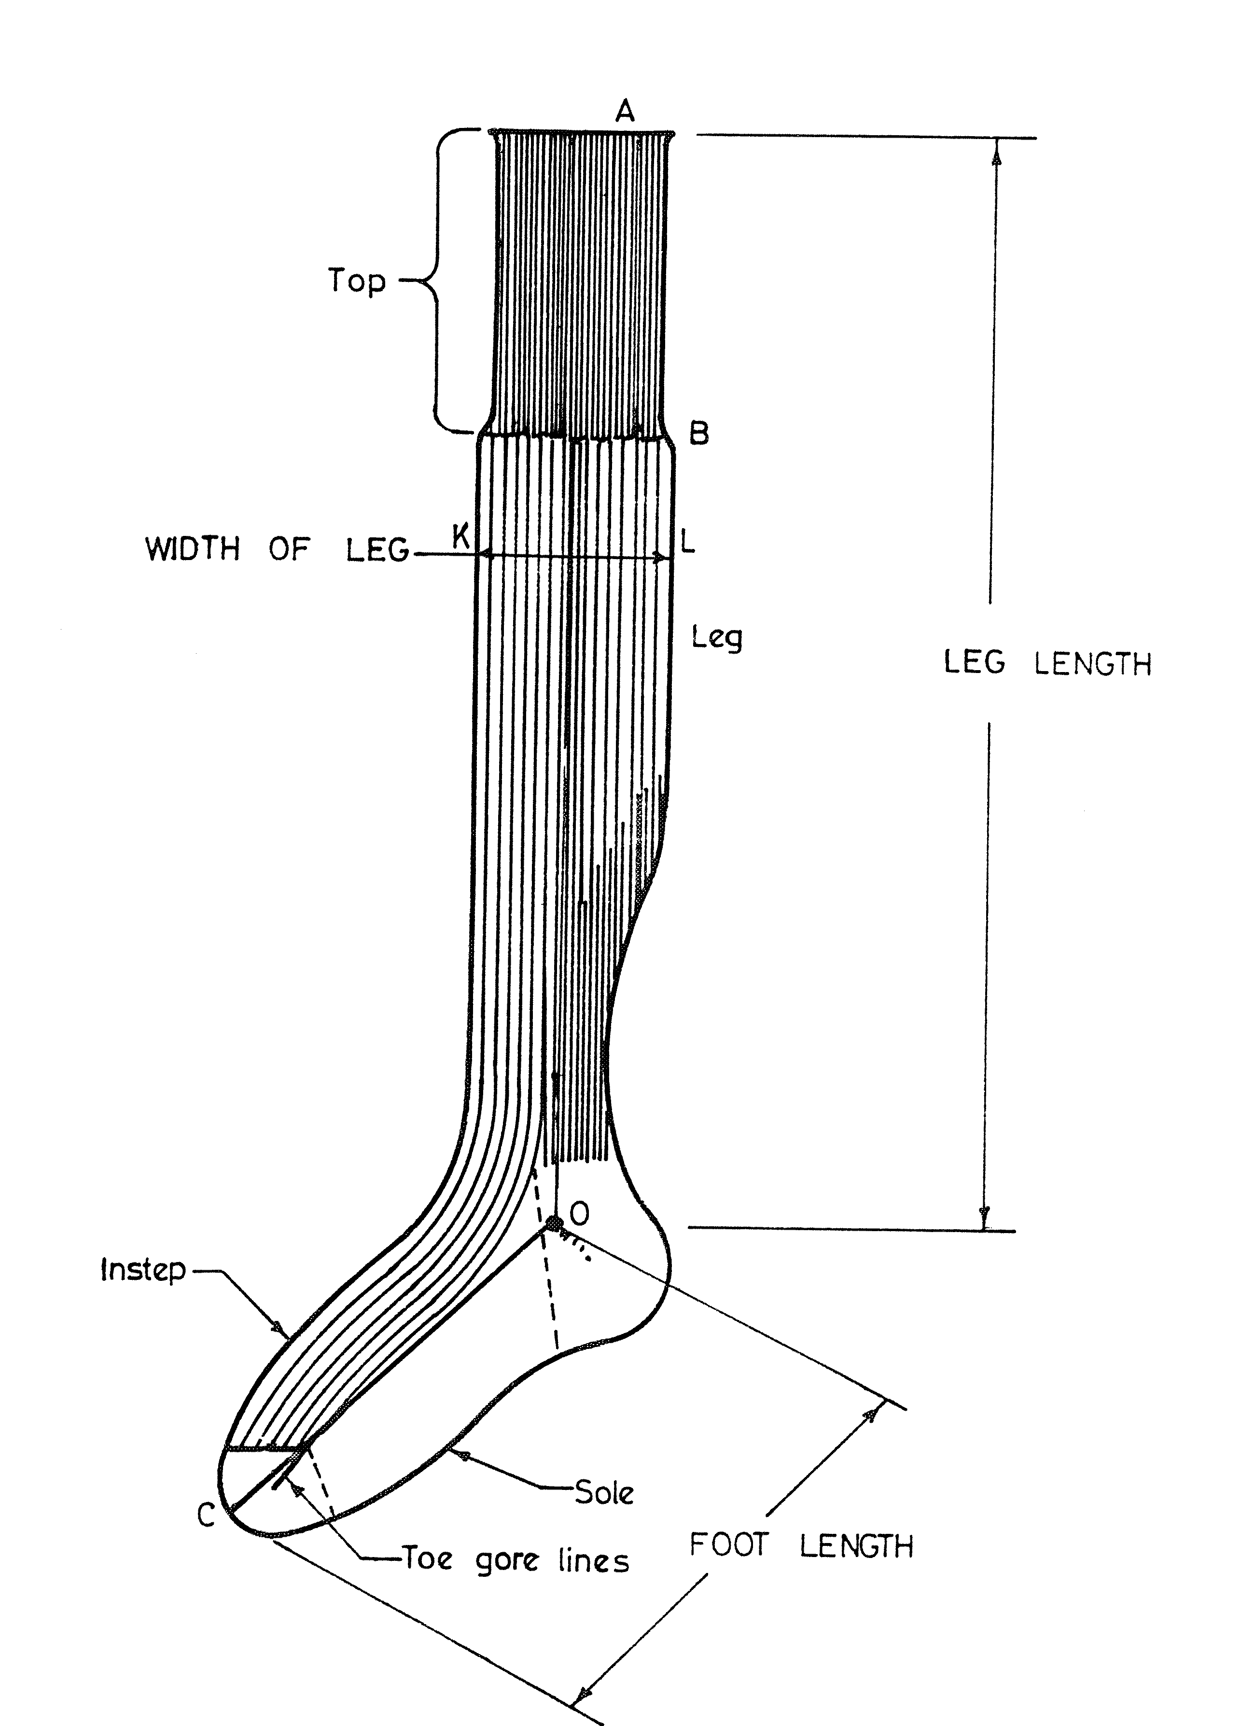

**Figure 1 — Stocking**

**5.1.2 Elastic yarn**

The elongation of elastic yarn or covered rubber thread used for laying in the top portion of a finished stocking shall be not less than 450 %. It shall also conform to other relevant requirements stipulated in KS 529.

**5.2 Stocking**

**5.2.1** The stocking shall be knitted on circular machines. The top of the stocking shall be knitted in rib or plain stitches with covered rubber thread or any other suitable elastic yarn laid-in; and the leg and instep shall be knitted in plain, rib or fancy stitches depending on the type of stocking.

**5.2.2** The top portion of the stocking with covered rubber thread or any other suitable elastic yarn shall be not less than 25 mm.

**5.2.3** In case the covered rubber thread or any other suitable elastic yarn is not used at the top of the stocking the top portion shall be knitted in a rib of not less than 80 mm and it shall be extended proportionally according to stocking sizes.

**5.2.4** The heel and toe portions of the stocking shall be knitted in plain stitches with splicing. The splicing shall be uniform throughout and spliced portions free from creases and/or folds.

**5.2.5** The stocking shall be securely joined at the toe. The joining shall be elastic, smooth and free from knots. The joining shall not give way when the stocking is stretched to the full extent of its stretchability of the stocking.

**5.2.6** The stocking shall be free from manufacturing defects, such as mends, ladders, improper splicing and both dyeing and finishing defects.

**5.2.7** The dyed stocking shall conform to colour fastness requirements as given in Table 3.

**Table 3 — Colour fastness requirements**

|  |  |  |  |  |
| --- | --- | --- | --- | --- |
| **S/N** | **Agency** | **Numerical rating (min.)** | | **Test method** |
| i) | Washing | Colour change | 4 | KS ISO 105 C10(A1) |
| Staining | 4 |
| ii) | Perspiration | Acid | 3 | KS ISO 105 E04 |
| Alkali | 3 |
| iii) | Rubbing | Dry | 4 | KS ISO 105 X12 |
| Wet | 4 |
| iv) | Peroxide washing | | 4 | KS ISO 105 N02 |
| v) | Light | | 5 | KS ISO 105 B02 |

**6 Defects**

The stocking shall be free from knitting defects as specified in KS 207, Part 2.

**7 Restricted colourants**

**7.1** Dyed stocking shall be free from colorants listed in KS ISO 14632, Parts 1 and 3 and KS ISO 16373, Parts 2 and 3.

**7.2** Dyestuffs shall be identified in accordance with KS ISO 16373-1.

**8 Size**

**8.1** The stockings shall be grouped into five different sizes as follows:

a) Small

b) Medium

c) Large

d) Extra large

e) Free

**8.3** The size of stockings shall be determined by foot length and leg length dimensions given in Table 4.

**8.4** The dimensions of both foot length and leg length shall be taken in accordance with Annex A.

**8.5** The free size shall be grouped further and designated numerical sizes whose size dimensions shall not be less than those specified in Table 4, item v). The dimensions of subsequent sizes shall be at intervals of at least 30 mm.

**Table 4 — Size dimensions**

|  |  |  |  |  |
| --- | --- | --- | --- | --- |
| **S/N** | **Size of stocking** | **Foot length,**  **(mm)** | **Leg length,**  **(mm)** | **Test method** |
| i) | Small | 100 - 125 | 270 - 295 | Annex A |
| ii) | Medium | 130 - 155 | 325 - 350 |
| iii) | Large | 160 - 185 | 380 - 410 |
| iv) | Extra large | 190 - 215 | 435 - 460 |
| v) | Free | Above 220 | Above 465 |

**9 Marking**

Each pair of stocking shall be marked with the following information;

a) name/trade mark of the manufacturer;

b) Fibre composition and proportion;

c) size designation in accordance with KS ISO 8559-2

d) care instructions in accordance with KS ISO 3758;

e)

f) country of manufacture.

**10 Packaging**

Stockings shall be packaged in accordance with KS 2659 and as follows:

**10.1** Each pair of stockings shall be folded properly at the heel gore line anal at the leg so as to form three layers. Each folded pair shall be wrapped or placed in a suitable packaging material.

**10.2** A batch of pairs of stockings or several batches shall be placed in a suitable packaging material of suitable size, which shall be secured properly.

**10.3** Each package containing a batch of stockings or several batches shall have the following information, which shall be indicated on the package, the swing ticket and/or accompanying documents:

1. Name/trade mark of the manufacturer;
2. Number of pairs in each batch;
3. Total number of batches in the package; and
4. Criteria of conformity

**10.4** Each pair of stockings shall comply with any of the requirements of this standard.

**Annex A**

(normative)

**Measurement of stockings for size determination**

**A.1 Condition of stocking**

Before foot length and/or leg length dimensions are taken, the stockings shall be conditioned in accordance with KS ISO 139. Take the measurements in an atmosphere similar to that used for conditioning.

**A.2 Sample stocking preparation**

Take the conditioned sample stocking to be measured. Lay it flat on a smooth table. Remove by hand all creases and wrinkles without stretching the stockings.

**A.3 Measurements**

**A.3.1** Take the dimensions of both the foot length and leg length as defined in 3.1, 3.2 and Figure 1, both measurements to be taken correct to the nearest 5 mm.

**A.3.2** The pair shall be in conformity with the requirements of Table 3 if none of the values as determined in A.3.1 varies from the specified value by more than the specified tolerance.