

**COVER LETTER FOR PUBLIC REVIEW DRAFT STANDARDS**

**CPR 183/F13**

|  |  |  |
| --- | --- | --- |
| **Title:** | **Milk and milk products Public Draft standards** | |
| **Document Type:** | Public review draft | |
| **Dates:** | Circulation date | Closing date |
| 23- 03 -2022 | 24– 05 - 2022 |

1. **DEAS 27: 2022 UHT Milk —Specification**
2. **DEAS 49: 2022 Milk powders and cream powder**
3. **DEAS 67**: **2022 Raw cow milk —Specification**
4. **DEAS 69: 2022 Pasteurized milk— Specification**
5. **DEAS 70: 2022 Dairy ice cream —Specification**
6. **DEAS 915: 2022 Ghee —Specification**

This Draft East African Standard has been prepared by the **EASC TC 017 - milk and milk products** Technical Committee in accordance with the principles and procedures for Development of East Africa Standards and is now being circulated for public comments.

The Committee would appreciate any comments on this Draft Standard, which should be submitted before **24-05-2022** using the attached template. It will also be appreciated if those who have no specific comments to make but find the draft standard generally acceptable can notify us accordingly.The absence of any reply or comments shall be deemed to be an acceptance of the technical contents of the draft Kenya standard and **shall constitute an approval vote**.

Suggestions entailing amendments of the text should include wording preferred and the relevant clause number quoted against any comments made.

**This draft standard is subject to change and should not be referred to or used as an East African Standard.**

All correspondence pertaining to these draft standards should be addressed to the Managing Director, Kenya Bureau of Standards for the attention of **Naomi Mariach**

Yours faithfully,

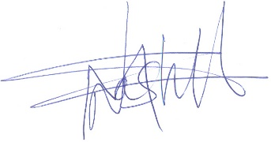

**For: DIRECTOR**

**STANDARDS DEVELOPMENT AND INTERNATIONAL TRADE**

**1 |** P a g e