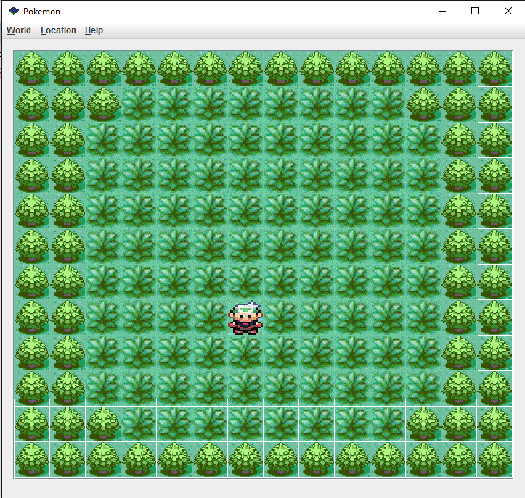

Tree:

Location: (11, 0)

Color: Irrelevant

Direction: Irrelevant

Player:

Location: (7, 6)

Color: Irrelevant

Direction: Irrelevant

Name: “Andrew”

PokeDexCount : 12

PokeDex: new PokeDex()

Party: new Pokemon[4]

Suffix: “_front”

Pc: new ArrayList<Pokemon>()

Grass:

Location: (10, 3)

Color: Irrelevant

Direction: Irrelevant

PokeBoolean: True

Pokemon: new Pokemon(“Mudkip”)