Immersion Model Study
How can immersion in PlayStation games be modeled as a measurable system that explains why players stay engaged, return, or drop off?
Christyana Walker

Abstract
This project explores whether game immersion can be treated as a measurable research signal rather than only a personal feeling. The study uses a workbook-centered dataset of player notes, exit quiz responses, scoring categories, and secondary public reception data. Each player session was structured around a 40-minute play period with notes captured every five minutes. The dataset includes 13 participants, 10 PlayStation titles, 1,040 timeline responses, and 130 exit quiz records. The primary goal is not to prove which game sells the most. The goal is to understand what makes players want to return to a game experience and how that insight can support game development, marketing, and long-term story usage.
The prototype component is a JavaScript website that imports the workbook data, lets the researcher browse all response rows, collects new local responses, and exports Excel-readable files. This makes the project more than a slide deck. It becomes a lightweight research pipeline: collect observations, code them by metric, compare games, and convert the results back into spreadsheet form.
Keywords: immersion, replayability, game user research, player experience, retention, PlayStation, JavaScript prototype, Excel dataset.
1. Introduction
Many conversations about games focus on whether a game is popular, visually impressive, or commercially successful. Those signals matter, but they do not fully explain why a player keeps playing, returns after the first session, or wants additional story content. A player may buy a game because of franchise recognition or marketing, but they return because the experience continues to feel meaningful, enjoyable, smooth, or personally engaging.
This study was built to examine that return-to-play experience. Instead of asking only whether a game is good, the project asks where immersion happens, when it weakens, and what parts of the game design pull different players back in. The model separates immersion into nine measurable categories: interaction density, agency, narrative integration, flow, environmental immersion, mechanical satisfaction, emotional engagement, fatigue resistance, and replay intent.
The final version of the project uses the Excel workbook as the source of truth. The workbook organizes player information, game-level scores, timeline responses, quiz responses, public reception data, and formula definitions. The website prototype then uses those same tables to create a more interactive version of the study.

2. Research Questions and Hypothesis
The main research question is: How can player immersion in PlayStation games be modeled, scored, and used to explain replayability, enjoyment, and audience retention?
A secondary question connects the project to game development and marketing: Does high immersion correlate more strongly with replayability than with a sales proxy or public reception scores? This matters because a game can perform well commercially for reasons outside of immersion, such as brand strength, marketing budget, release timing, or platform visibility. Replayability is closer to the experience itself because it asks whether the player wants to return.
The working hypothesis is that games with stronger flow, agency, emotional engagement, fatigue resistance, and mechanical satisfaction will show stronger replay intent. The model does not claim that immersion alone can predict sales. Instead, it treats immersion as one important design and retention signal that may help developers and marketers understand why certain experiences continue to hold player attention.
3. Dataset Overview
The study workbook contains 13 participants, 10 games, 1,040 timeline response rows, and 130 exit quiz records. Each participant is represented across each game with eight checkpoints, one for every five-minute interval in a 40-minute play session.
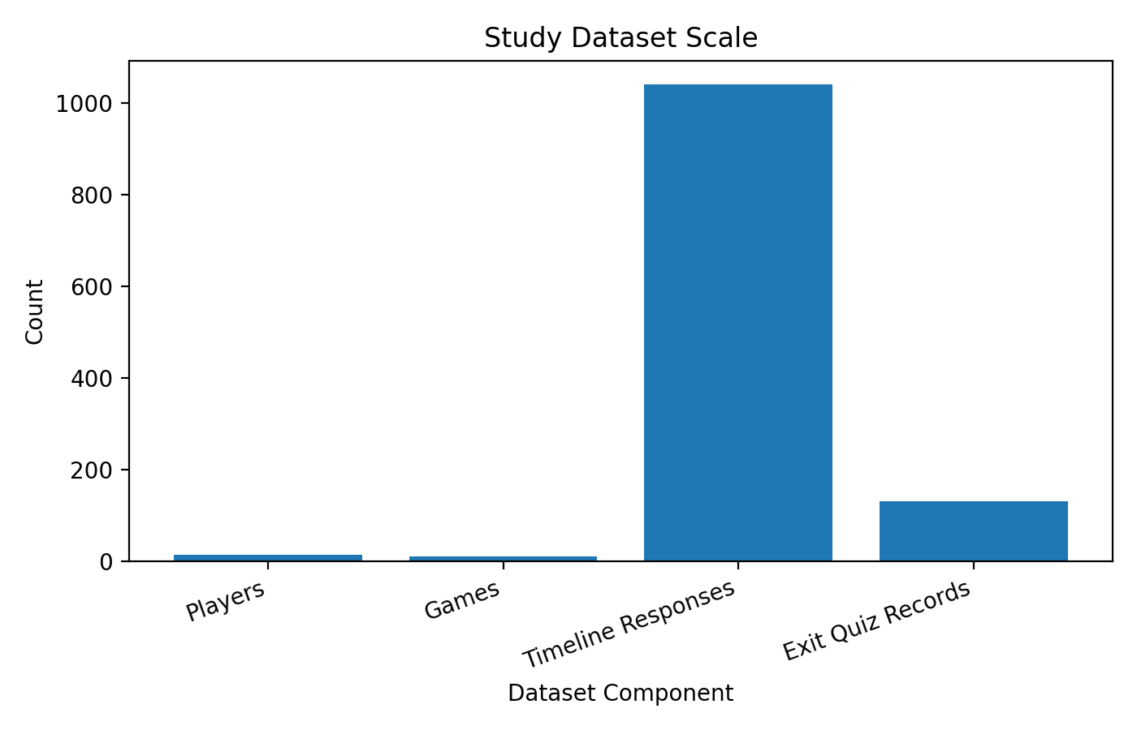
This design creates a large response timeline even with a small participant group. The project is not just comparing ten games once. It is comparing repeated moments inside each play session across both newer players and seasoned gamers.
4. Participants and Grouping
The participant structure includes two groups. The first group includes three non-gaming subjects: Armani Bradley, Mariah Staples, and Liana Candy. These participants are important because they reveal onboarding, pacing, clarity, and accessibility issues that experienced players may ignore or move through quickly.
The second group includes ten seasoned gamers. The known seasoned participants include Christopher Fowls, Demetrius Blue, and Maurice Vans. The remaining names are editable placeholders in the workbook. This group is used to observe mechanical satisfaction, challenge loops, combat depth, replay intent, and long-term engagement patterns.
Player ID | Name | Group | Experience | Research Use
P01 | Armani Bradley | Non-gaming subject | Newer player | Story/detail-oriented; used character familiarity to connect with Spider-Man.
P02 | Mariah Staples | Non-gaming subject | Newer player | Onboarding, pacing, and clarity signals.
P03 | Liana Candy | Non-gaming subject | Newer player | Clarity, fatigue, and accessibility reactions.
P04 | Christopher Fowls | Seasoned gamer | 5+ years | Mechanics-first; movement, feel, and control matter more than story/readability.
P05 | Demetrius Blue | Seasoned gamer | 5+ years | Challenge, pacing, and replay loops.
P06 | Maurvce Vans | Seasoned gamer | 5+ years | Combat and systems depth.
P07 | Avery Cole | Seasoned gamer | 5+ years | Placeholder name; edit as needed.
P08 | Jordan Reed | Seasoned gamer | 5+ years | Placeholder name; edit as needed.
P09 | Taylor Brooks | Seasoned gamer | 5+ years | Placeholder name; edit as needed.
P10 | Morgan Hayes | Seasoned gamer | 5+ years | Placeholder name; edit as needed.
P11 | Riley Parker | Seasoned gamer | 5+ years | Placeholder name; edit as needed.
P12 | Skylar Quinn | Seasoned gamer | 5+ years | Placeholder name; edit as needed.
P13 | Casey Monroe | Seasoned gamer | 5+ years | Placeholder name; edit as needed.
5. Method: 40-Minute Sessions and Five-Minute Notes
Each gameplay session is organized as a 40-minute uninterrupted experience. During the session, the researcher records or imports notes every five minutes. This creates eight checkpoints per player per game: 5, 10, 15, 20, 25, 30, 35, and 40 minutes.
The five-minute structure matters because immersion is not always stable. A game may start strong because the opening is cinematic, then slow down because the player encounters unclear objectives. Another game may start confusing, then become more satisfying after the player learns the controls. The response timeline lets the study capture those shifts instead of reducing the whole experience to a single opinion.
- Each player contributes 80 timeline rows across 10 games.
- Each game receives 104 timeline rows across 13 players.
- The full workbook contains 1,040 timeline responses.
- Exit quiz records add 130 post-session summaries.
6. Immersion Metrics
The scoring model uses nine metrics. Each metric is scored from 1 to 5. A score of 1 signals a weak design presence, while a score of 5 signals a strong design presence. Together, the nine categories create a maximum of 45 points per game.
Metric Code | Metric Name | Scale | Use
ID | Interaction Density | 1-5 | Used in score matrix and response coding
AG | Player Agency | 1-5 | Used in score matrix and response coding
NI | Narrative Integration | 1-5 | Used in score matrix and response coding
FL | Flow & Continuity | 1-5 | Used in score matrix and response coding
EN | Environmental Immersion | 1-5 | Used in score matrix and response coding
ME | Mechanical Satisfaction | 1-5 | Used in score matrix and response coding
EM | Emotional Engagement | 1-5 | Used in score matrix and response coding
FR | Fatigue Resistance | 1-5 | Used in score matrix and response coding
RI | Replay Intent | 1-5 | Used in score matrix and response coding
These categories are deliberately mixed. Some measure story and emotion, some measure mechanical feel, and some measure whether the experience prevents fatigue. The model works because immersion is complex; it is not just graphics, story, or combat alone.
7. Formula Guide
The workbook uses formulas to show how the score matrix becomes a 0-100 immersion score. The formulas are simple enough to audit and edit in Excel.
Formula | Workbook Logic | Purpose
Total Points | SUM(ID:RI) | Adds the nine metric scores for a game.
Calculated Immersion % | ROUND(Total Points / 45 * 100, 0) | Converts the metric total into a percentage.
Calibration Difference | Official Deck Score - Calculated Immersion % | Shows the difference between the presentation score and the formula score.
Average Pulse | Average of 5-minute response pulse values by game | Summarizes the timeline notes into a single pulse value.
Response Count | Count of response rows by game/player/group | Checks that all expected records are present.
Replay Comparison | X = Deck Score, Y = Replay Intent Index | Shows return-to-play relationship.
Sales Proxy Comparison | X = Deck Score, Y = Sales Proxy | Tests whether the model may be useful for marketing discussion.

8. Score Matrix Results
The score matrix is the model backbone. It displays the nine metric scores for each game, the total out of 45, the calculated immersion percentage, and the official deck score used in the presentation.
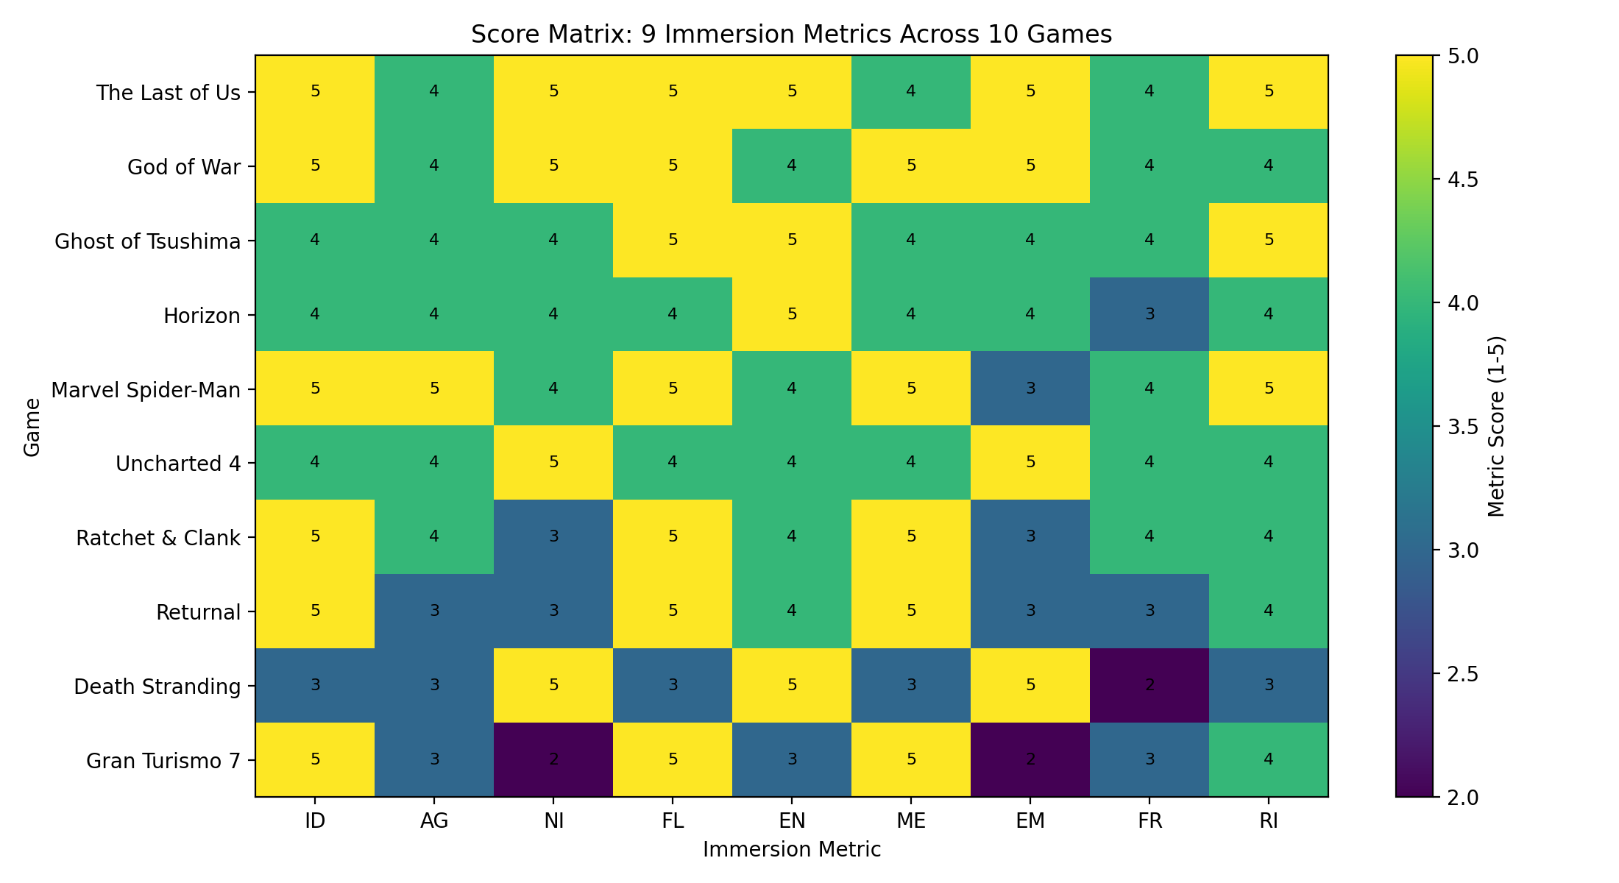
The heatmap makes it easier to see how different games earn immersion in different ways. A story-driven game may score high through narrative integration and emotional engagement, while a traversal-heavy game may score high through mechanical satisfaction, flow, and replay intent.
9. Game-Level Summary
Game | Deck | Calc % | Replay | Sales Proxy | Interpretation
The Last of Us | 92 | 93 | 96 | 88 | Peak: emotion + narrative integration; Risk: slower scavenging sections
God of War | 90 | 91 | 90 | 94 | Peak: combat weight + father/son stakes; Risk: puzzle pacing
Ghost of Tsushima | 88 | 87 | 92 | 82 | Peak: cinematic exploration + world beauty; Risk: travel fatigue
Horizon | 84 | 80 | 84 | 78 | Peak: machine combat + world mystery; Risk: resource/crafting friction
Marvel Spider-Man | 89 | 89 | 95 | 90 | Peak: movement freedom + instant joy; Risk: side activity repetition
Uncharted 4 | 86 | 84 | 82 | 87 | Peak: set pieces + character banter; Risk: linear pacing dips
Ratchet & Clank | 85 | 82 | 86 | 70 | Peak: weapon variety + spectacle; Risk: lower emotional weight
Returnal | 82 | 78 | 88 | 62 | Peak: challenge loop + replay structure; Risk: difficulty fatigue
Death Stranding | 75 | 71 | 70 | 68 | Peak: atmosphere + unique world; Risk: slow traversal and niche loop
Gran Turismo 7 | 78 | 71 | 76 | 72 | Peak: mechanical mastery + progression; Risk: weaker narrative pull
The official deck score is used for presentation clarity. The calculated immersion percentage is the formula result from the score matrix. Keeping both values visible helps the researcher explain how the model was calculated and how the final deck score was calibrated.
10. Official Deck Scores
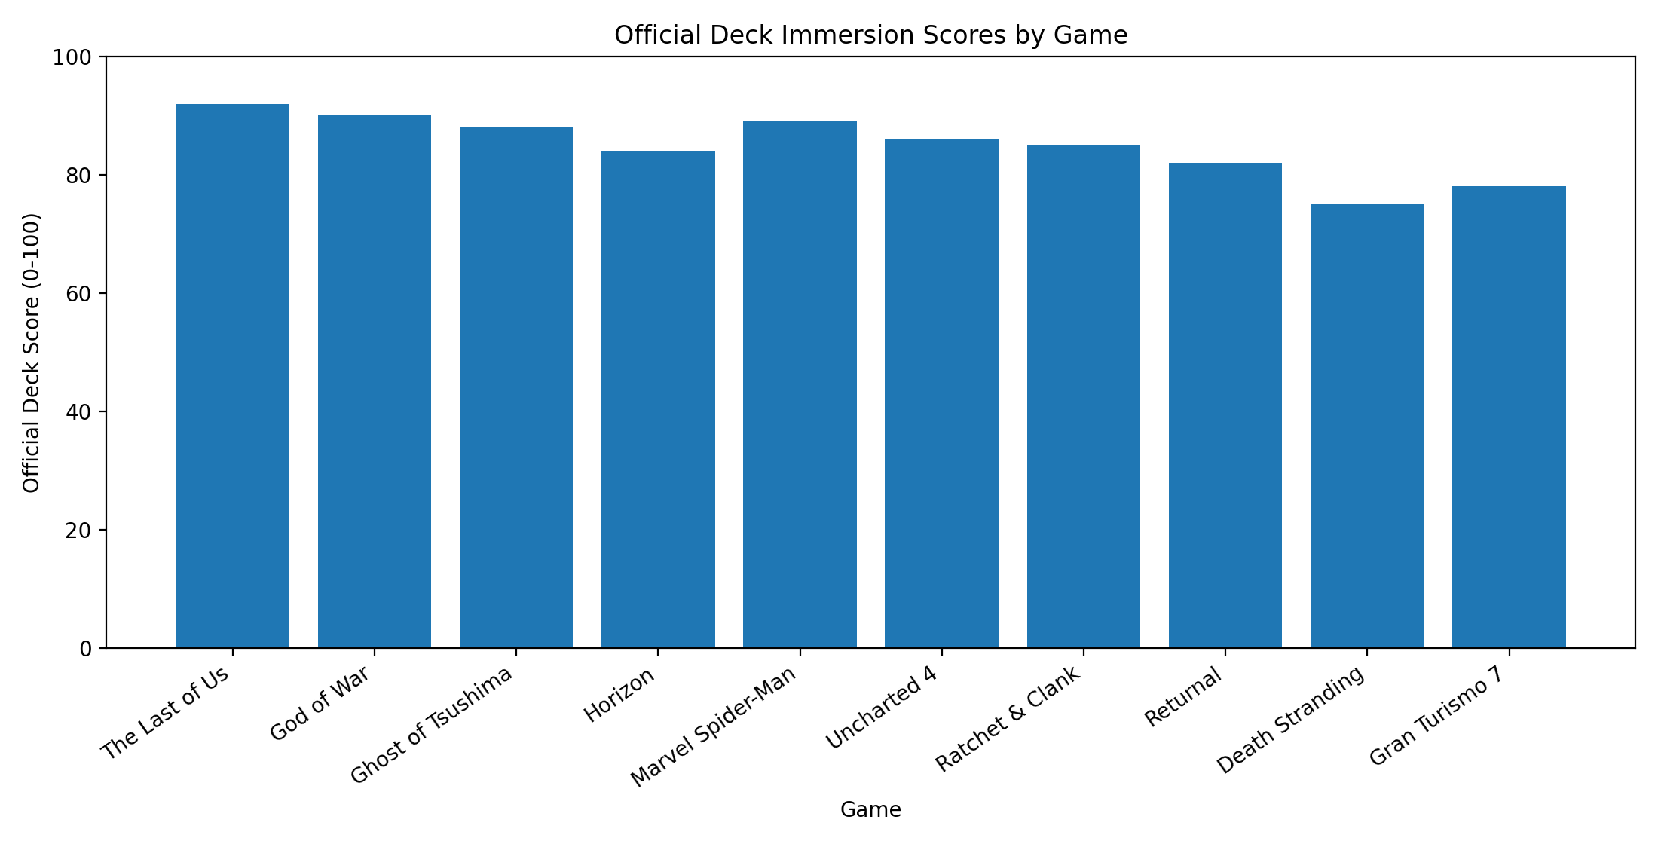
The Last of Us, God of War, Marvel Spider-Man, and Ghost of Tsushima appear near the top of the official deck score range. The model does not treat this as a ranking of which game is objectively best. It treats the scores as a way to compare the kind of immersion each game supports.

11. Response Timeline and Average Pulse
Each response row includes a 1-5 immersion pulse. This pulse gives a quick moment-level signal that can be compared across games and player groups. Because every game has 104 response rows, the average pulse is not based on a single reaction. It is based on repeated checkpoint observations.
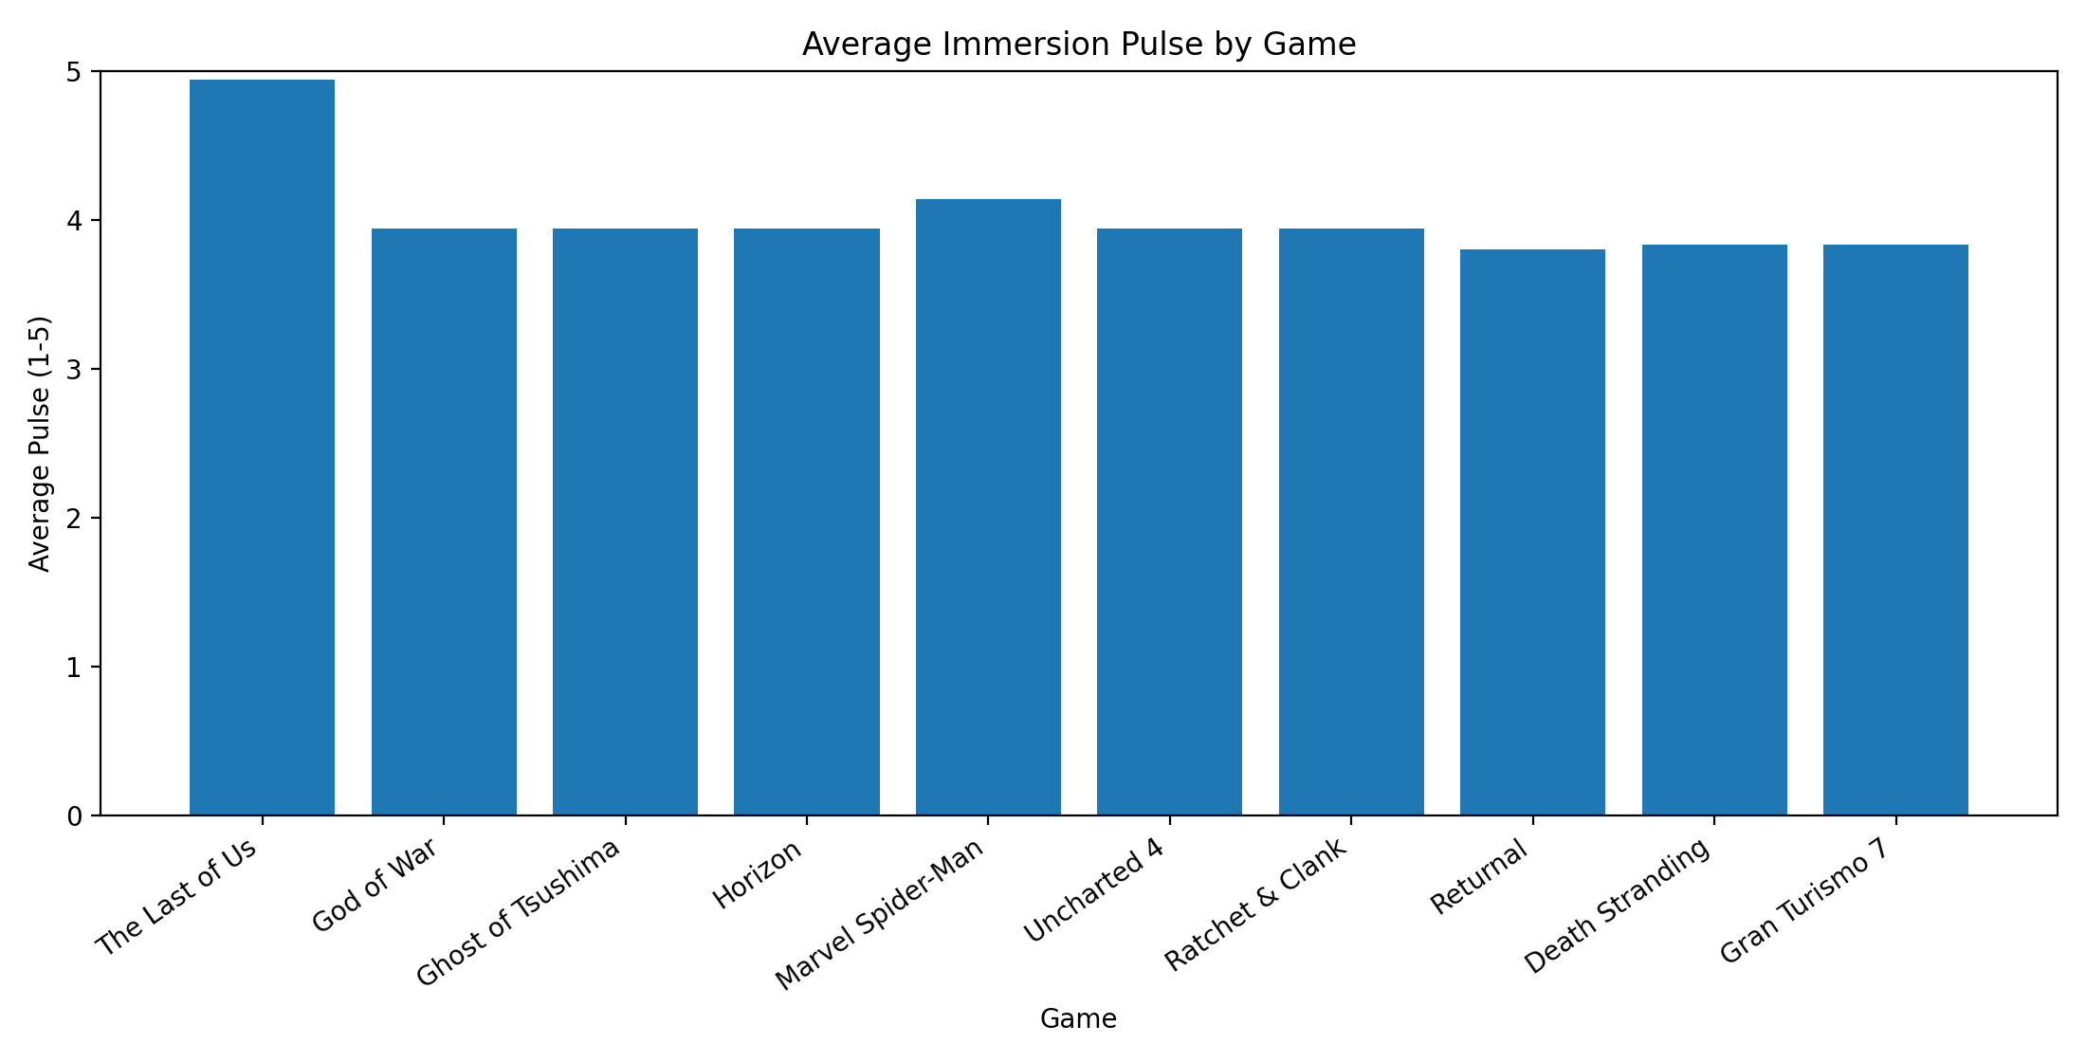
The timeline data is especially useful for identifying pacing and fatigue issues. A game may have a high overall score but still contain specific moments where a player slows down, becomes confused, or feels the loop repeating.

12. Non-Gaming Subjects vs Seasoned Gamers
The comparison between non-gaming subjects and seasoned gamers is one of the most important parts of the study. Non-gamers often move slower, read more, and respond strongly to clarity, familiarity, and story context. Seasoned gamers often react faster to mechanics, movement, challenge, and systems depth.
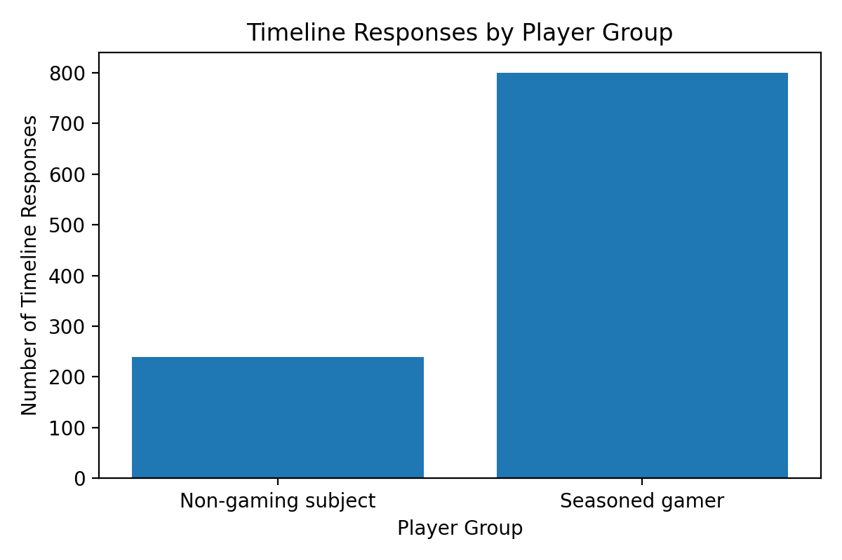
This means the same game can be immersive for different reasons. A newer player may enjoy Spider-Man because the character is familiar and the role feels easy to understand. A seasoned player may enjoy the same game because the movement is responsive and satisfying.
13. Testimony Example: Armani and Christopher on Spider-Man
Armani Bradley is coded as a non-gaming subject. Her Spider-Man response is important because she entered the experience with prior character familiarity. Knowing Spider-Man helped the game feel approachable. Her immersion came through story, character recognition, and feeling like she could understand Peter Parker as a person, not just as a playable avatar.
Christopher Fowls is coded as a seasoned gamer. His response to Spider-Man focused less on readability and story absorption and more on mechanics. For him, the movement system was the hook. Web-swinging, fast traversal, and the feeling of control made the experience fun. This contrast shows why the model needs multiple metrics. Armani and Christopher both found the game enjoyable, but their reasons were different.
- Armani: character familiarity, story attention, slower pace, detail absorption.
- Christopher: movement, mechanics, control feel, less focus on narrative readability.
- Research value: same game, different immersion pathway.
14.1 Game Report: The Last of Us
The Last of Us received an official deck score of 92, a calculated immersion percentage of 93, a replay intent index of 96, and a sales proxy of 88.
The response timeline includes 104 rows for this title. The average immersion pulse is 4.94 out of 5. The most common primary metric in the timeline is NI, which corresponds to Narrative Integration.
Interpretation: Peak: emotion + narrative integration; Risk: slower scavenging sections
Minute | Player | Group | Pulse | Primary | Secondary | Note
5 | Armani Bradley | Non-gaming subject | 4 | NI | EM | The opening felt tense and emotional while the player learned the controls. I needed time to understand the controls, so I moved slower at the beginning.
10 | Armani Bradley | Non-gaming subject | 4 | NI | EM | The opening felt tense and emotional while the player learned the controls. I needed time to understand the controls, so I moved slower at the beginning.
15 | Armani Bradley | Non-gaming subject | 5 | EN | FL | Story moments made the world feel serious and believable.
20 | Armani Bradley | Non-gaming subject | 5 | EN | FL | Story moments made the world feel serious and believable.
25 | Armani Bradley | Non-gaming subject | 5 | ID | NI | Scavenging slowed the pace, but it also made survival feel intentional.
30 | Armani Bradley | Non-gaming subject | 5 | ID | NI | Scavenging slowed the pace, but it also made survival feel intentional.
These sample notes are only a preview. The full response set for this game is stored in the workbook and imported into the website prototype.
14.2 Game Report: God of War
God of War received an official deck score of 90, a calculated immersion percentage of 91, a replay intent index of 90, and a sales proxy of 94.
The response timeline includes 104 rows for this title. The average immersion pulse is 3.94 out of 5. The most common primary metric in the timeline is ME, which corresponds to Mechanical Satisfaction.
Interpretation: Peak: combat weight + father/son stakes; Risk: puzzle pacing
Minute | Player | Group | Pulse | Primary | Secondary | Note
5 | Armani Bradley | Non-gaming subject | 3 | ME | ID | Combat felt heavy and satisfying from the first encounter. I needed time to understand the controls, so I moved slower at the beginning.
10 | Armani Bradley | Non-gaming subject | 3 | ME | ID | Combat felt heavy and satisfying from the first encounter. I needed time to understand the controls, so I moved slower at the beginning.
15 | Armani Bradley | Non-gaming subject | 4 | EM | NI | The father and son dynamic made the action feel connected to the story.
20 | Armani Bradley | Non-gaming subject | 4 | EM | NI | The father and son dynamic made the action feel connected to the story.
25 | Armani Bradley | Non-gaming subject | 4 | FL | ME | Puzzle moments sometimes slowed the pace after intense combat.
30 | Armani Bradley | Non-gaming subject | 4 | FL | ME | Puzzle moments sometimes slowed the pace after intense combat.
These sample notes are only a preview. The full response set for this game is stored in the workbook and imported into the website prototype.
14.3 Game Report: Ghost of Tsushima
Ghost of Tsushima received an official deck score of 88, a calculated immersion percentage of 87, a replay intent index of 92, and a sales proxy of 82.
The response timeline includes 104 rows for this title. The average immersion pulse is 3.94 out of 5. The most common primary metric in the timeline is EN, which corresponds to Environmental Immersion.
Interpretation: Peak: cinematic exploration + world beauty; Risk: travel fatigue
Minute | Player | Group | Pulse | Primary | Secondary | Note
5 | Armani Bradley | Non-gaming subject | 3 | EN | FL | The world felt cinematic, calm, and visually inviting. I needed time to understand the controls, so I moved slower at the beginning.
10 | Armani Bradley | Non-gaming subject | 3 | EN | FL | The world felt cinematic, calm, and visually inviting. I needed time to understand the controls, so I moved slower at the beginning.
15 | Armani Bradley | Non-gaming subject | 4 | ME | ID | Sword combat felt clean and intentional.
20 | Armani Bradley | Non-gaming subject | 4 | ME | ID | Sword combat felt clean and intentional.
25 | Armani Bradley | Non-gaming subject | 4 | EN | RI | Exploration felt beautiful, though travel could slow the session.
30 | Armani Bradley | Non-gaming subject | 4 | EN | RI | Exploration felt beautiful, though travel could slow the session.
These sample notes are only a preview. The full response set for this game is stored in the workbook and imported into the website prototype.
14.4 Game Report: Horizon
Horizon received an official deck score of 84, a calculated immersion percentage of 80, a replay intent index of 84, and a sales proxy of 78.
The response timeline includes 104 rows for this title. The average immersion pulse is 3.94 out of 5. The most common primary metric in the timeline is EN, which corresponds to Environmental Immersion.
Interpretation: Peak: machine combat + world mystery; Risk: resource/crafting friction
Minute | Player | Group | Pulse | Primary | Secondary | Note
5 | Armani Bradley | Non-gaming subject | 3 | EN | NI | The machine world felt visually complex and different. I needed time to understand the controls, so I moved slower at the beginning.
10 | Armani Bradley | Non-gaming subject | 3 | EN | NI | The machine world felt visually complex and different. I needed time to understand the controls, so I moved slower at the beginning.
15 | Armani Bradley | Non-gaming subject | 4 | ME | ID | Machine combat created a strong tactical loop.
20 | Armani Bradley | Non-gaming subject | 4 | ME | ID | Machine combat created a strong tactical loop.
25 | Armani Bradley | Non-gaming subject | 4 | FR | AG | Crafting and scanning added depth but could slow new players down.
30 | Armani Bradley | Non-gaming subject | 4 | FR | AG | Crafting and scanning added depth but could slow new players down.
These sample notes are only a preview. The full response set for this game is stored in the workbook and imported into the website prototype.
14.5 Game Report: Marvel Spider-Man
Marvel Spider-Man received an official deck score of 89, a calculated immersion percentage of 89, a replay intent index of 95, and a sales proxy of 90.
The response timeline includes 104 rows for this title. The average immersion pulse is 4.14 out of 5. The most common primary metric in the timeline is ME, which corresponds to Mechanical Satisfaction.
Interpretation: Peak: movement freedom + instant joy; Risk: side activity repetition
Minute | Player | Group | Pulse | Primary | Secondary | Note
5 | Armani Bradley | Non-gaming subject | 4 | ME | FL | Because I already knew Spider-Man, the game felt fun and familiar fast. I felt like I was stepping into Peter Parker’s world.
10 | Armani Bradley | Non-gaming subject | 5 | ME | FL | Because I already knew Spider-Man, the game felt fun and familiar fast. I felt like I was stepping into Peter Parker’s world.
15 | Armani Bradley | Non-gaming subject | 5 | AG | ID | I moved slower because I am not used to games, but that made me pay attention to story, details, and the city.
20 | Armani Bradley | Non-gaming subject | 5 | AG | ID | I moved slower because I am not used to games, but that made me pay attention to story, details, and the city.
25 | Armani Bradley | Non-gaming subject | 5 | NI | EM | The story connection helped me care about what was happening, not just swing around.
30 | Armani Bradley | Non-gaming subject | 5 | NI | EM | The story connection helped me care about what was happening, not just swing around.
These sample notes are only a preview. The full response set for this game is stored in the workbook and imported into the website prototype.
14.6 Game Report: Uncharted 4
Uncharted 4 received an official deck score of 86, a calculated immersion percentage of 84, a replay intent index of 82, and a sales proxy of 87.
The response timeline includes 104 rows for this title. The average immersion pulse is 3.94 out of 5. The most common primary metric in the timeline is NI, which corresponds to Narrative Integration.
Interpretation: Peak: set pieces + character banter; Risk: linear pacing dips
Minute | Player | Group | Pulse | Primary | Secondary | Note
5 | Armani Bradley | Non-gaming subject | 3 | NI | EM | The cinematic setup made the game feel like an adventure film. I needed time to understand the controls, so I moved slower at the beginning.
10 | Armani Bradley | Non-gaming subject | 3 | NI | EM | The cinematic setup made the game feel like an adventure film. I needed time to understand the controls, so I moved slower at the beginning.
15 | Armani Bradley | Non-gaming subject | 4 | ID | FL | Climbing and set pieces kept the pace moving.
20 | Armani Bradley | Non-gaming subject | 4 | ID | FL | Climbing and set pieces kept the pace moving.
25 | Armani Bradley | Non-gaming subject | 4 | FR | AG | Linear sections were clear, but sometimes reduced freedom.
30 | Armani Bradley | Non-gaming subject | 4 | FR | AG | Linear sections were clear, but sometimes reduced freedom.
These sample notes are only a preview. The full response set for this game is stored in the workbook and imported into the website prototype.
14.7 Game Report: Ratchet & Clank
Ratchet & Clank received an official deck score of 85, a calculated immersion percentage of 82, a replay intent index of 86, and a sales proxy of 70.
The response timeline includes 104 rows for this title. The average immersion pulse is 3.94 out of 5. The most common primary metric in the timeline is ME, which corresponds to Mechanical Satisfaction.
Interpretation: Peak: weapon variety + spectacle; Risk: lower emotional weight
Minute | Player | Group | Pulse | Primary | Secondary | Note
5 | Armani Bradley | Non-gaming subject | 3 | ME | ID | Weapon variety made combat feel playful and energetic. I needed time to understand the controls, so I moved slower at the beginning.
10 | Armani Bradley | Non-gaming subject | 3 | ME | ID | Weapon variety made combat feel playful and energetic. I needed time to understand the controls, so I moved slower at the beginning.
15 | Armani Bradley | Non-gaming subject | 4 | FL | EN | Fast transitions and colorful worlds kept the session moving.
20 | Armani Bradley | Non-gaming subject | 4 | FL | EN | Fast transitions and colorful worlds kept the session moving.
25 | Armani Bradley | Non-gaming subject | 4 | AG | RI | The player enjoyed experimenting with tools and weapons.
30 | Armani Bradley | Non-gaming subject | 4 | AG | RI | The player enjoyed experimenting with tools and weapons.
These sample notes are only a preview. The full response set for this game is stored in the workbook and imported into the website prototype.
14.8 Game Report: Returnal
Returnal received an official deck score of 82, a calculated immersion percentage of 78, a replay intent index of 88, and a sales proxy of 62.
The response timeline includes 104 rows for this title. The average immersion pulse is 3.8 out of 5. The most common primary metric in the timeline is ME, which corresponds to Mechanical Satisfaction.
Interpretation: Peak: challenge loop + replay structure; Risk: difficulty fatigue
Minute | Player | Group | Pulse | Primary | Secondary | Note
5 | Armani Bradley | Non-gaming subject | 3 | ME | FL | Movement and shooting felt fast, precise, and intense. I needed time to understand the controls, so I moved slower at the beginning.
10 | Armani Bradley | Non-gaming subject | 3 | ME | FL | Movement and shooting felt fast, precise, and intense. I needed time to understand the controls, so I moved slower at the beginning.
15 | Armani Bradley | Non-gaming subject | 4 | ID | RI | The loop created strong replay pressure for experienced players.
20 | Armani Bradley | Non-gaming subject | 3 | ID | RI | The loop created strong replay pressure for experienced players.
25 | Armani Bradley | Non-gaming subject | 3 | FR | ME | Difficulty and repeated failure could create frustration.
30 | Armani Bradley | Non-gaming subject | 3 | FR | ME | Difficulty and repeated failure could create frustration.
These sample notes are only a preview. The full response set for this game is stored in the workbook and imported into the website prototype.
14.9 Game Report: Death Stranding
Death Stranding received an official deck score of 75, a calculated immersion percentage of 71, a replay intent index of 70, and a sales proxy of 68.
The response timeline includes 104 rows for this title. The average immersion pulse is 3.83 out of 5. The most common primary metric in the timeline is EN, which corresponds to Environmental Immersion.
Interpretation: Peak: atmosphere + unique world; Risk: slow traversal and niche loop
Minute | Player | Group | Pulse | Primary | Secondary | Note
5 | Armani Bradley | Non-gaming subject | 3 | EN | NI | The world felt strange, quiet, and atmospheric. I needed time to understand the controls, so I moved slower at the beginning.
10 | Armani Bradley | Non-gaming subject | 3 | EN | NI | The world felt strange, quiet, and atmospheric. I needed time to understand the controls, so I moved slower at the beginning.
15 | Armani Bradley | Non-gaming subject | 4 | FL | FR | Slow traversal made the session feel more niche and patient.
20 | Armani Bradley | Non-gaming subject | 4 | FL | FR | Slow traversal made the session feel more niche and patient.
25 | Armani Bradley | Non-gaming subject | 3 | EM | NI | The tone made the story feel unusual and reflective.
30 | Armani Bradley | Non-gaming subject | 3 | EM | NI | The tone made the story feel unusual and reflective.
These sample notes are only a preview. The full response set for this game is stored in the workbook and imported into the website prototype.
14.10 Game Report: Gran Turismo 7
Gran Turismo 7 received an official deck score of 78, a calculated immersion percentage of 71, a replay intent index of 76, and a sales proxy of 72.
The response timeline includes 104 rows for this title. The average immersion pulse is 3.83 out of 5. The most common primary metric in the timeline is ME, which corresponds to Mechanical Satisfaction.
Interpretation: Peak: mechanical mastery + progression; Risk: weaker narrative pull
Minute | Player | Group | Pulse | Primary | Secondary | Note
5 | Armani Bradley | Non-gaming subject | 3 | ME | ID | Driving mechanics felt precise and skill-based. I needed time to understand the controls, so I moved slower at the beginning.
10 | Armani Bradley | Non-gaming subject | 3 | ME | ID | Driving mechanics felt precise and skill-based. I needed time to understand the controls, so I moved slower at the beginning.
15 | Armani Bradley | Non-gaming subject | 4 | AG | ME | The player felt improvement through timing, braking, and control.
20 | Armani Bradley | Non-gaming subject | 4 | AG | ME | The player felt improvement through timing, braking, and control.
25 | Armani Bradley | Non-gaming subject | 3 | FR | RI | Progression had replay value, but grinding could create fatigue.
30 | Armani Bradley | Non-gaming subject | 3 | FR | RI | Progression had replay value, but grinding could create fatigue.
These sample notes are only a preview. The full response set for this game is stored in the workbook and imported into the website prototype.
15. Exit Quiz Structure
The exit quiz is used after the 40-minute session. It captures overall immersion, pull factor, immersion breaks, agency, replay intent, fatigue, flow, believability, peak moment, and continuation interest. This gives the study a structured post-session layer in addition to the timeline notes.
# | Category | Question | Metric Connection
1 | Overall immersion | During the 40 minutes, how immersed did you feel overall? | Maps to overall immersion pulse
2 | Pull factor | What pulled you into the game the most? | Supports peak immersion hook
3 | Immersion break | What broke immersion the most? | Supports break risk
4 | Agency | Did your actions feel like they mattered? | Maps to AG
5 | Replay intent | How often did the game make you want to keep playing? | Maps to RI
6 | Fatigue | What made you feel tired or disconnected? | Maps to FR
7 | Flow | How smooth was gameplay flow? | Maps to FL
8 | Believability | Did the world feel believable? | Maps to EN
9 | Peak moment | What moment was the strongest immersion point? | Qualitative support
10 | Continuation | Would you keep playing after the 40 minutes ended? | Replayability signal

16. Public Reception Data vs Study Data
The workbook includes Metascore and User Score as secondary context. These values are not the same as the study scores. Metascore is a public critic aggregation. User Score is a public audience aggregation. The study score is built from the project scoring model and response timeline.
This distinction matters because public reception can show whether a game is broadly praised, but it does not directly reveal which moment made a player feel connected or which mechanic made them want to continue.
Game | Metascore | User Score | Deck Score | Use
The Last of Us | 89 | 8.1 | 92 | Context only: public reception does not directly measure immersion.
God of War | 94 | 8.3 | 90 | Context only: public reception does not directly measure immersion.
Ghost of Tsushima | 83 | 9.1 | 88 | Context only: public reception does not directly measure immersion.
Horizon | 88 | 8 | 84 | Context only: public reception does not directly measure immersion.
Marvel Spider-Man | 87 | 8.7 | 89 | Context only: public reception does not directly measure immersion.
Uncharted 4 | 93 | 8.7 | 86 | Context only: public reception does not directly measure immersion.
Ratchet & Clank | 88 | 8.5 | 85 | Context only: public reception does not directly measure immersion.
Returnal | 86 | 7.4 | 82 | Context only: public reception does not directly measure immersion.
Death Stranding | 85 | 8.1 | 75 | Context only: public reception does not directly measure immersion.
Gran Turismo 7 | 87 | 2.7 | 78 | Context only: public reception does not directly measure immersion.

17. Replayability and Sales Proxy Analysis
The project compares the official deck score against replay intent and sales proxy. The replay comparison is closer to the study goal because it focuses on return-to-play behavior. The sales proxy comparison is useful for marketing discussion, but it should be interpreted carefully. Sales are shaped by many external factors beyond immersion, including brand recognition, launch timing, platform reach, price, and promotional visibility.
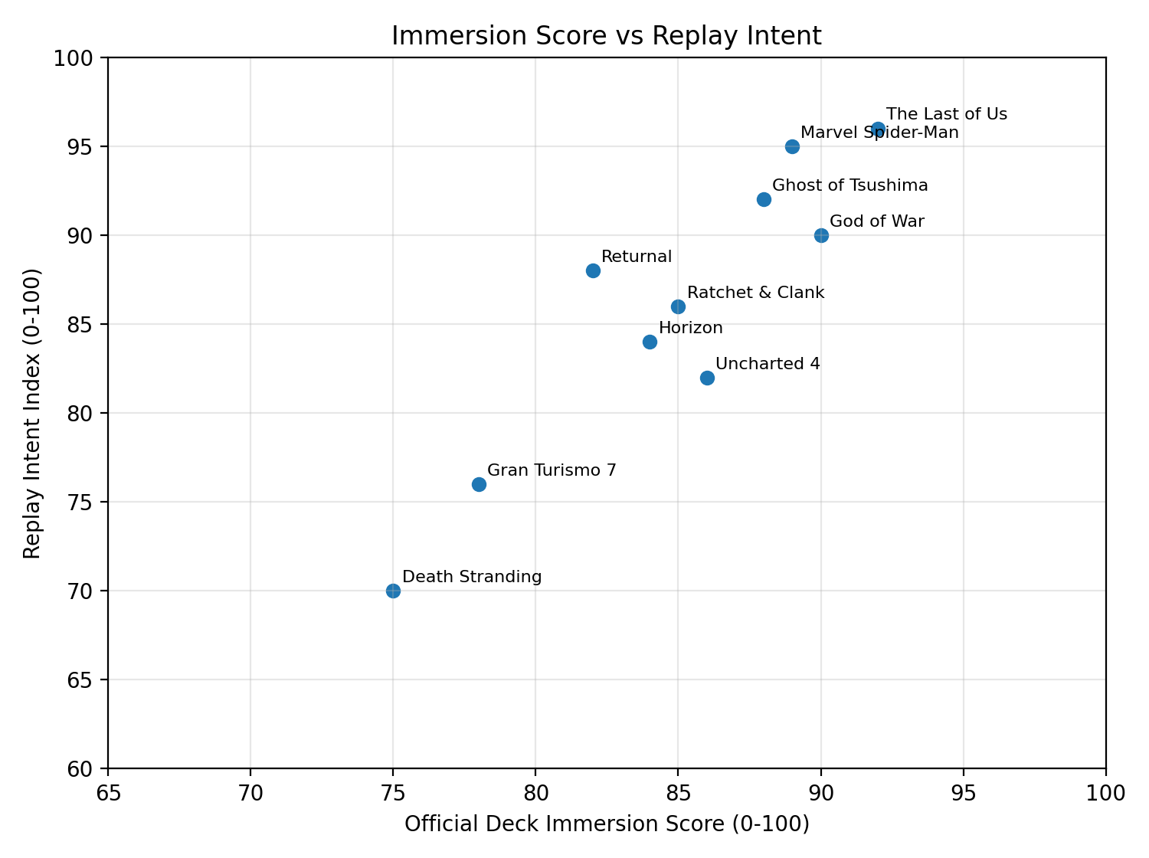
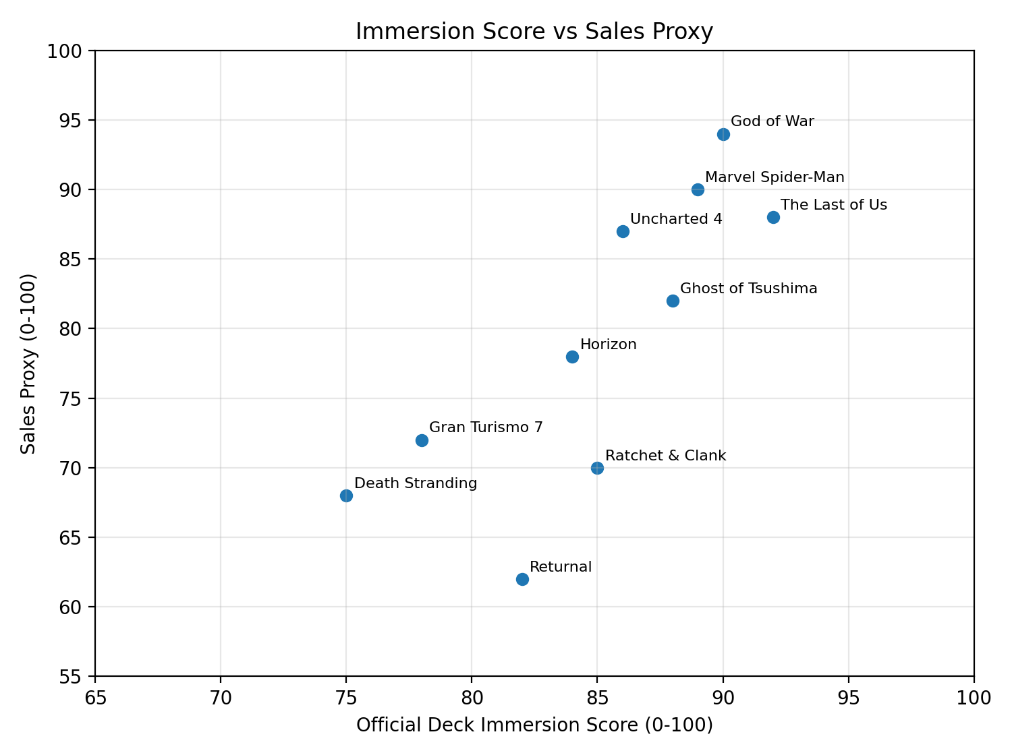

18. Website Prototype
The final prototype is a basic JavaScript website rather than only a Figma concept. The website imports all workbook responses through a data file, displays dashboards, renders a score matrix, filters response rows, lists exit quiz questions, collects new responses, and exports the data back into Excel-readable formats.
The prototype is intentionally simple. It does not require a server or domain to test. A user can open index.html locally, explore the dataset, add sample observations, and export the updated data. This makes the project feel like a real research tool instead of only a static presentation.
- data.js stores imported workbook records.
- app.js contains commented functions for charts, filters, local storage, and exports.
- The response form saves new rows in localStorage.
- The export tab creates .xls, .csv, and .json files.
19. Conclusion
This project shows that immersion can be made more measurable without removing the creative and emotional parts of games. By separating immersion into metrics and pairing those scores with timeline notes, the researcher can identify not only whether a game feels immersive, but why and when it feels immersive.
The larger value of the project is the connection between game experience and return-to-play behavior. A game does not become commercially meaningful only because it sells once. It becomes long-lasting when players want to return, replay, purchase side stories, explore expansions, or stay connected to the world. The immersion model gives game developers and marketers another way to study that relationship.
Final takeaway: immersion is not only what makes a player start caring. It is what makes them return, replay, purchase the next chapter, and stay connected to the story world.

