**1、Os.system(cmd)执行结果乱码**

Code:

cmd = "xxx"  
ret = os.system(cmd)  
print('system(cmd):', cmd, "ret:", ret)

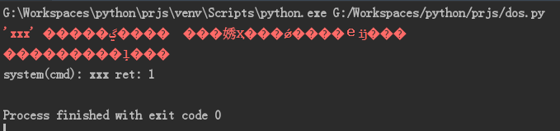

**2、popen返回的文件对象只能被读取一次**

import os  
  
class Os:  
 ret = -1  
 def system(self, cmd):  
 ret = -1  
 ret = os.system(cmd)  
 print('system(cmd):', cmd, "ret:", ret)  
  
 def popen(self, cmd):  
 ret = os.popen(cmd)  
 print(ret)  
 #data = self.ret.read() # way1  
 data = 1 # way2  
 print(data)  
 #if data.find("TTL") != -1: # way1  
 if data == 2: # way2  
 print('find TTL0')  
 else:  
 print('not find TTL0')  
 print('popen(cmd):', cmd, "ret:", ret)  
 return ret  
  
mOs = Os()  
  
cmd = "ping www.baidu.com"  
# cmd = "dir"  
# cmd = "md dir"  
# cmd = "rd dir"  
# cmd = "xxx"  
# cmd = 'tasklist'  
  
#mOs.system(cmd)  
ret = mOs.popen(cmd)  
data = ret.read()  
print(ret)  
print(data)  
if data.find("TTL") != -1:  
 print('find TTL1')  
else:  
 print('not find TTL1')  
  
if data.find("以毫秒为单位") != -1:  
 print('find 以毫秒为单位')  
else:  
 print('not find 以毫秒为单位')

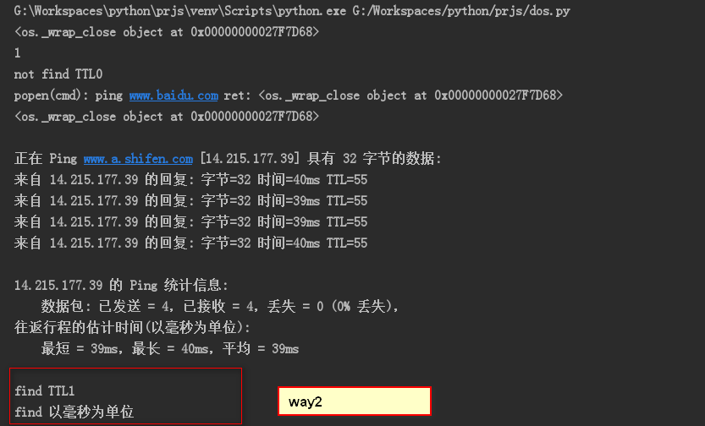

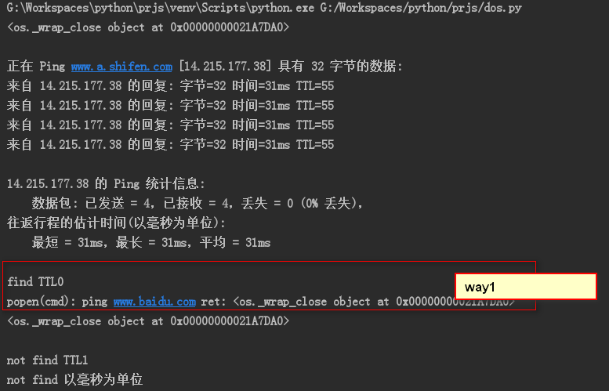

**3、python3和Python2在套接字返回值解码上有区别**

<https://www.fujieace.com/python/str-bytes.html>

