# ***Ahsanullah University of Science & Technology***

Department of Computer Science & Engineering



Travel Agency Management System

CSE 3224

Information System Design & Software Engineering Lab

Submitted By:

Shawon Lodh 16.01.04.064

Somaia Afrin 16.01.04.066

Md.Ruhul Amin 16.01.04.070

Project Motivation:

* In normal online travel agency system, users need to buy default packages for a tour. For this sometimes the packages can’t fulfill all the requirements of users.
* Suppose you have a group of members and want to go to a tour. But you have to choose default packages provided by the travel agency. But you can’t customize it. Our motivation comes from that.
* We have given users this opportunity that users can create his/her own packages according to their choice. It can be any kind of criteria like no of passengers, transport medium, desired hotel etc.

List of Primary Actors:

1. Guest user
2. Member user
3. Admin

List of Secondary Actors:

1. Telecommunication service
2. Mailing service
3. Social networking service
4. Payment service
5. Printer service
6. Transport company
7. Hotelier
8. Govt Agency

Use cases according to the Primary Actors:

Use case diagram according to guest users:

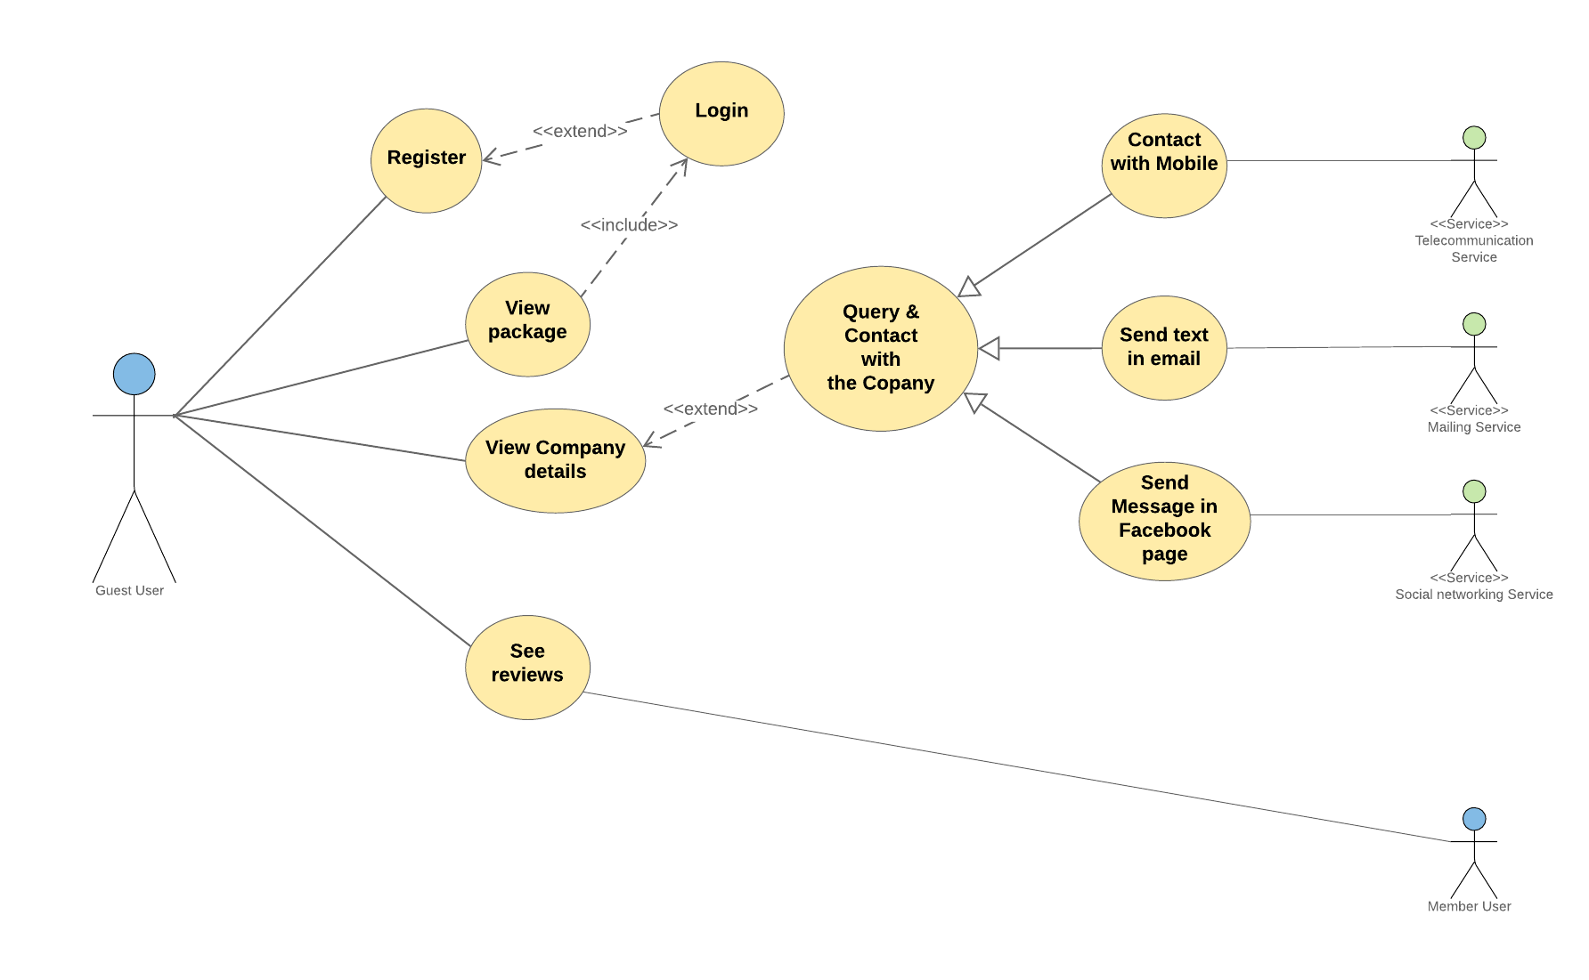

Use case diagram according to member users:

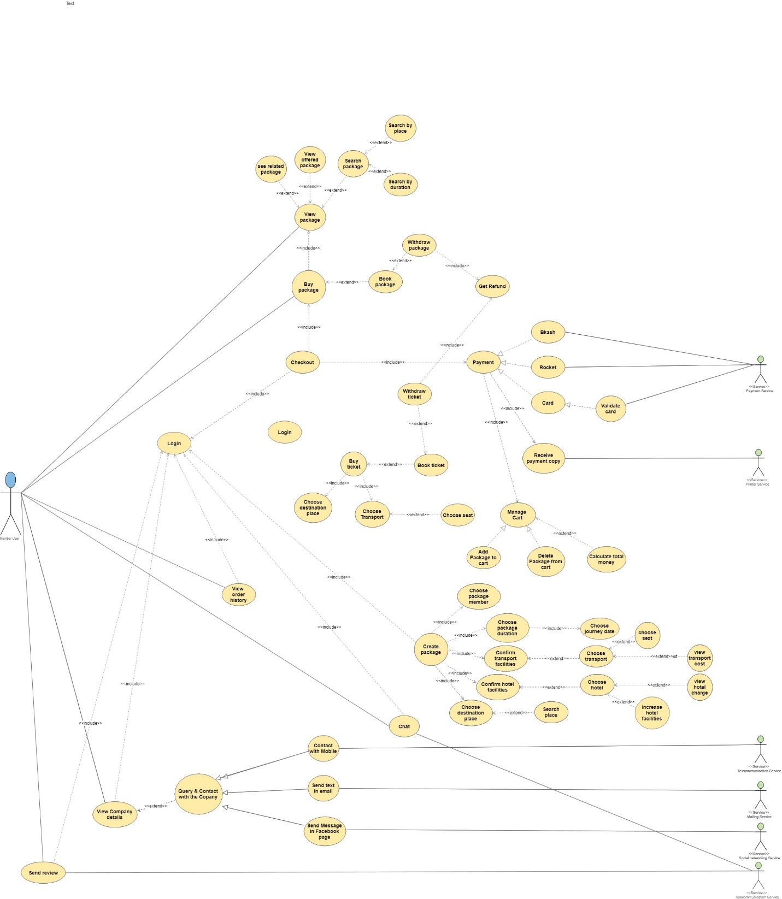

Use case diagram according to member users:

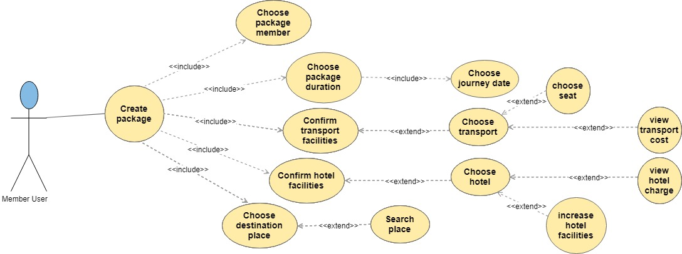

Use case diagram according to member users:

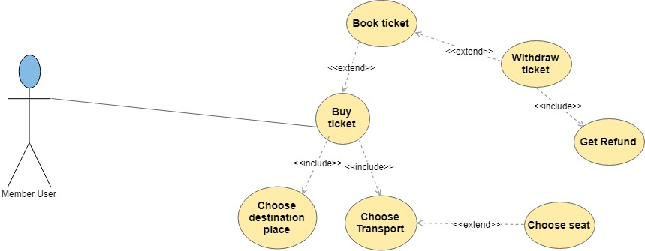

Use case diagram according to member users:

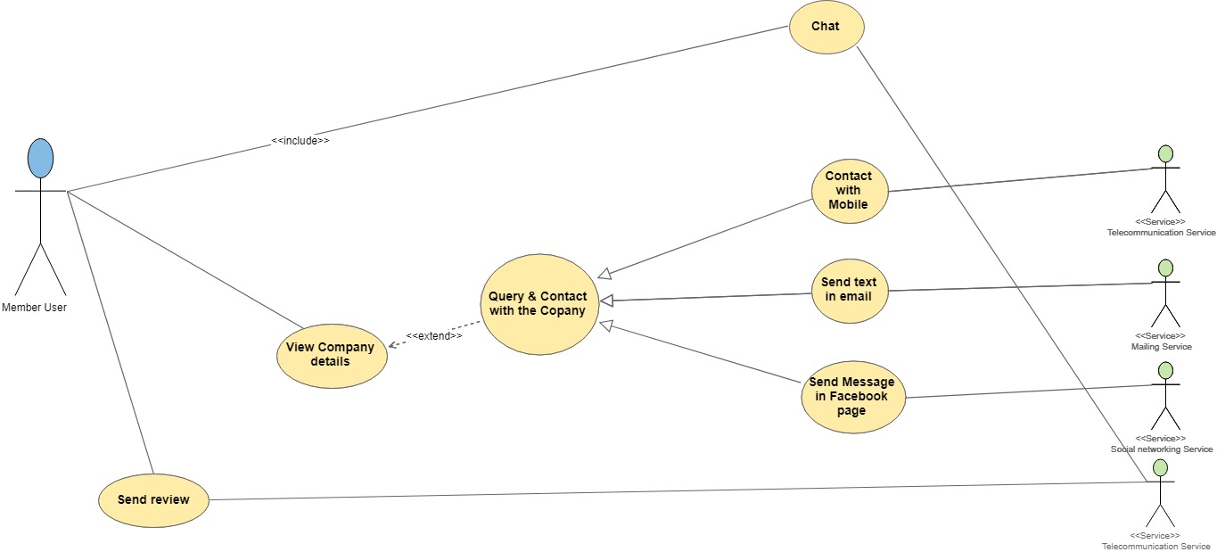

Use case diagram according to member users:

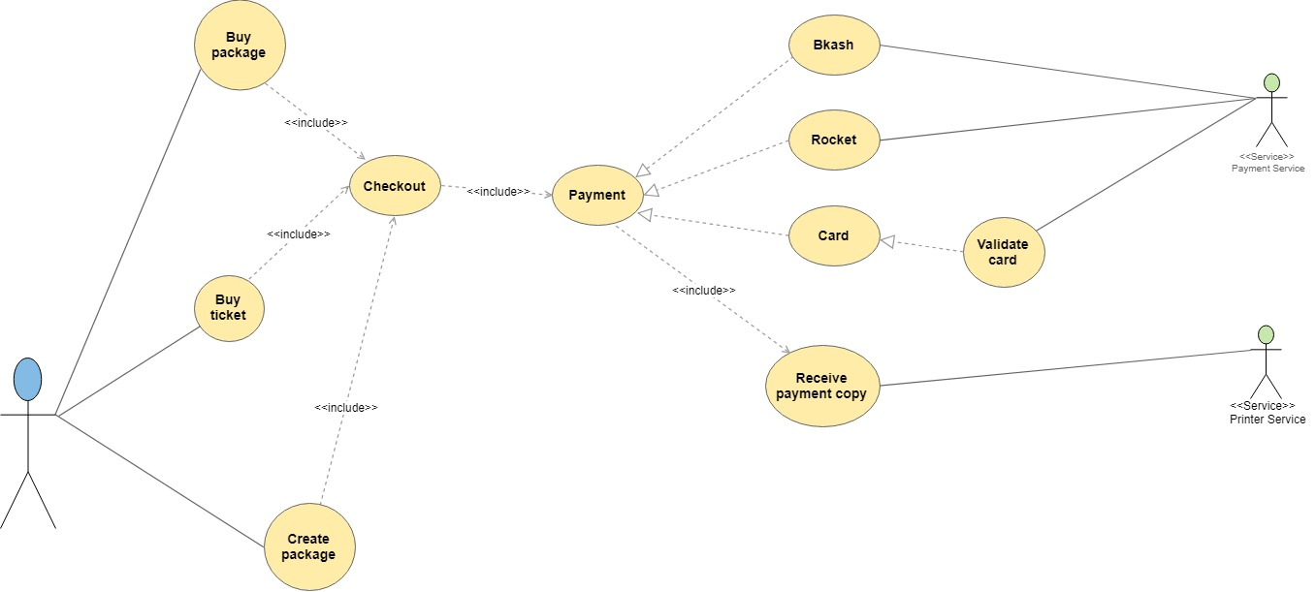

Use case diagram according to member users:

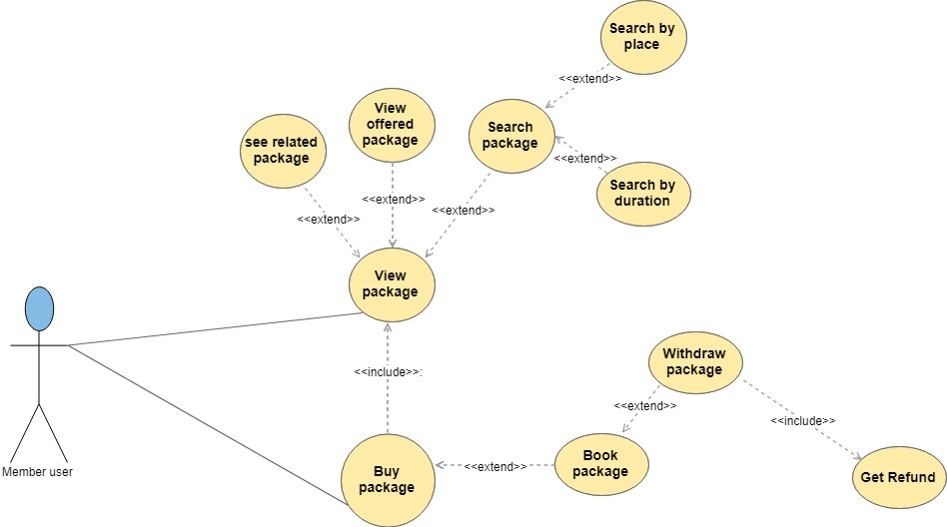

Use case diagram according to Admin:

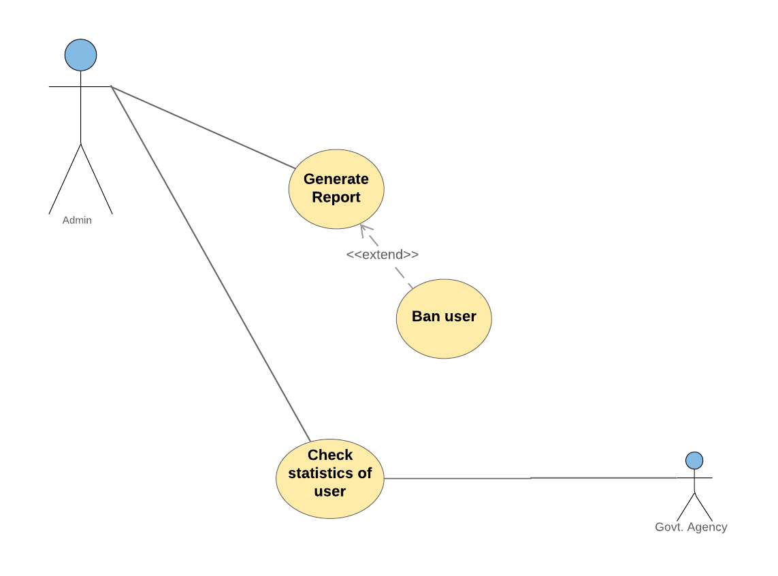

Use case diagram according to Admin:

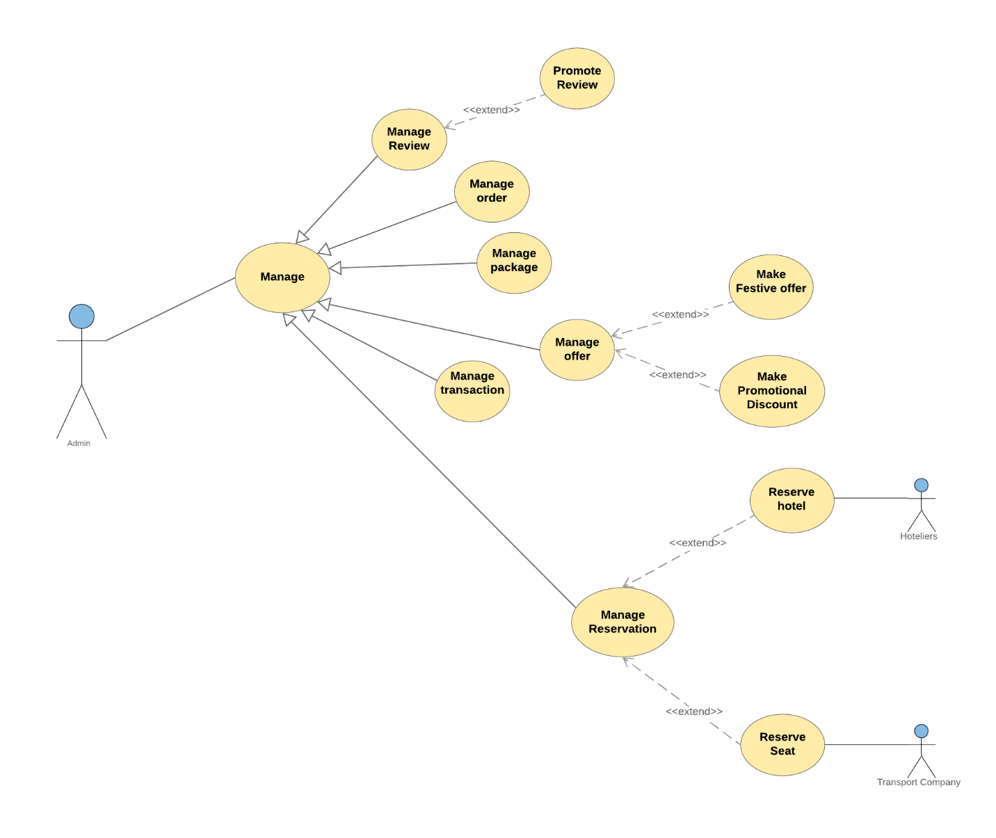

Class Diagram:

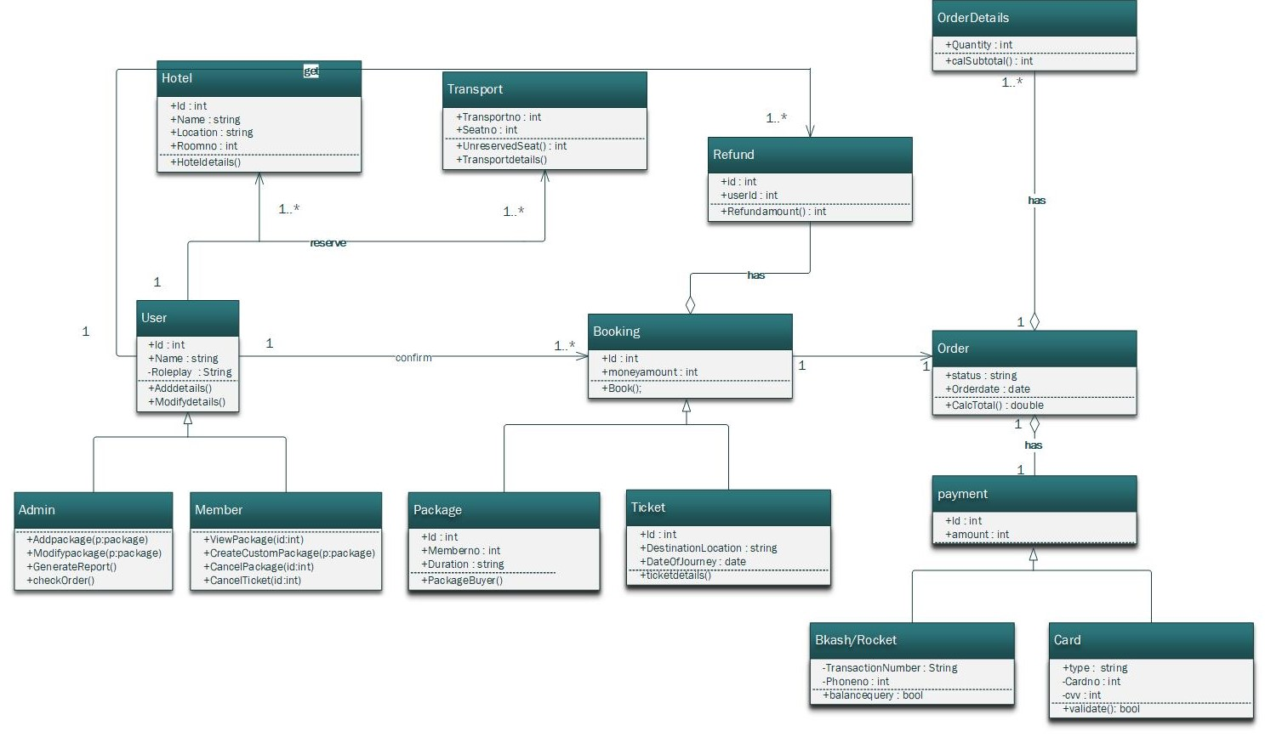

Conclusion:

Use cases capture the functional requirements of a system and tell us what the system should do. From this use diagram we can describe the interactions between the different actors and the system that how the system is going to be used. More over from the class diagram we can see classes and relationship among them.