# ***Ahsanullah University of Science & Technology***

Department of Computer Science & Engineering



Travel Agency Management System

CSE 3224

Information System Design & Software Engineering Lab

Submitted By:

Shawon Lodh 16.01.04.064

Somaia Afrin 16.01.04.066

Md.Ruhul Amin 16.01.04.070

Project Introduction:

ER-Modeling is a data modeling technique used in Software Engineering to produce a conceptual data model of an information system. Diagram created using this ER – Modeling technique are called entity relationship diagrams or ER diagrams or ERD. It is mainly a process that Graphically demonstrates an information of system’s entities and relationships between those entities. It is used to organize data within databases and visually understand how the separated elements are related to each other and working together. 3 key components of ERD are – Entity, Relationship & Attribute

List of Entity, Primary, Foreign & Composite keys:

|  |  |  |  |
| --- | --- | --- | --- |
| Entity | Primary key | Foreign key | Composite key |
| Admin | A_User_ID |  |  |
| Member | M_User_ID |  |  |
| Place | Name | A_User_ID |  |
| Hotel | H_ID | A_User_ID |  |
| Transport | T_ID | A_User_ID |  |
| Package | P_ID | Name, H_ID, T_ID |  |
| Order | O_ID |  |  |
| Package_Order |  |  | O_ID, P_ID |
| Payment | Pay_ID | M_User_ID, O_ID |  |
| Bkash/Rocket |  | Pay_ID | Pay_ID, Transaction_no |
| Card |  | Pay_ID | Pay_ID, Card_no |

ER Diagram:

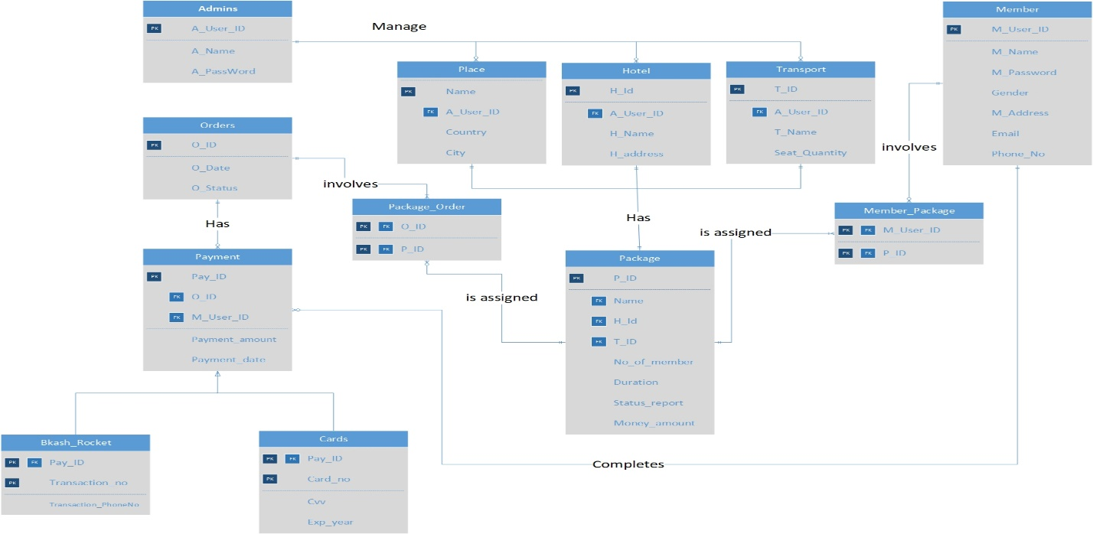

SQL Commands:

CREATE TABLE Orders

(

O_ID varchar(20) not null,

O_Date date not null,

O_Status char(20) not null,

PRIMARY KEY (O_ID),

);

CREATE TABLE Payment

(

Pay_ID varchar(20) not null,

O_ID varchar(20) not null,

M_user_ID varchar(20) not null,

Payment_amount Int not null,

Payment_date date not null,

PRIMARY KEY (Pay_ID),

FOREIGN KEY (O_ID) REFERENCES Orders(O_ID),

FOREIGN KEY (M_User_ID) REFERENCES Member(M_User_ID)

);

CREATE TABLE Bkash_Rocket

(

Pay_ID varchar(20) not null,

Transaction_no varchar(30) not null,

Transaction_PhoneNo varchar(30),

PRIMARY KEY (Pay_ID,Transaction_no),

FOREIGN KEY (Pay_ID) REFERENCES Payment (Pay_ID) ON DELETE CASCADE

);

CREATE TABLE Cards(

Pay_ID varchar(20) not null,

Card_no int not null,

cvv int not null,

Exp_year int not null,

PRIMARY KEY (Pay_ID,Card_no),

FOREIGN KEY (Pay_ID) REFERENCES Payment (Pay_ID) ON DELETE CASCADE

);

CREATE TABLE Place(

Name varchar(30) not null,

A_User_ID varchar(30) not null,

Country varchar(30) not null,

City varchar(30) not null,

PRIMARY KEY (Name),

FOREIGN KEY (A_User_ID) REFERENCES Admin (A_User_ID)

);

CREATE TABLE Hotel(

H_Id varchar(30) not null,

A_User_ID varchar(30) not null,

H_Name varchar(20) not null,

H_address varchar(30) not null,

PRIMARY KEY (H_Id),

FOREIGN KEY (A_User_ID) REFERENCES Admin (A_User_ID)

);

CREATE TABLE Transport(

T_ID varchar(30) not null,

A_User_ID varchar(30) not null,

T_Name varchar(20) not null,

Seat_Quantity int ,

PRIMARY KEY (T_ID),

FOREIGN KEY (A_User_ID) REFERENCES Admin (A_User_ID)

);

CREATE TABLE Package

(

P_ID varchar(20) not null,

Name varchar(30) not null,

H_Id varchar(30) not null,

T_ID varchar(30) not null,

No_of_member int not null,

Duration varchar(30) not null,

Status_report char(30) not null,

Money_amount int not null,

PRIMARY KEY (P_ID),

FOREIGN KEY (Name) REFERENCES Place (Name),

FOREIGN KEY (H_Id) REFERENCES Hotel (H_Id),

FOREIGN KEY (T_ID) REFERENCES Transport (T_ID),

);

CREATE TABLE Package_Order(

O_ID varchar(20) not null,

P_ID varchar(20) not null,

PRIMARY KEY (O_ID,P_ID),

FOREIGN KEY (O_ID) REFERENCES Orders (O_ID),

FOREIGN KEY (P_ID) REFERENCES Package (P_ID),

);

CREATE TABLE Member_Package(

M_User_ID varchar(20) not null,

P_ID varchar(20) not null,

PRIMARY KEY (M_User_ID,P_ID),

FOREIGN KEY (M_User_ID) REFERENCES Member (M_User_ID),

FOREIGN KEY (P_ID) REFERENCES Package (P_ID)

);

Relational Table Model:

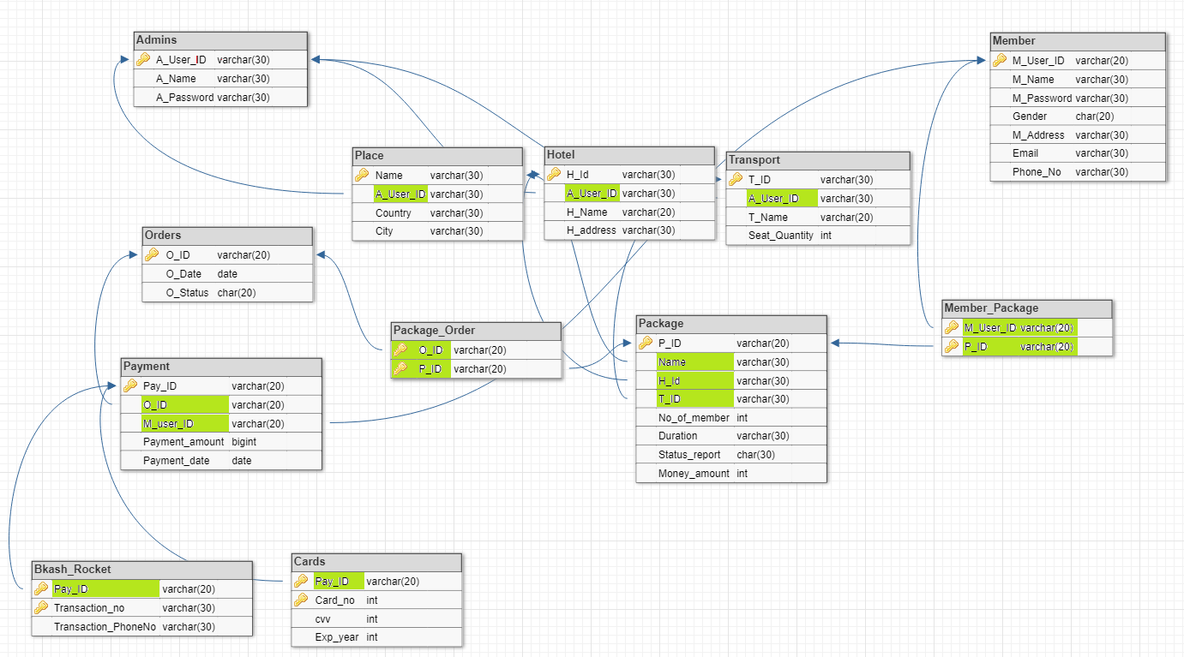

Conclusion:

The entity relationship diagram (ERD) is the logical structure of database and shows relationships of entity sets stored in a database. We have illustrated all the entities, attributes, data types and relationships of our entity relationship diagram. We have also illustrated SQL commands based on ER diagram. Above mentioned diagrams helped us to see the futurity of our project and now we can easily visualize the whole system more evidently.