HaMSa Developer Cookbook
For Developers
For Hospital Management Solution (HaMSa)

Version 0.1
10 June 2009

Contents

1 Introduction 3
2 phpMyAdmin Setup 3
3 Database configuration 4
4 svn checkout 6
5 Apache tomcat configuration 7
6 Import HaMSa in Galileo eclipse 9
7 Deploy and run HaMSa in apache tomcat server using Galileo eclipse. 12
8 Junit test case 12
9 Junit test case configuration 14
10 Run Junit test case 14
11 Debug HaMSa using Junit test case 14
12 HaMSa Layers 15
13 HaMSa Architecture 16
14 Example that explain what file needs to be where in HaMSa 16
15 Document History 18

1 Introduction
This document is a cookbook for HaMSa developers who will be getting started on HaMSa development. The document is intended to provide you the step-by-step approach to get development version of HaMSa running on your system. At the end, you shall be able to run HaMSa in development mode, debug it and enhance its functionality.
In case you find some step unclear or missing, send a mail to Manish Indoriya (manish.indoriya@walkingtree.in) with the detail.

1.1 Tasks
The following will be covered in this document:
- phpMyAdmin setup
- Databae configuration
- svn checkout
- Apache tomcat configuration
- Import HaMSa in Galileo eclipse
- Deploy and run HaMSa in apache tomcat server
- JUnit test case
- JUnit test case configuration
- Run JUnit test case
- Debug HaMSa using JUnit test case
- HaMSa Layers
- HaMSa Architecture
- An example that explain what file needs to where

2 phpMyAdmin Setup

2.1 Steps
- Extract phpMyAdmin in /usr/share/
tar -xzvf phpMyAdmin-2.7.0-pl1.tar.gz /usr/share/
- Configure phpMyAdmin (/usr/share/phpMyAdmin/config.inc.php )
$cfg['Servers'][$i]['auth_type'] = 'http'
$cfg['Servers'][$i]['user'] = 'username'(For HaMSa “hcis”).
$cfg['Servers'][$i]['password'] = 'password'(For HaMSa “nirvikulp”).
- Create the apache configuration file for phpMyAdmin
echo “alias /phpmyadmin /usr/share/phpMyAdmin”
>/etc/httpd/conf.d/phpMyAdmin
- Restart the http service
service httpd restart
- Open a browser and test the url as
http://localhost/phpmyadmin

3 Database configuration

3.1 Pre-requisite
- phpMyAdmin should be installed in your system.

3.2 Steps
- Create database :- Give the database name and click on create. This step is required for the HaMSa installation.
(For HaMSa this database name must be hcisit).
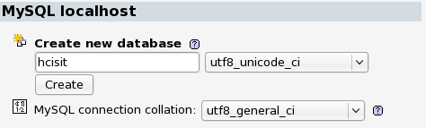
- Select database
- Create tables:- Give the table name and numbers of fields click on go. This step is not required for setting up HaMSa. Whenever you need to create new table you can use this step.
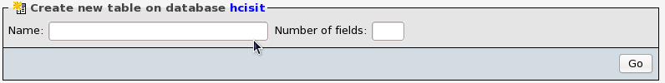
- Give Field names for the table. This step is not required for setting up HaMSa. Whenever you create table then you need to give its column name .
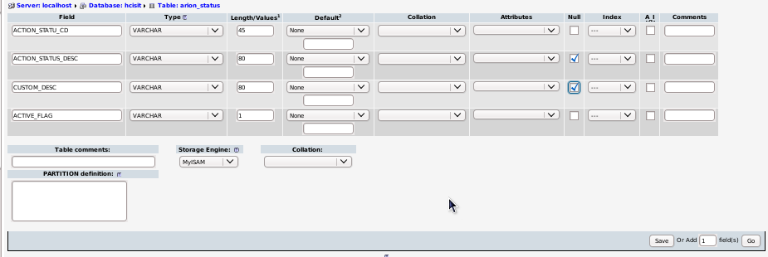
- Run sql queries:- This step is not required for setting up the HaMSa . However , if need arises , you can use this step to write and run a SQL query.
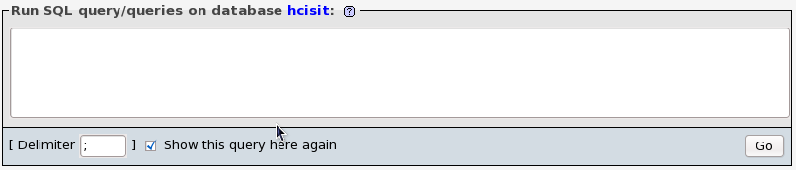
- import sql files:- This step is required for the HaMSa installation. In this step you can import sql files. Browse for the sql file and click on go.
For the installation of HaMSa you need to import Hamsa_Schema_With_data_04032010.sql that you can get from the checked out folder.

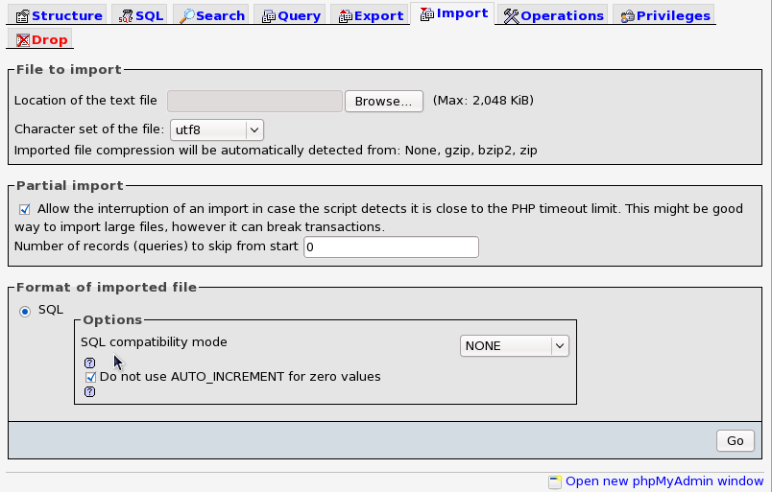

4 svn checkout

4.1 Pre-requisite
- RapidSVN should be installed in your system.
- url for HaMSa repository
- Access to the SVN repository.

4.2 Steps
From rapid svn
- Click on the 'Repository' menu
- Click on the menu item 'Checkout.. (CTRL-O)', this will open the 'Checkout' dialog box
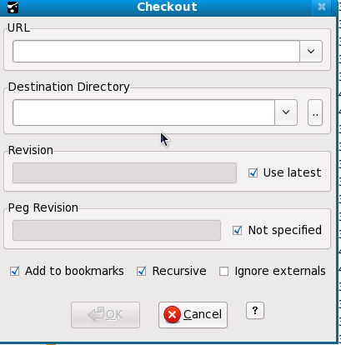
- Enter the URL of the Subversion repository in the 'URL Text box' .
- Select a local directory for your sandbox (working copy) .
- Click on 'OK' button
Checkout the following URL related to HaMSa
- http://192.168.1.50:8085/svn/wtchcis/trunk/
- http://192.168.1.50:8085/svn/wtccomponents/trunk/

4.3 Tips & Tricks
checkout from the terminal
Syntax: svn checkout(co) <url> <destination>
ex: svn co http://192.168.1.50:8085/svn/wtchcis/trunk
home/MANISH/SVNProjects/wtchcis/

5 Apache tomcat configuration

5.1 Pre-requisite
- Galileo eclipse should be installed in system.
- Apache tomcat should be installed in system.

5.2 Steps
- Launch Eclipse.
- Click on Window>Show view>Servers .
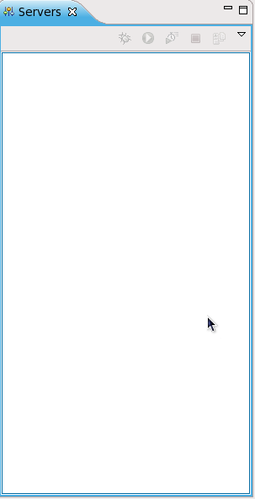
- Right click in this window and click on new>Server
- In the next window select Apache>Tomcat v6.0 Server and click on next

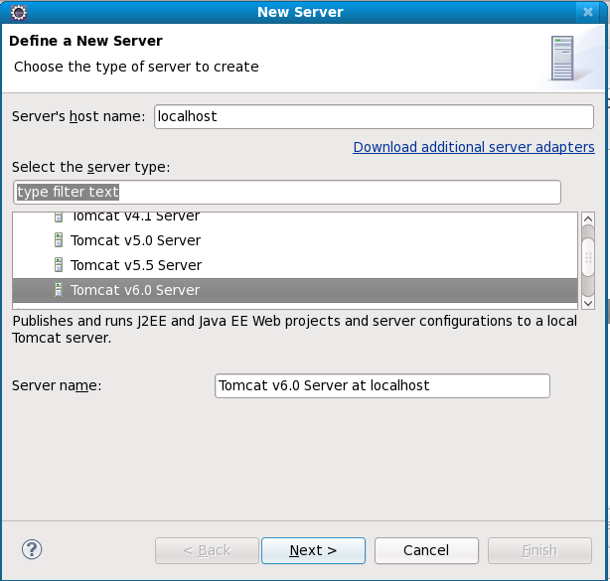
- browse for the apache tomcat,select latest jre and click on next.
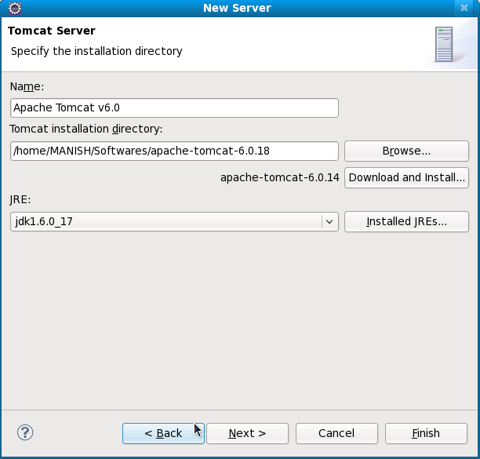
- click on finish.
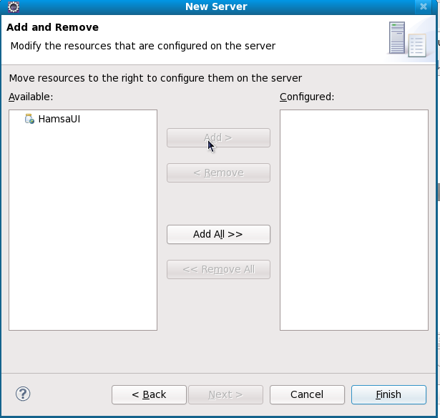

6 Import HaMSa in Galileo eclipse

6.1 Pre-requisite
- Galileo eclipse should be installed in your system
- Database should be configured in phpMyAdmin.

6.2 Steps
- Launch Eclipse.
- Click on File>Import... , This will open Import window.
- Select “Existing projects into workspace” and click on next.
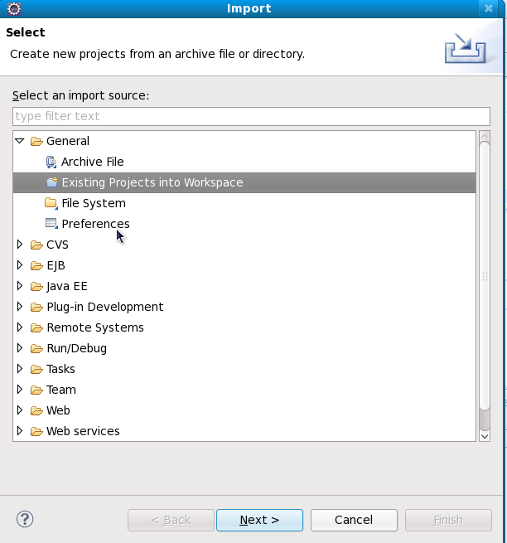
- Browse for the project and click on finish.

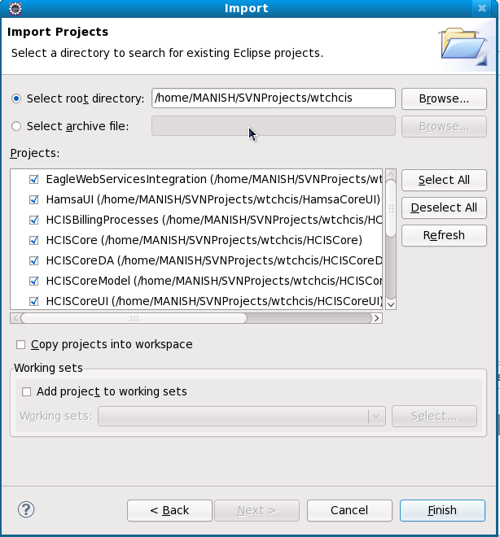

6.3 Tips & Tricks
General problem and its solution
a) HamsaUI is not being shown as a web project.
To solve this problem following are the steps:-
- Right click on HamsaUI and goto its Properties.
- Select “project facets” and the following options:-
Dynamic web module
Java
Javascript toolkit

b) Unbound classpath container 'JRE System Library [jre1.6.0_17]'
To solve this problem following are the steps:-
- Right click on the project and goto the properties.
- Select Java build path.
- In libraries tab select unbounded JRE System 'Library [jre1.6.0_17] (unbound)' and click on edit.
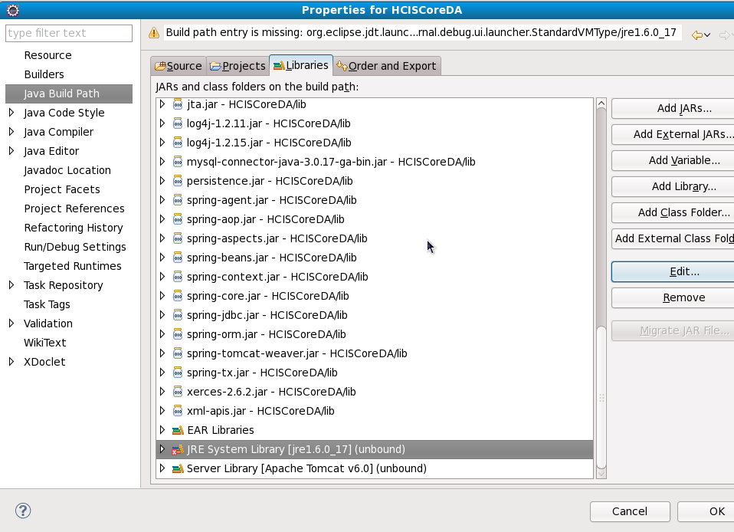
- Select the Workspace Default JRE library and click on finish.

c) in some project lib jar files are not added to the classpath . You need to add jar files into the classpath .
To solve this problem following are the steps:-
- Right click on the project and click on properties.
- Select “Java build path”.
- In Libraries tab click on “Add JARS...”
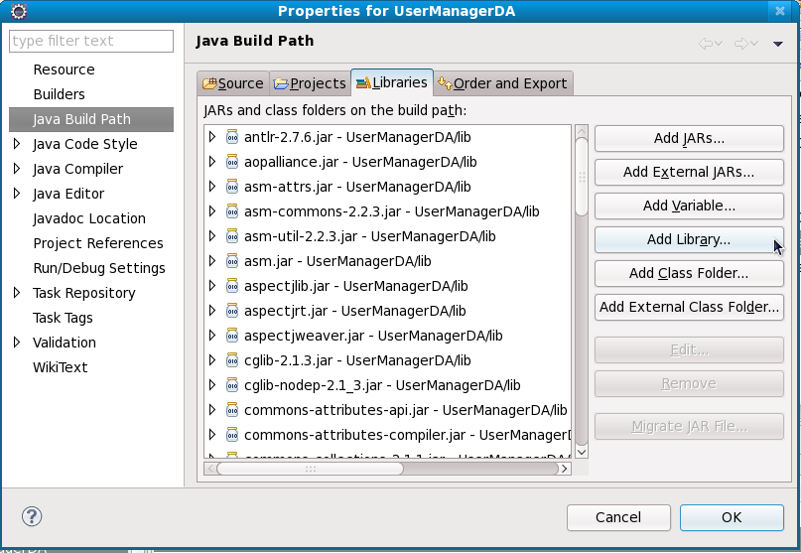
- Select “jar files” from Project>lib and click on ok

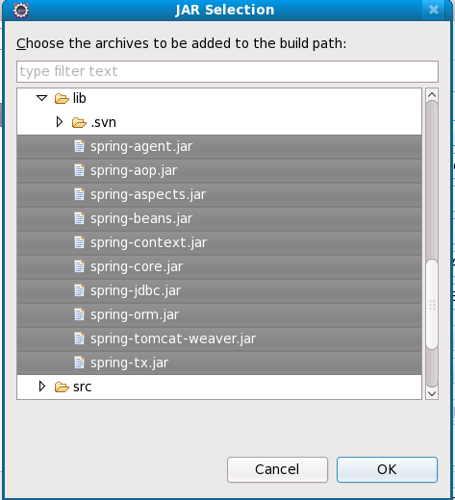

7 Deploy and run HaMSa in apache tomcat server using Galileo eclipse.

7.1 Pre-requisite
- No build error should be in the HaMSa project .

7.2 Steps
- Launch Eclipse.
- To deploy and run the HaMSa using Galileo eclipse right click on the HamsaUI in project explorer and click on “Run as>Run on Server” this will deploy the HaMSa project into the server and will start the server.

8 JUnit test case

8.1 Steps
- Launch Eclipse.
- Right click on the ManagerImpl class for which you want to write JUnit test case.
- click on “new>JUnit test case”
- Select the location where you want to save, Give the JUnit test case name , check setup() and click on next.name , check setup() and click on next.
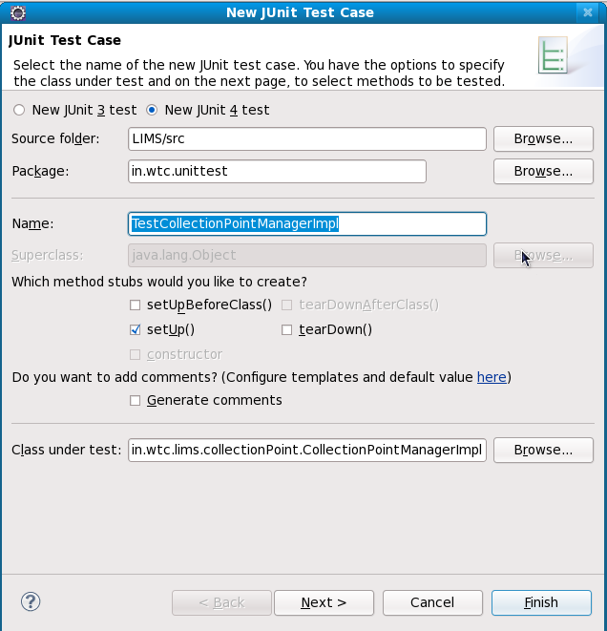
- Select the method and click on finish.
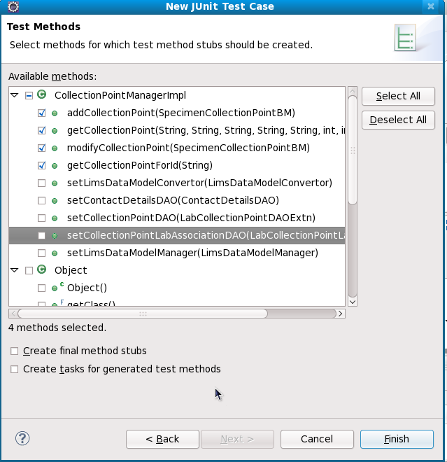

9 JUnit test case configuration

9.1 Steps
To run JUnit test case you need to configure setup() method in test file . In this setup method you need to write initialization code for Spring beans.
setup() method configuration For HaMSa:-
String ctxFileArr = {“applicationContext.xml”, ”applicationContextReport.xml”, ”HCISCoreContext.xml”, “LimsContext.xml”};
ApplicationContext ctx = new ClassPathXmlApplicationContext( ctxFileArr );
collectionPntMgr = (CollectionPointManager)ctx.getBean(“CollectionPointManager”);
In other method you need to write test code for which you want to test.

10 Run JUnit test case

10.1 Steps
- In package explorer right click on the junit test file and click on the Run As > JUnit test.

11 Debug HaMSa using JUnit test case

11.1 Steps
Put the break point where you want to debug and run JUnit test case in debug mode . (“Debug As > JUnit test.”)
When call will go to that point the excution of program will stop there. From there you can debug the HaMSa.
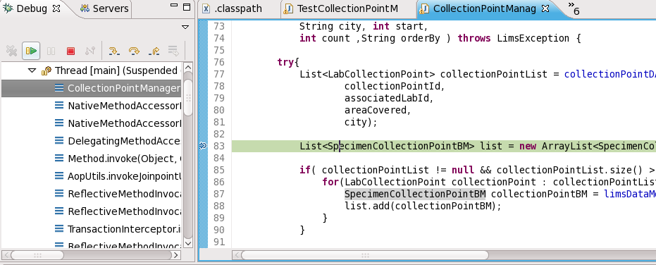
Keyboard shortcut while debugging the HaMSa:-
- Step over(F6):- Go to the next line.
- Step into(F5):- Go inside the method.
- Resume(F8):- Resume debugging upto the next break point.
- Stop(ctrl+F2):- Stop the debugging.

12 HaMSa Layers

12.1 GUI Layer(HamsaCoreUI)
GUI (usually pronounced GOO-ee) is a graphical (rather than purely textual) user interface to a computer. In this HaMSa product ExtJS is being used for GUI. All the GUI related code for HaMSa you can find in HamsaCoreUI/WebRoot/scripts/. If you want to extend HaMSa functionality then you need to add your GUI related code into this folder.

12.2 API Layer(HCISCore(Manager))
This layer is responsible to communicate with the GUI layer and Business layer. In this layer put only those method which you want expose to the GUI.

12.3 Business Layer(HCISCore(ManagerImpl))
Business layer is responsible for business logic. If you want to calculation or manipulation with the data or information then you can do in this layer. In this layer Business model is being used for transferring data or information from one place to another.
Business models are the group of data which will be transferred from one place to another. Every business model contains group of data that can be transferred from one place to another.

12.4 Data Access Layer(HCISCoreDA)
This layer is responsible to communicate with the database.Using this layer you can persist the data or information into the database OR you can retrieve the data or information from the database.
Data models are group of data that is directly mapped with database. It means you can easily map data model with the database. For persisting the data into the database or retrieving data from the database you need to use data models.

13 HaMSa Architecture

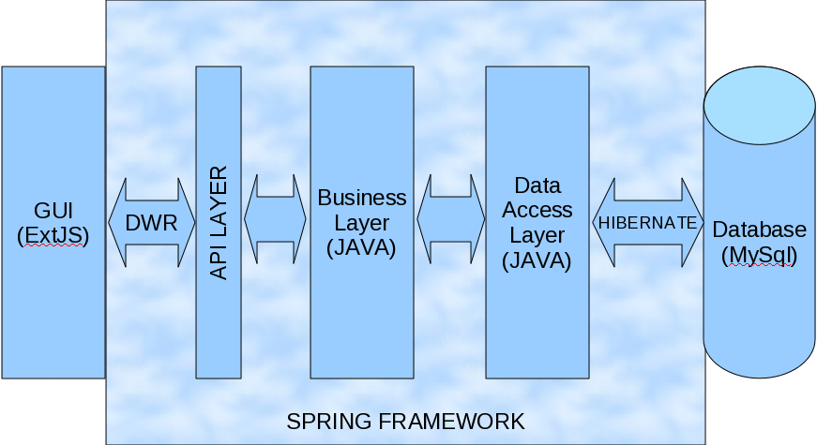

14 Example that explain what file needs to be where in HaMSa

For this example you need javascript and java files that you can get from the svn url http://192.168.1.50:8085/svn/wtchcis/trunk/cookbook/.

14.1 Configure GUI
- create folder named userRegistration in HamsaCoreUI/WebRoot/scripts/.
- Put Registration.js into HamsaCoreUI/WebRoot/scripts/ folder
- Configure Registration.js into index.jsp.
<script type=”text/javascript” src=”scripts/userRegistration/Registration.js”>

14.2 Configure API LAYER
- create package named userRegistration(or anything) in HamsaCore/src/in/wtc/hcis/bo
- Put UserRegistrationManager.java into HamsaCore/src/in/wtc/hcis/bo/userRegistration package

14.3 Configure Business Layer
- Put UserRegistrationManagerImpl .java into HamsaCore/src/in/wtc/hcis/bo/userRegistration package.
- Configure HCISCoreContext.xml
<bean id="RegistrationManager"
class="in.wtc.hcis.bo.userRegistration.UserRegistrationManagerImpl ">
<property name="userDAO">
<ref bean="UserDAO"/>
</property>
</bean>
- Put UserBM into HCISCoreModel /src/in/wtc/hcis/bm/base

14.4 Configure Business Layer
- Put UserRegistration.java and UserRegistrationDAO.java into HCISCoreDA/src/com/wtc/hcis/da.
- Configure TestMerOPIPapplicationContext.xml
<bean id=”UserRegistrationDAO”
class = “com.wtc.hcis.da.UserRegistrationDAO”>
<property name=”sessionFactory”>
<ref bean=”sessionfactory”>
</bean>

14.5 Tips and Tricks
- Constants should be in the ConstantManager files.
- Converter method should be in the Converter files.

14.6 Deploying new Report

15 Document History

15.1 Revision History

Date | Author | Version | Comment
10/06/2010 | Manish Indoriya | 0.1 | Initial Document

