**Good for beginners**

If you’re new to Flutter, we recommend starting with one of these codelabs:

**1.**[**Write your first Flutter app, part 1**](https://codelabs.developers.google.com/codelabs/first-flutter-app-pt1/)

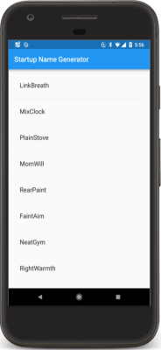 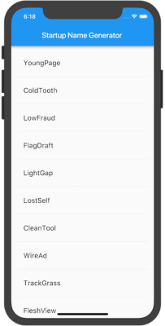

* Create a simple mobile app that generates proposed names for a startup company.
* In part one, you’ll use a package that returns pairs of words at random and inserts them into an infinite scrolling list.

**2.**[**Write Your First Flutter App, part 2**](https://codelabs.developers.google.com/codelabs/first-flutter-app-pt2/)

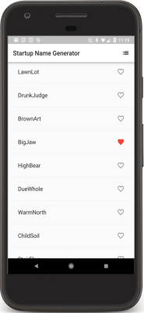 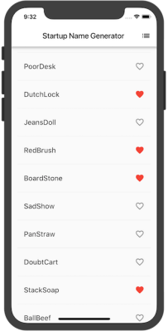

* Create a simple mobile app that generates proposed names for a startup company.
* In part two, you’ll extend the example from part 1 to allow the user to select favorite word pairs, and add a second “Saved Favorites” page where users can view the selected names.
* Finally, you’ll change the app’s theme color.

**3.**[**Write your first Flutter app on the web**](https://flutter.dev/docs/get-started/codelab-web)

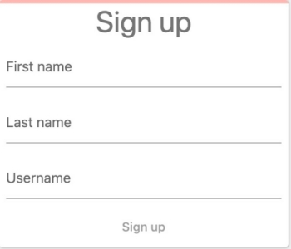

* Implement a simple web app in DartPad (no downloads required!) that displays a sign-in screen containing three text fields.
* As the user fills out the fields, a progress bar animates along the top of the sign-in area.
* This codelab is written specifically for the web, but if you have downloaded and configured Android and iOS tooling, the completed app works on Android and iOS devices, as well.

**4.**[**Building beautiful UIs with Flutter**](https://codelabs.developers.google.com/codelabs/flutter/)

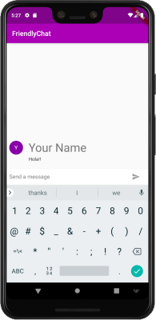 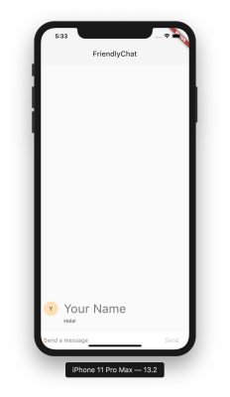

* A deeper “first dive” than “Write your first Flutter app.”
* Create a chat app that includes a simple animation, and customizes the UI for iOS and Android.
* As part of this codelab, learn how to use keyboard shortcuts in Android Studio.

**Designing a Flutter UI**

Learn about Material Design and basic Flutter concepts, like layout and animations:

**1.**[**Basic Flutter layout concepts**](https://flutter.dev/docs/codelabs/layout-basics)

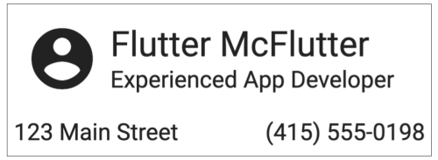

* Use DartPad in a browser (no downloads required!) to learn the basics of creating a Flutter layout.

**2.**[**Implicit animations**](https://flutter.dev/docs/codelabs/implicit-animations)

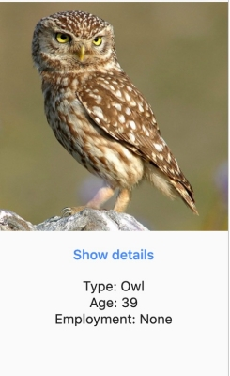 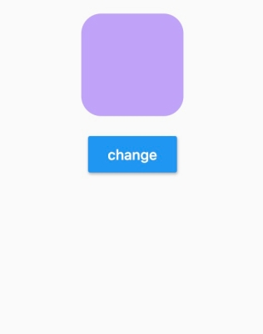

* Use DartPad (no downloads required!) to learn how to use implicit animations to add motion and create visual effects for the widgets in your UI.

**3.**[**Building Beautiful Transitions with Material Motion for Flutter**](https://codelabs.developers.google.com/codelabs/material-motion-flutter/)

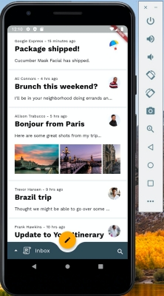 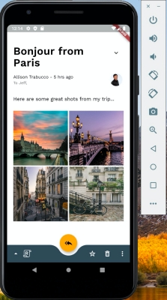

* Learn how to use the Material animations package to add pre-built transitions to a Material app called Reply.