NFL Database Documentation

1. Requirements
R1. The database must store information for all 32 NFL teams including team name, conference, division, and home stadium.
R2. The database must track player information including name, position, physical attributes, draft information, and current team assignment.
R3. The database must maintain coach information including name, position, head coach status, and team assignment.
R4. The database must store complete game schedules with season, week, date, time, teams, venue, and final scores.
R5. The database must record team statistics per season including offensive and defensive metrics (points, yards, turnovers).

2. Entity-Relationship (ER) Diagram

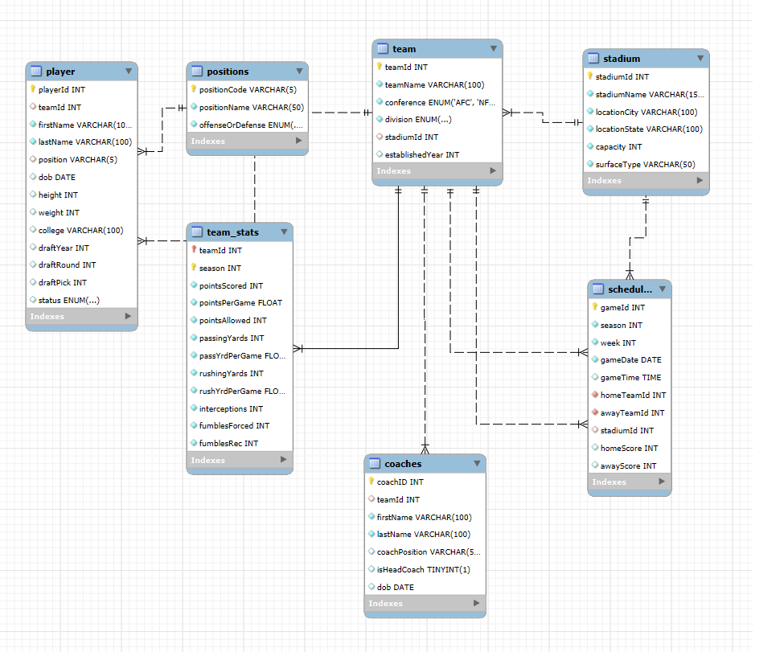3. Relational Schema

STADIUM
Column | Type | Constraints | Description
stadiumId | INT | PRIMARY KEY, AUTO_INCREMENT | Unique stadium identifier
stadiumName | VARCHAR(150) | NOT NULL | Name of the stadium
locationCity | VARCHAR(100) | NOT NULL | City where stadium is located
locationState | VARCHAR(100) | NOT NULL | State where stadium is located
capacity | INT | NOT NULL | Maximum seating capacity
surfaceType | VARCHAR(50) | NOT NULL | Playing surface type (grass/turf)

POSITIONS
Column | Type | Constraints | Description
positionCode | VARCHAR(5) | PRIMARY KEY | Abbreviation for position
positionName | VARCHAR(50) | NOT NULL | Full name of the position
offenseOrDefense | ENUM('Offense', 'Defense', 'Special') | NOT NULL | Category of position

TEAM
Column | Type | Constraints | Description
teamId | INT | PRIMARY KEY, AUTO_INCREMENT | Unique team identifier
teamName | VARCHAR(100) | NOT NULL, UNIQUE | Name of the team
conference | ENUM('AFC','NFC') | NOT NULL | Conference affiliation
division | ENUM('East','West','North','South') | NOT NULL | Division within conference
stadiumId | INT | FOREIGN KEY → stadium.stadiumId | Reference to home stadium
establishedYear | INT |  | Year team was established

PLAYER
Column | Type | Constraints | Description
playerId | INT | PRIMARY KEY, AUTO_INCREMENT | Unique player identifier
teamId | INT | FOREIGN KEY → team.teamId | Reference to player's team
firstName | VARCHAR(100) | NOT NULL | Player's first name
lastName | VARCHAR(100) | NOT NULL | Player's last name
position | VARCHAR(5) | FOREIGN KEY → positions.positionCode | Player's position
dob | DATE |  | Date of birth
height | INT |  | Height in inches
weight | INT |  | Weight in pounds
college | VARCHAR(100) |  | College attended
draftYear | INT |  | Year drafted
draftRound | INT |  | Draft round
draftPick | INT |  | Overall draft pick number
status | ENUM('Active','IR','Practice Squad') | DEFAULT 'Active' | Current player status

COACHES
Column | Type | Constraints | Description
coachID | INT | PRIMARY KEY, AUTO_INCREMENT | Unique coach identifier
teamId | INT | FOREIGN KEY → team.teamId | Reference to coach's team
firstName | VARCHAR(100) | NOT NULL | Coach's first name
lastName | VARCHAR(100) | NOT NULL | Coach's last name
coachPosition | VARCHAR(50) |  | Coaching position/title
isHeadCoach | BOOLEAN | DEFAULT 0 | Indicates if head coach
dob | DATE |  | Date of birth

SCHEDULES
Column | Type | Constraints | Description
gameId | INT | PRIMARY KEY, AUTO_INCREMENT | Unique game identifier
season | INT | NOT NULL | Season year
week | INT | NOT NULL | Week number in season
gameDate | DATE | NOT NULL | Date of the game
gameTime | TIME |  | Scheduled game time
homeTeamId | INT | NOT NULL, FOREIGN KEY → team.teamId | Home team reference
awayTeamId | INT | NOT NULL, FOREIGN KEY → team.teamId | Away team reference
stadiumId | INT | FOREIGN KEY → stadium.stadiumId | Stadium where game is played
homeScore | INT | DEFAULT 0 | Home team's score
awayScore | INT | DEFAULT 0 | Away team's score

TEAM_STATS
Column | Type | Constraints | Description
teamId | INT | PRIMARY KEY, FOREIGN KEY → team.teamId | Team reference
season | INT | PRIMARY KEY | Season year
pointsScored | INT | NOT NULL, DEFAULT 0 | Total points scored in season
pointsPerGame | FLOAT | NOT NULL, DEFAULT 0 | Average points per game
pointsAllowed | INT | NOT NULL, DEFAULT 0 | Total points allowed in season
passingYards | INT | NOT NULL, DEFAULT 0 | Total passing yards
passYrdPerGame | FLOAT | NOT NULL, DEFAULT 0 | Average passing yards per game
rushingYards | INT | NOT NULL, DEFAULT 0 | Total rushing yards
rushYrdPerGame | FLOAT | NOT NULL, DEFAULT 0 | Average rushing yards per game
interceptions | INT | NOT NULL, DEFAULT 0 | Total interceptions
fumblesForced | INT | NOT NULL, DEFAULT 0 | Total fumbles forced
fumblesRec | INT | NOT NULL, DEFAULT 0 | Total fumbles recovered

Foreign Key Relationships
• stadium.stadiumId ←── team.stadiumId
• stadium.stadiumId ←── schedules.stadiumId
• team.teamId ←── player.teamId
• team.teamId ←── coaches.teamId
• team.teamId ←── schedules.homeTeamId
• team.teamId ←── schedules.awayTeamId
• team.teamId ←── team_stats.teamId
• positions.positionCode ←── player.position

Primary Keys
• stadium: stadiumId
• positions: positionCode
• team: teamId
• player: playerId
• coaches: coachID
• schedules: gameId
• team_stats: (teamId, season) - Composite Primary Key

Unique Constraints
• team.teamName: UNIQUE (ensures no duplicate team names)

4. Normalization Evidence

Before Normalization (Unnormalized Table)
Consider a hypothetical unnormalized table that combines team, player, and coach information:
team_player_coach_unnormalized(
teamId, teamName, conference, division, stadiumName, stadiumCity,
playerId, playerFirstName, playerLastName, playerPosition,
coachId, coachFirstName, coachLastName, coachPosition
)

After Normalization (3NF)
The database is decomposed into separate normalized tables:
team(teamId, teamName, conference, division, stadiumId)
player(playerId, teamId, firstName, lastName, position)
coaches(coachID, teamId, firstName, lastName, coachPosition)

Explanation
The unnormalized table would store team information (teamName, conference, division, stadiumName, stadiumCity)
redundantly for every player and coach associated with that team. If a team has 50 players and 10 coaches,
the team information would be repeated 60 times, causing massive data redundancy and potential inconsistencies.
After normalization into separate tables, team information is stored once in the team table, and players and
coaches reference the team via foreign keys (teamId). This decomposition eliminates redundancy, ensures data
consistency (team name changes only need to be made in one place), reduces storage requirements, and maintains
referential integrity through foreign key constraints. The database now follows Third Normal Form (3NF), where
all non-key attributes depend only on the primary key, and there are no transitive dependencies.

5. NULL Policy
The following columns are allowed to be NULL for the following reasons:
• team.stadiumId: A team may not have a stadium assigned yet (e.g., expansion teams, relocating teams)
• player.teamId: Players may be free agents or unsigned, not currently on any team roster
• player.position: Undrafted or unsigned players may not have an assigned position yet
• player.dob, height, weight, college, draftYear, draftRound, draftPick: Personal and draft information may be unavailable for some players (e.g., international players, walk-ons)
• coaches.teamId: Coaches may be between teams or unemployed, not currently assigned to a team
• schedules.gameTime: Game time may be TBD (To Be Determined) when schedule is initially created

6. Index Rationale
Composite Index: schedules(season, week)
This composite index optimizes queries that retrieve all games for a specific season and week, which is a common
query pattern for displaying weekly schedules, game results, and standings.

