新A端插件整理

目录

1. Notify
2. Sweetalert
3. Modal
4. Animated
5. Loading_button
6. Select2
7. Ui-datepicker
8. 面包屑指令
9. 分页器pagination指令
10. notify

演示：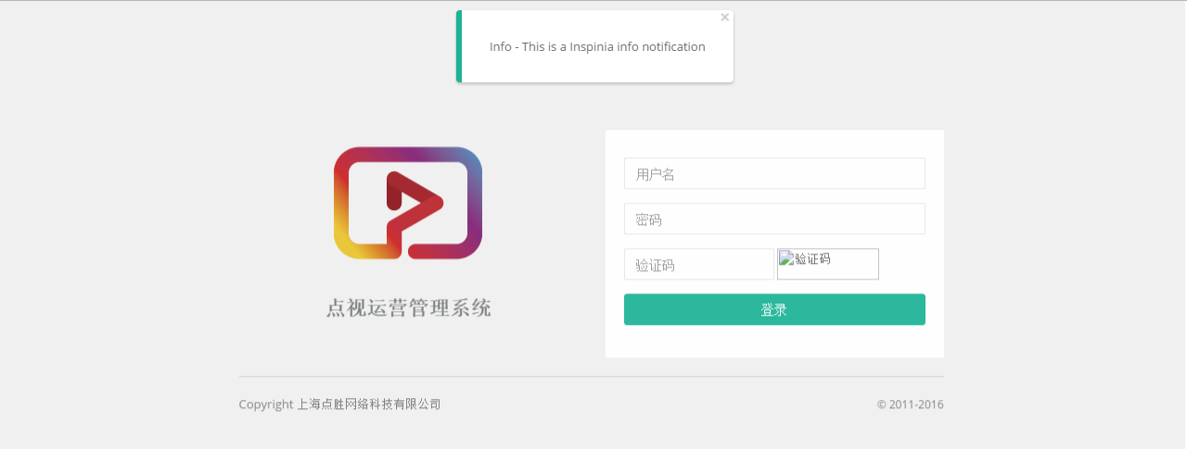

实现步骤：

1. 路由

resolve: {

loadPlugin: function ($ocLazyLoad) {

return $ocLazyLoad.load([

{

name: 'cgNotify',

files: ['css/plugins/angular-notify/angular-notify.min.css','js/plugins/angular-notify/angular-notify.min.js']

},

{

name: 'DsAdmin',

insertBefore: '#ng_load_plugins_before',

files: [

'js/controller/login.js'

]

}

]);

}

}

1. 注入

DsAdmin.controller('login', function($scope, $http, $cookies, DSHttpService,notify) {

//注入了notify

1. 实现代码

$scope.inspiniaTemplate = '../../views/common/notify.html';

$scope.inspiniaDemo1 = function(){

notify({ message: 'Info - This is a Inspinia info notification', classes: 'alert-info', templateUrl: $scope.inspiniaTemplate});

}

1. sweetalert

演示：

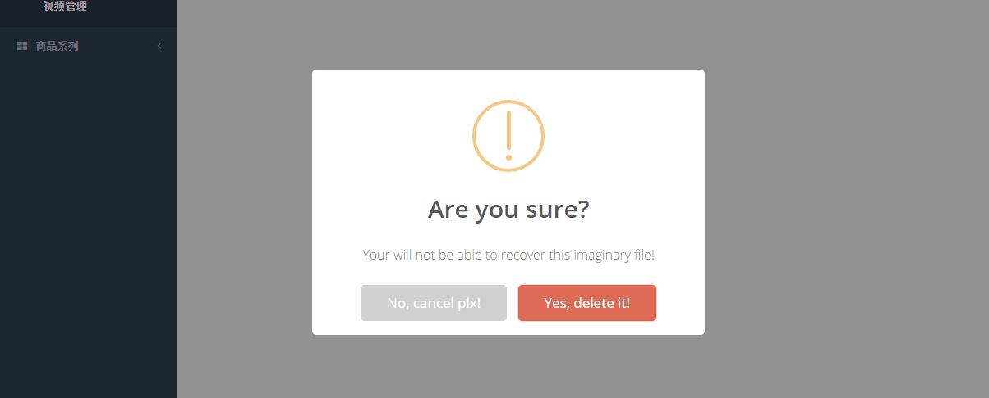

实现步骤：

1. 路由

resolve: {

loadPlugin: function ($ocLazyLoad) {

return $ocLazyLoad.load([

{

files: ['js/plugins/sweetalert/sweetalert.min.js', 'css/plugins/sweetalert/sweetalert.css']

},

{

name: 'oitozero.ngSweetAlert',

files: ['js/plugins/sweetalert/angular-sweetalert.min.js']

},

{

name: 'DsAdmin',

insertBefore: '#ng_load_plugins_before',

files: [

'js/controller/videoControl.js'

]

}

]);

}

}

1. 注入

DsAdmin.controller('videoControl', function($scope, $http, $cookies, DSHttpService,SweetAlert) {

//注入了SweetAlert

//factory函数封装在了service.js里，切勿修改

1. 实现代码

$scope.demo1 = function() {

SweetAlert.swal({

title: "Welcome in Alerts",

text: "Lorem Ipsum is simply dummy text of the printing and typesetting industry."

});

}

$scope.demo2 = function() {

SweetAlert.swal({

title: "Good job!",

text: "You clicked the button!",

type: "success"

});

}

$scope.demo3 = function() {

SweetAlert.swal({

title: "Are you sure?",

text: "Your will not be able to recover this imaginary file!",

type: "warning",

showCancelButton: true,

confirmButtonColor: "#DD6B55",

confirmButtonText: "Yes, delete it!",

closeOnConfirm: false,

closeOnCancel: false

},

function() {

SweetAlert.swal("Ok!");

});

}

$scope.demo4 = function() {

SweetAlert.swal({

title: "Are you sure?",

text: "Your will not be able to recover this imaginary file!",

type: "warning",

showCancelButton: true,

confirmButtonColor: "#DD6B55",

confirmButtonText: "Yes, delete it!",

cancelButtonText: "No, cancel plx!",

closeOnConfirm: false,

closeOnCancel: false

},

function(isConfirm) {

if (isConfirm) {

SweetAlert.swal("Deleted!", "Your imaginary file has been deleted.", "success");

} else {

SweetAlert.swal("Cancelled", "Your imaginary file is safe :)", "error");

}

});

}

1. Modal

演示：

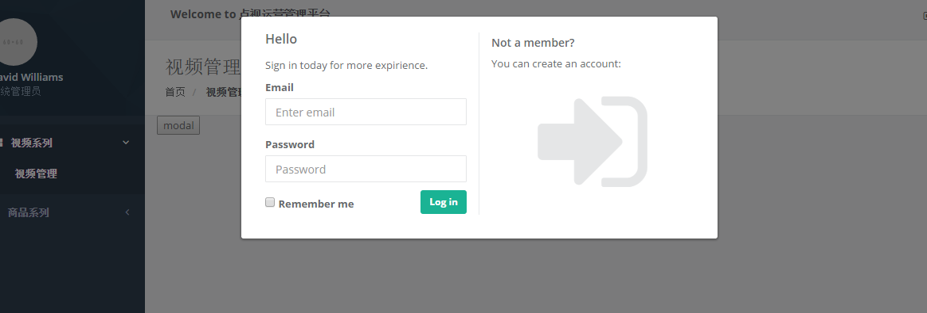

实现步骤：

1. 注入

DsAdmin.controller('videoControl', function($scope, $http, $cookies, DSHttpService,SweetAlert,$uibModal) {

//注入$uibModal

1. 实现代码

$scope.open = function () {

var modalInstance = $uibModal.open({

templateUrl: 'views/modal_example.html',

controller: ModalInstanceCtrl

});

};

//需要定义模板的url地址，包括该modal的controller

// ModalInstanceCtrl该函数封装在controller.js里

1. Animated
2. 实现代码：

<div class="row animated fadeInRight">

<div class="col-sm-12">

<button ng-click="open()">modal</button>

</div>

</div>

1. loading_button

演示：

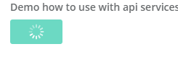

实现步骤：

1. 路由

resolve: {

loadPlugin: function ($ocLazyLoad) {

return $ocLazyLoad.load([

{

serie: true,

name: 'angular-ladda',

files: ['js/plugins/ladda/spin.min.js', 'js/plugins/ladda/ladda.min.js', 'css/plugins/ladda/ladda-themeless.min.css','js/plugins/ladda/angular-ladda.min.js']

}

]);

}

}

1. 注入

无

1. 实现代码

//html

<button ladda="loadingDemo" ng-click="runLoadingDemo()" class="ladda-button ladda-button-demo btn btn-primary" data-style="zoom-in">Submit</button>

//js

$scope.runLoadingDemo = function() {

// start loading

$scope.loadingDemo = true;

$timeout(function(){

// Simulate some service and stop loading

$scope.loadingDemo = false;

},2000)

};

1. Select2

引用：https://github.com/angular-ui/ui-select

演示：

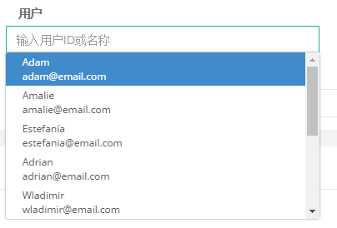

HTML：

<ui-select **user-select** ng-model="person.selected" theme="bootstrap">

<ui-select-match placeholder="输入用户ID或名称">{{$select.selected.name}}</ui-select-match>

<ui-select-choices repeat="item in people | filter: $select.search">

<div ng-bind-html="item.name | highlight: $select.search"></div>

<small ng-bind-html="item.email | highlight: $select.search"></small>

</ui-select-choices>

</ui-select>

JS：

//用户

$scope.person = {};

$scope.people = [

{ name: 'Adam', email: 'adam@email.com', age: 12, country: 'United States' },

{ name: 'Amalie', email: 'amalie@email.com', age: 12, country: 'Argentina' },

{ name: 'Estefanía', email: 'estefania@email.com', age: 21, country: 'Argentina' },

{ name: 'Adrian', email: 'adrian@email.com', age: 21, country: 'Ecuador' },

{ name: 'Wladimir', email: 'wladimir@email.com', age: 30, country: 'Ecuador' },

{ name: 'Samantha', email: 'samantha@email.com', age: 30, country: 'United States' },

{ name: 'Nicole', email: 'nicole@email.com', age: 43, country: 'Colombia' },

{ name: 'Natasha', email: 'natasha@email.com', age: 54, country: 'Ecuador' },

{ name: 'Michael', email: 'michael@email.com', age: 15, country: 'Colombia' },

{ name: 'Nicolás', email: 'nicolas@email.com', age: 43, country: 'Colombia' }

];

为了监听输入事件并发送请求获取推荐，需要额外加一个directive，名为user-select，红色标注：

//用户输入监听

.directive('userSelect', function($rootScope, DSHttpService, commonjs) {

return {

require: 'uiSelect',

link: function(scope, element, attrs, $select) {

scope.$watch('$select.search',function(newVal,oldVal){

if(newVal != oldVal){

console.log(scope.$parent);

var promise = DSHttpService.httpPost("http://www.click-v.com/s",newVal);

}

})

}

};

});

演示：

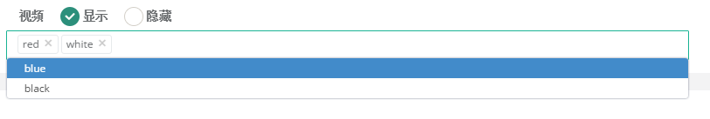

HTML：

<ui-select multiple ng-model="answer.colors" theme="bootstrap" ng-disabled="disabled" width="100%">

<ui-select-match placeholder="输入视频ID或名称">{{$item.color}}</ui-select-match>

<ui-select-choices repeat="color in availableColors | filter:$select.search">

{{color.color}}

</ui-select-choices>

</ui-select>

JS：

//批量

$scope.availableColors = [

{ "color": "red", "id": "1" },

{ "color": "blue", "id": "2" },

{ "color": "white", "id": "3" },

{ "color": "black", "id": "4" }

];

$scope.answer = {};

$scope.answer.colors = [];

$scope.$watch('answer.colors', function(newVal, oldVal) {

console.log(newVal)

});

1. ui-datepicker

引用：<https://github.com/g00fy-/angular-datepicker>

演示：

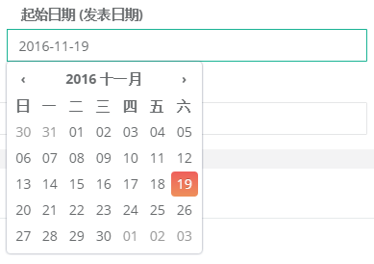

HTML：

<input type="datetime" class="form-control" placeholder="请选择发表起始日期" date-time ng-model="startDate" view="date" auto-close="true" min-view="date" format="YYYY-MM-DD">

1. 面包屑

演示：



HTML：

<div class="row wrapper border-bottom white-bg page-heading ng-scope">

<bread-crumb my-title="{{breadCrumb}}" my-bread="bread"></bread-crumb>

</div>

JS：

//面包屑设置层级

$scope.breadCrumb = '评论审核';

$scope.bread = [

{ 'title': '首页' },

{ 'title': '互动管理' }

];

1. 面包屑pagination指令

演示：

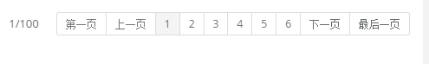

HTML：

<pagination page-info="page"></pagination>

JS：

//分页器

$scope.page = {

totalItems: 10000, //总条数

currentPage: 1, //当前页数

maxSize: 6, //显示的页码数量

perPage: 100, //一页显示多少个

pageChange: function(){ //页码改变后的回调

console.log(this.currentPage)

}

};

//监听页码，执行

$scope.$watch('page.currentPage',function(newVal,oldVal){

//console.log(newVal)

});