Name: Sydney Walker Period: 9 APCS Java CRUD Run-through

1st Run Through of CRUD

run:

0: Exit

1: Read in Data From File

2: Display List to the Console

3: Sort List

4: Edit a College

5: Delete a College

6: Add a College

7: Save Your List

1

0: Exit

1: Read in Data From File

2: Display List to the Console

3: Sort List

4: Edit a College

5: Delete a College

6: Add a College

7: Save Your List

2

Name Region Average GPA Average SAT Number Students Rating

MIT City 4.13 1520 11367 7

SUNY Buffalo City 3.5 1420 15000 50

WPI City 3.84 1370 4432 61

SUNY Binghampton City 3.4 1450 18000 200

Genesco Rural 3.9 1480 13000 55

0: Exit

1: Read in Data From File

2: Display List to the Console

3: Sort List

4: Edit a College

5: Delete a College

6: Add a College

7: Save Your List

5

Which college do you want to delete?

0: MIT

1: SUNY Buffalo

2: WPI

3: SUNY Binghampton

4: Genesco

3

0: Exit

1: Read in Data From File

2: Display List to the Console

3: Sort List

4: Edit a College

5: Delete a College

6: Add a College

7: Save Your List

4

Which college do you want to edit?

0: MIT

1: SUNY Buffalo

2: WPI

3: Genesco

0

Which aspect do you want to edit?

1: Name

2: Region

3: Average GPA

4: Average SAT Score

5: Number of Students

6: Rating

3

What is the new average GPA?

4.2

0: Exit

1: Read in Data From File

2: Display List to the Console

3: Sort List

4: Edit a College

5: Delete a College

6: Add a College

7: Save Your List

6

What is the new name?

Brown

What is the new region?

City

What is the new average GPA?

3.98

What is the new average SAT?

1530

What is the new number of students?

1200

What is the new rating?

5

0: Exit

1: Read in Data From File

2: Display List to the Console

3: Sort List

4: Edit a College

5: Delete a College

6: Add a College

7: Save Your List

3

0: Exit

1: Read in Data From File

2: Display List to the Console

3: Sort List

4: Edit a College

5: Delete a College

6: Add a College

7: Save Your List

7

0: Exit

1: Read in Data From File

2: Display List to the Console

3: Sort List

4: Edit a College

5: Delete a College

6: Add a College

7: Save Your List

2

Name Region Average GPA Average SAT Number Students Rating

Brown City 3.98 1530 1200 5

MIT City 4.2 1520 11367 7

SUNY Buffalo City 3.5 1420 15000 50

Genesco Rural 3.9 1480 13000 55

WPI City 3.84 1370 4432 61

0: Exit

1: Read in Data From File

2: Display List to the Console

3: Sort List

4: Edit a College

5: Delete a College

6: Add a College

7: Save Your List

0

BUILD SUCCESSFUL (total time: 3 minutes 20 seconds)

2nd Run Through of CRUD

0: Exit

1: Read in Data From File

2: Display List to the Console

3: Sort List

4: Edit a College

5: Delete a College

6: Add a College

7: Save Your List

1

0: Exit

1: Read in Data From File

2: Display List to the Console

3: Sort List

4: Edit a College

5: Delete a College

6: Add a College

7: Save Your List

2

Name Region Average GPA Average SAT Number Students Rating

Brown City 3.98 1530 1200 5

MIT City 4.2 1520 11367 7

SUNY Buffalo City 3.5 1420 15000 50

Genesco Rural 3.9 1480 13000 55

WPI City 3.84 1370 4432 61

0: Exit

1: Read in Data From File

2: Display List to the Console

3: Sort List

4: Edit a College

5: Delete a College

6: Add a College

7: Save Your List

0

Do you want to save first?

0 = Yes, Please Save My List.

1 = No, Leave Anyways.

0

BUILD SUCCESSFUL (total time: 8 seconds)

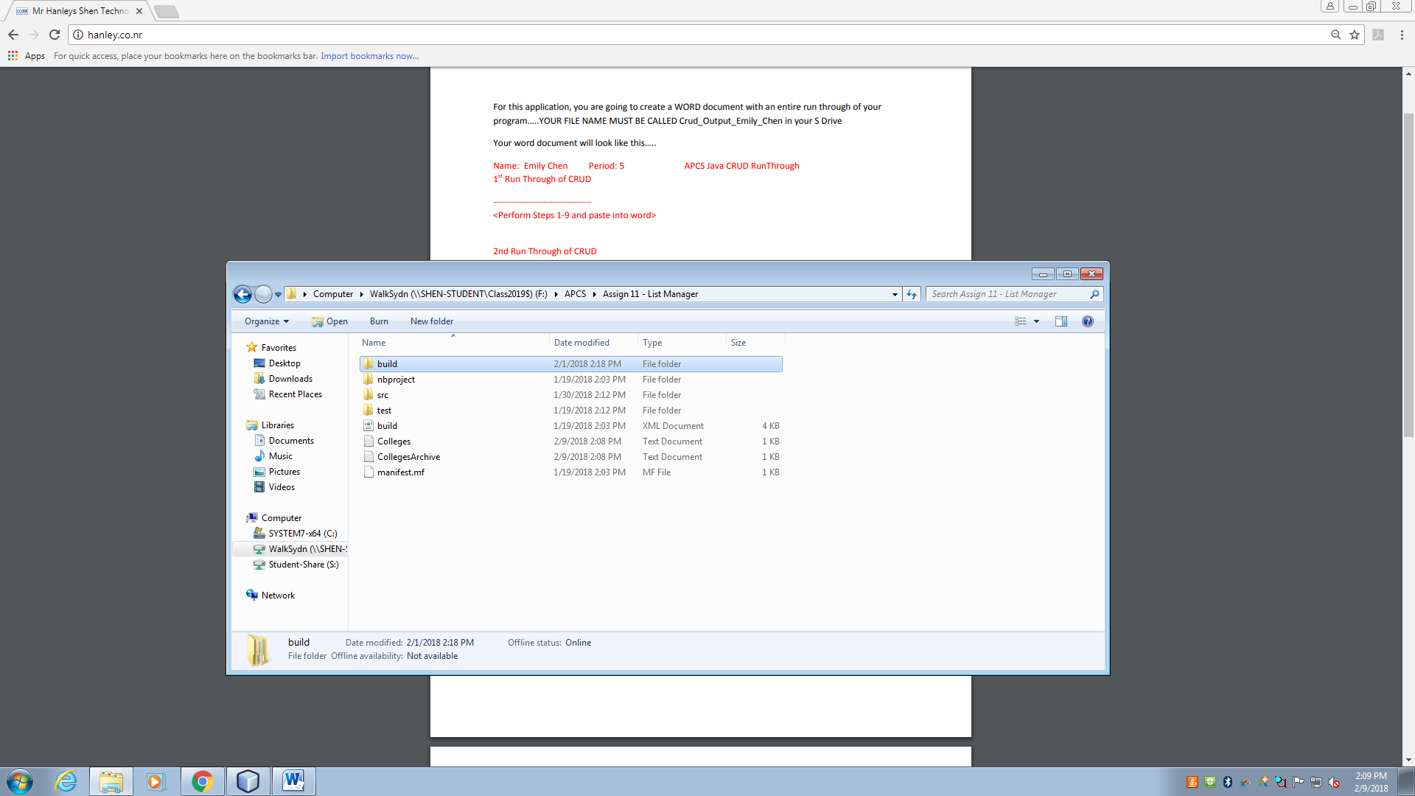

//reads from Colleges.txt and puts those colleges into the list

static private void readFromFile() {

File f = new File("Colleges.txt"); //create and initialize a File

Scanner fileInput = null; //create a Scanner

try {

fileInput = new Scanner(f); //set path of Scanner to the file

} catch (FileNotFoundException e) {

System.out.println(e.toString());

}

while (fileInput.hasNext()) { //check that there is another line in the file

String temp = fileInput.nextLine(); //get next line of file

String[] in = temp.split(";"); //split the file into needed parts

//create a college based off of data gotten from file

colleges.add(new College(in[0], in[1], Double.parseDouble(in[2]), Integer.parseInt(in[3]), Integer.parseInt(in[4]), Integer.parseInt(in[5])));

}

}