Do Historically Cyclical Stocks Tend to Perform Better Overnight, and, if so, is This Relationship Further Correlated with Beta? An Exploratory Study of the Borders of Financial Knowledge

Introduction
Stock returns often present themselves as relatively simple conclusions, viewed as a single day-by-day endpoint. A great deal of tangible empirical evidence supports this, and, for most investors, this school of thought will suffice if long term capital appreciation is desired. For instance, if a stock opened at $100 and closed at $103, it returned 3%. The calculation is transparent, objective, and easy to verify. However, I recently stumbled upon a post on social media explaining that if an investor only held Micron stock during overnight hours, then they would accrue an enormous return far outpacing the traditional buy and hold rhetoric of investing. Micron has undoubtedly had an incredible run in the past year (at the time of writing), regardless if held perpetually or merely overnight. As such, the online post sparked an intriguing thought experiment on the behavior and dynamics of market sessions, which blurred the lines for me as a young investor between the outwardly lucid aforementioned endpoint of stock returns and potentially poignant nuances.
Beginning this project with the aspiration to improve my knowledge of financial markets and economic patterns, I wanted to investigate if stocks with greater cyclicality, such as Micron, tend to perform better overnight than during regular trading hours. Simply put, do stocks that exhibit movement in tandem with broader business and market cycles typically perform better after the New York session? I also wanted to explore if this relationship is additionally or conversely associated with a greater beta, or price volatility and systematic risk relative to the broader market (the S&P 500 for the purposes of this essay). While analyzing the data, this project evolved beyond a static assessment of market returns into more of an exercise on how we think about evidence itself: how we as investors recognize patterns, how we form hypotheses from those patterns, how we interpret real-world results, how we decipher and react to these results, and, perhaps most importantly, how much we are entitled to conclude from them. These questions sit as much in the realm of philosophy as they do in finance and catalyzed my interest in their interplay.
Method
As aforementioned, my initial hypothesis was relatively straightforward: do stocks exhibiting greater cyclicality tend to have stronger overnight returns relative to daytime returns, and is this relationship correlated with beta? I was particularly interested in the distinction between the two periods. While the New York session is open for only part of each day, it is largely the benchmark for all economic investigation and scrutiny. Contrastingly, information continues to arrive after the closing bell from a myriad of sources including earnings reports, corporate announcements, international markets, economic data, real-world events, and other drivers which influence the behavior of the entire market. Thus, I pondered if companies whose businesses are more sensitive to economic conditions, or whose stocks are more sensitive to the broader market, might experience salutary price movement after hours.
To illuminate this, I chose ten companies that I believe span a wide range of cyclicality, beta, and market sectors. I started with Micron (MU), as it was the impetus for this experiment, and concurrently a highly cyclical stock. I then moved to NVIDIA (NVDA), a titan of the historically cyclical semiconductor industry. Moving down the line, I picked Ford (F), Caterpillar (CAT), Exxon Mobil (XOM), JPMorgan Chase (JPM), Apple (AAPL), Microsoft (MSFT), Walmart (WMT), and Coca-Cola (KO). This sample of ten companies intended to encompass a spectrum ranging from most cyclical (MU) to least (KO), as Coca-Cola stock characterized by stable demand and low volatility, also belonging to the defensive consumer staples sector (Table 1).
Table 1. Overview of selected companies including sector and expected cyclicality for future reference
Company | Ticker | Sector | Expected cyclicality
Micron | MU | Semiconductors | Very high
NVIDIA | NVDA | Semiconductors | High
Ford | F | Automobiles | High
Caterpillar | CAT | Industrials | High
Exxon Mobil | XOM | Energy | High
JPMorgan Chase | JPM | Financials | Moderate-high
Apple | AAPL | Technology | Moderate
Microsoft | MSFT | Technology | Low-moderate
Walmart | WMT | Consumer Staples | Low
Coca-Cola | KO | Consumer Staples | Low

I assigned each company a “Cyclicality Score” ranging from 1-5 based on historical financial performance and my knowledge of stock behavior. It is important to note that these scores were assigned qualitatively rather than estimated from a more definitive or formal source, and as such the cyclicality results ought to be viewed from an exploratory lens. I collected daily stock data from a period spanning five years: January 4, 2021, through December 31, 2025, using Yahoo Finance. Returns were calculated in two ways. For the cyclicality correlation test, unadjusted opening and closing prices for each day were gathered. For the beta correlation test, adjusted closing prices for each day were gathered. This was done because cyclicality and beta measure two markedly different principles. For cyclicality, I wanted to capture the actual unadjusted price movement that occurred between sessions as well as the daily return. To do so, I used raw, unadjusted prices, where R is equal to return:
R_{overnight} = Open_{t} / Close_{t-1} -1
R_{daytime} = Close_{t} / Open_{t} -1
R_{stpck,t} = Close_{t} / Close_{t-1} -1
I then found the night-day difference by subtracting the percent overnight return by its daytime counterpart. For beta, I needed to stratify how sensitive a stock’s overall daily return was relative to the S&P 500, so adjusted data was used that accounts for stock splits and dividends, which would otherwise distort the return between two closing prices:
R_{stpck,t} = AdjClose_{t} / Adj Close_{t-1} -1
To actually measure cyclicality and beta, I created a “Company Summary” tab, which can be found in the spreadsheet attached at the bottom of the essay. Calculations for beta were done in the “Beta” tab and linked to “Company Summary”. For cyclicality, I included the measures of average overnight return, average daytime return, and average night-day difference. For beta, I included the S&P 500’s adjusted close over the same five year window, and used Excel’s SLOPE function to calculate each company’s beta relative to the S&P 500:
=SLOPE(return_range, SPY_return_range)
Conceptually, this estimates the following:
R_{stock,t} = α + βR_{SPY,t} + ε_{t}
Where β represents the stock’s historical sensitivity to movement in SPY.
I independently checked each company’s results using the COVARIANCE.S formula, which utilizes:
β = Cov(R_{stock}, R_{SPY}) / Var(R_{SPY})
All preliminary calculations were outlined and documented (Table 2).

Table 2. Cyclicality score, beta, and average returns over five years for the ten companies studied
Ticker | Cyclicality | Beta | Avg Daily Return | Avg Overnight Return | Avg Daytime Return | Avg Night-day Difference
MU | 5 | 1.773 | 0.154% | 0.120% | 0.035% | 0.085%
NVDA | 4 | 2.165 | 0.265% | 0.168% | 0.100% | 0.068%
F | 4 | 1.233 | 0.066% | 0.006% | 0.057% | -0.051%
CAT | 4 | 0.980 | 0.108% | 0.059% | 0.049% | 0.011%
XOM | 4 | 0.541 | 0.100% | 0.037% | 0.063% | -0.026%
JPM | 3 | 0.894 | 0.087% | 0.028% | 0.059% | -0.031%
AAPL | 3 | 1.244 | 0.075% | -0.035% | 0.111% | -0.145%
MSFT | 2 | 1.154 | 0.077% | 0.040% | 0.038% | 0.001%
WMT | 1 | 0.457 | 0.074% | 0.008% | 0.067% | -0.059%
KO | 1 | 0.322 | 0.027% | 0.026% | 0.002% | 0.024%

Thereafter, I leveraged Excel’s CORREL function to calculate the Pearson correlation between the given cyclicality and each return measure (using unadjusted):
=CORREL(cyclicality_range, overnight_return_range)
=CORREL(cyclicality_range, daytime_return_range)
=CORREL(cyclicality_range, night_day_difference_range)
After calculating beta for each company, I used the CORREL function again in the Company Summary tab to test beta against each of the three average return measures:
=CORREL(beta_range, overnight_return_range)
=CORREL(beta_range, daytime_return_range)
=CORREL(beta_range, night_day_difference_range)
Results
The results demonstrated some support for my hypothesis (Table 3).
Table 3. Pearson correlation values for both cyclicality and beta calculated from the ten companies studied
Variable | Avg Overnight | Avg Daytime | Avg Night-day difference
Cyclicality | 0.495 | 0.271 | 0.308
Beta | 0.687 | 0.439 | 0.399

The strongest relationship I found was between beta and average overnight return, with a correlation of r = 0.687. When compared to the daytime average returns, the correlation was noticeably weaker at r = 0.439. Beta’s correlation with respect to night-day difference was r = 0.399. Cyclicality demonstrated a similar shape, though the relationship was weaker overall: r = 0.495 between cyclicality and average overnight return, r = 0.271 between cyclicality and average daytime return, and r = 0.308 between cyclicality and the night-day difference (Figure 1).
Figure 1. Correlation between company cyclicality and overnight-daytime return difference
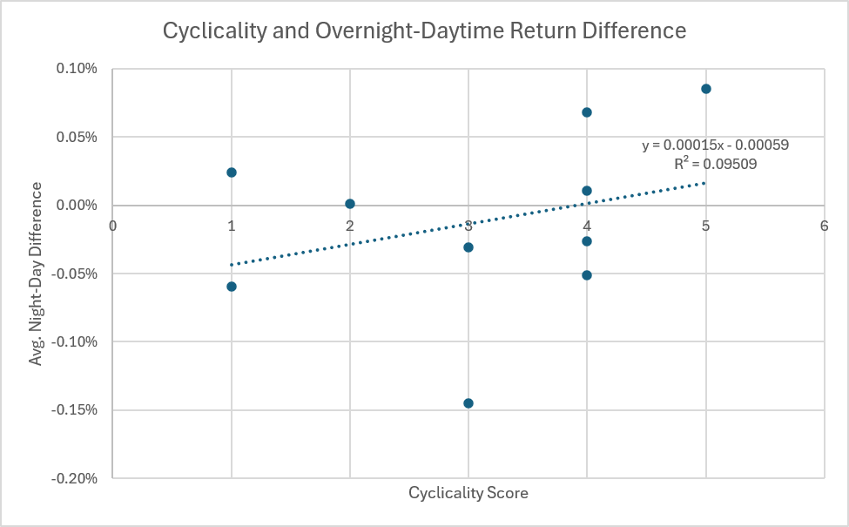

To look at the results from another quantifiable angle, I decided to run a simple hypothetical investment experiment. I proposed assessing what would happen given a $10,000 investment into each of the 10 companies at the inception of the study period, which followed the original logic of the social media post highlighting Micron. I compounded the historical returns using adjusted opening and close data from January 2021-December 2025. I considered three approaches: holding the stock overnight only, holding it during New York trading hours only, and holding it continuously across the entire period. For each approach the end value was calculated in Excel using the PRODUCT function:
=10000*PRODUCT(1+return_range)
This encompasses the compounded return of each stock as follows, and does not account for transaction costs, taxes, bid-ask spreads, or other considerations:
End Value = $10000×\prod_{t=1}^{T}{\left(1+R_{t}\right)}$
The results of this experiment yielded varying returns (Table 4). On its surface, the ending values after five years offered additional evidence consistent with the hypothesis that holding during overnight hours only is a superior strategy for companies with a higher beta.
Table 4. Growth of hypothetical $10,000 investment after 5 years under different scenarios and holding conditions, January 2021-December 2025
Ticker | Starting Investment | Overnight Ending Value | Daytime Ending Value | Total Ending Value
MU | $10,000 | $36,189 | $10,569 | $39,503
NVDA | $10,000 | $63,692 | $22,410 | $142,626
F | $10,000 | $12,596 | $16,228 | $21,136
CAT | $10,000 | $21,503 | $16,233 | $35,069
XOM | $10,000 | $18,201 | $20,048 | $36,445
JPM | $10,000 | $15,357 | $19,129 | $29,756
AAPL | $10,000 | $6,184 | $34,066 | $21,735
MSFT | $10,000 | $16,002 | $14,368 | $23,502
WMT | $10,000 | $11,313 | $22,114 | $24,637
KO | $10,000 | $15,791 | $9,631 | $15,644

For Micron, the theory held true that investing overnight only would have far exceeded only holding intraday, as an investor would have hypothetically earned $36,189 overnight versus only $10,569 during daytime hours only. NVIDIA buttressed this logic, with an overnight trading strategy yielding $63,692 compared to a daytime value of $22,410. The blatant blight to the hypothesis, as shown by the investment outputs, is Apple. An overnight-only strategy would have lost money, resulting in $6,184 after five years. This directly contrasts with a daytime-only strategy, which would have grown to $34,066. Apple also has a beta above one, meaning that this result is difficult to reconcile with any simple argument for “high beta stocks perform better overnight”. As such, this contradiction is one of the most intriguing findings of this project. Overall, the pattern from the data was, therefore, relatively consistent with my original hypothesis, as the companies within this sample that illustrated historically higher cyclicality also showed a weak-moderate correlation with higher overnight returns, with a higher beta slightly bolstering this trend. The key differentiator, however, was that this data did not exemplify whether higher beta causes higher overnight returns. While the data told me that the hand-picked list of companies coupled with a five-year time period translated that the two variables, cyclicality and higher overnight returns, moved together, it did not tell me that the relationship would hold for every company, or that these ten companies would exhibit the same behavior in a different period. The distinction between what a correlation shows and what it appears to promise then became an interesting discussion point of this project for me.
Discussion
In closing, I was able to espouse a couple takeaways that I believe align with some theories established by great thinkers of the past and can be translated into the context of this analysis. First, Hume’s problem of induction was a notable caveat in the back of my mind when working on this project, and I think is an important argument for any investor attempting to test the waters of the future. Hume argued, in brief, that we cannot prove that the future will follow past trends, insofar as inductive reasoning lacks a rational foundation through two main limits. First, there is no strict logic, or deduction, to prove that the past will uniformly inform the future because it is always possible to change. Second, trying to prove induction by arguing that “X worked in the past, therefore it will work in the future” creates a circular reasoning fallacy, as doing so would be using induction prove induction. I believe Hume’s problem is especially pertinent in finance, as the unpredictability and ubiquitous layers and sensitivities of markets make it nearly impossible to form one unified, unfailing investment strategy that is profitable (other than perhaps buying and holding a major index such as the S&P 500). The second theory I would like to conjure is Popper’s falsifiability, whereas a hypothesis is scientific only if it is capable of being disproven by an empirical observation. Thus, a hypothesis stands not by the number of times it is proven true, but rather by the lack of success from genuine attempts at falsifying it. My initial proposition that higher cyclical stocks would perform better overnight hinted towards having some legitimacy, yet was ultimately provided an important counterexample by Apple’s results, and is a reminder of how a single example can strain a general claim.
This project began as what I unwittingly deemed to be a relatively simple financial question. After delving into the data and interpreting its results, however, I learned that testing any financial hypothesis is incredibly intricate and nuanced, even with a smaller sample size, and no matter how straightforward. While the results of calculating financial data: returns, beta, correlation coefficients, et cetera can be precise, even to several decimal points, precision itself is by no means a substitute for certainty. On top of this, I took away that correlation describes a relationship but does not truly explain it. This is what interests me about economics; its complexity is often never able to be wholly explained. It feels humbling, and simultaneously enlightening to know that some questions we may never fully understand, yet endeavoring to learn merely a little more about them can provide fruitful knowledge. Further, I feel this concept can be applied to a myriad of facets in life itself. While we will never be able to explain or decipher the many mysteries of our lives, interactions, thoughts, and even existence, attempting to rectify them surely does not shirk our contributions to humanity.

