數位影像處理：Kawahera濾波器實作

01157026馮宥崴

**實習內容：**

1. 了解Kawahera濾波器的原理
2. 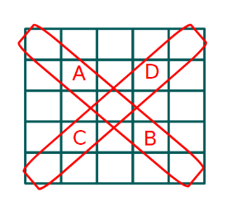使用以下鄰近區域定義實作Kawahera濾波器

**實習目標：**

* 熟悉Kawahera濾波器的操作

**實習步驟：**

1. 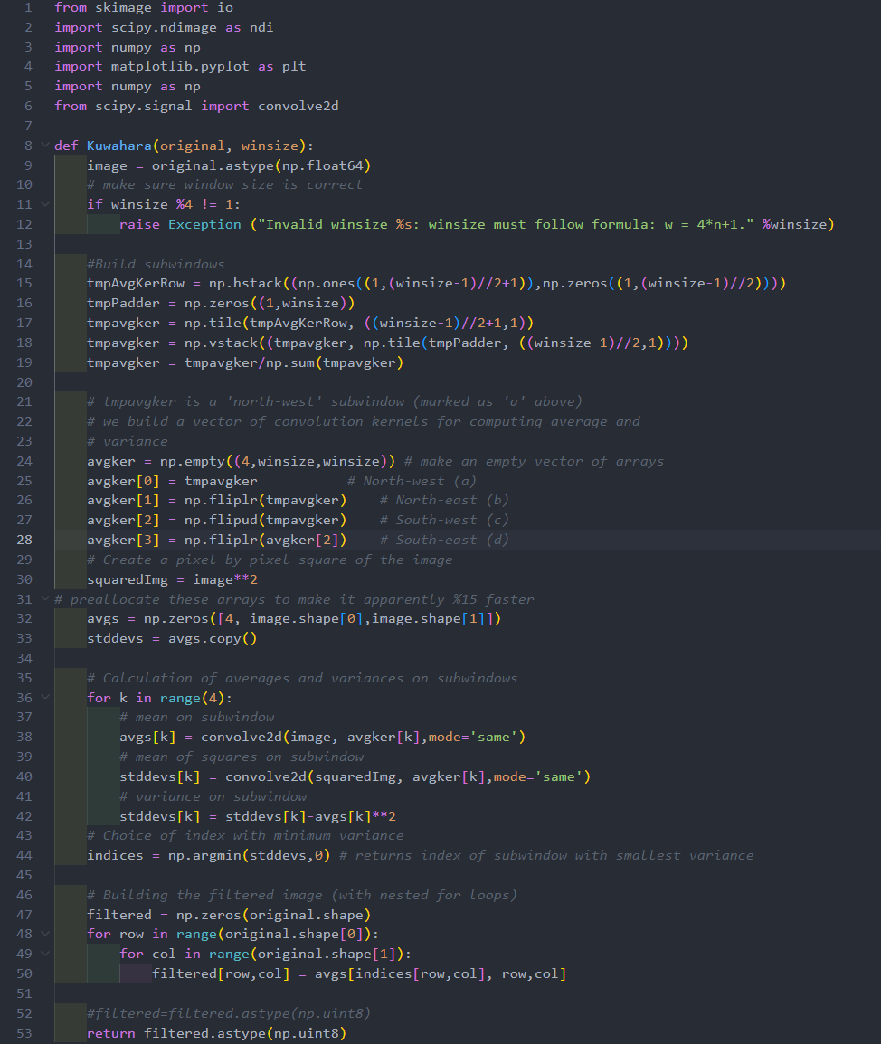詳讀Kawahera濾波器的程式碼，並了解其原理
2. 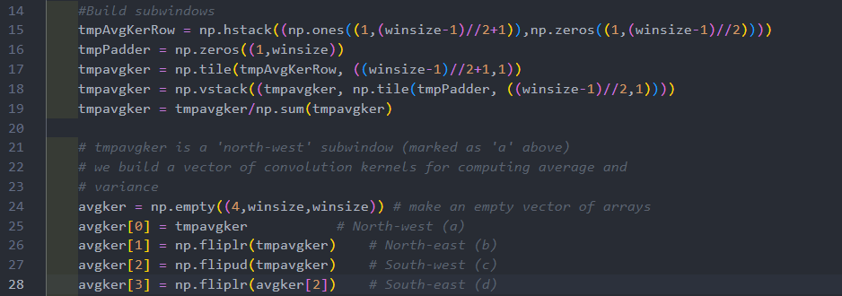透過閱讀程式碼，我們可以瞭解到：

這一段程式用於定義鄰近區域的圖形，我們只需要修程式碼即可

1. 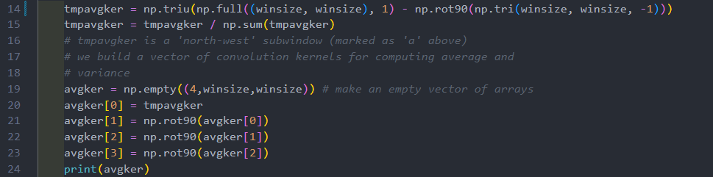定義鄰近區域的圖形

步驟：

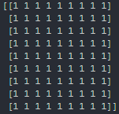

1. 生成二維矩陣

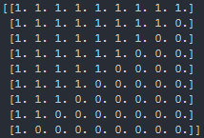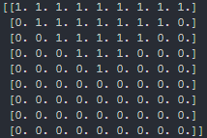

1. 過濾掉左下角

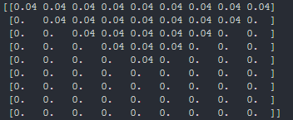

1. 賦值
2. 裁切右下角

**程式碼：**

from skimage import io

import scipy.ndimage as ndi

import numpy as np

import matplotlib.pyplot as plt

import numpy as np

from scipy.signal import convolve2d

def Kuwahara(original, winsize):

    image = original.astype(np.float64)

*# make sure window size is correct*

    if winsize %4 != 1:

        raise Exception ("Invalid winsize %s: winsize must follow formula: w = 4*n+1." %winsize)

*#Build subwindows*

    tmpAvgKerRow = np.hstack((np.ones((1,(winsize-1)//2+1)),np.zeros((1,(winsize-1)//2))))

    tmpPadder = np.zeros((1,winsize))

    tmpavgker = np.tile(tmpAvgKerRow, ((winsize-1)//2+1,1))

    tmpavgker = np.vstack((tmpavgker, np.tile(tmpPadder, ((winsize-1)//2,1))))

    tmpavgker = tmpavgker/np.sum(tmpavgker)

*# tmpavgker is a 'north-west' subwindow (marked as 'a' above)*

*# we build a vector of convolution kernels for computing average and*

*# variance*

    avgker = np.empty((4,winsize,winsize)) *# make an empty vector of arrays*

    avgker[0] = tmpavgker           *# North-west (a)*

    avgker[1] = np.fliplr(tmpavgker)    *# North-east (b)*

    avgker[2] = np.flipud(tmpavgker)    *# South-west (c)*

    avgker[3] = np.fliplr(avgker[2])    *# South-east (d)*

*# Create a pixel-by-pixel square of the image*

    squaredImg = image**2

*# preallocate these arrays to make it apparently %15 faster*

    avgs = np.zeros([4, image.shape[0],image.shape[1]])

    stddevs = avgs.copy()

*# Calculation of averages and variances on subwindows*

    for k in range(4):

*# mean on subwindow*

        avgs[k] = convolve2d(image, avgker[k],mode='same')

*# mean of squares on subwindow*

        stddevs[k] = convolve2d(squaredImg, avgker[k],mode='same')

*# variance on subwindow*

        stddevs[k] = stddevs[k]-avgs[k]**2

*# Choice of index with minimum variance*

    indices = np.argmin(stddevs,0) *# returns index of subwindow with smallest variance*

*# Building the filtered image (with nested for loops)*

    filtered = np.zeros(original.shape)

    for row in range(original.shape[0]):

        for col in range(original.shape[1]):

            filtered[row,col] = avgs[indices[row,col], row,col]

*#filtered=filtered.astype(np.uint8)*

    return filtered.astype(np.uint8)

def KuwaharaDiag(original, winsize):

    image = original.astype(np.float64)

*# make sure window size is correct*

    if winsize %4 != 1:

        raise Exception ("Invalid winsize %s: winsize must follow formula: w = 4*n+1." %winsize)

    tmpavgker = np.triu(np.full((winsize, winsize), 1) - np.rot90(np.tri(winsize, winsize, -1)))

    tmpavgker = tmpavgker / np.sum(tmpavgker)

*# tmpavgker is a 'north-west' subwindow (marked as 'a' above)*

*# we build a vector of convolution kernels for computing average and*

*# variance*

    avgker = np.empty((4,winsize,winsize)) *# make an empty vector of arrays*

    avgker[0] = tmpavgker

    avgker[1] = np.rot90(avgker[0])

    avgker[2] = np.rot90(avgker[1])

    avgker[3] = np.rot90(avgker[2])

    print(avgker)

*# Create a pixel-by-pixel square of the image*

    squaredImg = image**2

*# preallocate these arrays to make it apparently %15 faster*

    avgs = np.zeros([4, image.shape[0],image.shape[1]])

    stddevs = avgs.copy()

*# Calculation of averages and variances on subwindows*

    for k in range(4):

*# mean on subwindow*

        avgs[k] = convolve2d(image, avgker[k],mode='same')

*# mean of squares on subwindow*

        stddevs[k] = convolve2d(squaredImg, avgker[k],mode='same')

*# variance on subwindow*

        stddevs[k] = stddevs[k]-avgs[k]**2

*# Choice of index with minimum variance*

    indices = np.argmin(stddevs,0) *# returns index of subwindow with smallest variance*

*# Building the filtered image (with nested for loops)*

    filtered = np.zeros(original.shape)

    for row in range(original.shape[0]):

        for col in range(original.shape[1]):

            filtered[row,col] = avgs[indices[row,col], row,col]

*#filtered=filtered.astype(np.uint8)*

    return filtered.astype(np.uint8)

c = io.imread('Digital-Image-Processing\\Lab5\\cameraman.tif')

cK=Kuwahara(c,9)

cKD=KuwaharaDiag(c, 9)

fig = plt.figure()

plt.gray()  *# show the filtered result in grayscale*

ax1 = fig.add_subplot(131)  *# left side*

ax2 = fig.add_subplot(132)  *# right side*

ax3 = fig.add_subplot(133)

ax1.imshow(c/255,vmax=1.0,vmin=0.0)

ax2.imshow(cK/255,vmax=1.0,vmin=0.0)

ax3.imshow(cKD/255, vmax=1.0, vmin=0.0)

plt.show()

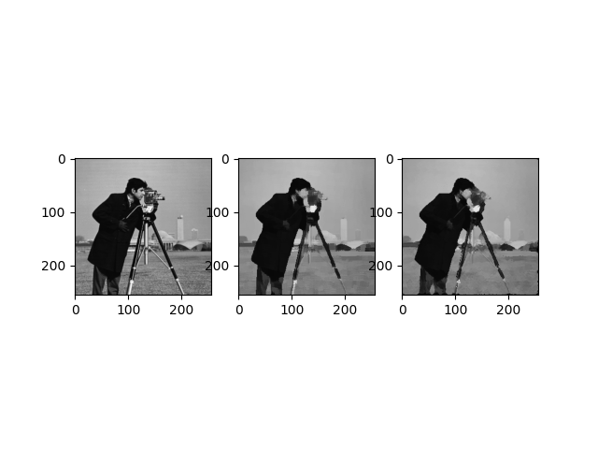**實習結果：**

左：原圖；中：Kawahera濾波；右：Kawahera對角濾波（實習結果）

**實習心得：**

這次的實習相對較為簡單，不需要過多複雜的程式，但就是要熟悉Numpy的用法，否則程式碼會變得較為冗長。