Atividade 2

1-

i)

**a)**

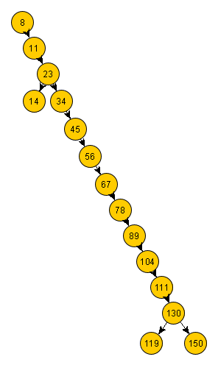

**b)**

|  |  |  |
| --- | --- | --- |
| Nó | Altura | Profundidade |
| 8 | 0 | 12 |
| 11 | 1 | 11 |
| 23 | 2 | 10 |
| 34 | 3 | 9 |
| 45 | 4 | 8 |
| 56 | 5 | 7 |
| 67 | 6 | 6 |
| 78 | 7 | 5 |
| 89 | 8 | 4 |
| 104 | 9 | 3 |
| 111 | 10 | 2 |
| 130 | 11 | 1 |
| 119 | 12 | 0 |
| 14 | 3 | 9 |
| 150 | 12 | 0 |

c)

|  |
| --- |
| Nó-folha |
| 119 |
| 14 |
| 150 |

**d)**

* Pré-ordem -> 8,11,23,14,34,45,56,67,78,89,104,111,130,119,150
* Pós-ordem -> 14,119,150,130,111,104,89,78,67,56,45,34,23,11,8
* Em-ordem -> 8,11,14,23,34,45,56,67,78,89,104,111,119,130,150

**e)**

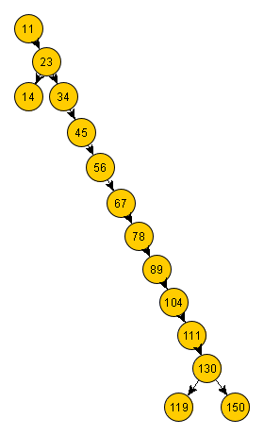

**f)**

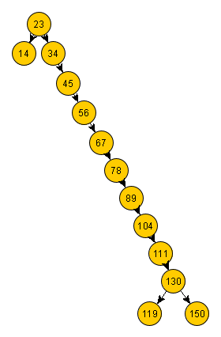

**g)**

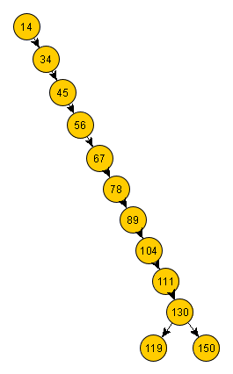

h)

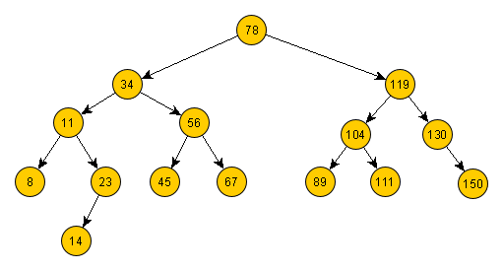

i)

* Pré-ordem -> 78, 34, 11, 8, 23, 14, 56, 45, 67, 119, 104, 89, 111, 130, 150
* Pós-ordem -> 8, 14, 23, 11, 45, 67, 56, 34, 89, 111, 104, 150, 130, 119, 78
* Em-ordem -> 8, 11, 14, 23, 34, 45, 56, 67, 78, 89, 104, 111, 119, 130, 150

**ii)**